

**CAPSTONE PROJECT REPORT**

**Report 5 – Software Test Documentation**

– Hanoi, August 2019 –

**Table of Contents**

I. Project Report 3

1. Status Report 3

2. Team Involvements 3

3. Issues/Suggestions 3

II. Project Management Plan 4

1. Overall Description 4

1.1 Test Model 4

1.2 Testing Levels 4

1.3 Testing Types 4

2. Test Plan 4

2.1 Test Stages 4

2.2 Resources 4

2.3 Test Milestones 5

2.4 Deliverables 5

3. Test Cases 5

4. Test Reports 5

# I. Project Report

## 1. Status Report

|  |  |  |  |
| --- | --- | --- | --- |
| **#** | **Work Item** | **Status** | **Notes (Work Item in Details)** |
| 1 |  | Pending |  |
| 2 |  | In Progress |  |
| 3 |  | Completed |  |

## 2. Team Involvements

|  |  |  |  |
| --- | --- | --- | --- |
| **#** | **Task** | **Member** | **Notes (Task Details, etc.)** |
| 1 |  | KienNT |  |
| 2 |  | TuanTV |  |
| 3 |  | AnhLM |  |

## 3. Issues/Suggestions

|  |  |  |  |
| --- | --- | --- | --- |
| **#** | **Issue** | **Status** | **Notes (Solution, Suggestion, etc.)** |
| 1 |  | Pending |  |
| 2 |  | In Progress |  |
| 3 |  | Completed |  |

# II. Project Management Plan

## 1. Overall Description

### 1.1 Test Model

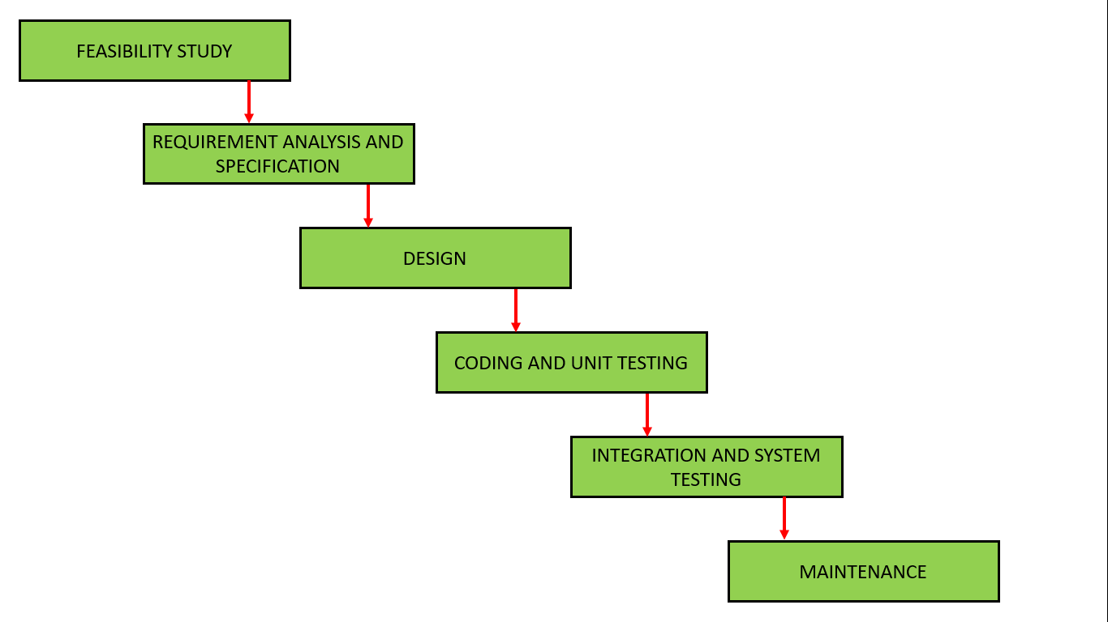

Software testing is a critical stage. Because any bugs or errors in the software can be identified and corrected before the software product is delivered. A properly tested software product guarantees dependability, security, and high performance, resulting in time savings, cost effectiveness, and customer satisfaction. We use the Waterfall model to implement the Testing phase for SLA services. The main reason we chose the Waterfall model is that SLA services are a short-term and medium-term project. Furthermore, this model is simple to use and follow.

### 1.2 Testing Levels

There are mainly three **levels of testing** in software testing:

|  |  |  |
| --- | --- | --- |
| **ID** | **Test stages** | **Description** |
| 1 | Unit testing | The main aim of this test level is to determine whether the application functions as designed. In this phase, a unit can refer to a function, individual program or even a procedure, and a White-box Testing method is usually used to get the job done. |
| 2 | Integration testing | Individual software modules are combined and tested as a group during the integration testing phase of software testing. The main goal of this phase is to test the combination of the Front-end module and the Back-end module. Furthermore, this phase will test the combination of submodules within the Back-end and Front-end modules. |
| 3 | System testing | System testing is a type of testing that validates the entire, fully integrated software product. A system test is used to evaluate the end-to-end system specifications. System testing is actually a collection of different tests whose sole purpose is to put the entire computer-based system through its paces. |

### 1.3 Testing Types

In this project, we use 2 testing types:

* Functional testing
* Graphic user interface testing

## 2. Test Plan

### 2.1 Test Stages

|  |  |  |  |
| --- | --- | --- | --- |
| **Type of Test** | **Stage of Test** | | |
| **Unit** | **Integration** | **System** |
| GUI testing |  | x | x |
| Functional testing | x | x | x |

### 2.2 Resources

### a. Human Resources

|  |  |  |
| --- | --- | --- |
| **Worker/Doer** | **Role** | **Specific Responsibilities/Comments** |
|  | Test leader | - Create test plan  - Create test cases  - Review test cases  - Execute test |
|  | Tester | - Create test cases  - Execute test cases |
|  | Tester | - Create test cases  - Execute test cases |
|  | Tester | - Create test cases  - Execute test cases |
|  | Tester | - Create test cases  - Execute test cases |

### b. Environment

|  |  |  |  |
| --- | --- | --- | --- |
| **Purpose** | **Tool** | **Provider** | **Version** |
| To view logs, inspect elements. Main testing environment. | Google Chrome | Google | 92.0.4515.131 |
| Used to store documents | Google drive | Google |  |
| Used to write test cases and manage test cases | Excel | Microsoft |  |
| Used to log bugs when software errors occur | Excel | Microsoft |  |

### 2.3 Test Milestones

|  |  |  |  |
| --- | --- | --- | --- |
| **Milestone Task** | **Effort (md)** | **Start Date** | **End Date** |
| Testing for Phase 1 |  |  |  |
| Testing for Phase 2 |  |  |  |
| Testing for Phase 3 |  |  |  |
| Testing for Phase 4 |  |  |  |

### 2.4 Deliverables

|  |  |  |
| --- | --- | --- |
| **No** | **Deliverables** | **Due Date** |
| 1 | Test cases, test report for module 1 |  |
| 2 | Test cases, test report for module 2 |  |
| 3 | Test cases, test report for module 3 |  |
| 4 | Test cases, test report for module 4 |  |

## 3. Test Cases

### 3.1. Integration testing

### 3.2. System testing

## 4. Test Reports

### 4.1. Integration testing

### 4.2. System testing