Đặng Thị Thùy Linh – THPT Bạch Đằng

Cauhoi

Cho tam giác Pascal là tam giác có dạng sau
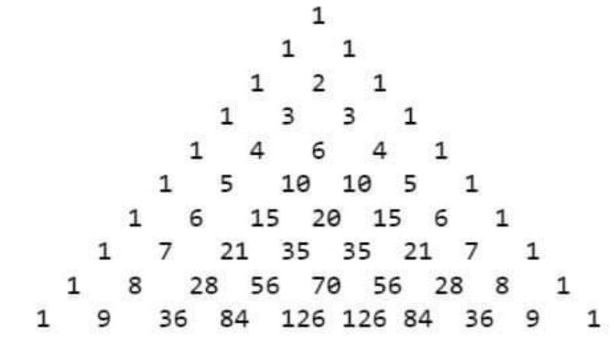
Viết chương trình in ra tam giác Pascal có N dòng.
Dữ liệu vào: đọc từ tệp PascalIn.txt gồm 1 số nguyên N
Dữ liệu ra: ghi ra tệp PascalOut.txt chứa tam giác Pascal có N dòng

Dapan

#include <bits/stdc++.h>
using namespace std;
#define ll long long
const int base = 1000000000; const int base_digits = 9;

struct bigint {
vector<int> a; int sign;

bigint() : sign(1) {}

bigint(long long v) {
*this = v;
}

bigint(const string &s) {
read(s);
}

void operator=(const bigint &v) {
sign = v.sign;
a = v.a;
}

void operator=(long long v) {
sign = 1;
if (v < 0)
sign = -1, v = -v;
for (; v > 0; v = v / base)
a.push_back(v % base);
}

bigint operator+(const bigint &v) const {
if (sign == v.sign) {
bigint res = v;
for (int i = 0, carry = 0; i < (int) max(a.size(), v.a.size()) || carry; ++i) {
if (i == (int) res.a.size())
res.a.push_back(0);
res.a[i] += carry + (i < (int) a.size() ? a[i] : 0);
carry = res.a[i] >= base;
if (carry)
res.a[i] -= base;
}
return res;
}
return *this - (-v);
}
bigint operator-(const bigint &v) const {
if (sign == v.sign) {
if (abs() >= v.abs()) {
bigint res = *this;
for (int i = 0, carry = 0; i < (int) v.a.size() || carry; ++i) {
res.a[i] -= carry + (i < (int) v.a.size() ? v.a[i] : 0);
carry = res.a[i] < 0;
if (carry)
res.a[i] += base;
}
res.trim();
return res;
}
return -(v - *this);
}
return *this + (-v);
}
void operator*=(int v) {
if (v < 0)
sign = -sign, v = -v;
for (int i = 0, carry = 0; i < (int) a.size() || carry; ++i) {
if (i == (int) a.size())
a.push_back(0);
long long cur = a[i] * (long long) v + carry;
carry = (int) (cur / base);
a[i] = (int) (cur % base);
}
trim();
}
bigint operator*(int v) const {
bigint res = *this;
res *= v;
return res;
}
friend pair<bigint, bigint> divmod(const bigint &a1, const bigint &b1) {
int norm = base / (b1.a.back() + 1);
bigint a = a1.abs() * norm;
bigint b = b1.abs() * norm;
bigint q, r;
q.a.resize(a.a.size());
for (int i = a.a.size() - 1; i >= 0; i--) {
r *= base;
r += a.a[i];
int s1 = r.a.size() <= b.a.size() ? 0 : r.a[b.a.size()];
int s2 = r.a.size() <= b.a.size() - 1 ? 0 : r.a[b.a.size() - 1];
int d = ((long long) base * s1 + s2) / b.a.back();
r -= b * d;
while (r < 0)
r += b, --d;
q.a[i] = d;
}
q.sign = a1.sign * b1.sign;
r.sign = a1.sign;
q.trim();
r.trim();
return make_pair(q, r / norm);
}
bigint operator/(const bigint &v) const {
return divmod(*this, v).first;
}
bigint operator%(const bigint &v) const {
return divmod(*this, v).second;
}
void operator/=(int v) {
if (v < 0)
sign = -sign, v = -v;
for (int i = (int) a.size() - 1, rem = 0; i >= 0; --i) {
long long cur = a[i] + rem * (long long) base;
a[i] = (int) (cur / v);
rem = (int) (cur % v);
}
trim();
}
bigint operator/(int v) const {
bigint res = *this;
res /= v;
return res;
}
int operator%(int v) const {
if (v < 0)
v = -v;
int m = 0;
for (int i = a.size() - 1; i >= 0; --i)
m = (a[i] + m * (long long) base) % v;
return m * sign;
}
void operator+=(const bigint &v) {
*this = *this + v;
}
void operator-=(const bigint &v) {
*this = *this - v;
}
void operator*=(const bigint &v) {
*this = *this * v;
}
void operator/=(const bigint &v) {
*this = *this / v;
}
bool operator<(const bigint &v) const {
if (sign != v.sign)
return sign < v.sign;
if (a.size() != v.a.size())
return a.size() * sign < v.a.size() * v.sign;
for (int i = a.size() - 1; i >= 0; i--)
if (a[i] != v.a[i])
return a[i] * sign < v.a[i] * sign;
return false;
}
bool operator>(const bigint &v) const {
return v < *this;
}
bool operator<=(const bigint &v) const {
return !(v < *this);
}
bool operator>=(const bigint &v) const {
return !(*this < v);
}
bool operator==(const bigint &v) const {
return !(*this < v) && !(v < *this);
}
bool operator!=(const bigint &v) const {
return *this < v || v < *this;
}
void trim() {
while (!a.empty() && !a.back())
a.pop_back();
if (a.empty())
sign = 1;
}
bool isZero() const {
return a.empty() || (a.size() == 1 && !a[0]);
}
bigint operator-() const {
bigint res = *this;
res.sign = -sign;
return res;
}
bigint abs() const {
bigint res = *this;
res.sign *= res.sign;
return res;
}
long long longValue() const {
long long res = 0;
for (int i = a.size() - 1; i >= 0; i--)
res = res * base + a[i];
return res * sign;
}
friend bigint gcd(const bigint &a, const bigint &b) {
return b.isZero() ? a : gcd(b, a % b);
}
friend bigint lcm(const bigint &a, const bigint &b) {
return a / gcd(a, b) * b;
}
void read(const string &s) {
sign = 1;
a.clear();
int pos = 0;
while (pos < (int) s.size() && (s[pos] == '-' || s[pos] == '+')) {
if (s[pos] == '-')
sign = -sign;
++pos;
}
for (int i = s.size() - 1; i >= pos; i -= base_digits) {
int x = 0;
for (int j = max(pos, i - base_digits + 1); j <= i; j++)
x = x * 10 + s[j] - '0';
a.push_back(x);
}
trim();
}
friend istream& operator>>(istream &stream, bigint &v) {
string s;
stream >> s;
v.read(s);
return stream;
}
friend ostream& operator<<(ostream &stream, const bigint &v) {
if (v.sign == -1)
stream << '-';
stream << (v.a.empty() ? 0 : v.a.back());
for (int i = (int) v.a.size() - 2; i >= 0; --i)
stream << setw(base_digits) << setfill('0') << v.a[i];
return stream;
}
static vector<int> convert_base(const vector<int> &a, int old_digits, int new_digits) {
vector<long long> p(max(old_digits, new_digits) + 1);
p[0] = 1;
for (int i = 1; i < (int) p.size(); i++)
p[i] = p[i - 1] * 10;
vector<int> res;
long long cur = 0;
int cur_digits = 0;
for (int i = 0; i < (int) a.size(); i++) {
cur += a[i] * p[cur_digits];
cur_digits += old_digits;
while (cur_digits >= new_digits) {
res.push_back(int(cur % p[new_digits]));
cur /= p[new_digits];
cur_digits -= new_digits;
}
}
res.push_back((int) cur);
while (!res.empty() && !res.back())
res.pop_back();
return res;
}
typedef vector<long long> vll;
static vll karatsubaMultiply(const vll &a, const vll &b) {
int n = a.size();
vll res(n + n);
if (n <= 32) {
for (int i = 0; i < n; i++)
for (int j = 0; j < n; j++)
res[i + j] += a[i] * b[j];
return res;
}
int k = n >> 1;
vll a1(a.begin(), a.begin() + k);
vll a2(a.begin() + k, a.end());
vll b1(b.begin(), b.begin() + k);
vll b2(b.begin() + k, b.end());
vll a1b1 = karatsubaMultiply(a1, b1);
vll a2b2 = karatsubaMultiply(a2, b2);
for (int i = 0; i < k; i++)
a2[i] += a1[i];
for (int i = 0; i < k; i++)
b2[i] += b1[i];
vll r = karatsubaMultiply(a2, b2);
for (int i = 0; i < (int) a1b1.size(); i++)
r[i] -= a1b1[i];
for (int i = 0; i < (int) a2b2.size(); i++)
r[i] -= a2b2[i];

for (int i = 0; i < (int) r.size(); i++)
res[i + k] += r[i];
for (int i = 0; i < (int) a1b1.size(); i++)
res[i] += a1b1[i];
for (int i = 0; i < (int) a2b2.size(); i++)
res[i + n] += a2b2[i];
return res;
}
bigint operator*(const bigint &v) const {
vector<int> a6 = convert_base(this->a, base_digits, 6);
vector<int> b6 = convert_base(v.a, base_digits, 6);
vll a(a6.begin(), a6.end());
vll b(b6.begin(), b6.end());
while (a.size() < b.size())
a.push_back(0);
while (b.size() < a.size())
b.push_back(0);
while (a.size() & (a.size() - 1))
a.push_back(0), b.push_back(0);
vll c = karatsubaMultiply(a, b);
bigint res;
res.sign = sign * v.sign;
for (int i = 0, carry = 0; i < (int) c.size(); i++) {
long long cur = c[i] + carry;
res.a.push_back((int) (cur % 1000000));
carry = (int) (cur / 1000000);
}
res.a = convert_base(res.a, 6, base_digits);
res.trim();
return res;
}
};

bigint Factorial(bigint n) {
bigint res = 1, i;
for (i = 2; i <= n; i += 1)
res *= i;
return res;
}

bigint Comb(bigint n, bigint k) {
return Factorial(n) / (Factorial(k) * Factorial(n - k));
}

int main()
{
//Attach files
freopen("PascalIn.txt", "r", stdin);
freopen("PascalOut.txt", "w", stdout);

//Main program
int n; scanf("%d", &n);
for (int i = 0; i <= n; i += 1) {
for (int j = 0; j <= i; j += 1)
cout << Comb(i, j) << " ";
cout << "\n";
}
return 0;
}

