-- ========================
-- DATABASE CREATION
-- ========================
CREATE DATABASE IF NOT EXISTS bakery_inventory;
USE bakery_inventory;

-- ========================
-- USER & ROLE
-- ========================
CREATE TABLE Roles (
role_id INT AUTO_INCREMENT PRIMARY KEY,
role_name VARCHAR(20) NOT NULL
);

CREATE TABLE Users (
user_id INT AUTO_INCREMENT PRIMARY KEY,
username VARCHAR(50) UNIQUE NOT NULL,
password_hash VARCHAR(255) NOT NULL,
email VARCHAR(100),
phone VARCHAR(20),
role_id INT,
created_at DATETIME DEFAULT CURRENT_TIMESTAMP,
last_login DATETIME,
FOREIGN KEY (role_id) REFERENCES Roles(role_id)
);

-- ========================
-- INGREDIENT & INVENTORY
-- ========================
CREATE TABLE Ingredients (
ingredient_id INT AUTO_INCREMENT PRIMARY KEY,
name VARCHAR(100) NOT NULL,
unit VARCHAR(20) NOT NULL,
shelf_life_days INT,
created_at DATETIME DEFAULT CURRENT_TIMESTAMP
);

CREATE TABLE Batches (
batch_id INT AUTO_INCREMENT PRIMARY KEY,
ingredient_id INT NOT NULL,
lot_code VARCHAR(50) UNIQUE NOT NULL,
quantity DECIMAL(10,2) NOT NULL,
unit VARCHAR(20) NOT NULL,
manufacture_date DATE,
expiry_date DATE,
status ENUM('Valid','NearExpiry','Expired','Opened','UsedUp') DEFAULT 'Valid',
created_by INT,
created_at DATETIME DEFAULT CURRENT_TIMESTAMP,
FOREIGN KEY (ingredient_id) REFERENCES Ingredients(ingredient_id),
FOREIGN KEY (created_by) REFERENCES Users(user_id)
);

CREATE TABLE Inventory (
inventory_id INT AUTO_INCREMENT PRIMARY KEY,
ingredient_id INT NOT NULL,
current_stock DECIMAL(10,2) NOT NULL DEFAULT 0,
unit VARCHAR(20) NOT NULL,
last_updated DATETIME DEFAULT CURRENT_TIMESTAMP ON UPDATE CURRENT_TIMESTAMP,
FOREIGN KEY (ingredient_id) REFERENCES Ingredients(ingredient_id)
);

-- ========================
-- MENU & RECIPE
-- ========================
CREATE TABLE Menu (
menu_id INT AUTO_INCREMENT PRIMARY KEY,
name VARCHAR(100) NOT NULL,
description TEXT,
is_active BOOLEAN DEFAULT TRUE,
created_by INT,
created_at DATETIME DEFAULT CURRENT_TIMESTAMP,
FOREIGN KEY (created_by) REFERENCES Users(user_id)
);

CREATE TABLE Recipes (
recipe_id INT AUTO_INCREMENT PRIMARY KEY,
menu_id INT NOT NULL,
approved_by INT,
created_at DATETIME DEFAULT CURRENT_TIMESTAMP,
FOREIGN KEY (menu_id) REFERENCES Menu(menu_id),
FOREIGN KEY (approved_by) REFERENCES Users(user_id)
);

CREATE TABLE Recipe_Ingredients (
recipe_ingredient_id INT AUTO_INCREMENT PRIMARY KEY,
recipe_id INT NOT NULL,
ingredient_id INT NOT NULL,
quantity DECIMAL(10,2) NOT NULL,
unit VARCHAR(20) NOT NULL,
FOREIGN KEY (recipe_id) REFERENCES Recipes(recipe_id),
FOREIGN KEY (ingredient_id) REFERENCES Ingredients(ingredient_id)
);

-- ========================
-- TRANSACTIONS
-- ========================
CREATE TABLE Transactions (
transaction_id INT AUTO_INCREMENT PRIMARY KEY,
batch_id INT NOT NULL,
type ENUM('Import','Export','Use','Waste','Adjust') NOT NULL,
quantity DECIMAL(10,2) NOT NULL,
unit VARCHAR(20) NOT NULL,
created_by INT,
created_at DATETIME DEFAULT CURRENT_TIMESTAMP,
note TEXT,
FOREIGN KEY (batch_id) REFERENCES Batches(batch_id),
FOREIGN KEY (created_by) REFERENCES Users(user_id)
);

CREATE TABLE Opened_Packages (
opened_id INT AUTO_INCREMENT PRIMARY KEY,
batch_id INT NOT NULL,
opened_date DATE,
new_expiry_date DATE,
handled_by INT,
FOREIGN KEY (batch_id) REFERENCES Batches(batch_id),
FOREIGN KEY (handled_by) REFERENCES Users(user_id)
);

-- ========================
-- ALERTS & WASTE
-- ========================
CREATE TABLE Alerts (
alert_id INT AUTO_INCREMENT PRIMARY KEY,
batch_id INT NOT NULL,
alert_type ENUM('NearExpiry','Expired','LowStock','Waste') NOT NULL,
severity ENUM('Yellow','Red') NOT NULL,
status ENUM('Pending','Resolved') DEFAULT 'Pending',
created_at DATETIME DEFAULT CURRENT_TIMESTAMP,
resolved_at DATETIME,
resolved_by INT,
FOREIGN KEY (batch_id) REFERENCES Batches(batch_id),
FOREIGN KEY (resolved_by) REFERENCES Users(user_id)
);

CREATE TABLE Waste_Reports (
waste_id INT AUTO_INCREMENT PRIMARY KEY,
batch_id INT NOT NULL,
reported_by INT,
reason TEXT,
quantity DECIMAL(10,2),
unit VARCHAR(20),
report_date DATETIME DEFAULT CURRENT_TIMESTAMP,
FOREIGN KEY (batch_id) REFERENCES Batches(batch_id),
FOREIGN KEY (reported_by) REFERENCES Users(user_id)
);

-- ========================
-- FORECASTS & SUGGESTIONS
-- ========================
CREATE TABLE Forecasts (
forecast_id INT AUTO_INCREMENT PRIMARY KEY,
ingredient_id INT NOT NULL,
forecast_type ENUM('Weekly','Monthly','Trend') NOT NULL,
predicted_quantity DECIMAL(10,2),
unit VARCHAR(20),
forecast_date DATE,
generated_at DATETIME DEFAULT CURRENT_TIMESTAMP,
FOREIGN KEY (ingredient_id) REFERENCES Ingredients(ingredient_id)
);

CREATE TABLE Suggestions (
suggestion_id INT AUTO_INCREMENT PRIMARY KEY,
suggestion_type ENUM('Menu','Recipe_Substitute','Purchase') NOT NULL,
details TEXT,
status ENUM('Pending','Approved','Rejected') DEFAULT 'Pending',
created_at DATETIME DEFAULT CURRENT_TIMESTAMP,
approved_by INT,
FOREIGN KEY (approved_by) REFERENCES Users(user_id)
);

CREATE TABLE Production_Reports (
report_id INT AUTO_INCREMENT PRIMARY KEY,
menu_id INT NOT NULL,
produced_quantity INT NOT NULL,
report_date DATE,
created_at DATETIME DEFAULT CURRENT_TIMESTAMP,
FOREIGN KEY (menu_id) REFERENCES Menu(menu_id)
);

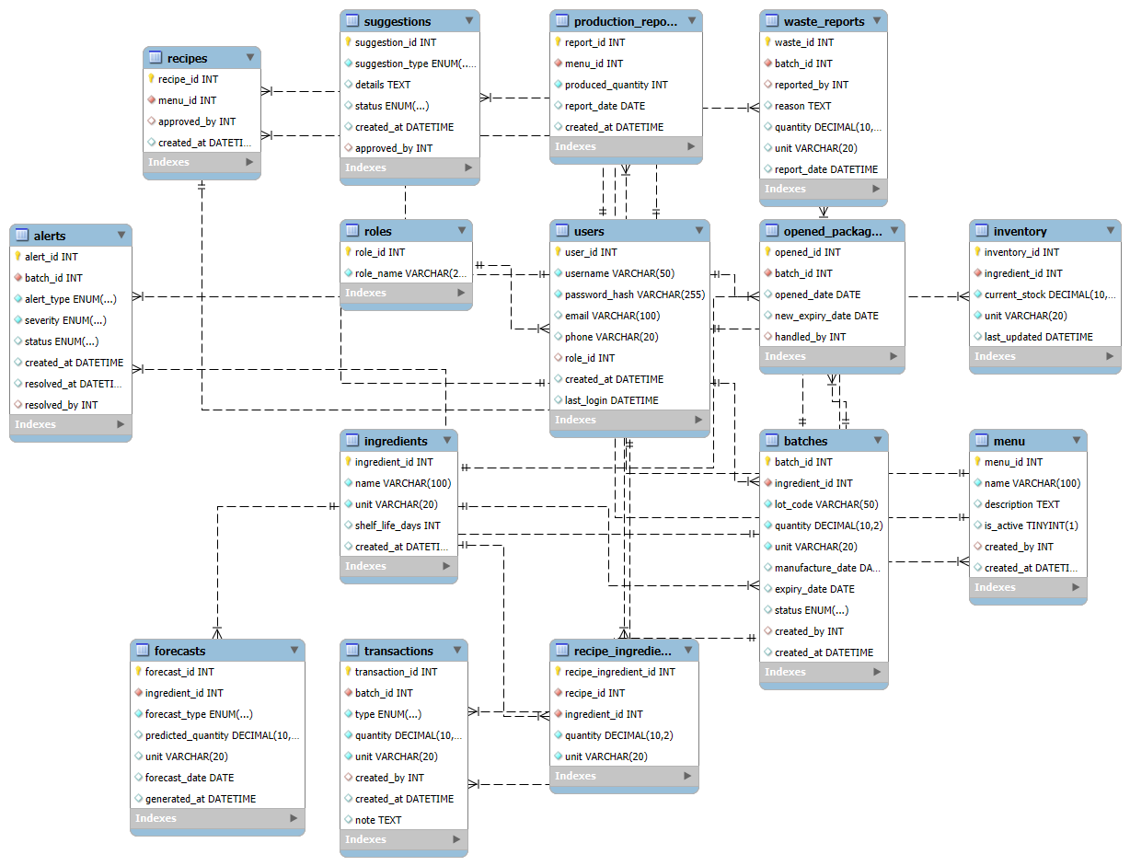

USE bakery_inventory;

-- ========================
-- 1. Roles & Users
-- ========================
INSERT INTO Roles (role_name) VALUES
('Owner'), ('Employee'), ('Admin');

INSERT INTO Users (username, password_hash, email, phone, role_id) VALUES
('owner1', 'hash_pw1', 'owner1@mail.com', '0901111111', 1), -- Owner
('emp1', 'hash_pw2', 'emp1@mail.com', '0902222222', 2), -- Employee
('emp2', 'hash_pw3', 'emp2@mail.com', '0903333333', 2), -- Employee
('admin1', 'hash_pw4', 'admin1@mail.com', '0904444444', 3); -- Admin

-- ========================
-- 2. Ingredients
-- ========================
INSERT INTO Ingredients (name, unit, shelf_life_days) VALUES
('Bột mì', 'kg', 180),
('Đường trắng', 'kg', 365),
('Bơ lạt', 'kg', 90),
('Sữa tươi', 'l', 10),
('Bột cacao', 'kg', 200);

-- ========================
-- 3. Batches (lô nhập kho)
-- ========================
INSERT INTO Batches (ingredient_id, lot_code, quantity, unit, manufacture_date, expiry_date, status, created_by) VALUES
(1, 'LOT001', 100, 'kg', '2025-09-01', '2026-03-01', 'Valid', 4), -- Bột mì
(2, 'LOT002', 50, 'kg', '2025-09-05', '2026-09-05', 'Valid', 4), -- Đường
(3, 'LOT003', 30, 'kg', '2025-09-10', '2025-12-10', 'Valid', 4), -- Bơ
(4, 'LOT004', 20, 'l', '2025-09-20', '2025-09-30', 'Valid', 4), -- Sữa
(5, 'LOT005', 10, 'kg', '2025-09-15', '2026-03-15', 'Valid', 4); -- Cacao

-- ========================
-- 4. Inventory (tồn kho)
-- ========================
INSERT INTO Inventory (ingredient_id, current_stock, unit) VALUES
(1, 100, 'kg'),
(2, 50, 'kg'),
(3, 30, 'kg'),
(4, 20, 'l'),
(5, 10, 'kg');

-- ========================
-- 5. Menu & Recipes
-- ========================
INSERT INTO Menu (name, description, created_by) VALUES
('Bánh mì ngọt', 'Bánh mì ngọt cơ bản', 1),
('Bánh kem bơ', 'Bánh kem dùng bơ và sữa', 1),
('Bánh sô-cô-la', 'Bánh cacao phủ sô-cô-la', 1);

INSERT INTO Recipes (menu_id, approved_by) VALUES
(1, 1),
(2, 1),
(3, 1);

INSERT INTO Recipe_Ingredients (recipe_id, ingredient_id, quantity, unit) VALUES
-- Bánh mì ngọt
(1, 1, 0.5, 'kg'),
(1, 2, 0.1, 'kg'),
-- Bánh kem bơ
(2, 1, 0.3, 'kg'),
(2, 3, 0.2, 'kg'),
(2, 4, 0.5, 'l'),
-- Bánh sô-cô-la
(3, 1, 0.4, 'kg'),
(3, 5, 0.2, 'kg'),
(3, 2, 0.1, 'kg');

-- ========================
-- 6. Transactions (nhập - xuất - dùng)
-- ========================
INSERT INTO Transactions (batch_id, type, quantity, unit, created_by, note) VALUES
(1, 'Import', 100, 'kg', 4, 'Nhập bột mì ban đầu'),
(2, 'Import', 50, 'kg', 4, 'Nhập đường ban đầu'),
(3, 'Import', 30, 'kg', 4, 'Nhập bơ ban đầu'),
(4, 'Import', 20, 'l', 4, 'Nhập sữa ban đầu'),
(5, 'Import', 10, 'kg', 4, 'Nhập bột cacao ban đầu'),
(1, 'Use', 5, 'kg', 2, 'Làm bánh mì ngọt'),
(4, 'Use', 2, 'l', 2, 'Làm bánh kem bơ'),
(5, 'Use', 1, 'kg', 2, 'Làm bánh sô-cô-la');

-- ========================
-- 7. Opened Packages (mở bao bì)
-- ========================
INSERT INTO Opened_Packages (batch_id, opened_date, new_expiry_date, handled_by) VALUES
(3, '2025-09-25', '2025-10-25', 2);

-- ========================
-- 8. Alerts & Waste Reports
-- ========================
INSERT INTO Alerts (batch_id, alert_type, severity, status) VALUES
(4, 'NearExpiry', 'Yellow', 'Pending'),
(3, 'Expired', 'Red', 'Pending');

INSERT INTO Waste_Reports (batch_id, reported_by, reason, quantity, unit) VALUES
(3, 2, 'Bơ bị hỏng, chảy nước', 1, 'kg'),
(4, 2, 'Sữa để quá hạn', 1, 'l');

-- ========================
-- 9. Forecasts & Suggestions
-- ========================
INSERT INTO Forecasts (ingredient_id, forecast_type, predicted_quantity, unit, forecast_date) VALUES
(1, 'Weekly', 60, 'kg', '2025-10-01'),
(2, 'Weekly', 20, 'kg', '2025-10-01'),
(4, 'Weekly', 15, 'l', '2025-10-01');

INSERT INTO Suggestions (suggestion_type, details, status, approved_by) VALUES
('Menu', 'Thêm Bánh Trung Thu cho dịp Tết Trung Thu', 'Pending', 1),
('Recipe_Substitute', 'Thiếu bơ, thay bằng dầu thực vật', 'Approved', 1),
('Purchase', 'Mua thêm 20kg bột mì chuẩn bị cho lễ 20/10', 'Pending', 1);

-- ========================
-- 10. Production Reports
-- ========================
INSERT INTO Production_Reports (menu_id, produced_quantity, report_date) VALUES
(1, 100, '2025-09-25'),
(2, 50, '2025-09-25'),
(3, 30, '2025-09-25');

