IC TRAINING CENTER VIET NAM
FUNDAMENTAL IC DESIGN AND VERIFICATION COURSE



FINAL PROJECT
TIMER IP DESIGN SPECIFICATION

Student: Trần Hồ Khánh Tân Class: IC36

Instructor: Phạm Thiều Khang

Contents
- Overview 3
  - Introduction 4
  - Main features 4
  - Block diagram 5,6
  - Interface signals 7
- Register Specification 8
  - Register Summary 8
  - Timer Control Register (TCR) 8,9
  - Timer Data Register 0 ( TDR0) 10
  - Timer Data Register 1 (TDR1) 10
  - Timer Compare Register0 (TCMP0) 11
  - Timer Compare Register 1 (TCMP1) 11
  - Timer Interrupt Enable Register ( TIER) 12
  - Timer Interrup Status Register (TISR) 13
  - Timer Halted Control Status Register (THCSR) 14
- Functional Description 14
  - APB slave 14,15,16,17,18,19,20
  - Register Block 20,21,22,23,24,25,26,27,28,29,30,31
  - Counter Control Block 32,33,34,35,36
  - Counter Block 36,37,38,39,40
  - Interrupt Block 40,41,42,43,44
- History 44

LIST OF TABLES
Table 1: interface signals of timer IP 7
Table 2: Register Summary 8
Table 3. Timer Control Register (TCR) 9
Table 4: Timer Data Register 0(TDR0) 10
Table 5: Timer Data Register 1 (TDR1) 10
Table 6. Timer Compare Register 0(TCMP0) 11
Table 7: Timer Compare Register 1 (TCMP1) 12
Table 8: Timer Interrupt Enable Register ( TIER) 12
Table 9. Timer Interrupt Status Register (TISR) 13
Table 10:Timer Halted Control Status Register(THCSR) 14

LIST OF FIGURES
Figure 1: Block diagram of Timer IP 5
Figure 2: Waveform of APB_SLAVE 15
Figure 3. Logic diagram of APB_SLAVE 18
Figure 4. Waveform of Register Block 21
Figure 5. Logic diagram of TCR 24
Figure 6: Logic diagram of TDR0 26
Figure 7: Logic diagram of TDR1 27
Figure 8. Logic diagram of TCMP0 28
Figure 9. Logic diagram of TCMP1 29
Figure 10. Logic diagram of TISR and TIER 30
Figure 11: Logic diagram of THCSR 31
Figure 12: Waveform of Counter_Control Block 33
Figure 13. Logic diagram of Counter Control Block 35
Figure 14. Waveform of Counter Block 37
Figure 15. Logic diagram of Counter Block 38
Figure 16. Waveform of Interrupt Block 41
Figure 17. Logic diagram of Interrupt Block 42

Overview

Introduction
- Introduction:
+ In a RISC-V architecture, the CLINT (Core Local Interruptor) is the standard hardware block responsible for generating real-time ticks and software interrupts. In this project, the CLINT-based timer module is customized to provide user-programmable interrupt generation, acting as a highly precise, flexible alarm clock for the processor.
- Application:
+ Timer is an essential module for every chip.
+ This is used to generate accurate timing interval or controlling the timing of various
operations within the circuit. Timer can be used in various applications: pulse generation, delay generation, event generation, PWM generation, Interrupt generation.

Main features
- 64-bit count-up
- 12-bit address
- Register set is configured via APB bus (IP is APB slave).
- Standard level:
+ Only support APB 32-bit transfer with no wait states and no error handling
- Advanced level:
+ Support wait state (1 cycle is enough) and error handling
+ Support byte access
+ Support halt (stop) in debug mode
- Timer uses active low async reset.
- Counter can be counted based on system clock or divided up to 256.
- Support timer interrupt (can be enabled or disabled).

Block diagram
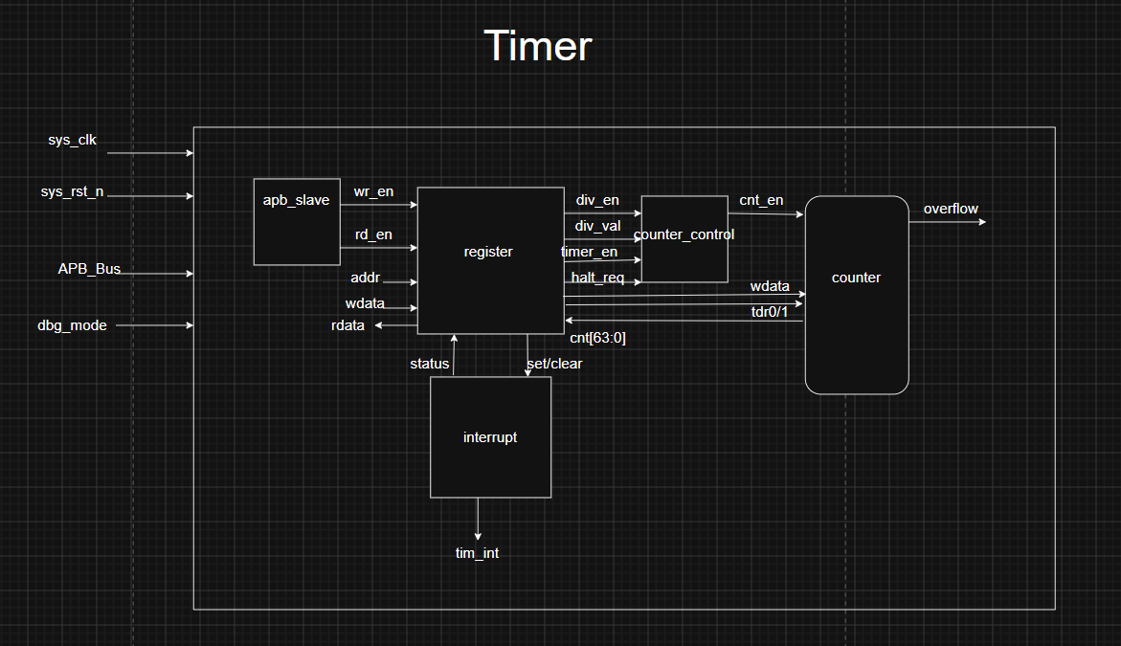
Figure 1: Logic diagram Timer
APB_Slave
- APB Slave Interface receives APB bus signals from Master (psel, penable, pwrite, paddr, pwdata, pstrb) and decodes them to generate internal control signals (wr_en, rd_en, addr, wdata) to Register Block.
- Read/write to reserved addresses is handled as RAZ/WI (read as zero, write ignored).
- It drives prdata, pready, pslverr back to the Master.
- This block is clocked by sys_clk and uses active low asynchronous reset (sys_rst_n)
Register_Block
- Core Function: Acts as the register interface that handles APB bus signals (wr_en, rd_en, addr, wdata, rdata) to store and manage all configuration and status registers for the Timer IP.
- Bus Interface Options: * Standard: Supports basic 32-bit APB transfers with zero wait states and no error response, treating reserved address accesses as RAZ/WI (Read As Zero / Write Ignored).
+ Advanced: Enhances capability with byte-level access, a 1-cycle wait state for timing optimization, and strict error handling that blocks writes during prohibited operations (e.g., modifying divisor settings while the timer is running).

- System Connectivity: Outputs critical configuration and control signals (timer_en, div_en, div_val, TCMP) directly to the Counter and Interrupt Logic blocks to drive the entire Timer system.

Counter Block
- Core Function: A 64-bit up-counter designed for continuous operation (unaffected by overflows or interrupts).

- Pace Control: Allows flexible control over the counting speed, which can either match the system clock or be regulated based on a software configuration (TCR.div_val).

- Enable/Disable Management: Handles system pausing and resetting (via software or hardware) when the timer_en signal is dropped, ensuring precise control over the timer's active duration.
Interrupt Logic Block
- Timer Interrupt :
+ Timer interrupt (tim_int) is asserted (set) when interrupt is enabled and counter’s value matches (equal) the compare value.
+ Once asserted, the timer interrupt (tim_int) remains unchange until it is cleared by writing 1 to TISR.int_st bit or the interrupt is disabled.

Interface signals

Table 1: Interface signals of timer IP

Signal name | Width | Direction | Description
sys_clk | 1 | input | System clock
sys_rst_n | 1 | input | Active low asynchronous reset
tim_psel | 1 | input | APB Slave select signal in timer
tim_pwrite | 1 | input | APB Slave write signal ( 0: read, 1: write)
tim_penable | 1 | input | APB Slave enable signal. Indicated at second cycle of transfer
tim_paddr[11:0] | 12 | input | APB Slave address bus
tim_pwdata[31:0] | 32 | input | APB Slave write data bus
tim_prdata[31:0] | 32 | output | APB Slave read data bus
tim_pstrb[3:0] | 4 | input | APB write strobe, indicates which byte lanes to update
tim_pready | 1 | output | APB Slave ready bus. Slave extend when pready is low
tim_pslverr | 1 | output | APB slave error response
tim_int | 1 | output | Timer interrupt output
dbg_mode | 1 | intput | Debug mode enable signal

Register Specification

Register Summary
Table 2: Register Summary

Offset | Abbreviation | Register name
0x00 | TCR | Timer Control Register
0x04 | TDR0 | Timer Data Register 0
0x08 | TDR1 | Timer Data Register 1
0x0c | TCMP0 | Timer Compare Register 0
0x10 | TCMP1 | Timer Compare Register 1
0x14 | TIER | Timer Interrupt Enable Register
0x18 | TISR | Timer Interrupt Status Register
0x1c | THCSR | Timer Halt Control Status Register
Others | Reserved

Timer Control Register (TCR)
Offset address: 0x00
Reset value: 0x0000_0000
31 30 29 28 27 26 25 24 23 22 21 20 19 18 17 16
Reserved

15 14 13 12 11 10 9 8 7 6 5 4 3 2 1 0
timer_en
div_en
Reserved
div_val
Reserved

Reserved | DIV_VAL[3:0] | Reserved | DIV_ EN | TIM_ EN
rw rw rw

Table 3. Timer Control Register (TCR)

Bit | Name | Type | Default value | Description
31:12 | Reserved |  | 20’h0 | Reserved
11:8 | DIV_VAL[3:0] | RW | 4’b0001 | Counter mode setting:  - 4’b0000: Counting speed is not divided    - 4’b0001: Counting speed is divided by 2 (default)  - 4’b0010: Counting speed is divided by 4  - 4’b0011: Counting speed is divided by 8  - 4’b0100: Counting speed is divided by 16  - 4’b0101: Counting speed is divided by 32  - 4’b0110: Counting speed is divided by 64  - 4’b0111: Counting speed is divided by 128 (*): advanced level  - 4’b1000: Counting speed is divided by 256  - Others : reserved  When setting the prohibit value, div_val is not changed.
7:2 | Reserved | RO | 6’b0 | Reserved
1 | DIV_EN | RW | 1’b0 | Counter control mode enable  + 0: Disabled. The counter counts with normal speed based on system clock  + 1 : Enabled. The counting speed of counter if controlled based on div_val  Note: user must not change div_en while timer_en is high
0 | TIM_EN | RW | 1’b0 | Timer enable  + 0: Disabled. Counter does not count.  + 1: Enabled. Counter starts counting

Timer Data Register 0 (TDR0)
Offset address: 0x04
Reset value: 0x0000_0000
31 30 29 28 27 26 25 24 23 22 21 20 19 18 17 16
TDR0

- 14 13 12 11 10 9 8 7 6 5 4 3 2 1 0
TDR0

TDR0[31:0]
RW

Table 4. Timer Data Register 0 (TDR 0 )
Bit | Name | Type | Default value | Description
31:0 | TDR0 | RW | 32’h0000_0000 | Lower 32-bit of 64-bit counter.

Timer Data Register (TDR1)
Offset address: 0x08
Reset value: 0x0000_0000

31 30 29 28 27 26 25 24 23 22 21 20 19 18 17 16
TDR1

- 14 13 12 11 10 9 8 7 6 5 4 3 2 1 0
TDR1

TDR1[31:0]
RW

Table 5. Timer Data Register 1 (TDR 1 )

Bit | Name | Type | Default value | Description
31:0 | TDR1 | RW | 32’h0000_0000 | Upper 32-bit of 64-bit counter.

Timer Compare Register 0 (TCMP0)
Offset address: 0x0C
Reset value: 0x0000_0000
31 30 29 28 27 26 25 24 23 22 21 20 19 18 17 16
TCMP0

- 14 13 12 11 10 9 8 7 6 5 4 3 2 1 0
TCMP0

TCMP0[31:0]
RW
Table 6. Timer Compare Register 0 (TCMP 0 )

Bit | Name | Type | Default value | Description
31:0 | TCMP0 | RW | 32’hFFFF_FFFF | -Lower 32-bit of 64-bit compare value.  -Interrupt pending bit is asserted when counter value is equal to compare value.

Timer Compare Register 1 (TCMP1)
Offset address: 0x10
Reset value: 0x0000_0000
31 30 29 28 27 26 25 24 23 22 21 20 19 18 17 16
TCMP1

- 14 13 12 11 10 9 8 7 6 5 4 3 2 1 0
TCMP1

TCMP1[31:0]
RW

Table 7. Timer Compare Register 1 (TCMP 1 )
Bit | Name | Type | Default value | Description
31:0 | TCMP1 | RW | 32’hFFFF_FFFF | -Upper 32-bit of 64-bit compare value.  -Interrupt pending bit is asserted when counter value is equal to compare value.

Timer Interrupt Enable Register (TIER)
Offset address: 0x14
Reset value:0x0000_0000
31 30 29 28 27 26 25 24 23 22 21 20 19 18 17 16
Reserved

- 14 13 12 11 10 9 8 7 6 5 4 3 2 1 0
Int_en
Reserved

Reserved[31:1] | Int_en[0]
RO R/W
Table 8. Timer Interrupt Enable Register ( TIER )
Bit | Name | Type | Default value | Description
31:1 | Reserved | R0 | 31’h0 | Reserved
0 | Int_en | R/W | 1’b0 | - Timer interrupt enable  + 0: Timer interrupt is disabled  + 1: Timer interrupt is enabled  - When this bit is 0, no timer interrupt is output  - When this bit is 1, timer interrupt pending bit can be output ( interrupt pending bit is set when counter value is equals to compare value).  - Clearing this bit to 0 while interrupt is asserting will mask the interrupt to 0 but does not affect the interrupt pending bit ( TISR.int_st bit).

Timer Interrupt Status Register ( TISR)
Offset address: 0x18
Reset value: 0x0000_0000
31 30 29 28 27 26 25 24 23 22 21 20 19 18 17 16
Reserved

- 14 13 12 11 10 9 8 7 6 5 4 3 2 1 0
Int_st
Reserved

Reserved[31:1] | Int_st
RO RW1C

Table 9. Timer Interrupt Status Register ( TISR )
Bit | Name | Type | Default value | Description
31:1 | Reserved | RO | 31’h0 | Reserved
0 | Int_st | RW1C | 1’b0 | - Timer interrupt trigger condition status bit (interrupt pending bit)  +0: the interrupt trigger condition does not occur.  +1: the interrupt trigger condition occurred.  - Write 1 when this bit is 1 to clear it to 0.  - Write 0 when this bit is 1 has no effect  - Write to this bit when it is 0 has no effect.  Note1: When interrupt trigger condition occurred (counter  reached compare value), counter continues to count normally.  Note2: the clearance condition has highest priority.

Timer Halt Control Status Register ( THCSR)
Offset address: 0x1C
Reset value: 0x0000_0000
31 30 29 28 27 26 25 24 23 22 21 20 19 18 17 16
Reserved

- 14 13 12 11 10 9 8 7 6 5 4 3 2 1 0
halt_req
halt_ack
Reserved

Reserved[31:2] | halt_ack[1] | halt_req[0]
RO RO RW
Table 10. Timer Halt Control Status Register ( THCSR )
Bit | Name | Type | Default value | Description
31:2 | Reserved | RO | 31’h0 | Reserved
1 | halt_ack | RO | 1’b0 | [Standard level]  -This bit is reserved bit
0 | halt_req | RW | 1’b0 | [Standard level]  This bit is normal R/W but has no function related.

Functional Description

APB slave
- The timer IP has an APB slave to receive settings from user. This APB slave has below features:
+ 12-bit width address
+ 32-bit width read/write data
+ Not support wait state and no error response
- Advanced level:
+ Support byte access: bus can access to individual bytes in the register.
+ Support wait state (1cycle) to improve the timing.
+ Support error handling for some prohibited access
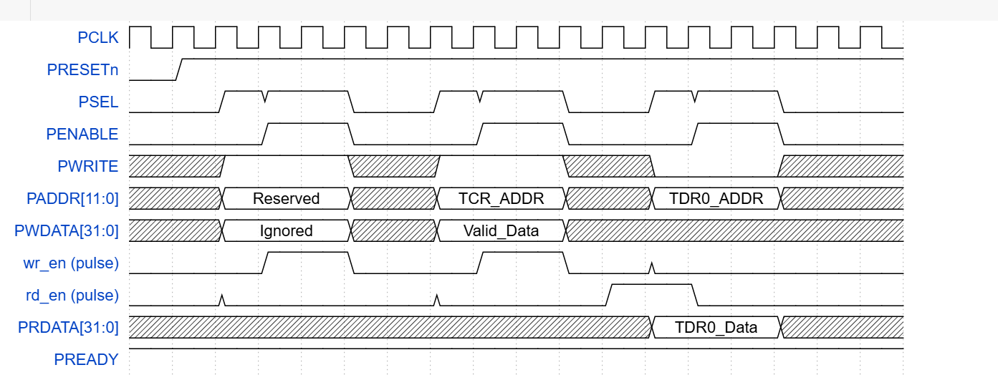
Figure 2: Waveform of APB_SLAVE

Analysis from the waveform.

Transaction 1: Write Ignored (Accessing a Reserved Address) :

- Cycle 1 (IDLE SETUP Phase):

+ Signal States: At the rising edge of the clock, the Master initiates a transaction by driving PSEL High (1) and PWRITE High (1) to signal a Write command. Simultaneously, PADDR holds a Reserved address, and PWDATA carries the data to be written (labeled Ignored).

+ Hardware Behavior: The APB Slave recognizes that it is being targeted via PSEL. At this point, PENABLE is still Low (0). This is the Setup Cycle of the APB protocol. The internal control logic prepares for the transaction but does not yet assert any internal enable pulses.

- Cycle 2 (ACCESS Phase & Write Ignored):

+ Signal States: At this rising edge, the Master drives PENABLE High (1).
+Hardware Behavior: The internal combinational logic detects that all three write conditions are met (PSEL = 1, PENABLE = 1, and PWRITE = 1). It immediately generates a High pulse lasting exactly one clock cycle on the internal wr_en (pulse) line (this is wr_pulse_1).

- Transaction 2: Write Valid (Writing Setup Data to TCR)

- Cycle 3 (SETUP Phase):

+ Signal States: The Master drops PENABLE to 0 to conclude the previous transaction and immediately updates the bus lines for the next one: PADDR switches to the valid control register address (TCR_ADDR), and PWDATA switches to Valid_Data. PSEL and PWRITE remain High.

+ Hardware Behavior: The system enters the Setup Cycle for the second transaction. The internal combinational logic temporarily drives wr_en back to Low to prepare for the next strobe.

- Cycle 4 (ACCESS Phase & Successful Write):

+ Signal States: The Master drives PENABLE High (1) once again.

+ Hardware Behavior: The write conditions match again (PSEL = 1, PENABLE = 1, PWRITE = 1), generating wr_pulse_2 on the internal wr_en (pulse) line.

+ Register Block Outcome: This time, the Address Decoder validates TCR_ADDR as a legitimate write address. The active wr_en pulse opens the input gates of the flip-flops making up the TCR register. At the next rising edge of the clock, Valid_Data from the PWDATA bus is officially latched into the TCR register, instantly deploying configurations like enabling the timer (timer_en) or updating the pace control (div_val).

Transaction 3: Read Valid (Reading Counter Value from TDR0)

- Cycle 5 (SETUP Phase):

+ Signal States: The Master drops PENABLE to 0. It switches PADDR to the data register address (TDR0_ADDR) and drives PWRITE Low (0) to flag a Read transaction. PSEL remains High.

+ Hardware Behavior: The internal write control line (wr_en) is completely deactivated. The system sits in the Setup Cycle of a Read transaction. The internal decoding logic verifies the address and begins prepping the data multiplexers.

-Cycle 6 (ACCESS Phase & Successful Read):

+ Signal States: The Master drives PENABLE High (1).

+Hardware Behavior: The interface satisfies the Read operation criteria (PSEL = 1, PENABLE = 1, PWRITE = 0). The combinational logic immediately asserts a High pulse on the internal read control line rd_en (pulse) (this is rd_pulse).

+ Register Block Outcome: The rd_en pulse enables the register block's multiplexers, fetching the active value of the lower 32-bit counter (TDR0_Data) and driving it straight onto the external read data bus PRDATA[31:0]. The Master (CPU/Bridge) samples this stable data at the next rising edge of the clock to complete the read.

- Cycle 7 (IDLE Phase - Termination):

+ Signal States: The Master drops both PSEL and PENABLE to Low (0).

+ Hardware Behavior: All internal operation pulses (wr_en and rd_en) drop back to Low. The PRDATA bus can either retain its last driven state or enter a tri-state/unknown condition depending on the exact bus wrapper implementation. The APB Slave returns to the IDLE state, waiting for the next request.

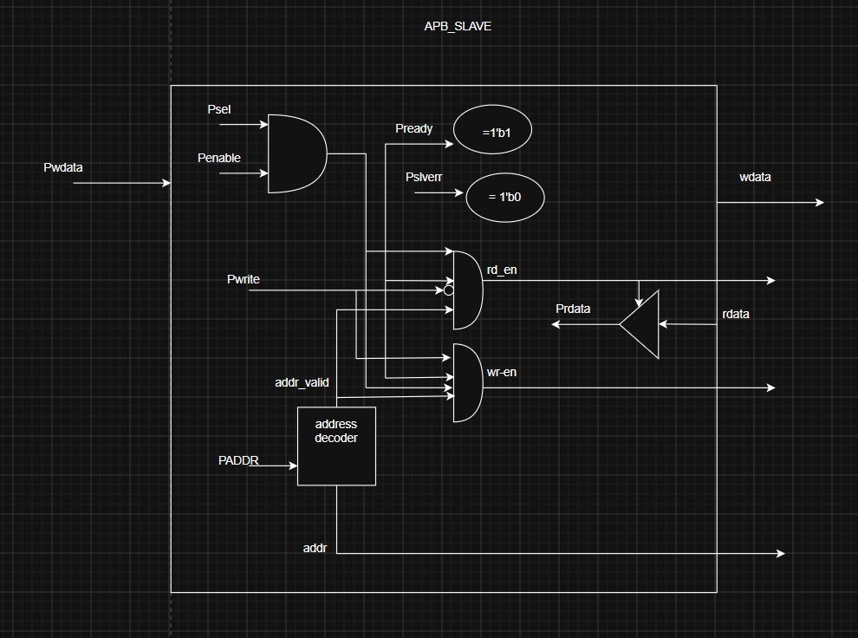
Figure 3: Logic diagram APB_SLAVE

Hardware Logic Analysis from the Logic Diagram

A. Address Decoding & Validation Layer
- At the heart of the entrance logic sits the Address Decoder:
+ Inputs: It takes the system address bus tim_paddr[11:0].
+ Outputs: It directly generates the internal relative offset address. This offset is driven out to the external Register File to index write operations, and is simultaneously fed into the internal Read Data MUX to index read operations.

- It evaluates whether the incoming address matches a valid register location. If it matches, it asserts the internal control signal addr_valid to 1. If the address hits a reserved or unmapped space, addr_valid stays 0.

- B. Control Pulse Generation (The Core Gating Logic)
- The design uses multi-input AND gates to create precise, glitch-free control pulses during the Access Phase of an APB transfer (when both tim_psel and tim_penable are High).
- Write Enable (wr_en) Generation:
+ Logic Equation: wr_en = tim_psel * tim_penable * tim_pwrite * addr_valid.
+ Hardware Behavior: The 4-input AND gate ensures that a write strobe is sent out to the external Register File only when the master selects this slave (tim_psel=1), executes the access phase (tim_penable=1), requests a write command (tim_pwrite=1), and targets a legitimate address (addr_valid=1). If any condition fails, wr_en remains low, implementing the WI (Write Ignored) feature.
- Read Enable (rd_en) Generation:
+ Logic Equation: rd_en = tim_psel * tim_penable * (~tim_pwrite) * addr_valid.
+ Hardware Behavior: This gate features an active-low bubble on the tim_pwrite input. When tim_pwrite = 0 (Read operation), the bubble inverts it to 1. Combined with a valid address and an active access phase, it triggers rd_en. This pulse acts as the final gating control for the tim_prdata output stage.

C. Bus Response Generation (tim_pready and tim_pslverr)
- Ready Response (tim_pready)
+ Logic Connection: Tied directly to the output of a 2-input AND gate fed by tim_psel and tim_penable.In standard level, tim_pready always get HIGH.
+ Hardware Behavior: Indicates a Zero-Wait-State (Standard Level) architecture. As soon as the bus enters the Access Phase, tim_pready immediately drives High, telling the APB Master that the slave can finish the transaction on the very next clock edge without inserting delay cycles.
- Slave Error Response (tim_pslverr)
+ Logic Connection: Driven to a static logic 0 (Standard Level requirement).

D. Data Path & Read Multiplexer Layer
- Write Data Path (wdata):
+ The system write data bus tim_pwdata[31:0] bypasses all gating logic and is directly forwarded out of the block as wdata[31:0], allowing the external Register File to sample the payload whenever wr_en pulses high.
- Read Data Path & Multiplexer (tim_prdata):
+ The module takes various individual status and configuration signals back from the Register block and Counter core: timer_en, div_en, div_val, int_en, halt_req, int_st, and the 64-bit cnt value.
+ Inside apb_slave, an address-controlled Multiplexer (Read Data MUX) uses the offset lines to dynamically assemble the 32-bit read vector based on the targeted register (TCR, TDR0, TDR1, TIER, TISR, or THCSR).
+ The output of this MUX is gated by an isolation block controlled by rd_en. When rd_en is low, tim_prdata is driven to 32'h0 to keep the system bus clean. When rd_en is high, the selected register data safely drives the external system bus tim_prdata[31:0].

3.2 Register Block
- The Register Block serves as the control and interface hub between the APB Slave bus and the internal Timer Core. It stores user configurations, updates the counter status, and manages interrupt and emulation/halt control signals.

- APB Interface Features:
+ Address Width: 12-bit (paddr[11:0]).
+ Data Width: 32-bit (pwdata[31:0], prdata[31:0]).
+ Reserved Area Access: Any read or write access to undefined addresses follows the RAZ/WI (Read As Zero, Write Ignored) policy.
- Advanced Level Features:
+ Byte Access Support: The bus can access individual bytes within a register using byte strobes (pstrb or address decoding).
+ Wait State Support: Introduces a 1-cycle wait state via the pready signal to optimize and improve timing.
+ Error Handling Support: Asserts the pslverr signal when a prohibited access occurs. When an error is detected, data is not written into the target register bits/fields

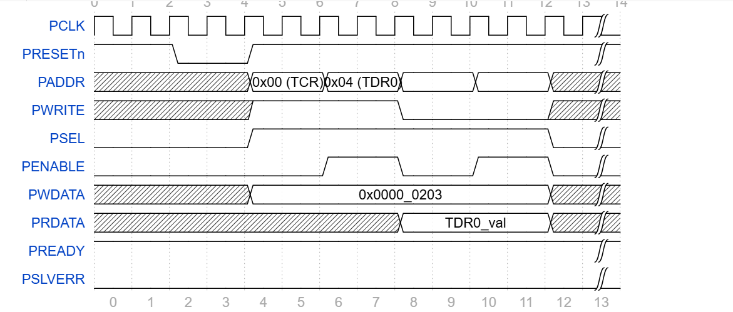
Figure 4: Waveform of Register Block

Analysis from the waveform.

A. Initialization & Reset Phase (From Clock 0 to Clock 4)
- PRESETn Signal: Driven Low at clock cycle 2 and de-asserted back to High at clock cycle 4.
-System Status: The entire block is forced into its default initialization state (Reset). During this window, bus control signals such as PSEL and PENABLE are held at 0, while the address and data buses remain in an undefined/inactive state (Don't care - represented by hatched lines).

B. Write Transfer Cycle to TCR (From Clock 4 to Clock 8)
- This protocol cycle spans exactly 4 clock periods and is clearly divided into two distinct APB operational phases:
+ Setup Phase (From Clock 4 to Clock 6):
- The Bus Master initiates the transaction by driving the target register address PADDR = 0x00 (TCR) and placing the configuration data PWDATA = 0x0000_0203 onto the write data bus.
- The PWRITE signal is driven High, indicating a Write operation.
- The peripheral select signal PSEL is asserted High.
- Note: During this phase, PENABLE must remain Low (0). The 0x00 (TCR) label is now allocated a full 2-clock-cycle window, ensuring clear visual alignment.
+ Access Phase (From Clock 6 to Clock 8):
- The Bus Master asserts the PENABLE signal High.
- Since the design implements the Basic Level specification, the Register Block responds instantly without delaying the bus by keeping PREADY = 1.
- On the rising edge of the clock at Clock 8, the data value 0x0000_0203 from the PWDATA bus is officially latched into the internal bit-fields of the TCR register.
- Upon completion of the write transfer, PENABLE is de-asserted back to 0.

C. Read Transfer Cycle from TDR0 (From Clock 8 to Clock 12)
- Immediately following the write transaction, the Master executes a read sequence to fetch the counter data.
+ Setup Phase (From Clock 8 to Clock 10):
- The Master updates the address bus with the new target address: PADDR = 0x04 (TDR0).
- The PWRITE signal is dropped Low (0), specifying a Read operation.
- The PSEL signal remains active High because the bus transaction sequence is still communicating with this specific IP block.
- PENABLE returns to Low (0) to properly set up the next access phase.
+ Access Phase (From Clock 10 to Clock 12):
- The Master asserts PENABLE High.
- The Register Block decodes the incoming address 0x04, activates the internal multiplexer logic to capture the runtime value from the Counter Core, and drives it onto the read data bus as PRDATA = TDR0_val.
- On the rising edge of the clock at Clock 12, the Bus Master samples and registers the TDR0_val data present on the line.
- The transfer session concludes as both PSEL and PENABLE are driven back to 0, returning the bus to its idle state.

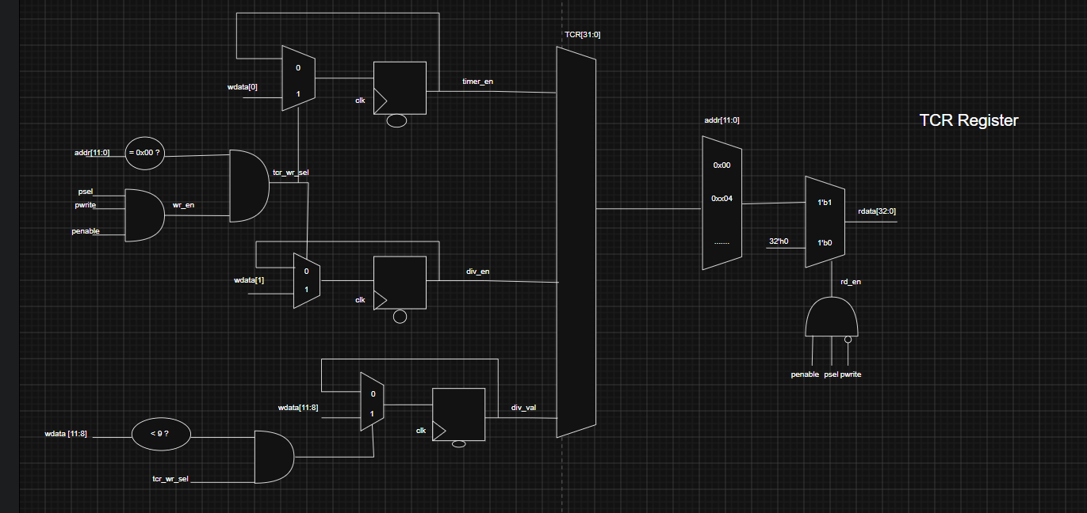
Figure 5: Logic diagram TCR

Hardware Logic Analysis from the Logic Diagram

A. Write Path Control Logic
- To latch write data into the Flip-Flops of the TCR register, the hardware evaluates a specific combination of gating conditions:
+ Bus Write Strobe (wr_en): Generated using a 3-input AND gate with the condition: psel && pwrite && penable. This signal pulses High exclusively during the Access Phase of an APB write transfer.
+ Address Decoding (tcr_wr_sel): A second stage combines the wr_en strobe with an address comparator evaluating if addr[11:0] == 0x00 (the target offset for TCR). This qualifies the write operation specifically for this block.
+Register Bit-Field Updates (TCR[31:0]):
- Bit [0] (timer_en) & Bit [1] (div_en): When tcr_wr_sel is asserted High, the respective 2:1 multiplexers select the incoming bus bits wdata[0] and wdata[1] to be clocked into the D-Flip-Flops on the next rising edge.
- Prescaler Value field div_val (Bits [11:8]): The circuit includes a hardware range validator checking if wdata[11:8] < 9. If the software attempts to write a valid divisor value (from 4'b0000 to 4'b1000 as specified in the manual), the bottom AND gate enables the load path to update the register.

B. Read Path Control Logic
- The read enable qualification signal rd_en is activated via an AND gate that decodes a read intent: penable && psel && (!pwrite).
- The incoming bus address addr[11:0] routes directly into a large decoding multiplexer structure:
+ If addr == 0x00, the 32-bit compiled outputs from the TCR Flip-Flops are selected.
+ If the access points to any unmapped or reserved address zone, the multiplexer defaults to routing a static constant value of 32'h0. This strictly satisfies the RAZ/WI (Read As Zero) architectural constraint outlined in the documentation.
- Finally, a tri-state driver or pass-gate network controlled by rd_en drives this selected word out onto the peripheral read bus line rdata[32:0] (PRDATA on the top-level APB bus).
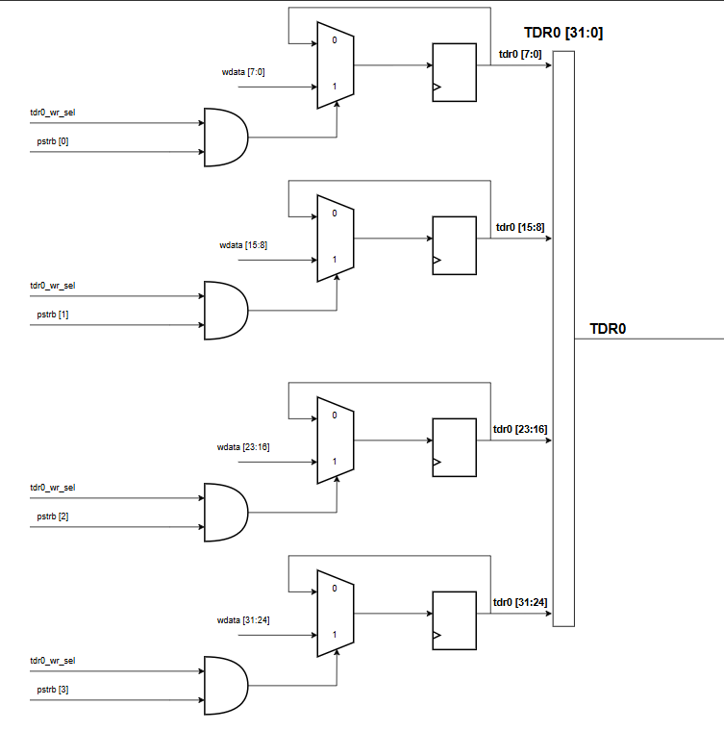
Figure 6: Logic diagram TDR0

Hardware Logic Analysis from the Logic Diagram
- Byte-by-Byte Write Control: The 32-bit register array is divided into four independent 8-bit slices. Each slice is qualified by an individual AND gate that combines the master register write select signal (tdr0_wr_sel / tdr1_wr_sel) with its corresponding byte strobe bit (pstrb[3:0]). This enables the system to update specific byte lanes accurately without altering or corrupting adjacent byte data.
- Multiplexed Feedback Synchronizers: Each 8-bit segment utilizes a 2-to-1 Multiplexer (MUX) coupled with a D-Flip-Flop (DFF) storage bank.
+ When the gating AND gate outputs a High (1), the MUX routes the new incoming byte from the write data bus (wdata) into the DFFs on the next clock edge.
+ When the AND gate outputs a Low (0), the current registered DFF value loops back to the MUX input, preserving the existing state across clock cycles.
- Output Bus Concatenation: Finally, the registered outputs of all four 8-bit segments are merged back into a unified 32-bit bus (TDR0[31:0] / TDR1[31:0]) to interface directly with the internal counter core.

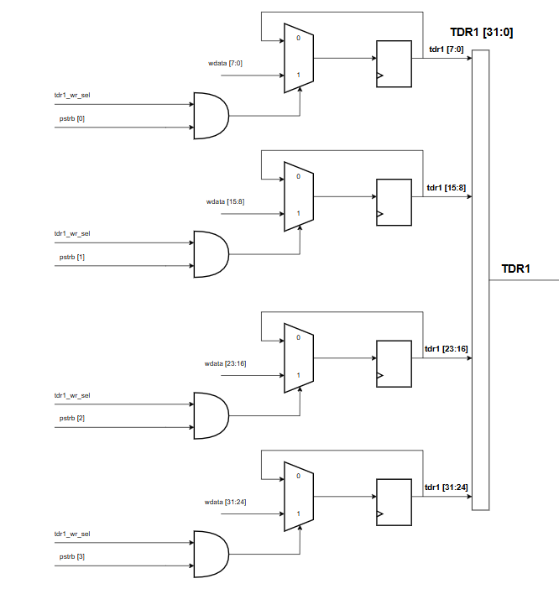
Figure 7: Logic diagram TDR1

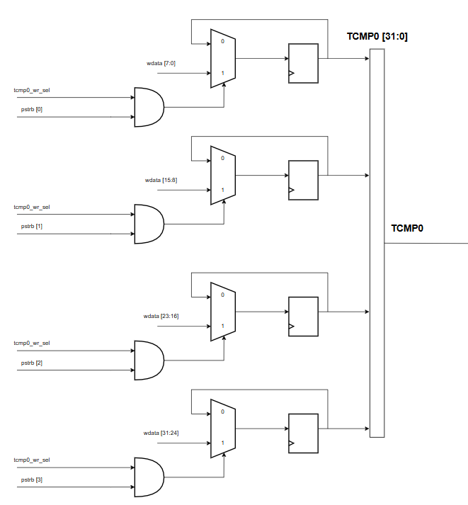
Figure 8: Logic diagram TCMP0

Hardware Logic Analysis from the Logic Diagram
- Byte-by-Byte Write Control: Mirroring the data register architecture, the comparison register block employs individual gating AND gates driven by the block write select signals (tcmp0_wr_sel / tcmp1_wr_sel) and the system byte strobes pstrb[3:0] to manage write access at a fine byte level.
- Multiplexed Feedback Synchronizers: The combination of a 2-to-1 MUX and a registered DFF array ensures that the target threshold configured by software remains completely stable. New data from the wdata bus is only latched into the Flip-Flops when a valid byte write strobe is active; otherwise, the hardware loops the existing value back to maintain state retention.
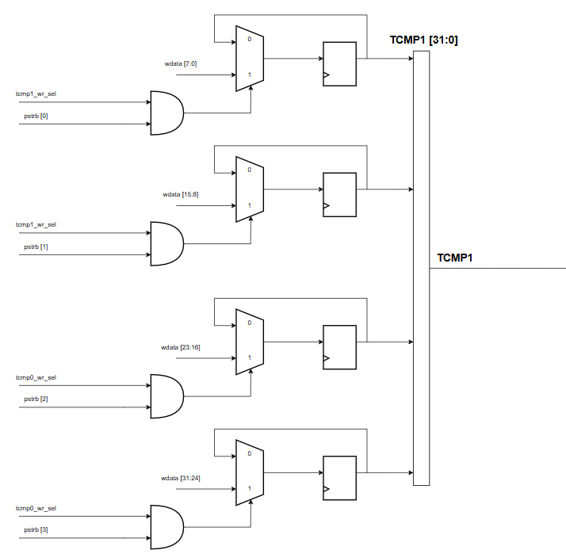
Figure 9 Logic Diagram TCMP1

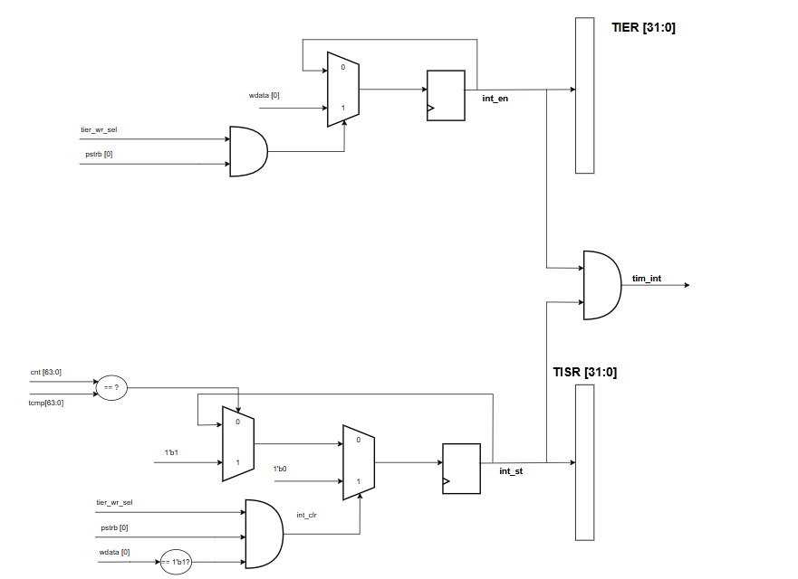
Figure 10 Logic Diagram TISR and TIER

Hardware Logic Analysis from the Logic Diagram
- Byte-by-Byte Write Control: Both register blocks target the lowest bit of the data bus (wdata[0]) to handle interrupt configurations.
+ For TIER, a 2-input AND gate combines tier_wr_sel and pstrb[0] to safely gate the interrupt enabling cycle.
+ For TISR, a specialized 3-input AND condition validates the Write-1-to-Clear (W1C) command by verifying that tisr_wr_sel, pstrb[0], and the clearing bit wdata[0] are simultaneously asserted High.
- Multiplexed Feedback Synchronizers: Each block utilizes an optimized combinational MUX-DFF loop to govern state updates based on system priorities.
+ In TIER, the MUX either latches the new wdata[0] value into the int_en DFF or loops the existing state back to preserve it.
+ In TISR, the loop manages hardware-software priority. A valid software W1C command overrides the loop to clear the flag (Clear Dominance); otherwise, an incoming hardware timeout pulse (set_int_st) from the comparator automatically forces the int_st DFF to 1.

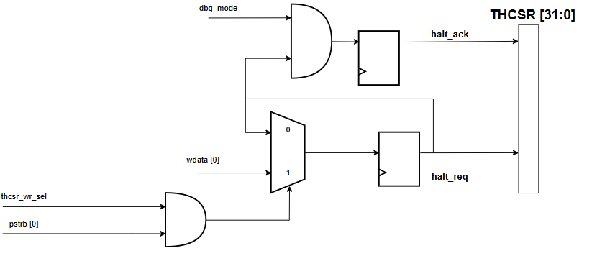

Figure 11 Logic Diagram THCSR

Hardware Logic Analysis from the Logic Diagram
- Byte-by-Byte Write Control: The THCSR block focuses specifically on the lowest byte slice configuration by gating the write transaction through a 2-input AND gate. The write cycle is validated only when the master write select signal (thcsr_wr_sel) and the lowest byte strobe (pstrb[0]) are simultaneously driven High. This locks out unintended byte modifications during core configuration.
- Multiplexed Feedback Synchronizers for Halt Request: The state tracking of the halt request bit (halt_req) is managed by a 2-to-1 MUX and a registered DFF cell.
+ When a valid byte write strobe is validated (AND gate outputs 1), the MUX captures the control bit from the write data bus lane (wdata[0]) into the DFF.
+ Otherwise (AND gate outputs 0), the current registered state loops back to maintain its exact configuration.

3.3 Counter_Control Block

A. Standard Level Features
- Default Counting Mode: When timer_en = 1 and div_en = 0, the block asserts cnt_en = 1 continuously on every clock cycle. The counter increments at the full speed of the system clock (sys_clk).
- Control Counting Mode (Pulse Gating): When timer_en = 1 and div_en = 1, the block generates a periodic cnt_en pulse based on the value configured in TCR.div_val[3:0]:
+ The counting speed is scaled down by a factor of 2 of TCR_div_val.
- For example, if div_val = 2, cnt_en will only be asserted High once every 4 system clock cycles, forcing the counter to take 4 cycles for each single increment.
- Note on Hardware Behavior: These settings only control when the counter increments, they do not physically alter or divide the clock frequency of the sequential logic.
- Static Configuration Constraint: In the Standard Level, the testbench (software) must ensure that div_en and div_val are never modified while the timer is actively running (timer_en = 1).
- Halt Ignored: The debug halt request input (halt_req) is treated as a reserved bit and has no functional relation to cnt_en generation.

B. Advanced Level Features
- Dynamic Parameter Change Protection & Error Signaling: If a software write operation attempts to change div_en or div_val while timer_en = 1, the counter_control block suppresses the update to protect the prescaler state machine from glitching. Concurrently, it flags an error handshake back to the APB Slave to trigger an error response.
- Synchronous Debug Halted Mode: Supports freezing the timer during on-chip debugging operations. The block accepts and processes the halt_req input only when the chip's global dbg_mode signal is asserted High:
+ When dbg_mode = 1 and THCSR.halt_req = 1, the block immediately forces cnt_en = 0, freezing the counter at its current value.
+ Once the counter successfully pauses, the block returns a halt_ack = 1 signal back to the registers.
+ When the halt request is cleared (halt_req = 0), cnt_en resumes its periodic pulsing normally without losing any fractional cycle history.
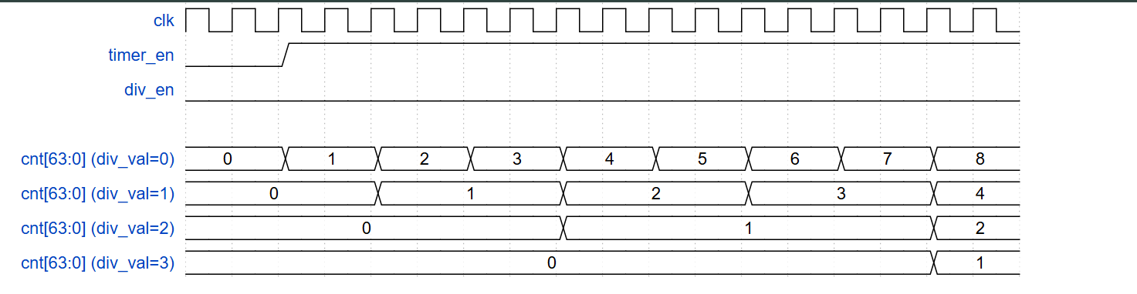
Figure 12: Waveform of Counter Control Block

Analysis from the waveform.

A. The div_val = 0 Case ( Prescaler Scale = 2^0 = 1)
- In this configuration, the block width is exactly 1 system clock cycle. The core timer increments its value at the maximum operational frequency of clk.
+ Cycle-by-Cycle Behavior: On every rising edge of clk, the reference signal cnt[63:0] (div_val=0) shifts seamlessly: 0 -> 1 -> 2 -> 3...
- Summary: Instantaneous response. Both the entry and exit propagation latencies are effectively zero clock cycles.

B. The div_val = 1 Case (Prescaler Scale = 2^1 = 2)
- In this case the block boundary spans exactly 2 system clock cycles for each distinct increment of the counter value.
+ Cycle-by-Cycle Behavior: The counter requires 2 consecutive rising edges to step up by 1 unit.
- Summary: The entry buffer delay and the exit wake-up recovery phase are balanced at 2 clock cycles.

C. The div_val = 2 Case (Prescaler Scale = 2^2 = 4)
- This configuration is explicitly labeled in the waveform using the red markers 1, 2, 3, 4 to denote a block length of 4 system clock cycles.
+ Cycle-by-Cycle Behavior: The baseline reference cnt[63:0] (div_val=2) org increments once every 4 cycles.
- Summary: Both the delay to enter the halt state and the recovery window require exactly 4 clock cycles.

D. The div_val = 3 Case (Prescaler Scale = 2^3 = 8)
- This is the lowest frequency profile shown, requiring 8 system clock cycles to complete a single count block.
+ Cycle-by-Cycle Behavior: The trace must sit stable for 8 full clocks to increment. It successfully finishes its initial 8-cycle sequence to establish 1 before the control change occurs.
- Summary: The halt entry latency and wake-up synchronization interval scale up to 8 clock cycles.

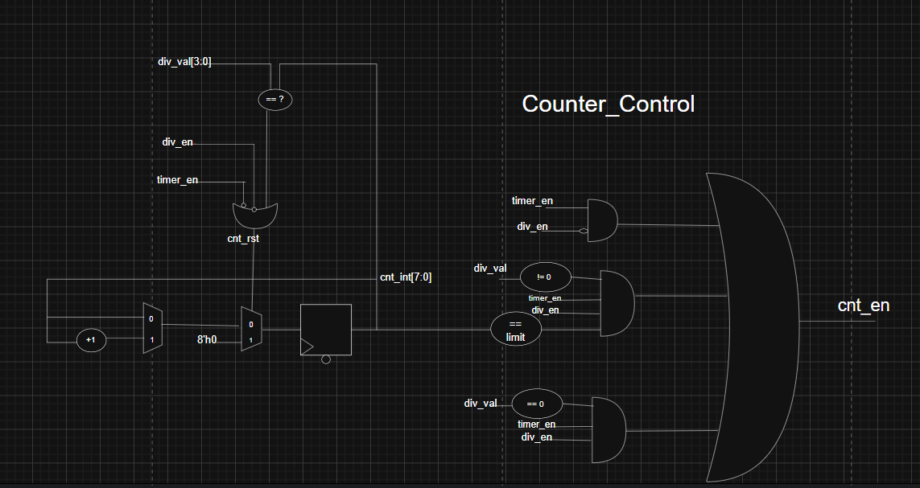
Figure 13: Logic diagram Counter Control Block

Hardware Logic Analysis from the Logic Diagram

A. Internal Phase Tracker Array (Prescaler Counter)
- The left side of the diagram implements an 8-bit, synchronous, self-resetting phase tracker (cnt_int[7:0]). This internal counter defines the current cycle number within a dynamic clock division block.
+ State Storage: The 8-bit D-Flip-Flop array captures the next phase state on the rising edge of the system clock (sys_clk), which is implicit for this block.
+ Next State Logic: * An adder (+1) continuously calculates the next incremented value of cnt_int.
- An address comparator (div_val[3:0] == ?) monitors the input scaling register. (NOTE: The schematic is missing the target value for this comparison; however, based on standard power-of-two behavior, this likely checks if the address register itself is stable and valid for decoding).
- When this comparison is true, it likely enables the first Multiplexer to select the incremented value (+1), allowing the phase tracker to count.
+ Internal Reset Control (cnt_rst): * A complex logic gate (likely a NOR gate with one inverted input, equivalent to an AND-NOT structure) monitors two key master enable signals: div_en and timer_en.
- This gates when the internal phase tracker should be cleared to zero. Based on the NOR structure, the cnt_rst line is only pulled Low (forcing 8'h0 into the second Multiplexer) when both control inputs sit at specific levels (e.g., when timer_en is disabled or div_en is active, forcing the prescaler to sit in a stable zero-phase).

B. Behavioral Mode Decoding Matrix
- The central section analyzes the current operating context using three independent decoder comparators to establish which gating mode should be active.
+ Phase Limit Comparator: This unit compares the current tracker value (cnt_int) against a target limit. This limit is derived on-the-fly to establish the $N$ factor window.
+ Address Zero Detect (div_val == 0): This detects when the prescaler scaling factor is set to the minimum (e.g., direct 1:1 system clock mode).
+ Address Non-Zero Detect (div_val != 0): This detects any scaling configuration that requires active phase gating.

C. Final Output Gating Logic (The AND-OR Matrix)
- The behavioral decoded bits are routed through a series of three parallel AND gating conditions, which are finally merged via a large 3-input OR gate to generate the master cnt_en strobe.
3.4 Counter Block
- Counter
- 64-bit count-up.
- Counting mode:
+ Default mode: counter’s speed is same as system clock.
+ Control mode: when enabled by writing 1 to TCR.div_en bit, the counter's speed is determined by the divisor value set in TCR.div_val
- Counter continues counting when interrupts occurs.
- Counter continues counting when overflow occurs.
- [Standard]: when timer_en is H->L, counter is stopped and counter needs to be initialized by testbench (software). When timer_en is L->H again, timer can work normally.
- [Advanced] support halted mode describe in next page.
- [Advanced] When timer_en changes from H->L, the counter is cleared to its initial value by timer itself (hardware). When timer_en is L->H again, timer can work normally.
- Note: the div_en and div_val is not related to frequency divisor (clock divider). Those settings only
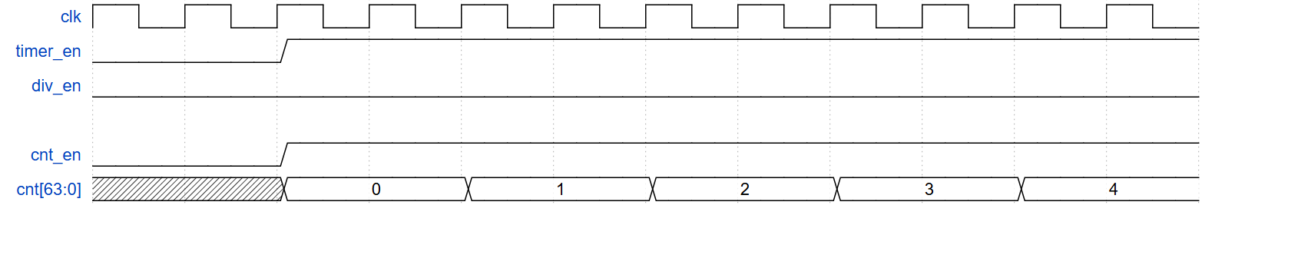
Figure 14: Waveform of Counter Block
Analysis from the waveform.

A. Control Inputs State
- clk: The system clock, providing the synchronous timing edge for the counting operation.
- div_en = 0 (Static Low): The clock division feature is completely disabled. The hardware operates strictly under the Default Mode.
- timer_en: Transitions from Low to High (L --> H) to activate and enable the timer circuit.

B. cnt_en (Count Enable) Activation Logic
- Because the clock scaling block is bypassed (div_en = 0), the final master count enable signal cnt_en directly mirrors and follows the timer_en control input.
- The moment timer_en is asserted High, the cnt_en line immediately rises to a High state at the exact same system clock boundary.

C. Counter Data Transition (cnt[63:0])
- On the very first rising edge of clk after cnt_en becomes active (1), the data bus initializes and starts tracking at 0.
- Since it skips any frequency division (div_val = 0), the counting speed matches the system clock frequency (clk) perfectly.
- For every single clock cycle, the counter steps forward sequentially by 1 unit with zero phase delay: 0 --> 1 --> 2 --> 3 --> 4…
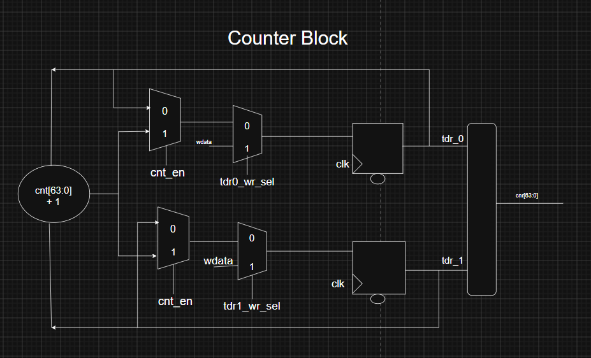
Figure 15: Logic diagram Counter Block

Hardware Logic Analysis from the Logic Diagram

A. Combinational Arithmetic Core: The Incrementer (cnt[63:0] + 1)
- Logic Block: The circle element on the far left represents a pure combinational adder.
- Function: It samples the current feedback state of the counter outputs and continuously computes the next sequential increment (+ 1) ahead of the next clock edge. This look-ahead value is routed simultaneously to input channel 1 of the first-stage Multiplexers in both parallel branches.

B. Cascaded Multiplexer (MUX) Control Network
- Each tracking branch (top branch for tdr_0, bottom branch for tdr_1) uses an identical two-stage 2-to-1 Multiplexer tree to evaluate state conditions:

+ Stage 1 MUX: Counting Enable Gating (cnt_en)
- Purpose: Determines whether the timer is permitted to step forward based on the cnt_en strobe generated by the Counter_Control block.
- When cnt_en = 0 (Select Channel 0): The MUX selects the feedback path originating directly from the output of its own register. This isolates the branch in a stable Hold Mode.
- When cnt_en = 1 (Select Channel 1): The MUX opens the data path to accept the pre-calculated increment value from the +1 logic block, preparing the circuit for Counting Mode.

+ Stage 2 MUX: Direct Configuration Write Selection (tcr_wr_sel)
- Purpose: This select line (tcr_wr_sel) acts as a hardware override. It grants software or testbench routines the ability to force-load a specific initialization value (wdata) directly into the counter registers, bypassing standard operation.
- When tcr_wr_sel = 0 (Select Channel 0): Normal runtime tracking is enabled. The register accepts whatever state was calculated by the Stage 1 MUX (either Hold or Count Up).
- When tcr_wr_sel = 1 (Select Channel 1): The standard timer progression is overridden. The MUX locks onto the external input bus, routing the write data (wdata) straight to the flip-flop inputs.

C. Synchronous State Storage: D-Flip-Flops (DFF)
- Logic Block: The two centralized squares denote synchronous D-Flip-Flop arrays clocked to the rising edge of the system clock (clk).
- Function: On each active clock transition, these blocks latch the data present at the output of the Stage 2 MUX, updating the state of tdr_0 and tdr_1 simultaneously. The bubble notation at the bottom of each register represents an active-low asynchronous/synchronous reset pin used to clear the counter to its baseline state upon system initialization.

D. Output Bus Reconstruction Block
- Logic Block: The vertical rounded block on the far right interface.
- Function: It acts as an architectural multiplexer or bus consolidator. It processes the split internal lanes (tdr_0 and tdr_1) and reconstructs them cleanly into a standard, coherent 64-bit output bus, cnt[63:0], ready for consumption by the broader System-on-Chip (SoC) matrix.
3.5 Interrupt Block
- In this design, the Timer Interrupt functions as a vital hardware-to-software signaling bridge. It enables the peripheral IP to independently flag specific operational milestones directly to the CPU without wasting processor clock cycles on continuous software polling.
- The interrupt cycle relies on three distinct architectural phases:
+ Evaluation & Assertion: The hardware monitors the running 64-bit counter value against a software-defined target threshold (the compare value). When an exact match occurs—and the feature is unmasked via the Interrupt Enable register (TIER.int_en = 1)—the core logic asserts the primary interrupt line (tim_int) and latches a pending flag inside the Interrupt Status register (TISR.int_st = 1).
+ Non-Blocking Counter Continuity: A critical industry-standard feature of this block is its non-blocking design. The moment an interrupt is tripped, the event is offloaded to the interrupt controller asynchronously, while the core counter registers continue to step forward linearly and uninterrupted on subsequent clk cycles. This safeguards the absolute continuity of the system's time tracking.
+ Status Latching & Handshaking: Once the interrupt status bit (int_st) is latched High by hardware, it remains permanently locked. It cannot be altered by subsequent counter changes or simple zero-writes. To clear the line and conclude the event, the CPU's Interrupt Service Routine (ISR) must perform a explicit Write-1-to-Clear (W1C) operation by writing a 1'b1 directly to TISR.int_st, resetting the status field back to zero and preparing the IP for the next match event.
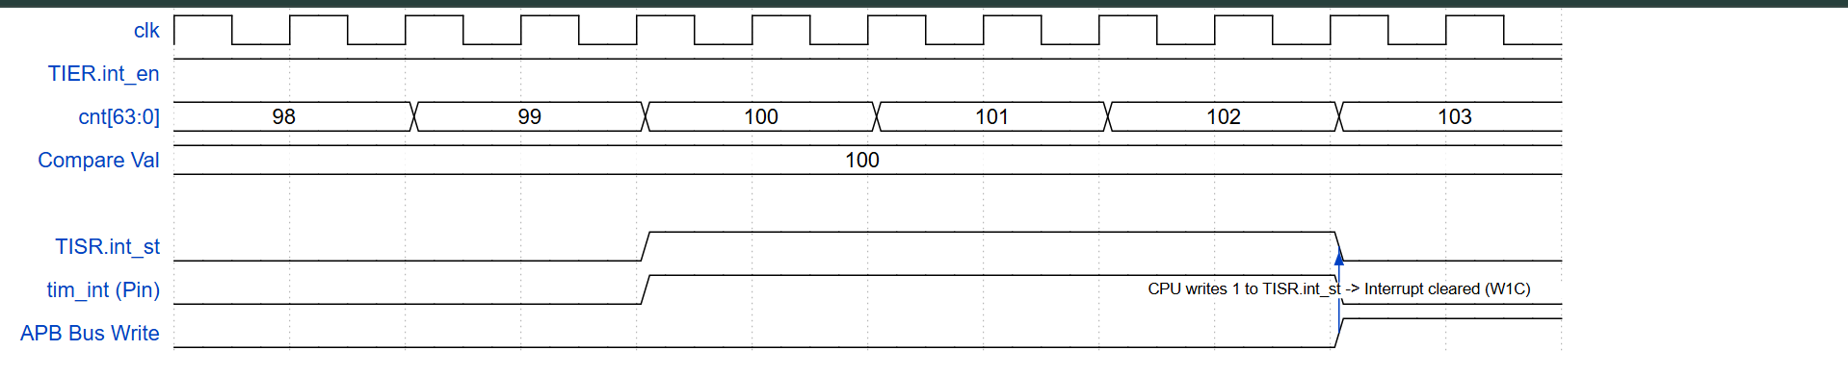
Figure 16: Waveform of Interrupt Block

Analysis from the waveform.

A. Initial Setup Conditions
- clk: The system clock runs continuously to synchronize all internal hardware operations.
- TIER.int_en = 1: The interrupt feature is unmasked (enabled) by software throughout the entire window.
- Compare Val = 100: The target reference threshold is statically configured to 100.

B. Phase 1: Interrupt Assertion (Threshold Match)
- Behavior: The core counter cnt[63:0] increments sequentially from 98 --> 99 --> 100.
- Hardware Reaction: On the exact rising edge of clk where the counter value reaches 100 (matching the Compare Val), the detection logic immediately trips:
+ The interrupt status flag TISR.int_st latches from 0 to 1.
+ The physical hardware pin tim_int (Pin) is driven High (1) instantly to signal the CPU that an interrupt event requires immediate service.

C. Phase 2: Non-Blocking Counter Continuity
- Behavior: Once the interrupt line is pulled High, notice that on all subsequent clock cycles, the counter cnt[63:0] continues stepping forward regularly: 101 --> 102 --> 103.
- Significance: Triggering an interrupt does not freeze, halt, or delay the counter core. The timer continues running smoothly to guarantee that the system's baseline timekeeping remains perfectly accurate and continuous.

D. Phase 3: CPU Handshake & Interrupt Clearing (W1C)
- Behavior: The status flag and the physical tim_int pin remain locked at a High level (1), waiting for the processor's intervention.
- Hardware Reaction: When the CPU's Interrupt Service Routine (ISR) executes a write command across the peripheral bus (APB Bus Write transitions High):
+ The CPU writes a logic 1 straight into the TISR.int_st register field (the Write-1-to-Clear protocol).
+ On that exact clock edge, the internal TISR.int_st cờ and the external tim_int (Pin) line are pulled back down to a Low state (0). This cleanly concludes the interrupt service lifecycle.

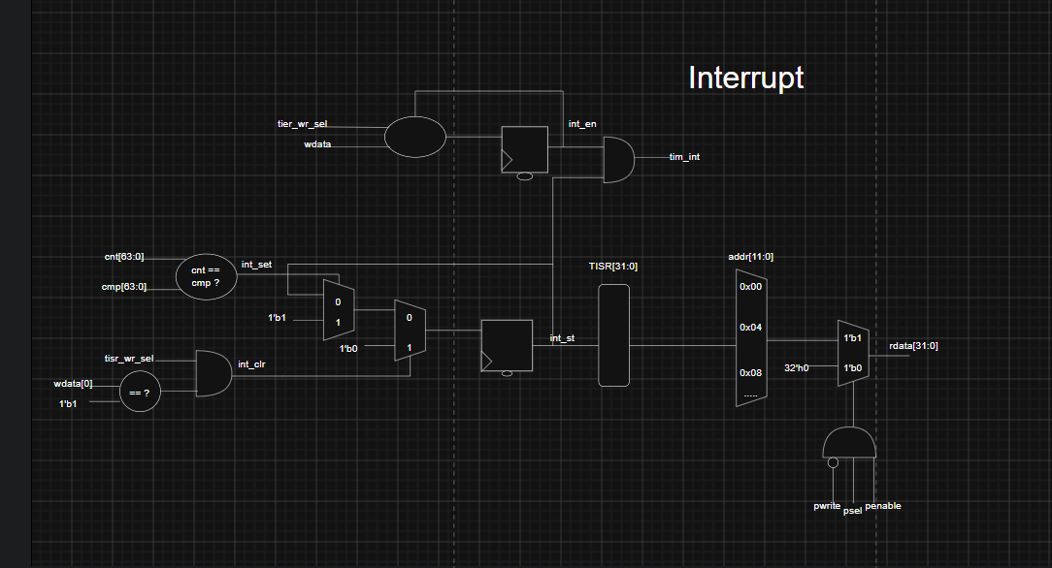
Figure 17: Logic diagram Interrupt Block

Hardware Logic Analysis from the Logic Diagram

Interrupt Status Latching & Lockout Logic (int_st)

- Located at the bottom center, this sequential loop captures and holds the interrupt status flag int_st (Bit 0 of the TISR register). It relies on a D-Flip-Flop (DFF) paired with a cascaded 2-to-1 Multiplexer tree to create a permanent hardware latch:
+ Hardware Set Trigger (int_set): An identity comparator evaluates if the core counter cnt[63:0] matches the pre-loaded compare register tcmp[63:0]. Upon a true match, int_set transitions to 1, forcing the first MUX to feed a logic constant 1'b1 toward the register data input.
+ Feedback Retention Loop: The output int_st of the DFF loops back into channel 0 of the initial MUX. Consequently, once tripped, the flag locks itself at a stable High state (1) across subsequent clock cycles, even as the counter continues stepping forward.
+ Software Clear Trigger (int_clr - The W1C Protocol): To release the latch, the CPU must invoke a specific write sequence. An AND gate decodes the clearing condition: the TISR write select line must be active (tisr_wr_sel) AND the incoming write data bit must be a logic one (wdata[0] == 1'b1).
- When satisfied, int_clr goes High, forcing the second-stage MUX to route a logic constant 1'b0 into the DFF, clearing the status flag back to zero on the next clock edge.

B. Physical Interrupt Output Gating Logic (tim_int)
- Positioned at the upper right, this combinational stage dictates whether the internal status flag is allowed to drive the chip's external pin boundary:
+ The interrupt enable state (int_en from the TIER register) is latched via its own setup network at the top (triggered by tier_wr_sel and wdata[0]).
+ The system's primary physical interrupt pin, tim_int, is the output of an AND gate combining int_en and int_st.
- When int_en = 0 (Disabled): The AND gate is masked. The tim_int pin remains hard-tied to 0, effectively masking the event from the processor.
- When int_en = 1 (Enabled): The AND gate acts as a transparent pass-through. The physical tim_int line mirrors the internal int_st flag. When int_st latches to 1, the tim_int pin instantly drives High to alert the CPU.

C. Register Bus Read Interface (Read Data Path)
- The right-hand side of the diagram details how the CPU samples the status register fields during an APB bus read cycle:
+ The int_st bit is mapped directly onto Bit 0 of the internal 32-bit bus structure TISR[31:0] (with higher order bits 31:1 tied off as zero/reserved).
+ This vector feeds an address-decoding multiplexer network controlled by the 12-bit address bus addr[11:0] (aligning with your APB slave specification).
+ When the CPU targets the specific address offset of the interrupt status register (labeled here as channel select 0x18), the multiplexer selects and routes the TISR byte lane forward.
+ Finally, a three-input AND gate decodes a valid APB read phase (psel AND penable AND NOT pwrite). When active, it opens the output bus transceiver to place the data cleanly onto the system read bus rdata[31:0].

History

Date | Version | Description | Author
05/6/2026 | 1.0 | Finish Overview(1) | Trần Hồ Khánh Tân
06/6/2026 | 1.1 | Finish Overview logic diagram | Trần Hồ Khánh Tân
08/6/2026 | 1.2 | Finish Register Specification | Trần Hồ Khánh Tân
10/6/2026 | 1.3 | Finish Function description ( APB_SLAVE) | Trần Hồ Khánh Tân
13/6/2026 | 1.4 | Finish all Function description | Trần Hồ Khánh Tân
25/06/2026 | 1.5 | Fix some detail and add logic diagram of TCMP,TDR,TIER,TISR | Trần Hồ Khánh Tân

