PERSONAL DESIGN VERIFICATION PROJECT
SYNCHRONOUS FIFO
DESIGN SPECIFICATION
Author: Trần Hồ Khánh Tân
IC Design Student — FPT University

Contents

Contents 2
List of Tables 3
List of Figures 3
Overview 4
Introduction 4
Main features 4
Block diagram 4
Interface signals 5
Functional Description 6
Write operation 6
Read operation 6
Element counter (r_count) 6
Flag generation 6
Case 1: Write until Full 7
Analysis from the waveform 7
Case 2: Read until Empty 8
Analysis from the waveform 8
Case 3: Simultaneous Read/Write 9
Analysis from the waveform 9
Corner cases / Design rules 10
History 11

List of Tables
Table 1: Interface signals of FIFO
Table 2: Flag generation logic summary

List of Figures
Figure 1: Block diagram of Synchronous FIFO
Figure 2: Waveform — Case 1: Write until Full
Figure 3: Waveform — Case 2: Read until Empty
Figure 4: Waveform — Case 3: Simultaneous Read/Write

Overview

Introduction
- Introduction:
+ The FIFO (First-In-First-Out) is a fundamental buffering module used to store data temporarily between two interfaces that may operate at different rates or are not always active at the same time. This project implements a parameterizable synchronous FIFO using a count-based architecture, verified as part of a personal Design Verification portfolio.
- Application:
+ FIFO is a widely used building block in digital systems for rate matching, burst buffering, and elastic data transfer between modules.

Main features
- Parameterizable data width (W) and depth (L).
- Count-based architecture: binary write/read pointers for RAM addressing, separate r_count register for flag generation
- Full / Empty flag generation
- Configurable Almost-Full (af_flag) and Almost-Empty (ae_flag) flags via runtime threshold inputs af_level / ae_level
- Default threshold configuration used in this project: af_level = L-2, ae_level = 2
- FIFO uses active-low asynchronous reset
- Supports simultaneous read and write in the same clock cycle
- Write and read pointers wrap around at depth boundary (address 0 to L-1)

Block diagram
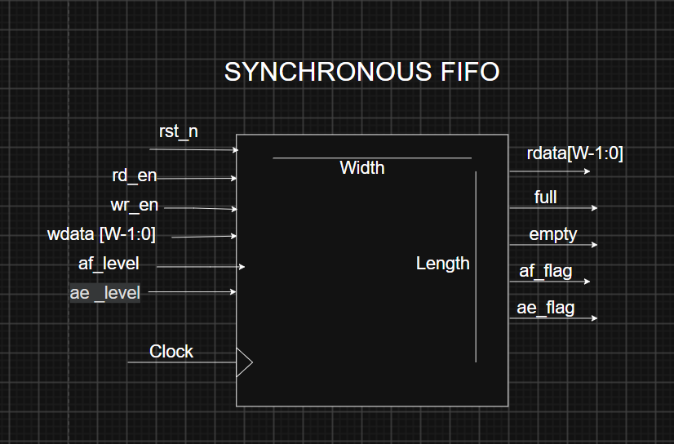
Figure 1: Block diagram of Synchronous FIFO

Write Interface
- Receives wr_en and wdata, drives write address (wr_ptr) into the Memory Array when write is enabled and FIFO is not full.
Read Interface
- Receives rd_en, drives read address (rd_ptr) into the Memory Array and outputs rdata when read is enabled and FIFO is not empty.
Memory Array
- Register array of depth L and width W, integrated directly inside sync_fifo (no separate submodule). Written at wr_ptr, read at rd_ptr.
r_count
- Register tracking the number of valid elements currently stored in the FIFO. Independent from wr_ptr/rd_ptr, which are only used for RAM addressing.
Flag logic
- Combinational block comparing r_count against L, 0, af_level, and ae_level to generate full, empty, af_flag, and ae_flag.

Interface signals
Signal name | Width | Direction | Description
clk | 1 | input | System clock
rst_n | 1 | input | Active-low asynchronous reset
wr_en | 1 | input | Write enable
wdata[W-1:0] | W | input | Write data bus
rd_en | 1 | input | Read enable
rdata[W-1:0] | W | output | Read data bus
full | 1 | output | FIFO full flag
empty | 1 | output | FIFO empty flag
af_level | $clog2(L+1) | input | Almost-full threshold (configured to L-2)
ae_level | $clog2(L+1) | input | Almost-empty threshold (configured to 2)
af_flag | 1 | output | Almost-full flag
ae_flag | 1 | output | Almost-empty flag
Table 1: Interface signals of FIFO

Functional Description

* Write operation ( wr = wr_en && !full )
- When wr_en = 1 and full = 0, wdata is written into the memory array at address wr_ptr on the rising edge of clk.
- next_wr_ptr = (wr_ptr == L-1) ? 0 : wr_ptr + 1. wr_ptr updates to next_wr_ptr only when a valid write occurs.
- If wr_en = 1 while full = 1, the write is ignored (no data corruption, no pointer update).

* Read operation (rd = rd_en && !empty)
- When rd_en = 1 and empty = 0, data at address rd_ptr is driven onto rdata.
- next_rd_ptr = (rd_ptr == L-1) ? 0 : rd_ptr + 1. rd_ptr updates to next_rd_ptr only when a valid read occurs.
- If rd_en = 1 while empty = 1, the read is ignored .

* Element counter (r_count)
- r_count tracks the number of valid elements in the FIFO and updates synchronously as follows:
- Write only (wr_en=1, rd_en=0, not full): r_count <= r_count + 1
- Read only (wr_en=0, rd_en=1, not empty): r_count <= r_count - 1
- Simultaneous read and write: when wr_en = 1 && full = 0 and rd_en = 1 && empty = 0, both operations are accepted in the same clock cycle and r_count remains unchanged.
- No operation: r_count <= r_count (unchanged)
- On reset (rst_n = 0): r_count <= 0, wr_ptr <= 0, rd_ptr <= 0.

Flag generation
Flag | Expression | Type
full | r_count == L | Combinational
empty | r_count == 0 | Combinational
af_flag | r_count >= af_level (af_level = L-2) | Combinational
ae_flag | r_count <= ae_level (ae_level = 2) | Combinational
Table 2: Flag generation logic summary
- full, empty, af_flag, and ae_flag are combinational functions of r_count.Therefore, each flag reflects the current value of r_count after r_count is updated.

- af_level and ae_level are static input values configured once at the start of simulation (af_level = L-2, ae_level = 2 for this project).

Case 1: Write until Full
Description: FIFO starts empty. Writes are asserted continuously until the FIFO becomes full, at which point the write is expected to stop (driven externally) and the full flag asserts.
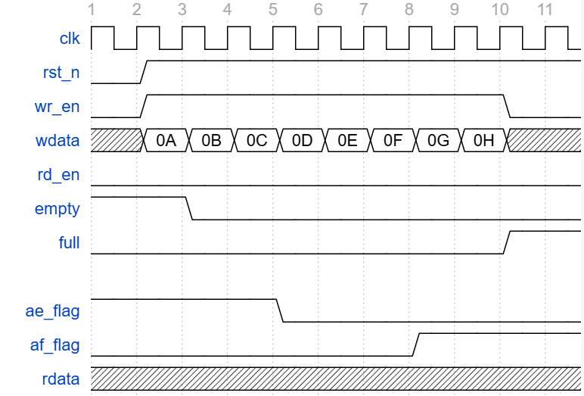
Figure 2: Waveform — Case 1: Write until Full

Analysis from the waveform
- rst_n and wr_en go high in cycle 2. wdata presents 0A starting at cycle 2, and continues through 0B–0H up to cycle 9, one value written per clock cycle, while rd_en remains low throughout.
- empty goes low at cycle 3, one clock cycle after the first write (0A, written during cycle 2) updates the element count.
- ae_flag goes low at cycle 5, once the element count exceeds the ae_level threshold, and remains low for the rest of the case.
- af_flag goes high at cycle 8, one cycle after the write of 0F (cycle 6) raises the element count to the af_level threshold.
- full goes high at cycle 10 — one clock cycle after the write of 0H completes at cycle 9, not in the same cycle as the write itself.
- wr_en goes low shortly after full is observed, and rdata remains don't-care throughout, since no read operation occurs in this case

Case 2: Read until Empty
Description: FIFO starts full (or partially full). Reads are asserted continuously until the FIFO becomes empty, at which point the empty flag asserts.
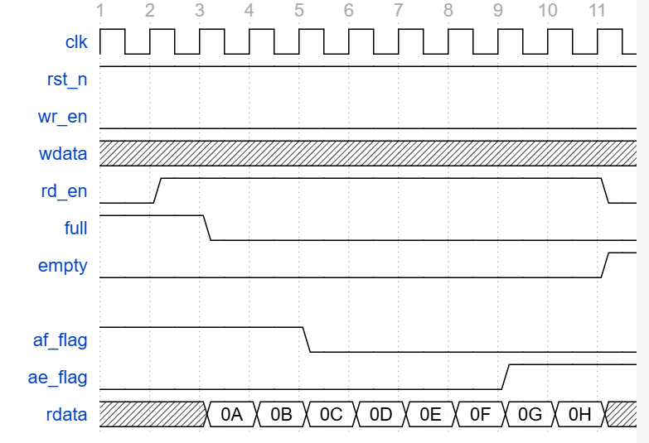
Figure 3: Waveform — Case 2: Read until Empty

Analysis from the waveform
- rst_n remains high throughout. rd_en goes high at cycle 2, while wr_en remains low throughout.
- full goes low at cycle 3, one clock cycle after the first read request (rd_en asserted at cycle 2) updates the element count. rdata presents its first valid value, 0A at this same cycle (cycle 3) — one cycle after rd_en was asserted, reflecting the registered read path.
- rdata continues presenting 0B through 0H sequentially from cycle 4 to cycle 11, one value per clock cycle.
- af_flag goes low at cycle 5, once the element count drops below the af_level threshold, and remains low for the rest of the case.
- ae_flag goes high at cycle 9, one cycle after the read of 0F lowers the element count to the ae_level threshold.
- rd_en goes low at cycle 10, after the last read (0H) has been issued. empty goes high at cycle 11
- wdata remains don't-care throughout, since no write operation occurs in this case.

Case 3: Simultaneous Read/Write
Description: wr and rd are asserted together for several cycles. r_count is expected to remain unchanged during the overlap window, so full and empty should not toggle during this period.
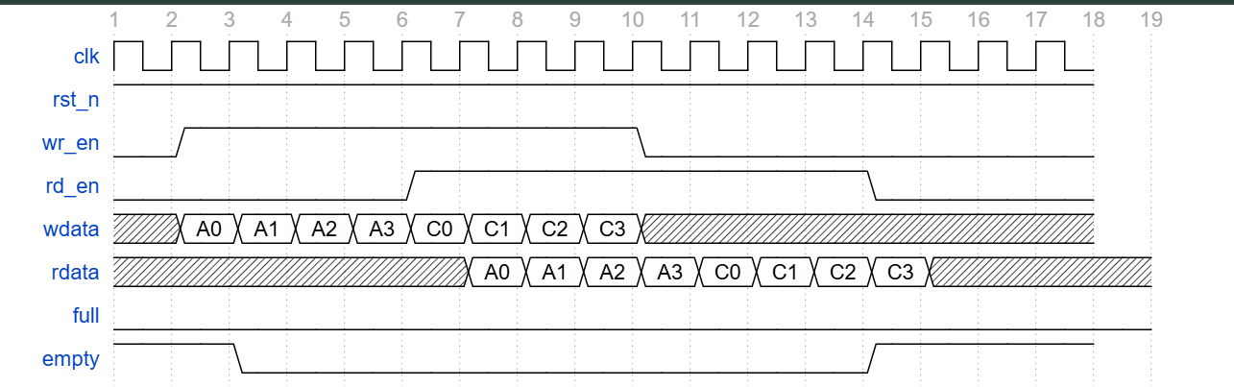
Figure 4: Waveform — Case 3: Simultaneous Read/Write

Analysis from the waveform
- rst_n remains high throughout. wr_en goes high at cycle 2 and stays high until cycle 10, when it goes low. wdata presents A0–A3 and C0–C3 sequentially from cycle 2 to cycle 9, one value written per clock cycle.
- empty goes low at cycle 3, one clock cycle after the first write (A0, written at cycle 2) updates the element count.
- rd_en goes high at cycle 6, four cycles after writing begins, and stays high until cycle 14, when it goes low. rdata presents its first valid value, A0, at cycle 7 — one cycle after rd_en was first asserted, reflecting the registered read path. rdata continues presenting A1 through C3 sequentially from cycle 8 to cycle 14.
- From cycle 6 to cycle 9, both wr_en and rd_en are high simultaneously — the FIFO is written and read in the same cycles.
- full remains low throughout the entire case, since the element count never approaches the FIFO depth (writes and reads are close to balanced from cycle 6 onward).
- empty goes high at cycle 14 — one clock cycle after the read of C3 completes, once all written elements have been consumed

Corner cases / Design rules
-If wr_en = 1 while full = 1, the write request is ignored and no data is written to the FIFO.
- If rd_en = 1 while empty = 1, the read request is ignored and rdata is not valid.
- af_level and ae_level must satisfy 0 <= ae_level < af_level <= L for meaningful (non-overlapping) AF/AE behavior.
- Reset (rst_n = 0) clears r_count, wr_ptr, and rd_ptr to 0 asynchronously.
- Minimum supported depth: L >= 2. For small depths (e.g. L < 4), the default threshold configuration (af_level = L-2, ae_level = 2) may overlap or become invalid; users must verify 0 <= ae_level < af_level <= L before configuring af_level/ae_level for such cases.

History
Date | Version | Description | Author
29/08/2026 | 0.1 | Initial draft: overview, block diagram, interface signals | Trần Hồ Khánh Tân
30/08/2026 | 0.2 | Fix the overview and signal in block diagram | Trần Hồ Khánh Tân
31/08/2026 | 0.3 | Adding waveform in case 1 , 2,3 | Trần Hồ Khánh Tân
01/09/2026 | 0.4 | Adding more requirement for design rule

