# Exercise 2: Setting up your first React application

***Objectives and Outcomes***

React is a popular JavaScript library used to build user interfaces. To start developing React applications, you need to set up a development environment and install the necessary tools. At the end of this exercise you will be able to set up your first React application on your computer..

***Guidelines***

Setting up your first React app includes the following steps:

* Install Node.js and npm (if not already installed – Exercise 1).
* Create a new React app using Create React App.
* Run the React application on your computer and view the results in the browser..
* Fix issue in Powershell:

Set-ExecutionPolicy -Scope CurrentUser RemoteSigned

**Step 1**: Create a new React application using Create React App

* Open terminal and run the following command to install Create React App:

npm install -g create-react-app

* Once the installation is complete, navigate to the folder where you want to create the React app in the terminal.
* Setting legacy-peer-deps in new version.

npm config --location=project set legacy-peer-deps=true

* Run the following command to create a new React application:

npx create-react-app my-app

(Replace "my-app" with the optional directory name for your application)

* This process will create a new folder named "my-app" (or the name you chose) containing the necessary structure and files of your React application.

**Step 2:** Run the React application on your computer and see the results in the browser

* In the terminal, navigate to the new React app folder with the command:

cd my-app

(Replace "my-app" with the folder name you chose)

* Run the following command to start the React application:

npm start

* This process will start the development server and open the browser with the address http://localhost:3000. You will see your React app pre-built and ready to edit.

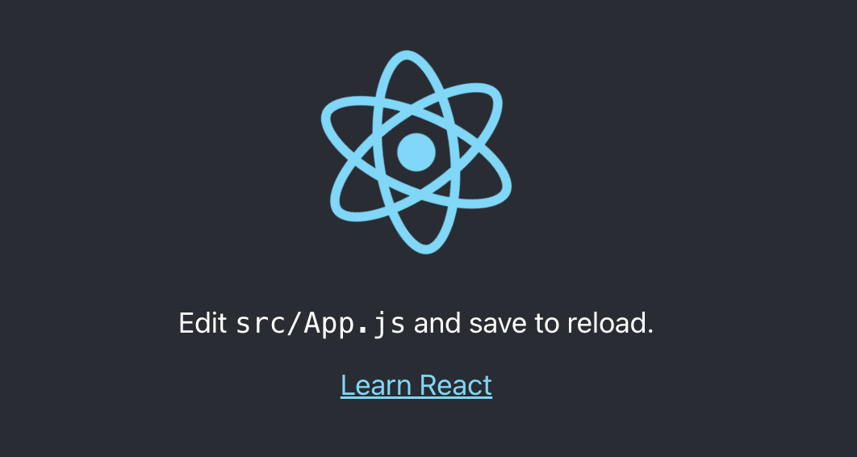

* Within the src folder of the myfirstapp project folder, you will find App.js and index.js.

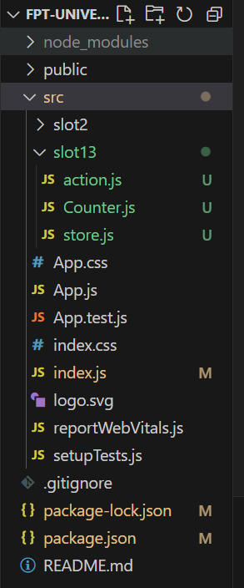

* Press Ctlr+C at the command prompt to stop the react development server
* The following code should be replaced in index.js inside of the src folder. All the styling will be removed as a result, leaving you with the basic needs.

import React from 'react';

import ReactDOM from 'react-dom/client';

import App from './App';

const root = ReactDOM.createRoot(document.getElementById('root'));

root.render(

    <App />

);

* Replace the content of **App.js** inside the folder src, with the following code.

function App() {

    return (

      <h1>Hello World</h1>

    );

  }

export default App;

* Now start the server again and follow the steps mentioned earlier to launch and view the application on the browser. You will see the page render with the message “Hello World”.

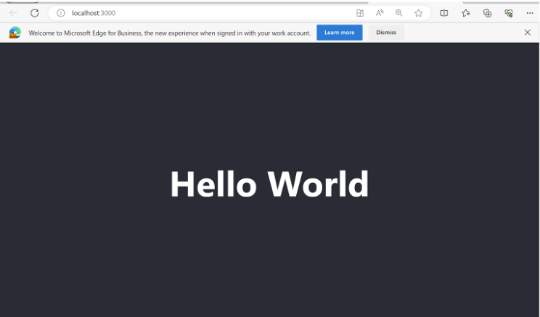

***Conclusion***

Through the above steps, you have successfully set up your first React application on your computer. You can now start developing your own React app by editing the source code in the app folder and viewing the results directly in the browser.