**INFO 210, Database Management Systems**

**Homework 1**

Due Apr 27th, 2020

**Description**

This assignment covers the following topics: DBMS Introduction and the relational model

**Submission instructions**

Submit your assignment electronically to Bblearn “HW 1” slot(https://learn.dcollege.net/).

* Place all parts of your answers into one file, and name it as follows: **INFO210_*yourDrexelid*_HW1**, with the appropriate file extension. For example, INFO210_abc123_HW1.pdf, INFO210_xyzw98_HW1.docx, are valid file names. The file name should not contain any space symbols, replace spaces with underscore symbols.
* You have only **one** chance for a late submission. Other late submissions won’t be graded. So please remember to submit before due!! For your one chance of late submission, each late day will be penalized with 10% of the score off the score you get on that assignment up till 2 days.

You may submit multiple times before the due date, only your last submission will be graded.

Remember all the assignments **MUST be completed individually**. You must not discuss or share the assignment answers with your classmates. Please consult the course syllabus for a description of the plagiarism policy and your signed Academic Integrity Statement that should have been already submitted to Bblearn “Academic Integrity Statement” slot.

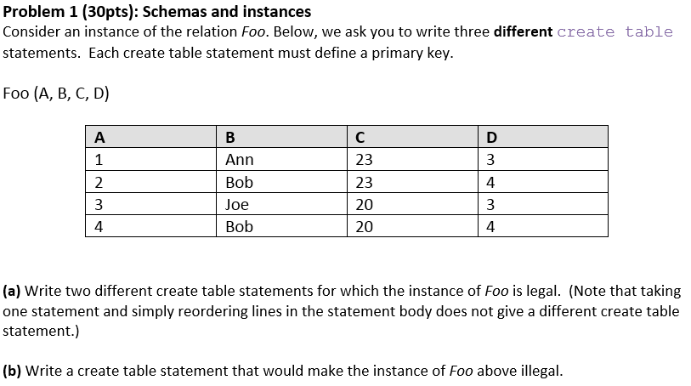







**Answer Sheet:**

Feel free to adjust the spaces in the table to accommodate your answers. This typed answer table is preferred for submission; But if you’d like to write and then scan to submit, it is also acceptable as long as your answers are clear to recognize otherwise it could lead to zero score for the smudged parts

|  |  |  |
| --- | --- | --- |
| **Problem 1** | **a1** | create table little_Foo (  A number primary key,  B varchar(128),  C number,  D number,  unique (B, C)  ); |
| **a2** | create table little_Foo (  A number primary key,  B varchar(128) not null,  C number,  D number,  unique (C, D)  ); |
| **b** | create table little_Foo (  A number,  B varchar(128) primary key,  C number,  D number,  unique (B, D)  ); |
|  | | |
| **Problem 2** | **a1** | **(all** candidate keys**)**  {ssn}  {name, address, dob} |
| **a2** | **(all** superkeys)  {ssn}  {ssn, name}  {ssn, nickname}  {ssn, address}  {ssn, dob}  {ssn, name, nickname}  {ssn, name, address}  {ssn, name, dob}  {ssn, nickname, address}  {ssn, nickname, dob}  {ssn, address, dob}  {ssn, name, nickname, address}  {ssn, name, nickname, dob}  {ssn, name, address, dob}  {ssn, nickname, address, dob}  {ssn, name, nickname, address, dob}  {name, address, dob}  {name, address, dob, nickname} |
| **b** | create table Person (  ssn char(12) primary key,  name varchar(128) not null,  nickname varchar(128),  address varchar(128),  dob date not null,  unique (name, address, dob)  ); |
|  | | |
| **Problem 3** | **a** | **(all** statements)  create table State (  name varchar(128) primary key,  region varchar(128)  );  create table Governor (  name varchar(128),  state char(2),  party varchar(128),  primary key (name, state),  foreign key (state) references State(name)  );  create table City (  name varchar(128),  state char(2),  population number,  elevation number,  primary key (name, state)  foreign key (state) references State(name)  );  create table Mayor (  name varchar(128),  city varchar(128),  state char(2),  party varchar(128),  primary key (name, city, state)  foreign key (city, state)  references City(name, state)  ); |
| **b** | **(all** valid dropping sequences)  drop table Governor;  drop table Mayor;  drop table City;  drop table State;  drop table Mayor;  drop table Governor;  drop table City;  drop table State;  drop table Mayor;  drop table City;  drop table Governor;  drop table State; |
|  | | |
| **Problem 4** | Possible symbols that you might need to copy-paste if you find it challenge to type manually**:** ∪ ∩ \ – | × | |
| **b** | (S ∩ W) - C, OR: S ∩ (W \ C), OR: (S - M) - C |
| **c** | (W - S) ∩ C |
| **d** | ((W - S) ∩ C) ∪ ((S ∩ W) - C) |
| **e** | (S \ M) × (S \ W) |