NOTE: X-Axis represent by lambda, Y-Axis is varied

5.2) Regularization_path

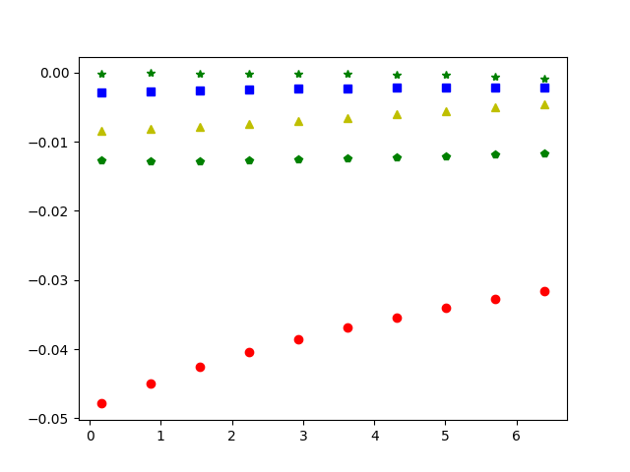

5.3) RSS on training data

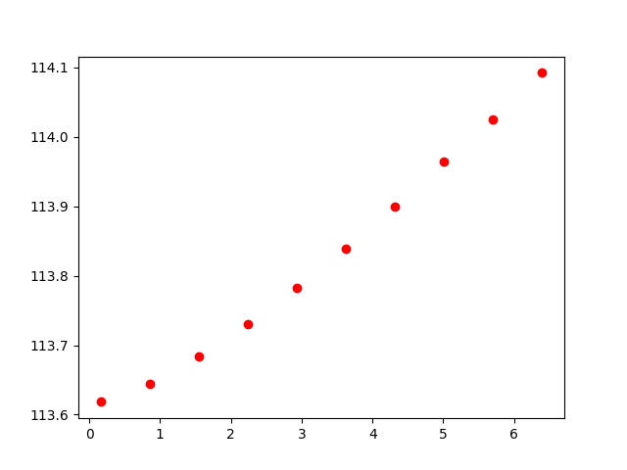

5.4) RSS on test data

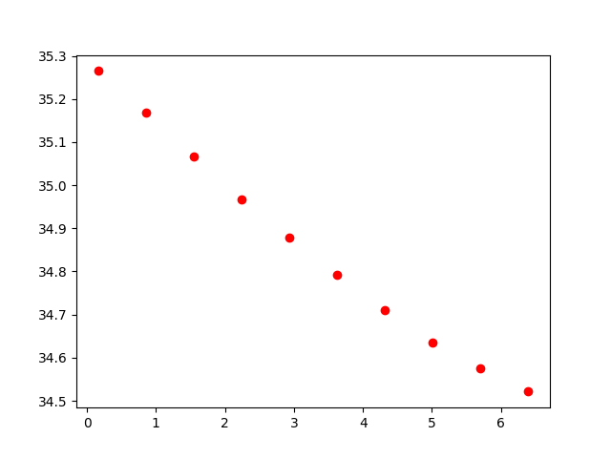

5.5) Lambda against number of coeff

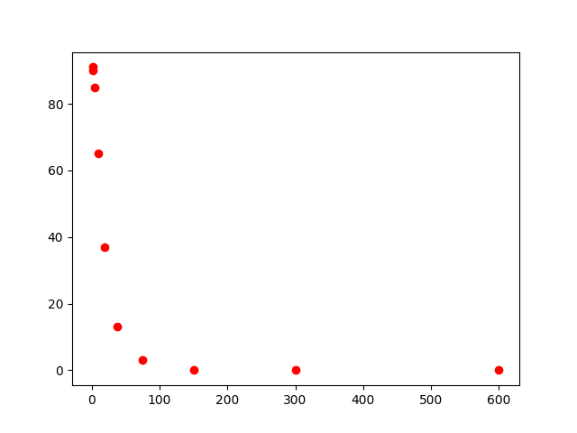

5.6, 5.7) Graph to pick best lambda (the min dot is when lambda around 20 ish)

