APPROACH & TECHNICAL DESIGN
Candidate Onboarding
auto parse CV
Travis – 12 July 2026

A first look at the screens
Before the detail, here's what the candidate actually sees. The whole experience is just two screens.
Screen 1 · Upload
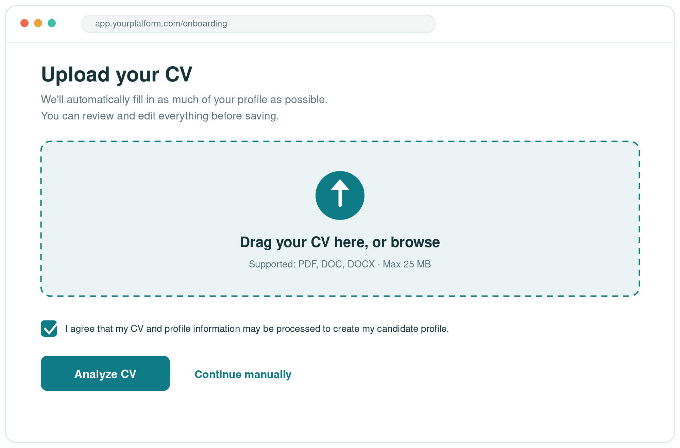
A simple screen: drop in the CV, accept a short consent, and click Analyze. Anyone who'd rather not upload can continue manually.
Screen 2 · Review & complete
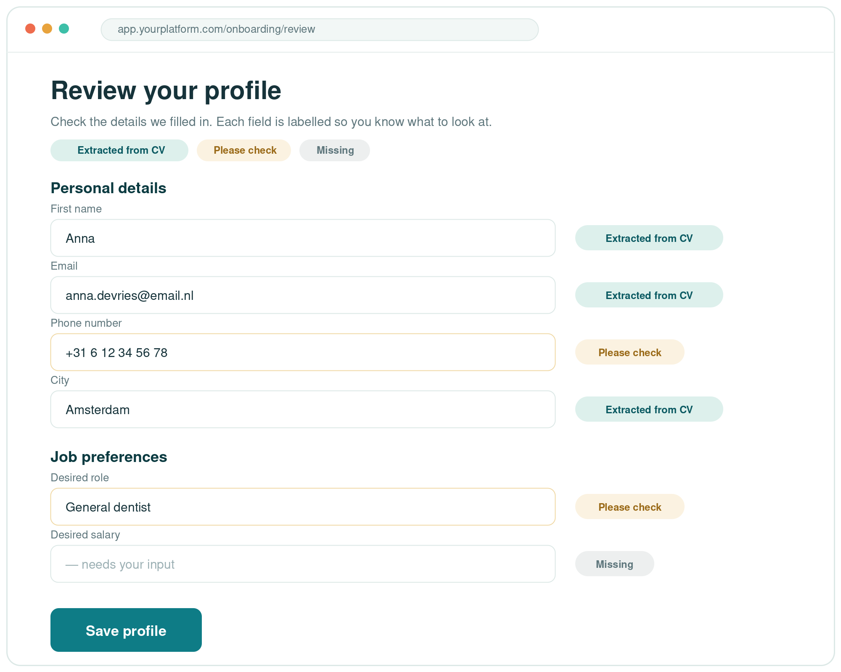
The profile comes back pre-filled, with a label on every field — green for “extracted from CV”, amber for “please check”, grey for “missing”. The candidate edits anything, fills the gaps, and saves.

1 Context
Today, a new candidate has to fill in a long profile form by hand which is boring and taking much time. Many people see a screen full of empty fields and give up or rush it and leave out details we need to match them to the right jobs.
Instead of asking candidates to type everything, we do the boring part for them and ask them only to review it which to help them feel supportive.

2 What the candidate sees
From the candidate's point of view, onboarding is just two steps: upload then review, should takes a few minutes.
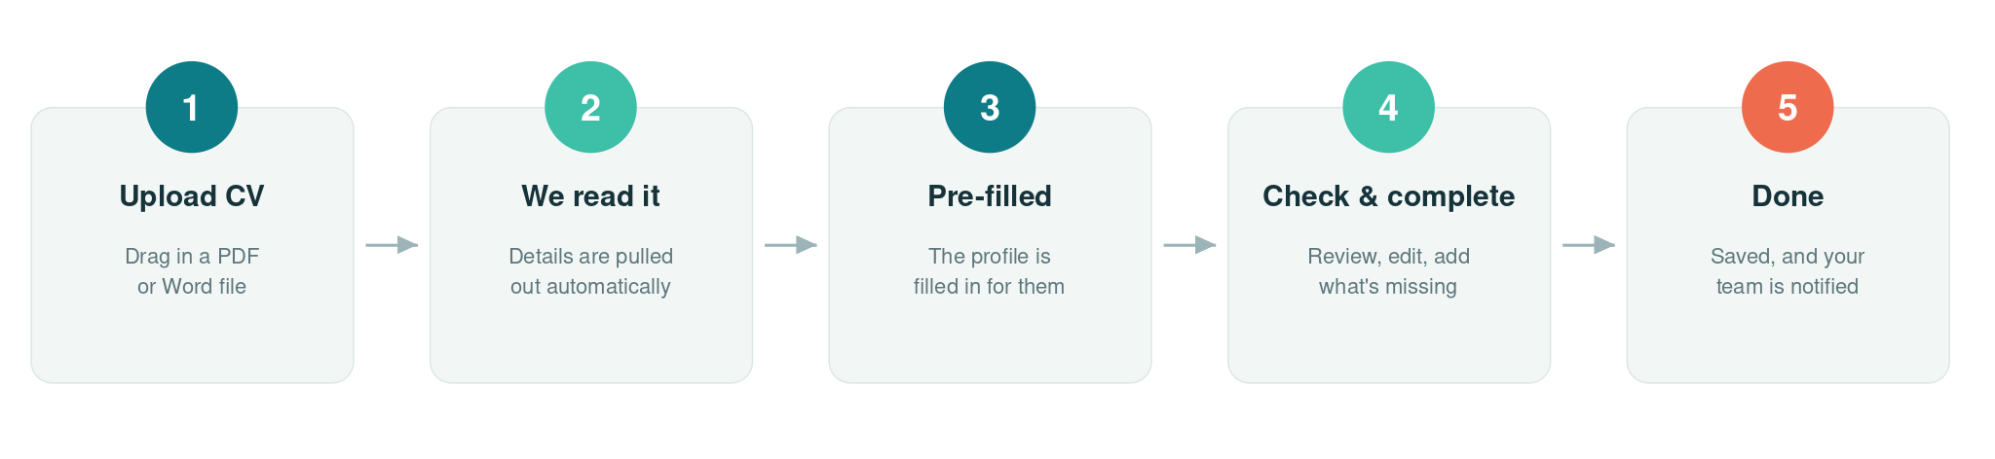
Nothing is asked of them upfront except the CV. Everything the system fills in is clearly labelled, so they can see at a glance what has been pre-filled, what to double-check, and what still needs their input.

3 Our approach
A few principles guide how we're building this:
- Keep it simple for the candidate. Two clear steps, no clutter, and only the questions that are relevant to their role.
- Do the heavy lifting automatically. The system reads the CV and pre-fills the profile, so the candidate reviews instead of retypes.
- Always keep the person in control. Nothing is saved until the candidate has checked and confirmed it.
- Build it to grow. Roles, skills and other options are managed in a list your team can edit so the product can scale up without rebuilding it.
- Deliver in phases. A complete, useful first version comes early; the extras come later.

4 What happens behind the scenes
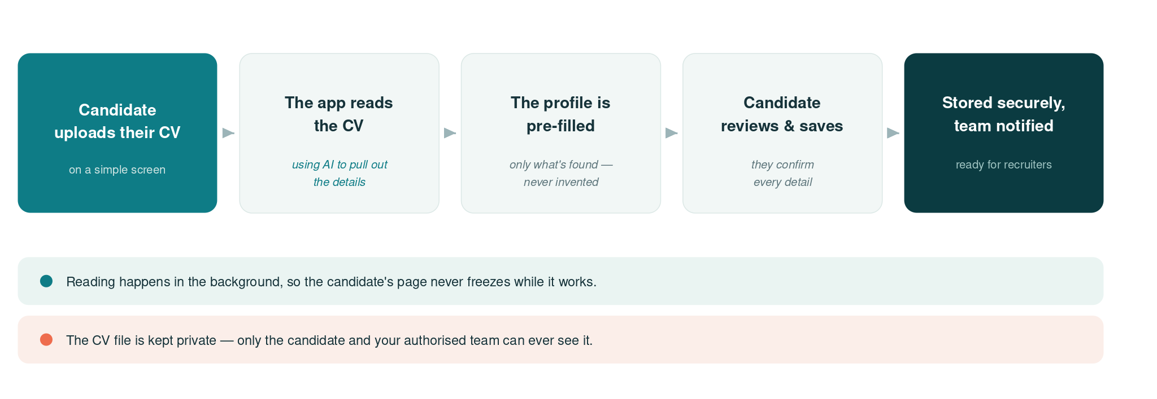
When a CV is uploaded, the reading happens in the background. That's important: it means the candidate's screen never freezes while the system works, even if a CV takes a little longer to process. Once it's done, the pre-filled profile appears automatically.
Why this matters: Reading a CV can take several seconds. Doing it in the background keeps the experience smooth, and means that if the candidate closes the page, their upload isn't lost — they can pick up where they left off.

5 How we read the CV
This is the core part of the system, so it's worth explaining plainly.
The system will use AI service reads the words in the CV and extract which piece of information is which: the person's name, their contact details, their jobs, their education, their skills, and so on. It then matches those against the platform's own lists (for example, mapping a job title on the CV to one of fixed role categories). Then will map to our defined formatted fields.
- If a detail isn't in the CV, the field is simply left blank.
- The candidate always reviews it. Anything the system is unsure about is flagged with a small label like “please check”, and nothing is saved until the candidate confirms.

Why we chose this method
We looked at three ways to read CVs:
Option | What it is | Our take
AI reading | A modern AI service reads the CV text and returns the details, in any layout or language. | Chosen. Handles Dutch and English and messy CV layouts, is quick to build, and costs very little at your volume.
Third party CV reader | A specialist service built only for parsing CVs. | Weaker at specific categories, and still needs custom work to fit our lists.
Build our own | Write our own CV-reading logic from scratch. | Slow and costly to build and maintain, and brittle across different CV formats.

On privacy: Only the text of the CV is sent to the AI service, which is configured not to keep any of it, and can run within the EU. The candidate never sees the raw AI output — only the tidy, pre-filled fields.

Example: the data flow, step by step
Here's the full journey of a single CV through the system — from the uploaded file, into the AI, and back out as tidy, labelled fields for the candidate to review.
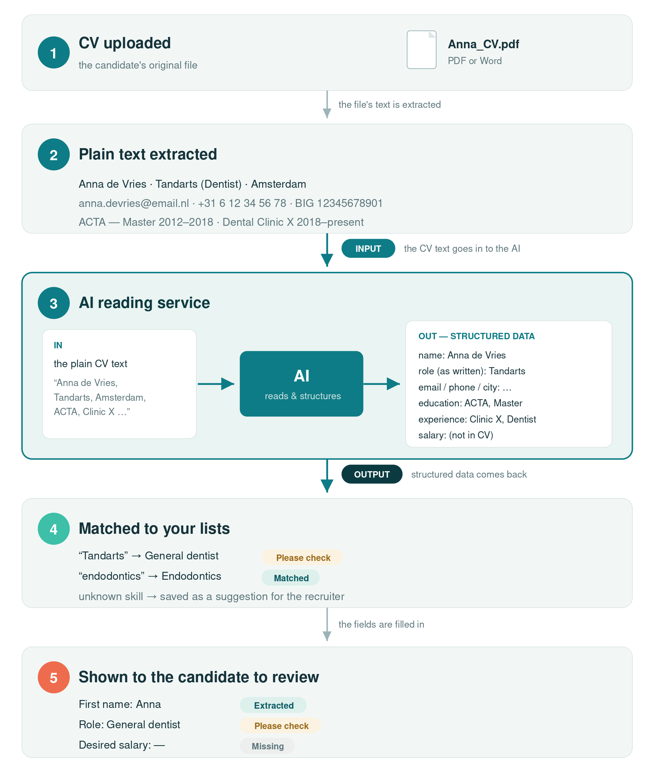
The AI takes the plain CV text as its input and returns structured data as its output. Notice the role comes back as “Tandarts” and is mapped to your “General dentist” category (flagged “please check”), while desired salary is left “missing” because a CV doesn't contain it — nothing is invented.

6 What information we keep
All the details come together into one candidate profile the main record. Some parts, like education and work experience, can hold several entries, because people usually have more than one job or qualification. The CV file itself is stored separately and privately.
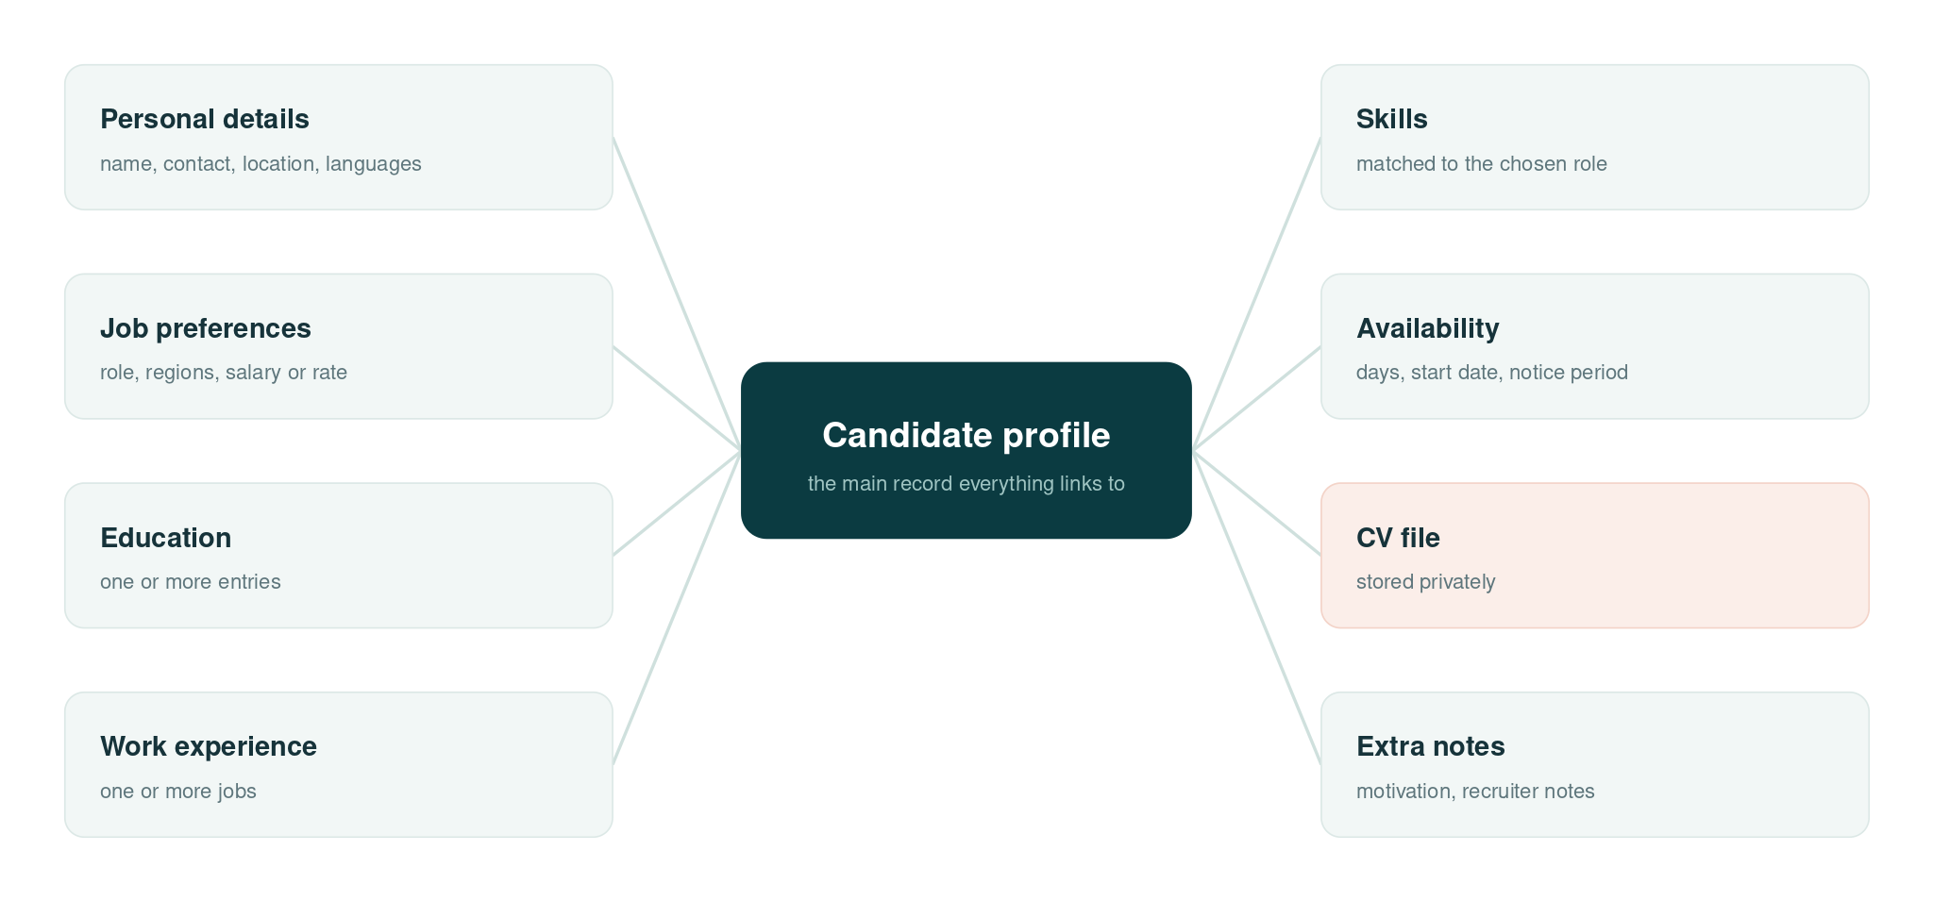
Keeping the information organised like this (rather than as one big block of text) is what later makes it easy to search and to match candidates to the right vacancies.

7 Keeping it private and safe
Because CVs contain personal information, privacy is built in from the start:
- CV files are never public. Only the candidate and your authorised team can open them, through secure, time-limited links.
- The candidate gives clear consent, in plain language, before anything is saved.
- We store only what's needed for recruitment and matching.
- The raw output of the AI reader is never shown to candidates; they only see the finished fields.

8 When something goes wrong
The system is designed so a candidate is never left stuck. Here's how common situations are handled:
Situation | What happens
The file type isn't supported | A clear message explains which types are accepted (PDF and Word).
The file is too large | The candidate is told, and can upload a smaller version.
The CV can't be read | The candidate simply fills the form in by hand -> no dead end.
The CV has very little detail | Whatever is found is pre-filled; the rest is left for the candidate.
The candidate closes the page | Their upload is saved, so they can come back and continue.
Something was read incorrectly | The candidate corrects it before saving, they review everything.
The CV reader is slow or unavailable | The system waits, then tries again automatically. If it still can't read the CV, the candidate is offered manual entry — never left waiting.
The reader is busy (rate-limited) | The request is queued and retried a moment later; the candidate just sees the normal “reading your CV” message.
The connection drops mid-read | The upload is already saved safely. The system retries, and falls back to manual entry if needed — nothing is lost.

Under the hood: The system never waits forever on the AI reader. If it doesn't respond within a set time, the request times out, retries a couple of times, and then quietly hands over to manual entry. The candidate's progress is always safe, and your team can see when a CV needed the manual route.

9 Roadmap & estimates
We deliver a working, valuable first version early, then build on it. The work breaks into milestones, each with a rough estimate. Phase 1 is the first usable product; Phases 2 and 3 come afterwards.
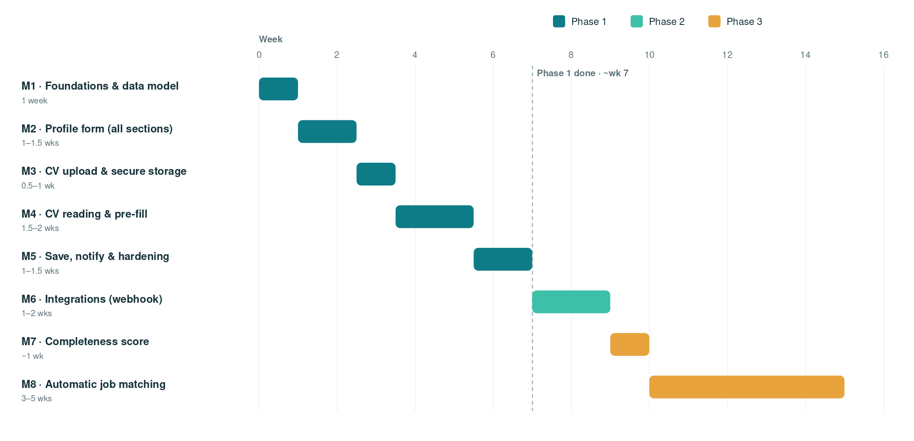

Milestones
Milestone | What's delivered | Estimate
Phase 1 — First working version | The complete two-step onboarding, from upload to a saved profile with your team notified. | ~7 weeks
M1 · Foundations & data model | The profile and its parts (education, work, skills, languages) and the editable option lists. | 1 weeks
M2 · Profile form | All sections, role-based conditional fields, add/remove education & work, and validation. | 1–1.5 weeks
M3 · CV upload & storage | The upload screen, file-type and size checks, and private storage. | 0.5–1 week
M4 · CV reading & pre-fill | AI reading, mapping to your lists, the review labels, and background processing. | 1.5–2 weeks
M5 · Save, notify & hardening | The save flow, recruiter notification, error handling, testing and polish. | 1–1.5 weeks
Phase 2 — Connect & automate | Send completed profiles into your other tools automatically. | ~1–2 weeks
M6 · Integrations | A webhook that hands finished profiles to your other systems. | 1–2 weeks
Phase 3 — Smart extras | Optional enhancements once the core is proven. | ~4–6 weeks
M7 · Completeness score | A simple score showing how complete each profile is. | ~1 week
M8 · Automatic job matching | Suggesting suitable vacancies from the profile. | 3–5 wks

About these estimates: These are indicative ranges to help planning, not a fixed quote. They assume one to two developers, and exclude time for design sign-off and for setting up your role and skill lists. We'd firm them up after a short detailed-scoping step at the start.

10 Technology choices, in plain terms
None of the technology here is exotic. Each piece is a standard, well-supported tool, which keeps the project low-risk, easy to maintain, and straightforward to hire for.
Choice | What it is | Why it's a sensible pick
Ruby on Rails | The framework the application is built with. | Mature, widely used, and easy to find developers for.
Background worker | Handles slow jobs (like reading a CV) away from the screen. | Keeps the experience smooth; a standard, reliable pattern.
Secure file storage | Where CV files are kept. | Keeps files private, shared only through time-limited links.
Database | The organised store for all profile information. | Makes searching and matching fast and reliable.
AI reading service | Reads the CV and returns the details. | Best fit for languages and layouts; configured for privacy.

The takeaway: This is a maintainable, future-proof build — not a one-off hack — so it can grow into matching, recruiter workflows and other features later.

11 What we need from you
To get started on the first version, we'd need three things:
- Confirm the roles, skills and other options you want candidates to choose from.
- Agree the look and feel, so the screens match your brand.
- Give the go-ahead on Phase 1 — the first working version.

Appendix For your technical team
The diagrams below show the full build architecture and the data model in more detail. They're here for any developer reviewing the design; they aren't needed to understand the sections above.

Build architecture
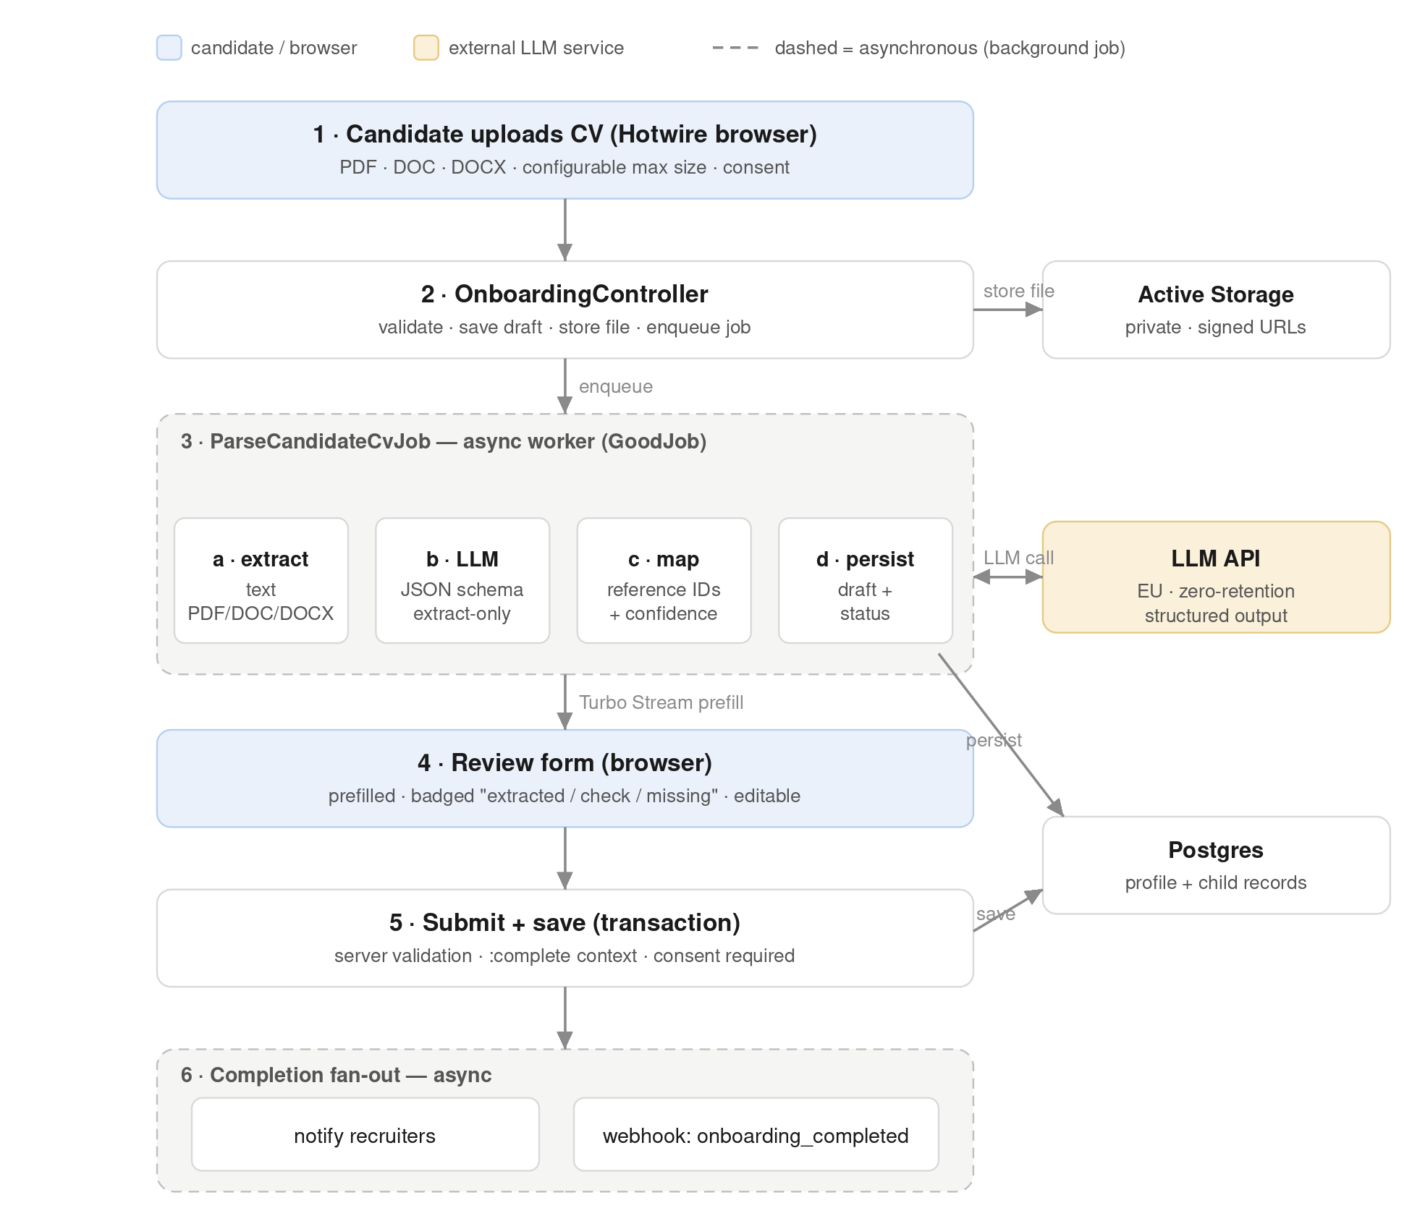

Data model (entity-relationship diagram)
The tables that store the candidate's information and how they relate. PK marks a primary key, FK a foreign key; a crow's foot marks the “many” side of a relationship (for example, one profile has many education and work-experience records).


