**OPENFL**

Cross-Platform

Build games and applications for almost every platform imaginable -- Windows, Mac, Linux, iOS, Android, BlackBerry, Firefox OS, Tizen, Flash and even HTML5. Bring your creative vision to life, on desktops, tablets, phones, even consoles. Publish to Steam, Amazon, OUYA... practically anywhere.

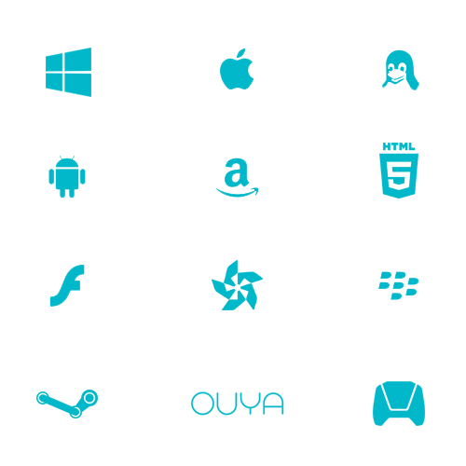

Open-Source

Unlock potential with an open, hackable platform that is 100% free and open-source, backed by a passionate and responsive developer community. Delve deep when you want the power or flexibility of a native codebase, but keep your hands clean when you are focused on content.



Easy-to-Use

Accelerate your workflow with the fast, easy-to-use Flash API, as well as integrated support for SWF file assets, allowing use of the Flash editing environment directly. Build content in weeks instead of months, using a powerful and flexible programming language.

