function fizzBuzz() {

    for (let i = 1; i <= 100; i++) {

      if (i % 3 === 0 && i % 5 === 0) {

        console.log("FizzBuzz");

      } else if (i % 3 === 0) {

        console.log("Fizz");

      } else if (i % 5 === 0) {

        console.log("Buzz");

      } else {

        console.log(i);

      }

    }

  }

  fizzBuzz();

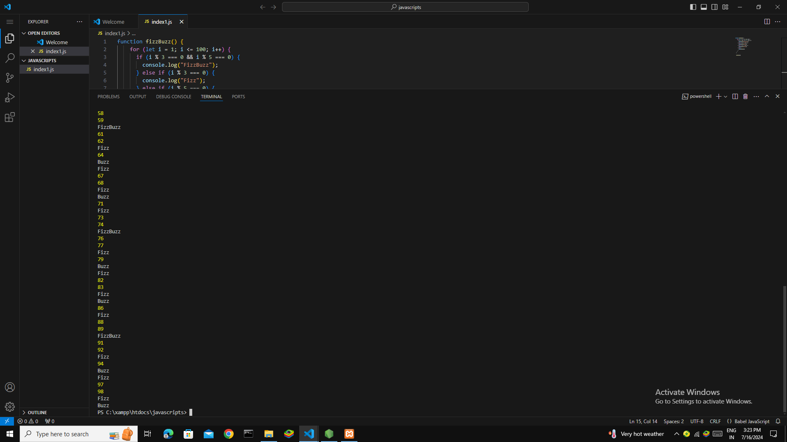

function evaluateExpression(expression) {

    return Function('"use strict";return (' + expression + ')')();

  }

  // Test cases

  console.log(evaluateExpression("2+3")); // Output: 5

  console.log(evaluateExpression("5-2")); // Output: 3

  console.log(evaluateExpression("10+2-3")); // Output: 9

  console.log(evaluateExpression("7-2+1")); // Output: 6

  console.log(evaluateExpression("1+1+1+1+1")); // Output: 5

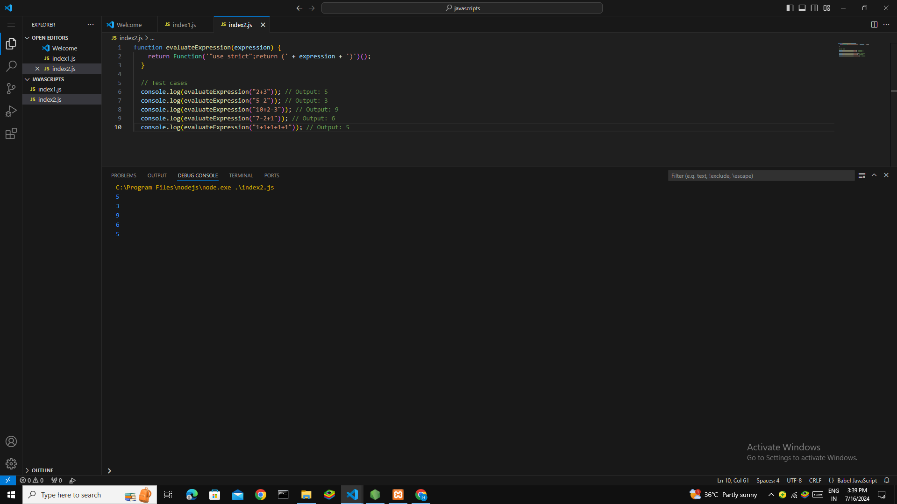

function flattenArray(arr) {

    return arr.reduce((acc, current) => {

      return acc.concat(Array.isArray(current)? flattenArray(current) : current);

    }, []);

  }

  // Test cases

  console.log(flattenArray([1, 2, [3, 4], 5])); // Output: [1, 2, 3, 4, 5]

  console.log(flattenArray([1, [2, [3, 4]], 5])); // Output: [1, 2, 3, 4, 5]

  console.log(flattenArray([[1, 2], [3, 4], [5, 6]])); // Output: [1, 2, 3, 4, 5, 6]

  console.log(flattenArray([1, 2, 3, 4, 5])); // Output: [1, 2, 3, 4, 5]

  console.log(flattenArray([])); // Output: []

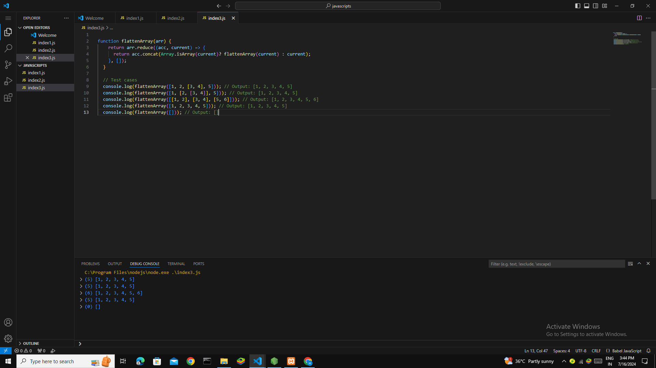

function areAnagrams(str1, str2) {

    return sortString(str1) === sortString(str2);

  }

  function sortString(str) {

    return str.split('').sort().join('');

  }

  // Test cases

  console.log(areAnagrams("listen", "silent")); // Output: true

  console.log(areAnagrams("hello", "world")); // Output: false

  console.log(areAnagrams("acts", "cats")); // Output: true

  console.log(areAnagrams("weird", "wired")); // Output: true

  console.log(areAnagrams("abc", "cba")); // Output: true

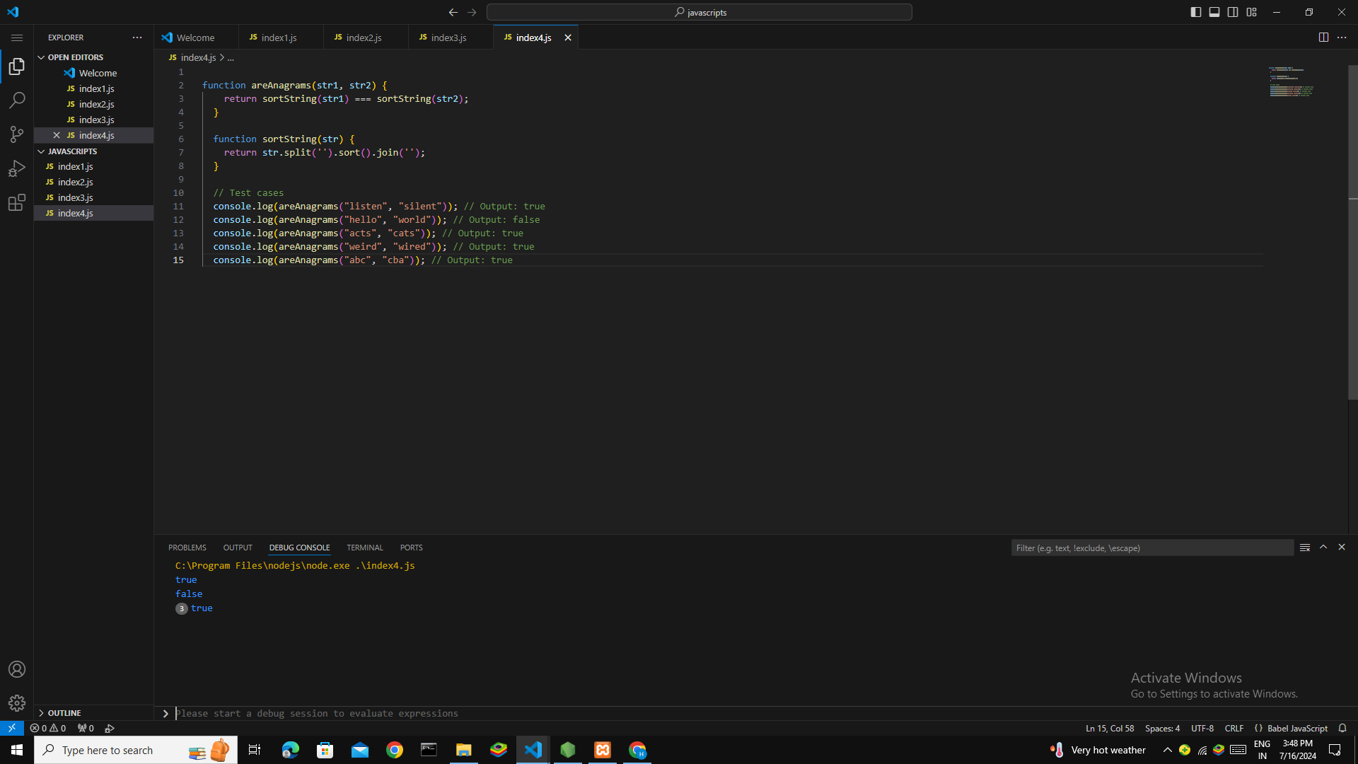

function removeDuplicates(arr) {

    return [...new Set(arr)];

  }

  console.log(removeDuplicates([1, 2, 2, 3, 4, 4, 5, 6, 6]));

  console.log(removeDuplicates(["apple", "banana", "apple", "orange", "banana"]));

  console.log(removeDuplicates([1, 1, 1, 1, 1]));

  console.log(removeDuplicates([]));

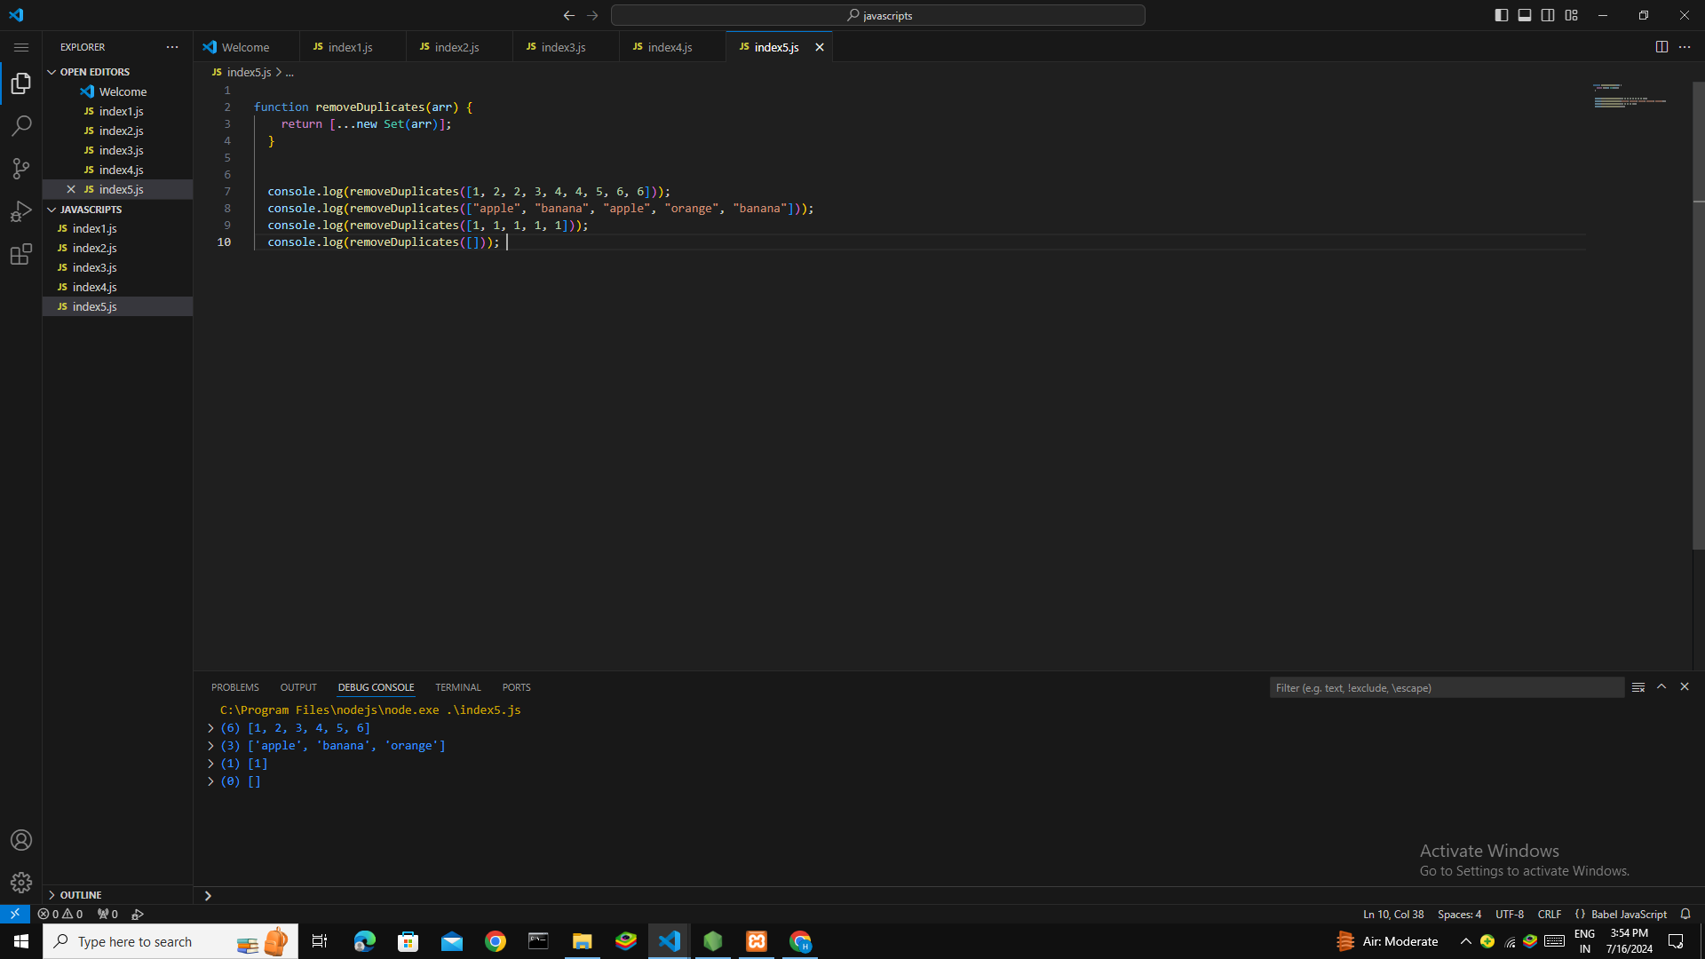

function capitalizeWords(str) {

    return str.split(' ').map(word => word.charAt(0).toUpperCase() + word.slice(1)).join(' ');

  }

  console.log(capitalizeWords("hello world"));

  console.log(capitalizeWords("this is a test"));

  console.log(capitalizeWords("javascript is fun"));

  console.log(capitalizeWords(""));

  console.log(capitalizeWords("a single word"));

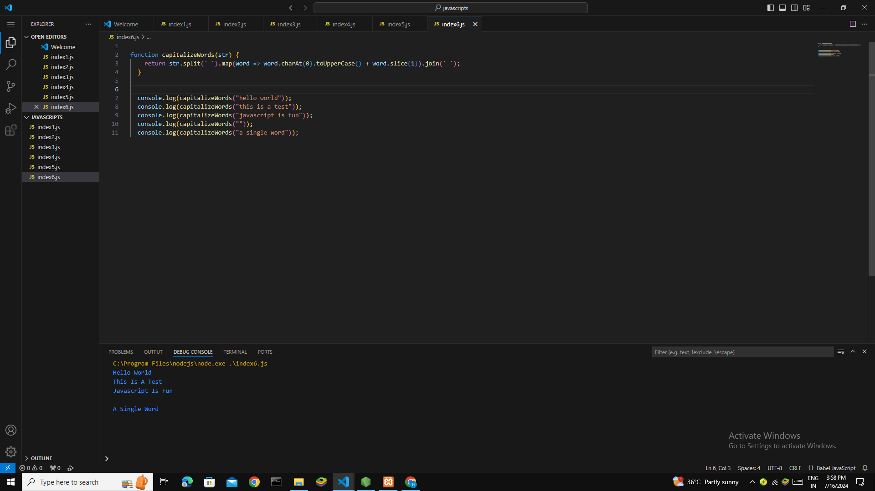

function fibonacci(n) {

    const sequence = [0, 1];

    for (let i = 2; i < n; i++) {

      sequence.push(sequence[i - 1] + sequence[i - 2]);

    }

    return sequence.slice(0, n);

  }

  console.log(fibonacci(5));

  console.log(fibonacci(8));

  console.log(fibonacci(1));

  console.log(fibonacci(2));

  console.log(fibonacci(0));

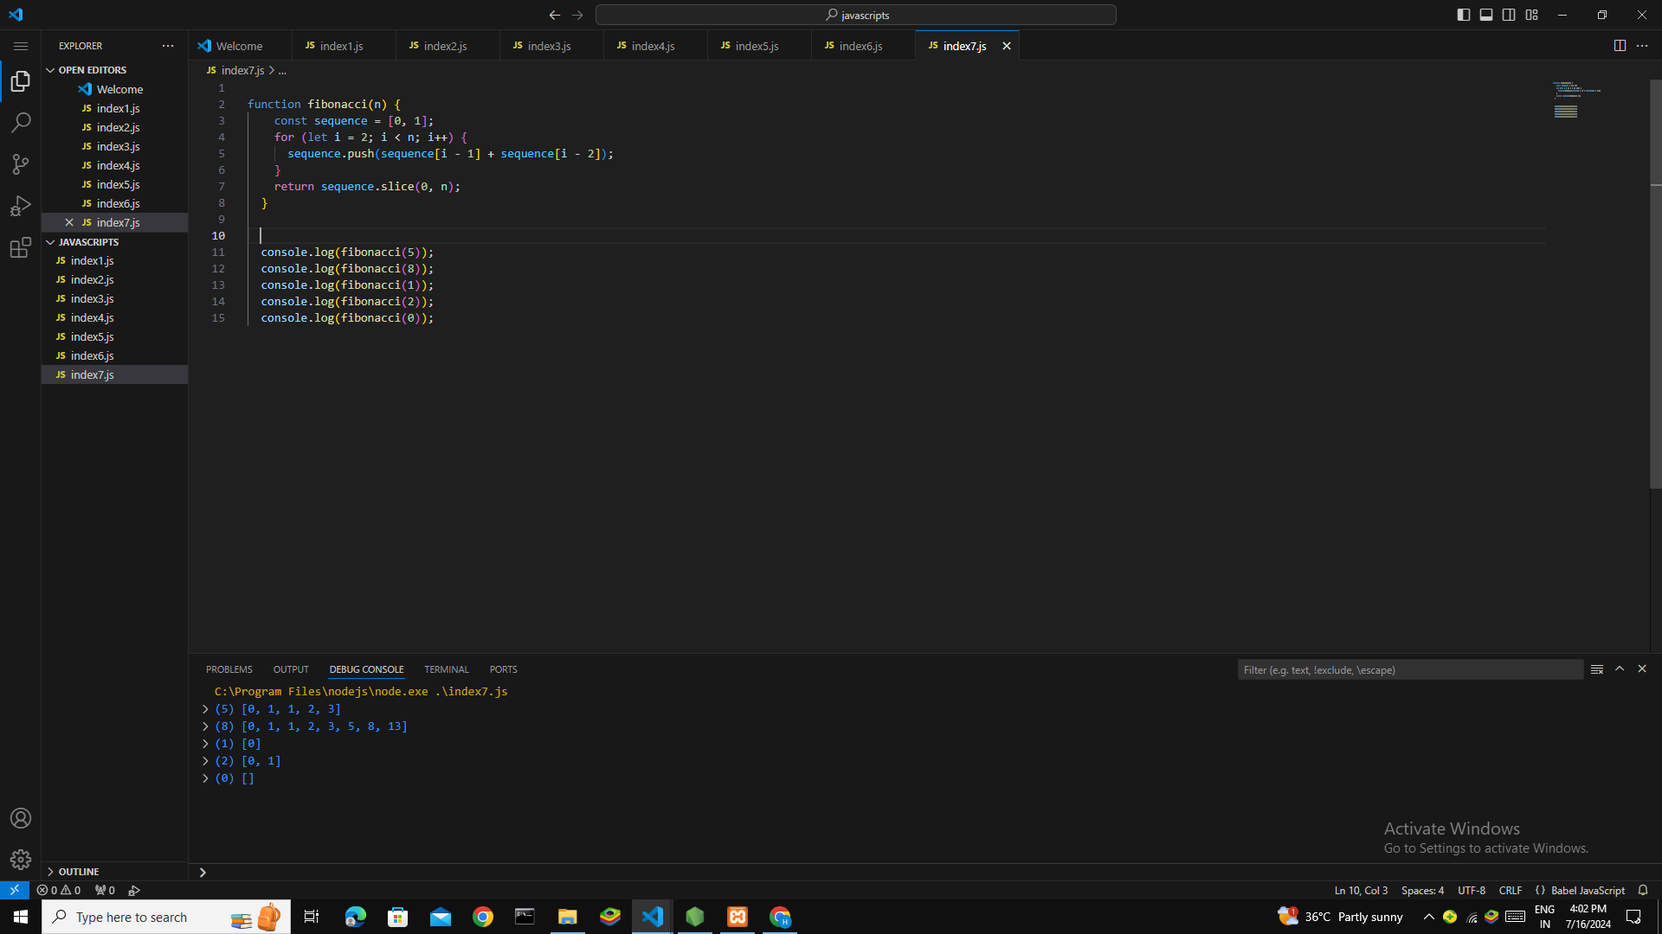

class HashMap {

    constructor() {

      this.map = {};

    }

    put(key, value) {

      this.map[key] = value;

    }

    get(key) {

      return this.map[key];

    }

    remove(key) {

      delete this.map[key];

    }

    size() {

      return Object.keys(this.map).length;

    }

    isEmpty() {

      return this.size() === 0;

    }

    clear() {

      this.map = {};

    }

  }

  const map = new HashMap();

  map.put("name", "John");

  map.put("age", 30);

  map.put("city", "New York");

  console.log(map.get("name"));

  console.log(map.get("age"));

  console.log(map.get("city"));

  map.remove("age");

  console.log(map.get("age"));

  console.log(map.size());

  console.log(map.isEmpty());

  map.clear();

  console.log(map.size());

  console.log(map.isEmpty());

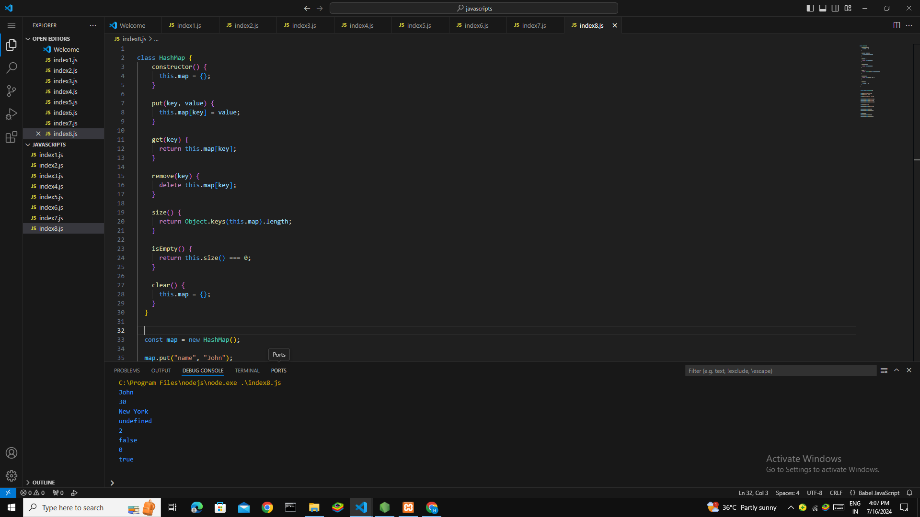

function filterOutEvenNumbers(arr) {

    return arr.filter(num => num % 2!== 0);

  }

  const arr1 = [1, 2, 3, 4, 5, 6];

  const arr2 = [10, 20, 30, 40, 50, 60];

  const arr3 = [1, 3, 5, 7, 9];

  console.log(filterOutEvenNumbers(arr1));

  console.log(filterOutEvenNumbers(arr2));

  console.log(filterOutEvenNumbers(arr3));

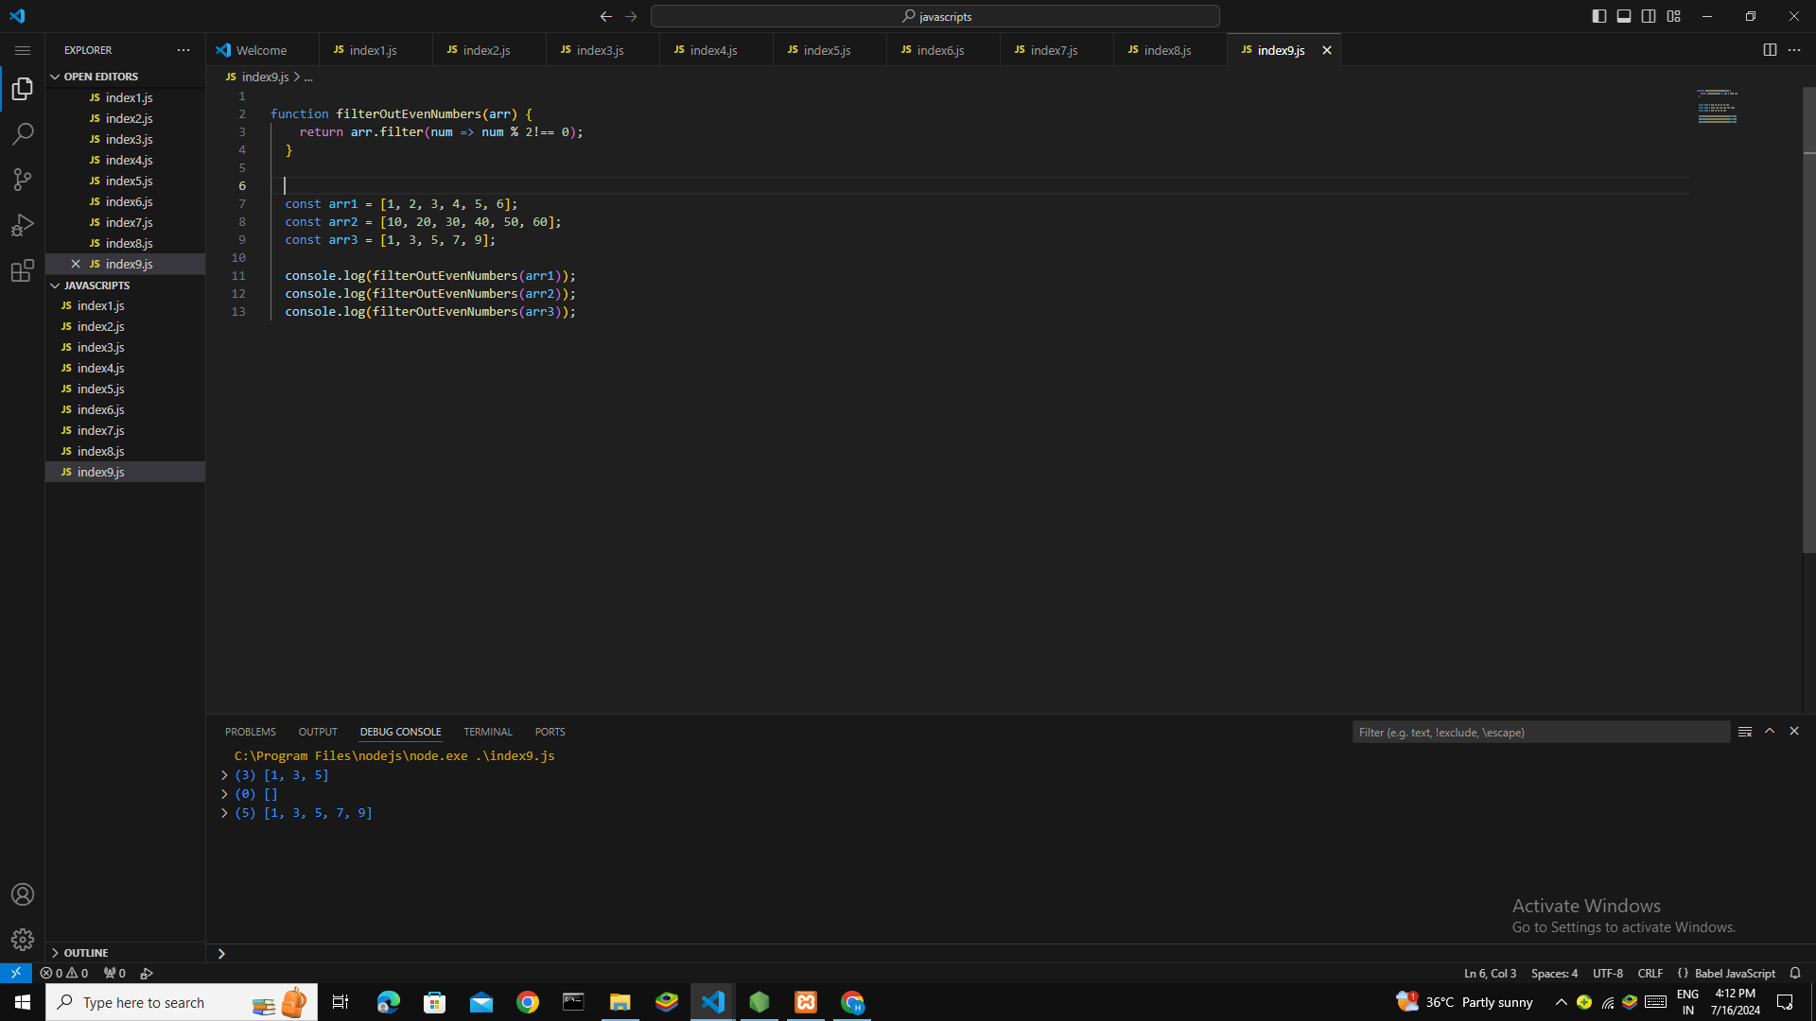

function toTitleCase(str) {

    return str.split(' ').map(word => word.charAt(0).toUpperCase() + word.slice(1).toLowerCase()).join(' ');

  }

  console.log(toTitleCase("hello world"));

  console.log(toTitleCase("this is a test"));

  console.log(toTitleCase("ALL UPPERCASE"));

  console.log(toTitleCase("mixed Case"));

