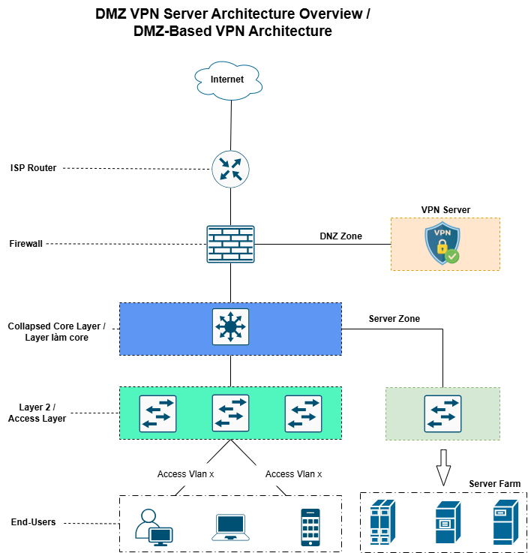

- DNS Server: 192.168.99.11, GW 192.168.99.7
- IT Server: 192.168.99.56, GW 192.168.99.7
- Pro Server: 192.168.99.55, GW 192.168.99.7
- End-user/LAN: 192.168.0.114/24, GW 192.168.0.7

- Core:
+ 192.168.99.7, nối đến Server Zone
+ 192.168.128.2, nối đến Firewall
- Firewall:
+ 192.168.128.1, nối đến Core
+ 125.234.102.234, nối đi internet
+ 192.168.131.7, nối DMZ/OpenVPN
- OpenVPN:
+ 192.168.131.11, nối đến Firewall DMZ

- Range IP cho VPN client:
+ 192.168.5.x/24
- Firewall trên Ubuntu của OpenVPN đã disable

- OpenVPN Access Server 3.1 (tài liệu https://openvpn.net/as-docs/v3/access-control.html#managing-access-control-in-access-server )
- Phase 1:

- Phase 2

