RZ/A2M

e2Studio for Linux - u-boot debugging issue

# Overview

This document shows current issue when debugging u-boot on RZ/A2M board.

Issue description: When setting breakpoint at functions that are relocated to RAM, the program can stop at breakpoint but cannot show function source code and there is an error: **Break at address "0x803964ca" with no debug information available, or outside of program code.** Where **0x803964ca** is address of function on RAM that is set breakpoint.

# Settings and debugging result

This part shows some settings to debug u-boot and result for each case.

## Original setting and result

**2.1.1 Setting:**

- Follow part 3: U-boot Debugging of material: e2Studio_for_Linux_20180809.docx

- Change relocate offset for RZ/A2M board

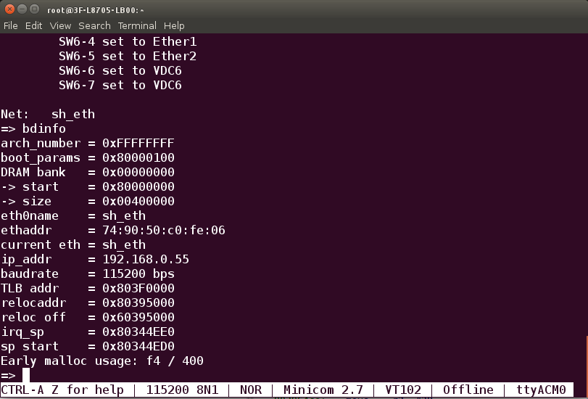  
Figure 1: relocate offset on terminal

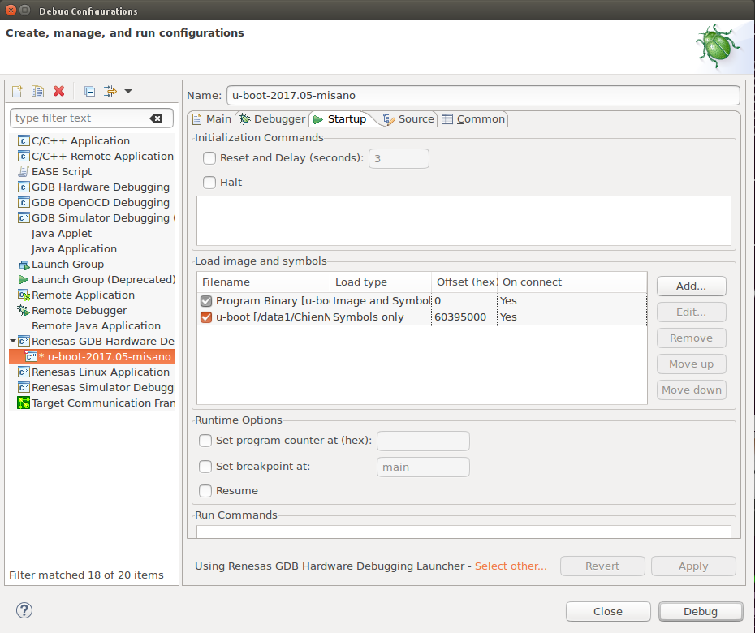  
Figure 2: Setting new reloc off for RZ/A2M

**2.1.2 Result:**

- Can debug functions that run on Flash (EX: relocate_code() function)

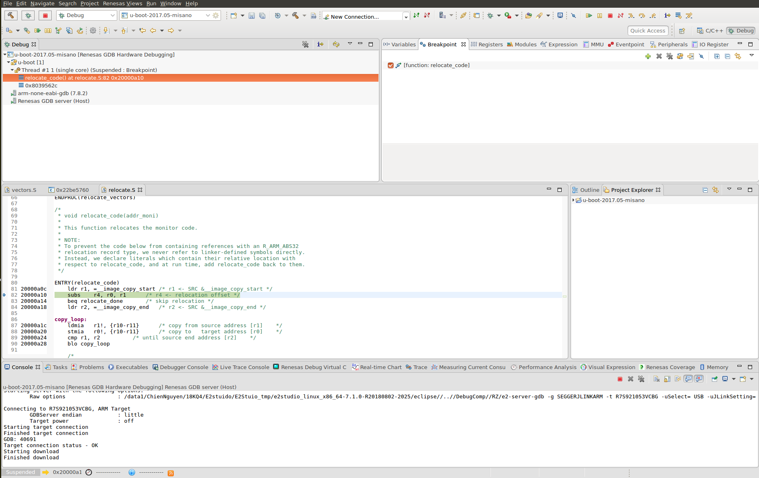  
Figure 3: Result of relocate_code function

- But debug with error for functions that run on RAM (EX: board_late_init() function)

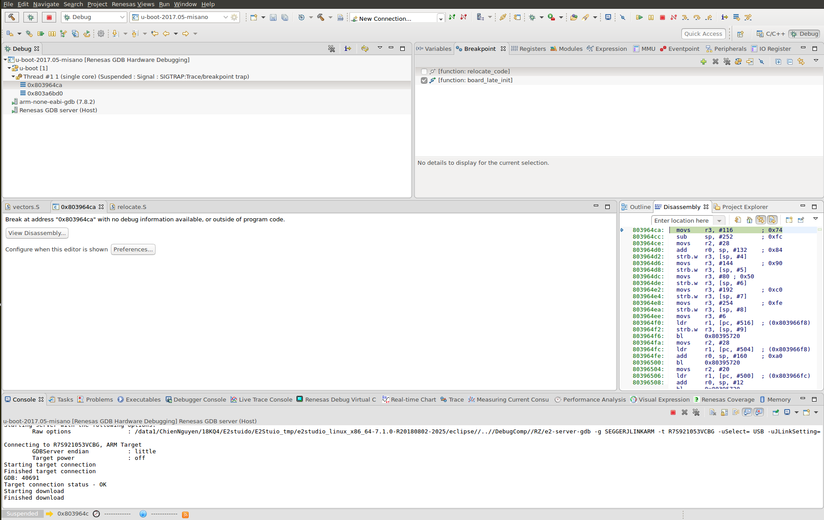  
Figure 4: Result of board_late_init function

## Change Endian setting and result

**2.2.1 Setting:**

- Follow part 3: U-boot Debugging of material: e2Studio_for_Linux_20180809.docx

- Change setting about memory endian of debugger from Little Endian to Big Endian

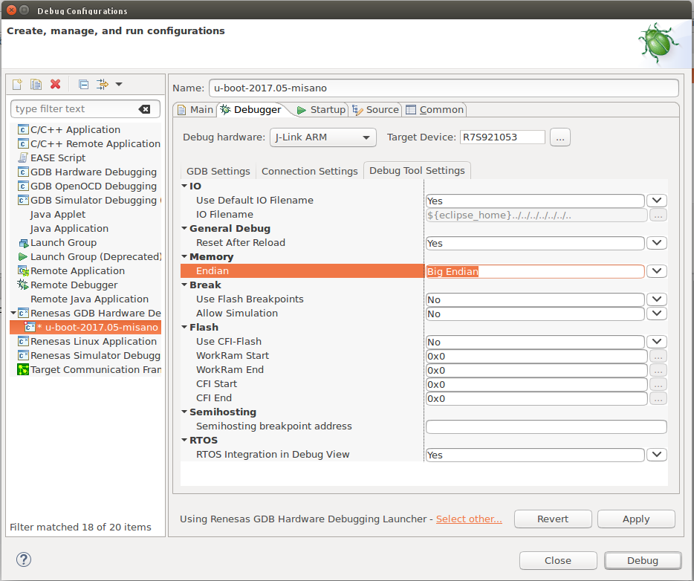  
Figure 5: Endian setting

**2.2.2 Result**

- Can stop at breakpoint for functions that run on Flash (EX: relocate_code() function) but cannot get register value.

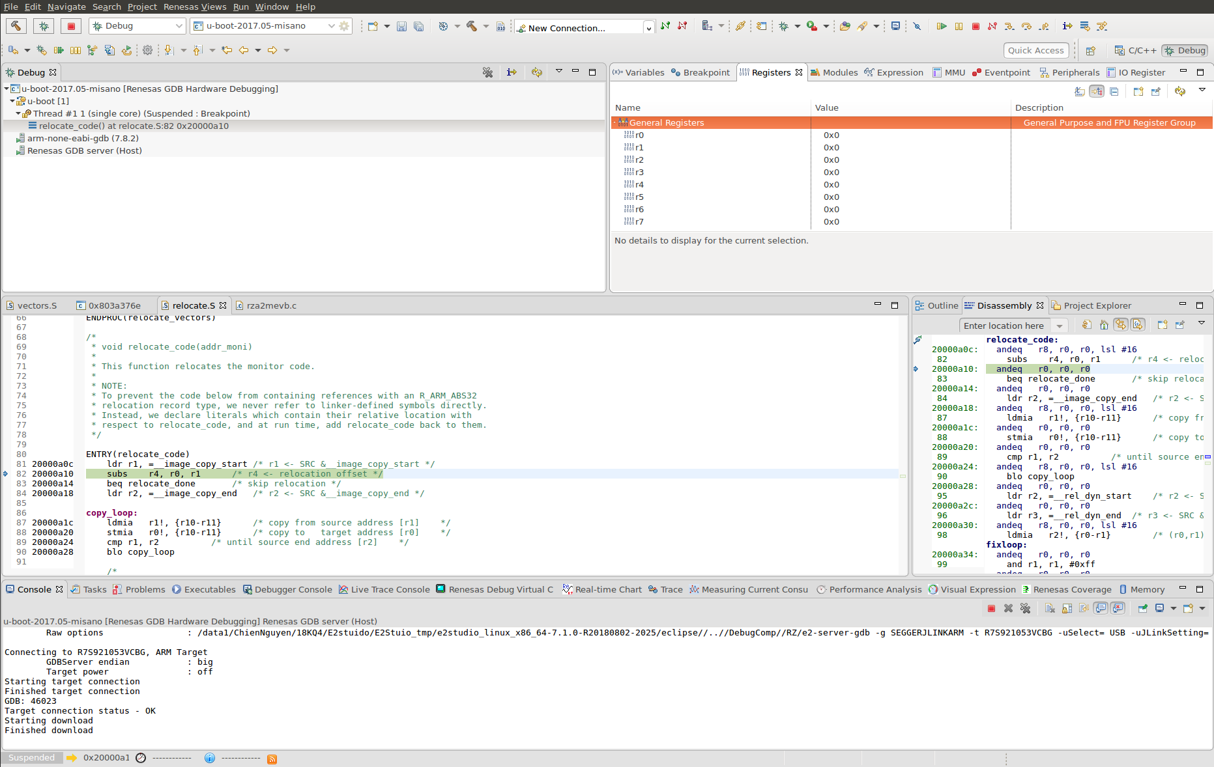  
Figure 6: Result of relocate_code function

- Can stop at function that run on RAM but function address is wrong (0x2XXX instead 0x8XXX) and cannot get register value.

Note: To debug function on RAM in this case, first push Stop button → set breakpoint at function (EX: board_late_init) → push Debug button to run debug → push Resume button to enter breakpoint, program will stop at board_late_init function.

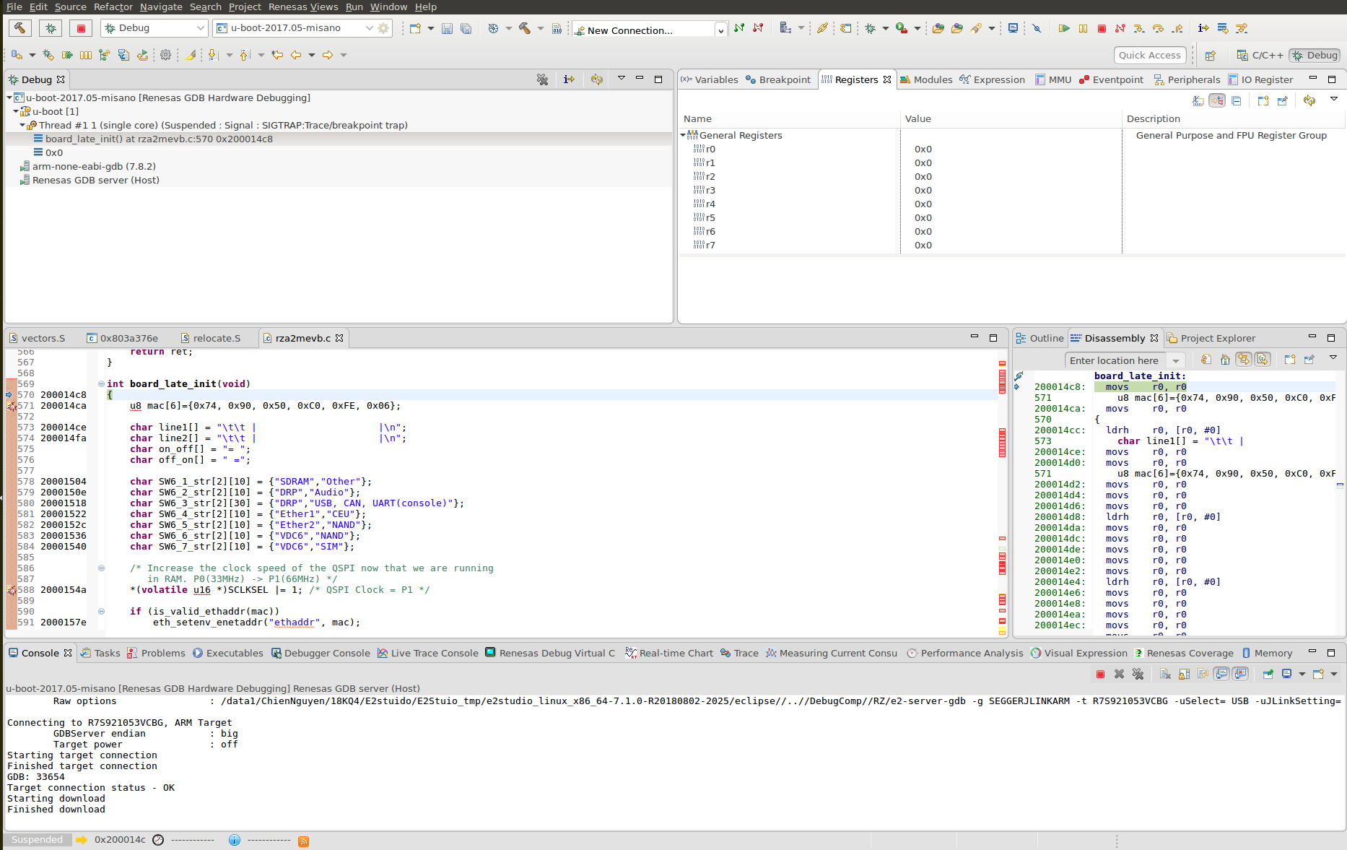  
Figure 7: Result of board_late_init function

## Change Load type setting and result

**2.3.1 Setting:**

- Follow part 3: U-boot Debugging of material: e2Studio_for_Linux_20180809.docx

- Change setting about Load Type same as following image:

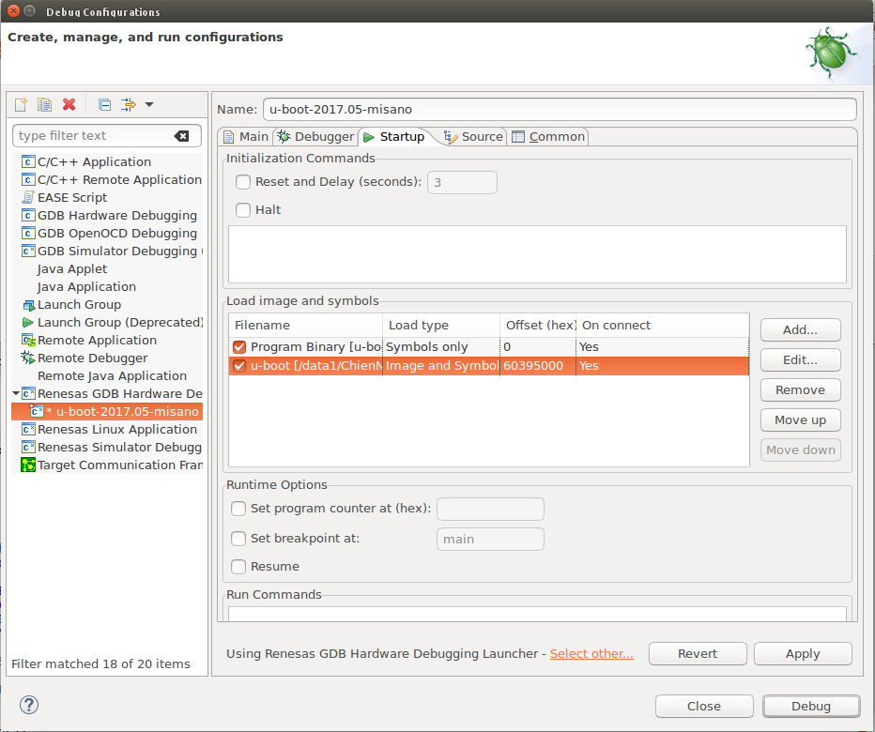  
Figure 8: Load Type setting

**2.3.2 Result**

- Functions that run on Flash: Same as result in 2.2.2

- Functions that run on RAM: Same as result in 2.2.2.

Note: To debug function on RAM in this case, first push Stop button → set breakpoint at function (EX: board_late_init) → push Debug button to run debug → push Resume button to enter breakpoint, program will stop at board_late_init function.