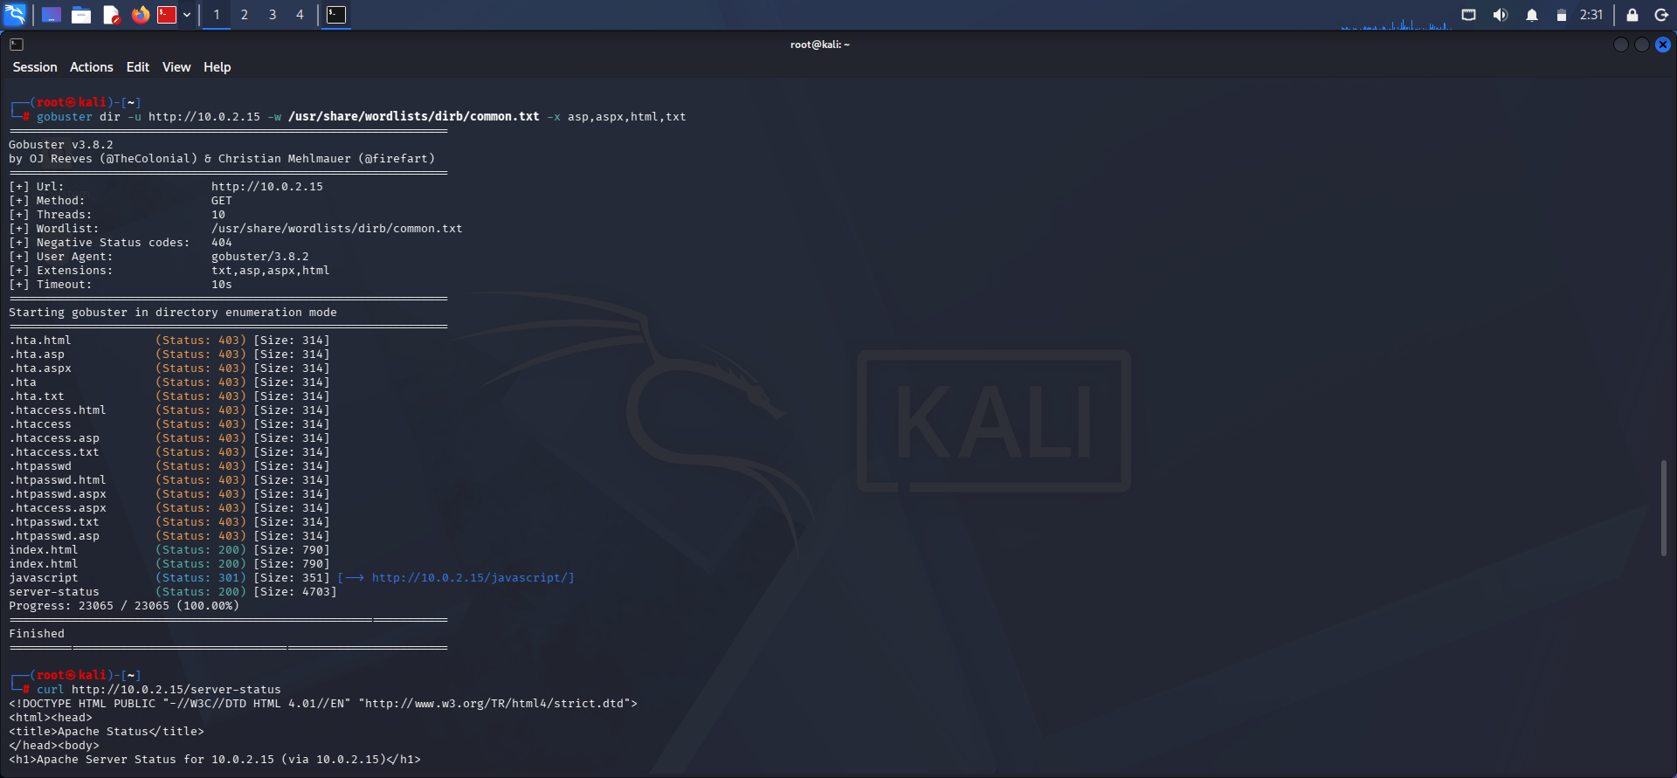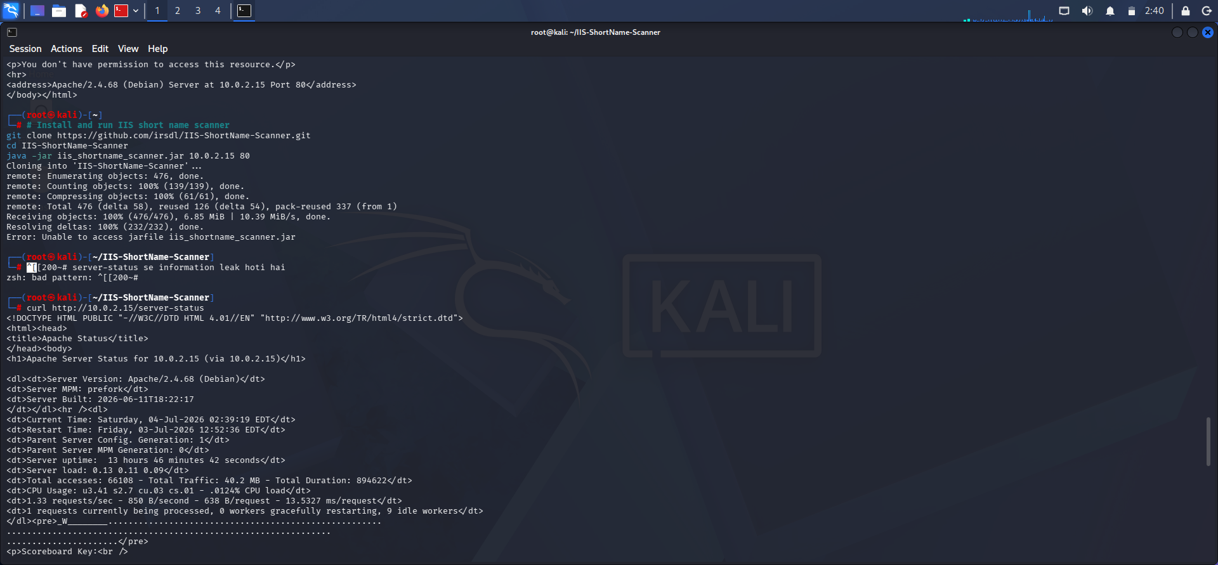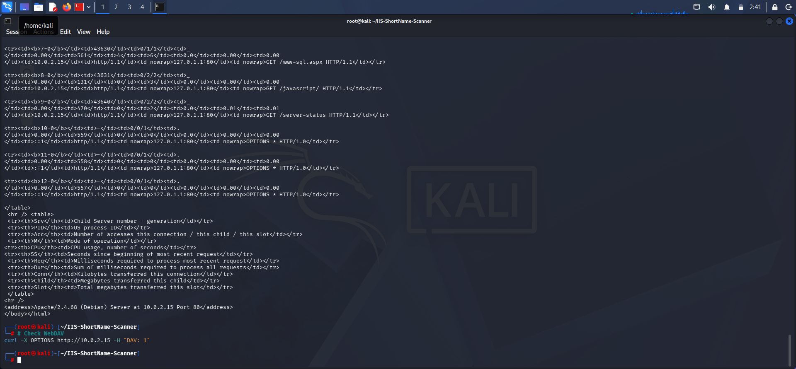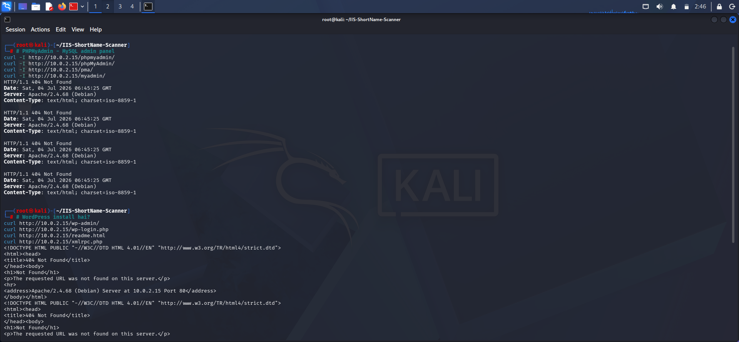

Description :
The reconnaissance successfully identified the following:
- Hidden directories were enumerated using Gobuster.
- Apache server version and configuration details were exposed through the server-status page.
- Sensitive files returned 403 Forbidden, indicating access restrictions.
- WebDAV service was not detected.
- No phpMyAdmin installation was found.
- No WordPress installation was found.
- IIS Short Name Scanner could not be executed because the required JAR file was unavailable.
Ye content directly report me Steps Performed, Commands Used, Observations, aur Result ke sections me use kar sakte ho.

- ✅ Windows Firewall bypassed
- ✅ RDP enabled successfully
- ✅ Remote connection established from Kali
- ✅ GUI access obtained
- ✅ Command-line access obtained
- ✅ Persistence created
- ✅ Credentials extracted

