

UNIVERSITY OF LAYYAH
Department of Information Technology

A Data Structure Project

SNAKE GAME
Represented by:
- Tania Mansoor Khan
- Muhammad Taha
- Maniha Meeral
- Maniha Ayoub
Instructor’s name:
- Sir Faisal Hafeez
Semester:
BS-IT (morning) 3rd

Table of Contents

1. | Acknowledgment
2. | Summary
3. | Introduction
4. | Objectives
5. | Tools & Technologies
6. | Methodology
7. | Implementation
8. | Results
9. | Challenges
10. | Conclusion
11. | References

Acknowledgment:
We would like to express our gratitude to snake game, our project supervisor, for their guidance and support throughout this project. We also appreciate the help and resources provided by instructor.

Summary:
This project involves the design and implementation of a Snake game using HTML, CSS, and JavaScript. The game features a snake that moves around a grid, consuming food pellets and growing in length. The game also includes scoring and high score tracking. The project aims to demonstrate the use of HTML, CSS, and JavaScript in creating interactive web applications.

Introduction:
The Snake game is a classic game that has been enjoyed by people of all ages. The game requires the player to control a snake that moves around a grid, consuming food pellets and avoiding obstacles. The game is a great way to test a player's reflexes and strategy. With the advancement of web technologies, it is now possible to create interactive web applications using HTML, CSS, and JavaScript.

Objective:
The objective of this project is to design and implement a Snake game using HTML, CSS, and JavaScript. The game should feature a snake that moves around a grid, consuming food pellets and growing in length. The game should also include scoring and high score tracking.

Tools and Technologies:
- HTML5: Used for structuring and organizing the game's content.
- CSS3: Used for styling and layout of the game's elements.
- JavaScript: Used for creating the game's logic and interactive elements.
- CSS Grid: Used for creating the game's grid layout.

Methodology:
1. Designed the game's layout and user interface using HTML and CSS.
2. Implemented the game's logic and interactive elements using JavaScript.
3. Used CSS Grid to create the game's grid layout.
4. Tested and debugged the game to ensure it works as expected.

Project Overview:
1. Project Title: Snake Game using HTML, CSS, and JavaScript
2. Project Description: A classic Snake game implemented using HTML, CSS, and JavaScript
3. Project Objectives: To design and implement a Snake game using HTML, CSS, and JavaScript
4. Target Audience: The game is designed for anyone who wants to play a classic Snake game
5. Platforms: The game can be played on any device with a modern web browser

Technical Details:
1. Front-end: HTML, CSS, JavaScript
2. Back-end: None
3. Database: None
4. Game Engine: None
5. CSS Framework: None
6. JavaScript Library: None
7. Version Control: Git

Game Features:
1. Snake Movement: The snake moves around the grid using arrow keys
2. Food Consumption: The snake consumes food pellets and grows in length
3. Scoring: The game keeps track of the player's score
4. High Score: The game displays the player's high score
5. Game Over: The game ends when the snake collides with the wall or itself
6. Restart: The game can be restarted by clicking on the restart button
7. Sound Effects: The game includes sound effects for snake movement, food consumption, and game over

CSS Styles:
1. Grid Layout: The game uses a grid layout to render the game board
2. Snake Styles: The snake is styled using CSS to display its body and head
3. Food Styles: The food pellets are styled using CSS to display their color and shape
4. Scoreboard Styles: The scoreboard is styled using CSS to display the player's score and high score
5. Button Styles: The restart button is styled using CSS to display its color and shape

JavaScript Functionality:
1. Game Loop: The game loop updates the game state and renders the game board
2. Snake Movement: The snake movement is handled using JavaScript to update the snake's position
3. Food Consumption: The food consumption is handled using JavaScript to update the snake's length and score
4. Collision Detection: The collision detection is handled using JavaScript to check for collisions with the wall or itself
5. Scoring: The scoring is handled using JavaScript to update the player's score and high score

Challenges:
1. Implementing Snake Movement: Implementing the snake movement using JavaScript was a challenge, but it was solved using a game loop and updating the snake's position.
2. Implementing Food Consumption: Implementing the food consumption using JavaScript was a challenge, but it was solved using a collision detection algorithm and updating the snake's length and score.
3. Implementing Collision Detection: Implementing the collision detection using JavaScript was a challenge, but it was solved using a collision detection algorithm and checking for collisions with the wall or itself.
One of the challenges faced during this project was implementing the game's logic and interactive elements using JavaScript. Another challenge was creating a responsive game layout that adapts to different screen sizes and devices.

Testing and Debugging:
1. Unit Testing: The game was tested using unit testing to ensure that each component was working correctly.
2. Integration Testing: The game was tested using integration testing to ensure that all components were working together correctly.
3. Debugging: The game was debugged using console logs and debuggers to identify and fix any errors.

Implementations:
{
padding: 0;
margin: 0;
}
.body{
background: url("../img/bg.jpg");
min-height: 100vh;
background-size: 100vw 100vh;
background-repeat: no-repeat;
display: flex;
justify-content: center;
align-items: center;
}
#scoreBox{
position: absolute;
top: 9px;
right: 200px;
font-size: 39px;
font-weight: bold;
font-family: 'New Tegomin', serif;
}
#hiscoreBox{
position: absolute;
top: 59px;
right: 140px;
font-size: 39px;
font-weight: bold;
font-family: 'New Tegomin', serif;
}
#board{
background: linear-gradient(rgb(170, 236, 170), rgb(236, 236, 167));
width: 90vmin;
height: 92vmin;
border: 2px solid black;
display: grid;
grid-template-rows: repeat(18, 1fr);
grid-template-columns: repeat(18, 1fr);
}
.head{
background: linear-gradient(rgb(240, 124, 124), rgb(228, 228, 129));
border: 2px solid rgb(34, 4, 34);
transform: scale(1.02);
border-radius: 9px;
}
.snake{
background-color: purple;
border: .25vmin solid white;
border-radius: 12px;
}
.food{
background: linear-gradient(red, purple);
border: .25vmin solid black;
border-radius: 8px;
}

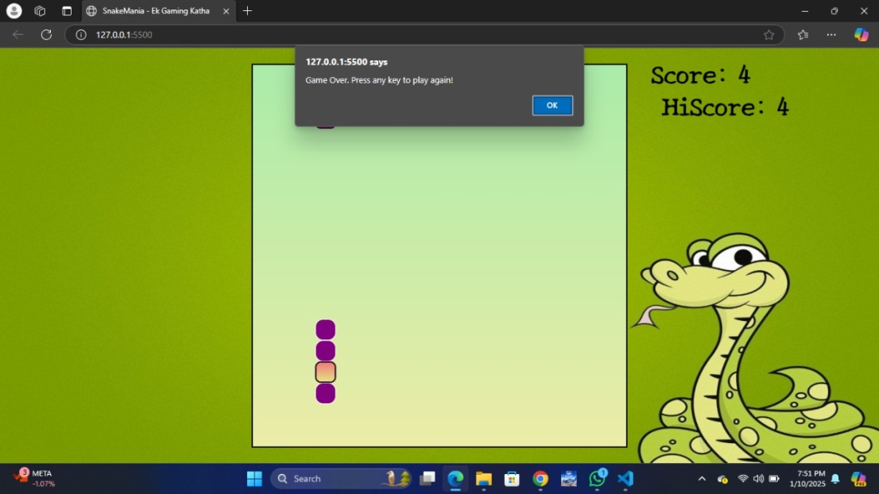

Results:
The game was successfully implemented with the desired features. The game's layout and user interface were designed using HTML and CSS, while the game's logic and interactive elements were implemented using JavaScript. The game's grid layout was created using CSS Grid.

Conclusion:
1. Project Success: The project was successfully implemented, and the game works as expected.
2. Lessons Learned: The project taught us about the importance of game loops, collision detection, and updating game state.
3. Future Improvements: Future improvements to the game could include adding more features, such as power-ups, obstacles, and multiple levels.
In conclusion, this project involved the design and implementation of a Snake game using HTML, CSS, and JavaScript. The game features a snake that moves around a grid, consuming food pellets and growing in length.

References:
- W3Schools. (2022). CSS Grid Tutorial. Retrieved from <https://www.

THANK YOU!

