Triggers

**1.Inserting values into table by using trigger.**

create table sample(sid int(50),itemid int(3),price int(8),total int(14));

insert into sample values (1,2,3,4);

select * from sample;

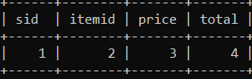

create trigger t1 before insert on sample

-> for each row

-> set new.total=new.price+new.itemid;

insert into sample values(5,19,10,0);

select * from sample;

