**Kiran Khaniya**

**Part 5. Details for Spark Project**

1 Follow all the steps mentioned in professor’s note:

* 1. Download Scala IDE
  2. Create a new Scla Project on Eclipse
  3. Update pom.xml

1. Create a new Scala Project

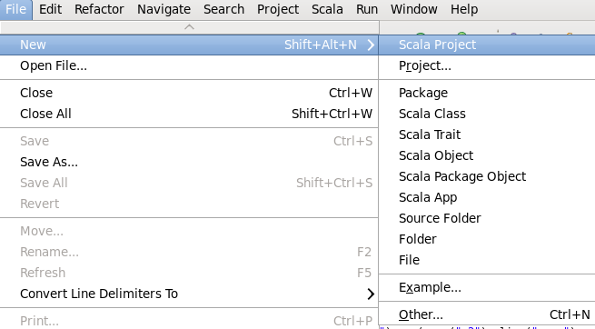

1. Create a new Scala object and name it

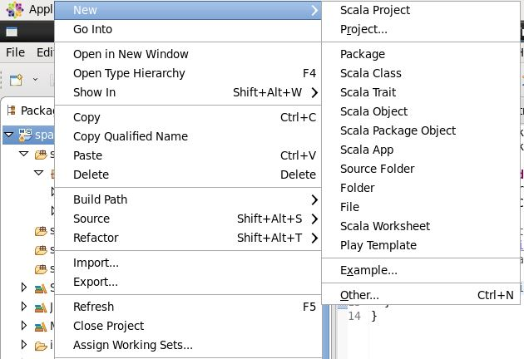

1. Convert project into maven project

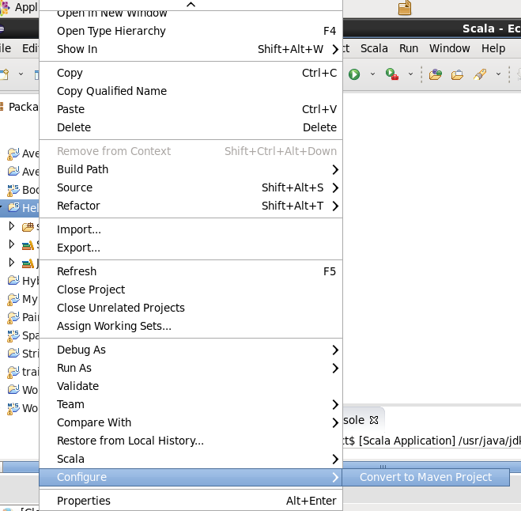

1. Update Maven and required dependency
2. Create and input file/folder under the project
3. Save output to new folder

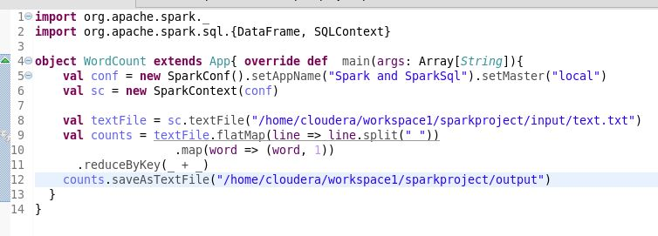

1. Run the scala application

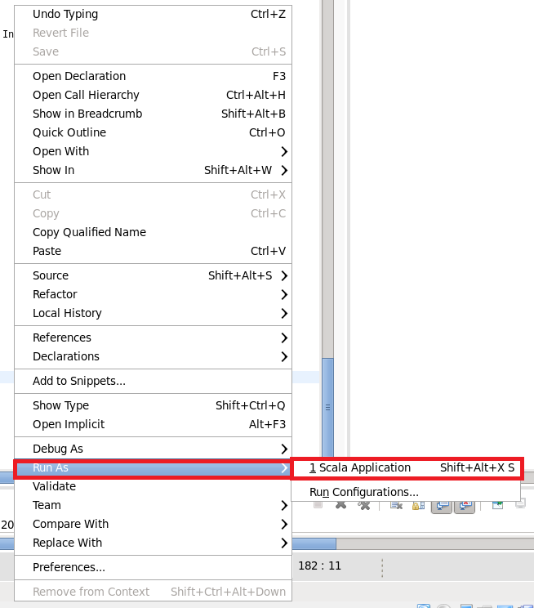

1. If you do not get any error then find the generated output folder with output file(s), part-00000 and a _SUCCESS file

