CHAPTER 1
INTRODUCTION
1.1 Introduction to Project
Attendance management is an essential administrative process in every educational institution, corporate office, training center, and secure workplace. Traditionally, attendance is recorded through manual registers, biometric systems, RFID cards, or QR-based solutions. While these mechanisms serve their purpose, they come with several limitations related to speed, authenticity, ease of use, hygiene, and scalability. To overcome these drawbacks, face recognition technology has emerged as a powerful, modern alternative that ensures seamless, contactless, and highly reliable attendance marking.
The Real-Time Face Recognition Attendance System presented in this project is an automated web-based application developed to enhance and modernize the attendance process using cutting-edge artificial intelligence and computer vision techniques. The system utilizes Flask for building the web interface, OpenCV for processing live video streams, and DeepFace for performing highly accurate face detection and identification. These technologies work together to create a system capable of recognizing individuals in real time as they appear in front of a camera.
When a person stands before the webcam, the system captures their live video feed, analyses each frame, and attempts to match the detected face against a dataset of known faces. Upon successfully identifying an individual, the system records their name, date, and time in a structured CSV file, which acts as the attendance log. This process is entirely automated, requiring no manual intervention, physical touch, or authentication cards. Additionally, the system is designed to prevent duplicate entries by ensuring that each individual’s attendance is marked only once per session.
This project represents a shift toward modernizing organizational processes through AI. By combining deep learning-based facial recognition models with real-time web technologies, the system not only improves accuracy and efficiency but also aligns with the need for touchless and safe technological solutions. This is particularly valuable in environments where hygiene is crucial, such as during health crises or in high-traffic workplaces.

1.2 Defining the Problem
Even though attendance management appears to be a small administrative task, it has a direct impact on productivity, monitoring, and accountability. Traditional attendance systems—manual registers, RFID cards, biometric fingerprints, or QR scanning—have several long-standing issues:
1.2.1 Issues With Manual Attendance
Manual attendance is slow, involves human effort, and is prone to mistakes. Teachers or administrators must call out names or pass around registers, which consumes valuable time. Additionally, manual attendance does not prevent proxy entries, as students or employees may sign on behalf of others.
1.2.2 Issues With RFID/Smart Card Attendance
RFID cards offer a partially automated solution, but they still require users to carry physical cards. Cards can be:
- Lost
- Exchanged
- Misused
- Forgotten
This again raises the possibility of proxy attendance. Physical contact is also required to swipe or tap the card.
1.2.3 Issues With Biometric Fingerprint Systems
Fingerprint scanners were popular for automation, but they have significant drawbacks:
- Require physical touch
- Unhygienic, especially during outbreaks
- Often fail when fingers are dirty, sweaty, or injured
- Cause queues when many users need to clock in

1.2.4 Issues With QR/Barcode Attendance
QR attendance is somewhat modern but still not fully automated. Users must scan codes manually, and the system requires a device to perform the scan. It also doesn't prevent users from scanning codes on behalf of others.
1.2.4.1 The Core Problem
What organizations truly need is a:
- Fully automated
- Touchless
- Fast and accurate
- Real-time
- Proxy-proof
attendance system that works simply when a person appears in front of a camera and does not require any physical interaction.
The problem addressed in this project is to design a web-based real-time attendance system that instantly detects and recognizes faces using modern AI techniques, and records attendance accurately without manual involvement.
1.3 Existing System
To better understand the need for this solution, it is important to analyze the shortcomings of existing attendance systems.
1.3.1 Manual Attendance Systems
Manual methods are the oldest and simplest but have major limitations:
- Susceptible to fraud
- Time-consuming
- Can be manipulated
- Difficult to maintain large records
- Poor security and reliability
1.3.2 RFID or Smart Card-Based Systems
Although these systems automate tracking to some extent, they still require:
- Carrying a physical card
- Each person to swipe the card manually
- Risk of losing cards or borrowing/exchanging them
This compromises the integrity of attendance data.
1.3.3 Biometric Fingerprint Attendance Systems
Biometrics improved accuracy but still face issues:
- Sensors malfunction due to dust or moisture
- Long queues during peak hours
- Physical contact is mandatory
- Infection spread risk through shared surfaces
1.3.4 QR Code or Barcode Systems
These modern solutions improve efficiency but still require:
- Manual scanning
- A device to hold the QR code
- No foolproof mechanism for preventing proxy attendance
1.3.4 Conclusion of Existing Systems
Although existing systems automate parts of the attendance process, none offer a fully automated, contactless, real-time solution.This gap motivates the development of a smart face recognition attendance system leveraging modern AI.
1.4 Proposed System
The proposed Real-Time Face Recognition Attendance System utilizes computer vision and deep learning to eliminate the problems in existing systems. This system is capable of automatically recognizing individuals based on their facial features captured through a webcam.
1.4.1 Key Features of the Proposed System
- A Flask-based web interface displays real-time video from a webcam.
- OpenCV processes each frame captured from the live stream.
- DeepFace using ArcFace recognition model identifies individuals with high precision.
- Attendance is automatically stored in a CSV file with date and time.
- Users are labeled as Known or Unknown, ensuring clarity.
- Only one attendance entry is recorded per person per session using the marked_today logic.
The proposed system delivers a fast, accurate, cost-effective, and fully automated attendance solution that removes the need for physical contact and manual operations.
1.5 Objectives
The project has several clear and measurable objectives:
- Develop an AI-powered attendance system using facial recognition technology.
- Automate the attendance process to reduce manual effort and eliminate human error.
- Provide a user-friendly, web-based interface for displaying real-time recognition results.
- Ensure that each individual’s attendance is recorded only once per session.
- Achieve high recognition accuracy using the ArcFace deep learning model.
- Deliver a portable, lightweight, and easily deployable solution for institutional use.

1.6 Feasibility Study
1.6.1 Technical Feasibility
The system uses widely available and open-source technologies such as Python, Flask, OpenCV, and DeepFace. These tools run efficiently on normal hardware without requiring specialized machines or GPUs. A standard webcam is sufficient for capturing live footage.
1.6.2 Operational Feasibility
The system is intuitive and requires no training. Users simply appear in front of the camera, and the system takes care of detection, recognition, and attendance recording automatically. The interface is simple and accessible through any web browser.
1.6.3 Economic Feasibility
Since the system uses open-source frameworks, the cost of development is minimal. There is no need for purchasing expensive hardware, biometrics, or RFID equipment. The only requirement is a camera-enabled device, making this solution extremely cost-effective.

CHAPTER 2
SYSTEM ANALYSIS & DESIGN
2.1 Model Used
The system relies on two important AI models:
2.1.1 ArcFace Recognition Model
ArcFace is a deep-learning model known for:
- High accuracy
- Robust performance under different lighting conditions
- Effective handling of variations such as angles and facial expressions
It uses deep metric learning to distinguish between faces with high precision, making it ideal for attendance systems.
2.1.2 RetinaFace Detection Model
RetinaFace helps in:
- Fast and accurate face detection
- Working efficiently in real-time conditions
- Handling multiple faces in a single frame
Together, ArcFace and RetinaFace form the backbone of the recognition engine.
2.1.3 Client–Server Architecture
Flask acts as the server, running the backend logic and streaming frames.
The browser acts as the client, displaying live results and interacting with the system.
2.2 System Requirement Specification (Srs)
2.2.1 Functional Requirements
- The system streams webcam footage in real time.
- It detects faces from live video input.
- It recognizes individuals using stored database images.
- It marks attendance automatically with name, date, and time.
- Unknown faces are identified and labeled correctly.
2.2.2 Non-Functional Requirements
- Performance: Should process frames in real time with minimal delay.
- Reliability: Recognition should be stable and accurate.
- Security: Data remains local, ensuring privacy.
- Usability: Simple user interface accessible from browsers.
- Portability: Runs on Windows, Linux, or macOS.
2.2.3 Hardware Requirements
- Standard webcam
- Minimum 4GB RAM
- Dual-core processor
2.2.4 Software Requirements
- Python 3.10+
- Flask
- DeepFace
- OpenCV
- Code editor or IDE
2.3 Data Flow Diagrams (Dfds)
2.3.1 Level 0 DFD Explanation
The user appears in front of the camera, the system detects and recognizes the face, and attendance is recorded in a CSV file.

2.3.2 Level 1 DFD Explanation
The system captures frames, detects faces, compares them with known faces, identifies recognized individuals, and updates attendance accordingly.
2.3.3 Level 2 DFD Explanation
The recognition engine checks the database, and the attendance module writes attendance data. Flask handles display of real-time results.
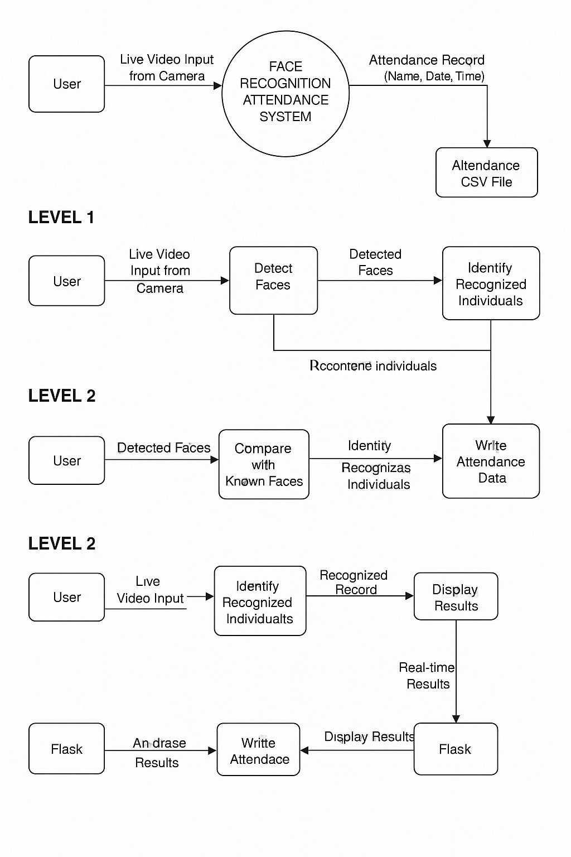
Figure 2.1: Data flow diagram

CHAPTER 3
WORKING OF PROJECT
3.1 Introduction To Project
This chapter provides a comprehensive explanation of how the Real-Time Face Recognition Attendance System functions internally. The system works by continuously capturing video frames from a webcam and analysing them using computer vision and deep learning techniques. Each frame passes through several crucial stages—starting from frame acquisition, face detection, identity recognition, attendance marking, and finally rendering the results on the frontend interface.
The workflow begins when a user opens the application in a web browser. Flask, acting as the backend server, initialises the webcam and streams live video frames through a dedicated route. These frames are then processed sequentially in real time. OpenCV handles the extraction and pre-processing of image frames, while DeepFace is responsible for detecting faces within the frame and recognising whether the detected face belongs to a registered individual. If the system identifies a match, attendance is recorded and stored automatically in a CSV file. If no match exists, the user is labelled as “Unknown.” Once processing is complete, the annotated frame (with labels such as the person’s name or “Unknown”) is sent back to the frontend for real-time display. This cyclical process enables the system to operate continuously and autonomously without requiring user interaction.
3.2 Technology Used In The Project
The system integrates multiple technologies, each playing a vital role in achieving real-time and accurate face recognition.
3.2.1 Flask
Flask is a lightweight Python web framework used to create the backend server of the application. It manages routing, handles user requests, and streams the live webcam feed to the browser. Flask enables seamless communication between the frontend and backend and ensures that processed video frames (including detected and recognized face information) are delivered to the client efficiently.

3.2.2 OpenCV
OpenCV (Open Source Computer Vision Library) is the core computer vision engine used in the project. It captures real-time video frames from the webcam, converts them into readable formats, preprocesses images, and adds visual labels such as names or “Unknown” onto the frames. OpenCV is also responsible for encoding frames so they can be streamed as MJPEG content through Flask.
3.2.3 DeepFace
DeepFace is a deep-learning facial recognition framework used to detect and identify individuals. The system uses:
- RetinaFace for face detection, which locates faces within the input frame.
- ArcFace for recognition, which compares the detected face with stored images and determines the closest identity match.
DeepFace ensures high accuracy and reliability even when there are variations in lighting, pose, or facial expressions.
3.2.4 CSV File Handling
Attendance data (Name, Date, Time) is stored in a simple CSV file, making it easy to access and analyze using spreadsheet software like Excel, Google Sheets, or database tools. CSV handling ensures lightweight, fast, and platform-independent attendance storage.
3.2.5 HTML Frontend
The frontend of the application is designed using HTML, which serves as the visual interface for the user. It displays the live webcam feed, showing real-time recognition results such as the person’s name or “Unknown.” The frontend also refreshes automatically without requiring page reloads, thanks to continuous video streaming from Flask.
3.3 Working Of Project
The working of the project follows a structured sequence of operations to ensure smooth and real-time face recognition.
The system starts when the user opens the homepage, which is served through Flask. Once the page loads, a request is sent to the /video route, initiating the webcam stream. Flask captures frames through OpenCV and passes each frame to DeepFace for analysis. First, DeepFace uses RetinaFace to detect the presence of one or more faces in the frame. If a face is detected, the system then uses the ArcFace recognition model to compare it with the stored images inside the known_faces directory.
If a matching identity is found, the system extracts the name and checks whether attendance for that person has already been recorded. If not, their attendance is marked by writing a new row into the attendance.csv file. The annotated frame—either with the identified name or the label “Unknown”—is then encoded and streamed back to the browser.
This entire sequence happens continuously for every captured frame, enabling real-time recognition. As a result, the system operates autonomously, requiring no manual intervention, and ensures reliable and immediate attendance tracking.

CHAPTER 4
RESULTS & DISCUSSION
The system demonstrates highly efficient performance in real-time face recognition, meaning it can continuously process live video frames from the webcam without noticeable delay. As soon as a face appears in front of the camera, the system quickly detects and compares it with stored facial data using advanced deep learning models. This results in a high level of accuracy, ensuring that recognised individuals are correctly identified and their attendance is accurately recorded without requiring manual intervention.
One of the significant advantages of the system is its ability to label unknown individuals correctly. If a person whose face is not stored in the database appears before the camera, the system reliably marks them as “Unknown,” preventing incorrect or false attendance entries. This improves the authenticity and security of the attendance record.
The entire operation is executed through a web browser, making it extremely convenient for users. There is no need to install additional software or use external devices. The browser displays the live camera feed along with real-time recognition results, allowing smooth and uninterrupted interaction.
Furthermore, the system is designed to be scalable—meaning it can handle an increasing number of users simply by adding more known face images to the database. It performs efficiently even on modest hardware such as standard laptops or desktops without requiring GPUs or high-end processors. This accessibility and ease of use make the system practical for institutions and organisations of all sizes.
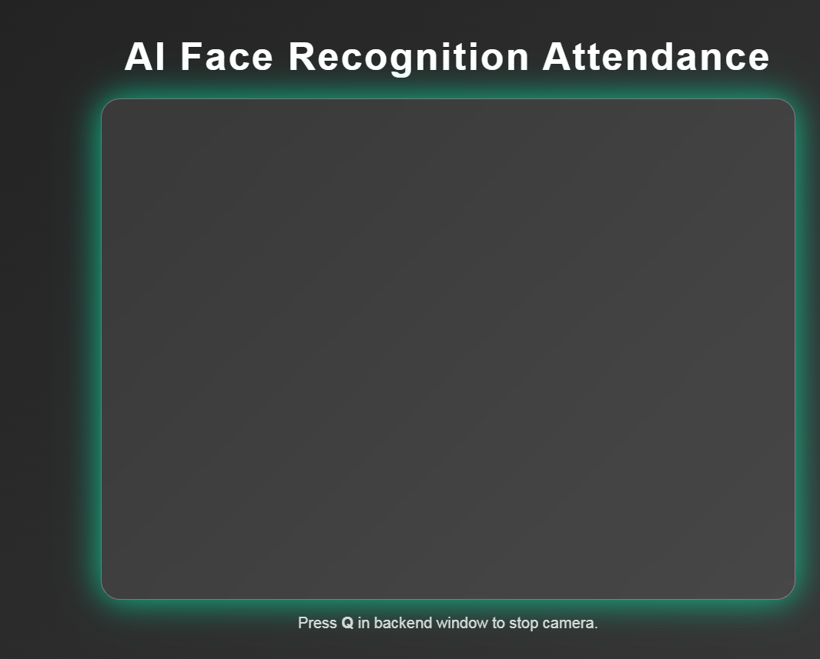
Figure 4.1: Camera Feed
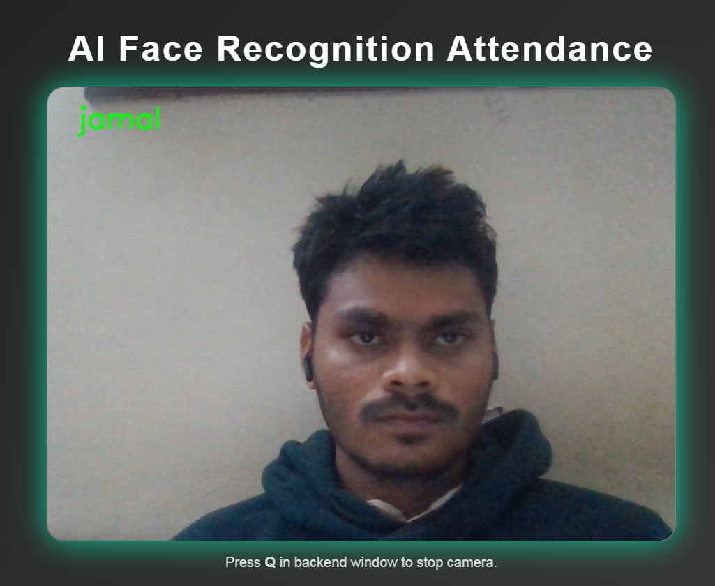
Figure 4.2: Person detected

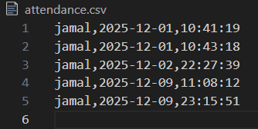
Figure 4.3: Attendance Marked File
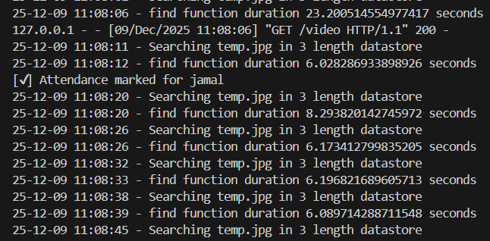
Figure 4.4: Model processing

CHAPTER 5
CONCLUSION & FUTURE SCOPE
5.1 Conclusion
The project successfully demonstrates the implementation of a fully automated attendance management system using advanced face recognition technology. By combining Flask, OpenCV, and DeepFace, the system eliminates the need for manual or physical attendance marking methods such as signatures, RFID cards, or fingerprint scanners. This greatly improves the overall accuracy of attendance data, as the system identifies individuals based on unique facial features that are difficult to duplicate or manipulate.
Another significant benefit is the improvement in hygiene. Traditional biometric devices require physical contact, which can spread germs or infections, especially in high-traffic environments like schools, offices, and workplaces. In contrast, this face recognition system is entirely contactless, enhancing safety and reducing health risks.
The automation offered by this system also increases operational efficiency. The process of capturing, detecting, and recognizing faces happens in real time, saving valuable time for teachers, administrators, or organization managers. Attendance is marked instantly without human intervention, reducing workload and eliminating human errors.
Overall, the project proves to be practical, reliable, and highly suitable for use in academic institutions, corporate organizations, training centers, and facilities where accurate and efficient attendance tracking is required. By leveraging modern artificial intelligence techniques, the system provides a scalable and future-oriented solution that aligns with the technological demands of today's digital world.
5.2 Future Scope
Although the system performs efficiently in its current form, it offers several opportunities for enhancement and future development. One potential improvement is the addition of interactive dashboards that visualize attendance data using charts, graphs, and statistical insights. This would help administrators easily monitor trends, analyze attendance patterns, and generate reports.
Another enhancement involves integrating the system with cloud-based databases such as Firebase, MongoDB Atlas, or MySQL Cloud. This would allow attendance records to be stored securely online, enabling remote access, multi-location support, and improved data management.
A user registration module can also be implemented, allowing new faces to be added to the dataset directly through the web interface rather than manually inserting images into folders. This would improve usability and streamline the onboarding process.
To improve security, spoof detection techniques—such as liveness detection, blink detection, or anti-photo/video spoofing algorithms—can be incorporated. These features would prevent individuals from using photos, videos, or digital screens to fake attendance.
Additionally, deploying the system on cloud servers would allow multiple users to access it from different devices without needing local installations. Cloud deployment makes the system more scalable and accessible for large organisations.
Finally, support for multiple cameras can enhance the system's usability in larger environments. Each camera can track different entrances or classrooms, all connected to the same centralised attendance database.

REFERENCES
- O. M. Parkhi, A. Vedaldi, and A. Zisserman, “Deep face recognition.” in BMVC, 2015.
- I. Masi, Y. Wu, T. Hassner, and P. Natarajan, “Deep face recognition: A survey,” in SIBGRAPI, 2018.
- G. Guo and N. Zhang, “A survey on deep learning based face recognition,” CVIU, 2019.
- K. Zhang, Z. Zhang, Z. Li, and Y. Qiao, “Joint face detection and alignment using multitask cascaded convolutional networks,” SPL, 2016.
- J. Deng, J. Guo, E. Ververas, I. Kotsia, and S. Zafeiriou, “Retinaface: Single-shot multi-level face localisation in the wild,” in CVPR, 2020.
- Q. Cao, L. Shen, W. Xie, O. M. Parkhi, and A. Zisserman, “Vggface2: A dataset for recognising faces across pose and age,” in FG, 2018.
- I. Masi, A. T. Tran, T. Hassner, J. T. Leksut, and G. Medioni, “Do we really need to collect millions of faces for effective face recognition?” in ECCV, 2016.
- I. Masi, A. T. Tran, T. Hassner, G. Sahin, and G. Medioni, “Face-specific data augmentation for unconstrained face recognition,” IJCV, 2019.
- Accuracy on LFW benchmark: The 2014 paper reported ~ 97.35% ±0.25% accuracy on the Labeled Faces in the Wild (LFW) dataset — comparable to human performance (~97.53%). Wikipedia+1
- Open-source Python library: The widely used “DeepFace” library on GitHub (by “serengil”) wraps not only the original DeepFace model but also many other face recognition models (VGG-Face, FaceNet, ArcFace, OpenFace, DeepID, Dlib, etc.), and exposes simple APIs for verification, recognition, and facial attribute analysis (age, gender, emotion, race). GitHub+1
- DeepFace usage & pipeline: The DeepFace library abstracts the typical pipeline — detect → align → normalize → represent → verify/recognize — so users don't need to implement low-level steps manually. GitHub+1

