L-3FAs: A Lightweight Three-Dimensional Face Authentication System Using Knowledge Distillation and Geometric Pruning

ABSTRACT
Three-dimensional (3D) face authentication verifies identity from facial geometry rather than appearance. It is therefore unaffected by illumination in the way 2D images are, and far harder to deceive with photographs or screens. Its deep point-cloud networks, however, are too large for the low-cost devices that would benefit most. This thesis designs and evaluates L-3FAs, a Light 3D Face Authentication System, that compresses a large 3D face model through knowledge distillation and geometric pruning.
A clean, labelled dataset of 4,200 facial point clouds was generated entirely from the Basel Face Model 2017. It covers 140 synthetic identities, including deliberate look-alikes, with varied expressions and poses, and 40 identities are held out for verification. A KPConv teacher (956,128 parameters, 2,048 points per face) was distilled into a PointNet++ student (116,736 parameters, 1,024 points). Distillation was adaptive: it was weighted by the teacher's confidence and transferred both predictions and embeddings. The student was then pruned by Filter Pruning via Geometric Median (FPGM), with BatchNorm recalibration and distillation-based recovery.
On identities never seen in training, the distilled student matched the teacher's equal error rate (0.0062) and halved the error of the same network trained without a teacher (0.0150). Pruning reduced the student to 47,744 parameters (0.18 MB, 20 times smaller than the teacher), but returned its error to the non-distilled level (0.0145). Latency changed little, because point sampling dominates inference time. The results, from one seed on synthetic data, show that a 3D face authenticator's ability can be transferred to a model small enough for constrained hardware. Validation on real scans, devices and presentation attacks remains future work.
Keywords: 3D face authentication, point clouds, knowledge distillation, network pruning, FPGM, KPConv, PointNet++, Basel Face Model

CHAPTER 1 - INTRODUCTION

1.1 Background
Face authentication has become one of the most widely used forms of biometric verification. It unlocks smartphones, admits employees to buildings, records attendance and approves payments. Its appeal is convenience: unlike a password, a face cannot be forgotten, and unlike a fingerprint reader, a camera needs no physical contact. Most deployed systems, however, still work from two-dimensional (2D) colour images. Their performance depends on how the face looks under the prevailing conditions rather than on the shape of the face itself.
This dependence creates two well-known weaknesses. The first is illumination. Poor, uneven or changing light alters the pixel values of a face image, and the accuracy of 2D systems degrades accordingly. The second is presentation attacks (spoofing). A printed photograph, a video replayed on a screen or a realistic mask held in front of the camera can be accepted as the genuine user, which defeats the security purpose of the system.
Three-dimensional (3D) face authentication addresses both weaknesses at their source. Depth sensors, such as the structured-light and time-of-flight cameras now built into many smartphones, measure the geometry of the face as a set of 3D points (a point cloud). Geometry does not depend on illumination in the way appearance does. A flat photograph or screen also has none of the depth relief of a real face, so 3D methods are considerably harder to deceive with 2D media. They are not immune: realistic 3D masks remain a threat.

1.2 Problem Context
The strength of 3D face authentication comes at a computational price. Point clouds are irregular, unordered sets of thousands of points, and the deep networks that learn identity from them are large and expensive. Kernel Point Convolution (KPConv), one of the most accurate point-cloud architectures for faces (You and Zhao, 2025), uses hundreds of thousands to millions of parameters. It performs neighbour searches and convolutions over every point.
Many of the devices that would benefit most from 3D authentication have little capacity for such models. Office attendance terminals, door controllers, low-cost smartphones and embedded boards have limited memory, little or no GPU and strict energy budgets. In practice, such devices often fall back to 2D recognition because it is cheaper to run. They accept its weaknesses in illumination and spoofing in exchange for feasibility. This research is motivated by that gap: the security benefits of 3D geometry are available in principle but out of reach on the hardware where they are needed.

1.3 Motivation: Compressing What A Large Model Knows
Model compression offers a way to close this gap. Two techniques are central to this thesis:
- Knowledge distillation (Hinton, Vinyals and Dean, 2015) trains a small student network to imitate a large teacher. The student learns not only from the correct labels but also from the teacher's richer outputs, which encode how the teacher relates one identity to another.
- Pruning removes parts of a trained network that contribute little. Geometric pruning in the sense of FPGM (He et al., 2019) removes filters that are redundant because they lie close to the geometric median of their layer.
Both techniques are well established for 2D images. Their combination for 3D facial point clouds, where teacher and student may use entirely different mechanisms to aggregate local geometry, has received far less attention (Chapter 2).
A second obstacle is data. Real 3D face scans are scarce, and facial geometry used for identification is biometric personal data, which is tightly protected under data-protection law. Training and comparing several deep networks on real scans would therefore require large, consented datasets that are difficult to obtain. Statistical face models such as the Basel Face Model 2017 (Gerig et al., 2018) offer an alternative. They can generate unlimited synthetic identities with exact labels and no personal data, an approach shown to transfer to real benchmarks by Zhang et al. (2022).

1.4 The Proposed System: L-3fas
This thesis designs and evaluates L-3FAs, a Light Three-Dimensional Face Authentication System. L-3FAs verifies identity from facial point clouds and is trained entirely on synthetic faces generated from the Basel Face Model 2017. It combines three ideas:
- A KPConv teacher that learns a strong identity representation from dense (2,048-point) facial point clouds.
- A PointNet++ student with about one-eighth of the teacher's parameters. It reads half as many points and is trained by adaptive knowledge distillation: it follows the teacher most closely where the teacher is confident and correct, and learns the teacher's embedding space as well as its predictions.
- Geometric pruning (FPGM) of the distilled student, which removes about 59% of its remaining parameters, followed by distillation-based recovery.
The resulting models are compared on the measures that matter for authentication: their error rates when verifying people never seen during training, their robustness to look-alike impostors, and their size and speed.
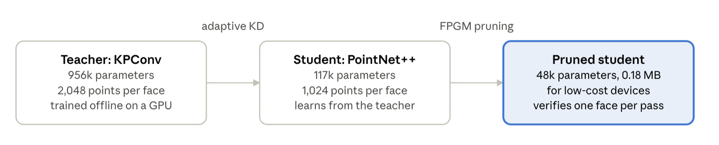
Figure 1.1 · The L-3FAs concept
Figure 1.1. The L-3FAs concept. Knowledge moves from a large KPConv teacher into a PointNet++ student through adaptive distillation. Geometric pruning then shrinks the student to a size suited to constrained devices.

1.5 Research Aim
The aim of this research is to design and develop a lightweight three-dimensional face authentication model by applying geometric pruning and knowledge distillation to a larger 3D face authentication model, and to evaluate its accuracy and efficiency on synthetically generated facial data.

1.6 Research Objectives
- To understand current trends in 3D facial recognition research, including point-cloud representations, point-cloud deep learning, data pre-processing and model compression.
- To study and evaluate deep-learning architectures and knowledge distillation for point clouds, particularly point-based models such as KPConv and PointNet++, as means of transferring knowledge without noticeable performance degradation.
- To examine the current state of research in facial recognition and model compression, in order to identify its strengths and weaknesses and apply them to improve the proposed model.
- To design and develop a resource-efficient 3D face authentication model: a PointNet++ student that applies geometric pruning and knowledge distillation from a KPConv teacher, and to measure its performance and efficiency.
- To produce comprehensive documentation of the methodology, limitations and key findings, and a data-generation pipeline structured for reproducibility in future work.

1.7 Research Questions
RQ1. What changes in performance measures, such as accuracy, robustness to varied lighting and resistance to spoof attacks, can be achieved with a lightweight student model trained with the help of a teacher model?
RQ2. Can a lightweight model trained with a teacher model be used on computing devices with limited resources, such as mobile devices and office attendance systems, to run authentication with acceptable performance?

1.8 Hypotheses
H1. A lightweight student model trained via knowledge distillation from a teacher model achieves accuracy comparable to the larger teacher model, while outperforming a standalone student model trained without a teacher.
H2. A lightweight student model trained with a teacher model maintains acceptable authentication performance while substantially reducing model size, making it suitable for deployment on low-resource computing devices.

1.9 Scope And Delimitations
The study is experimental and computational. All data is synthetic, generated from the Basel Face Model 2017, and no human participants are involved. Within RQ1, accuracy is measured directly, through closed-set identification and open-set verification on unseen identities. Robustness to lighting and resistance to spoofing are addressed through the properties of the geometric representation and the literature, not through dedicated experiments. The dataset contains no illumination variation (point clouds carry none) and no presentation attacks. Within RQ2, suitability for low-resource devices is assessed through model size, parameter count and inference latency measured on a GPU, not by deployment on a physical device. Chapter 3 maps each question to its evidence in detail.

1.10 Contribution And Significance
The study makes four contributions:
- A reproducible synthetic 3D face dataset pipeline. It generates clean, labelled point clouds from the Basel Face Model 2017, with controlled look-alike identities as hard negatives and a strict separation of unseen identities for verification.
- A KPConv-to-PointNet++ distillation design for 3D faces. It combines confidence-weighted logit distillation, embedding distillation through a learned projection, and resolution distillation: a dense-input teacher guides a sparse-input student.
- An evaluation of geometric (FPGM) pruning on a distilled point-cloud student. It includes the finding that BatchNorm recalibration and a sufficient recovery budget decide whether pruning succeeds, more than the choice of which filters to remove.
- A documented record of design iterations, including negative results, which allows other researchers to avoid the same dead ends.
Practically, the work indicates how much of a large 3D model's authentication ability can be preserved in a model small enough for constrained devices. Academically, it connects three literatures that have developed largely separately: 3D face recognition, point-cloud knowledge distillation and network pruning.

1.11 Structure of The Thesis
- Chapter 2 reviews the literature on 3D face authentication, point-cloud learning, knowledge distillation and pruning, through five case studies, and identifies the research gap.
- Chapter 3 presents the research methodology: the data, the three model stages, training, evaluation and the iterative development record.
- Chapter 4 reports the results.
- Chapter 5 discusses them in relation to the research questions, hypotheses and literature.
- Chapter 6 concludes and sets out future work.

CHAPTER 2 - LITERATURE REVIEW

2.1 Overview
This chapter reviews four bodies of work that L-3FAs brings together:
- 3D face authentication;
- Deep learning on point clouds;
- Knowledge Distillation;
- Geometric Pruning.
It then examines five case studies in depth (Sections 2.7–2.11) and closes by identifying the research gap this thesis addresses (Section 2.12). The review is organised around one question: what is known about building an accurate 3D face authenticator that is small enough for constrained hardware, and what is not?

2.2 3D Face Authentication and Presentation Attacks
Research on 3D face recognition predates deep learning by more than a decade. Early surveys already identified its two main advantages over 2D images: insensitivity to illumination and to pose-induced appearance changes, because geometry rather than pixel intensity is measured (Bowyer, Chang and Flynn, 2006). The same property underpins resistance to presentation attacks. A printed photograph or a replayed video is flat, so a system that verifies 3D shape rejects it by construction. A comprehensive review of presentation attack detection shows that 2D systems instead need dedicated, often fragile, anti-spoofing modules (Ramachandra and Busch, 2017). 3D sensing does not end the arms race: rigid or silicone 3D masks reproduce facial relief and remain an open problem. It does, however, raise the cost of a successful attack substantially.
Early 3D methods converted scans into depth images or meshes and applied hand-crafted descriptors. Modern approaches learn directly from point clouds, the native output of depth sensors. This removes conversion steps and preserves geometric detail, but requires networks that can handle irregular, unordered data.

2.3 Deep Learning on Point Clouds
A point cloud is a set: reordering its points does not change the object, and its points do not lie on a grid. Standard convolutional networks assume both order and a grid, so dedicated architectures were developed.
- PointNet (Qi et al., 2017a) applies the same multilayer perceptron to every point and aggregates them with a symmetric max-pooling function. This makes the output independent of point order, but captures no local structure.
- PointNet++ (Qi et al., 2017b) adds local structure through hierarchical set abstraction. It samples centroids, groups their neighbours and applies a small PointNet to each group, repeating at growing scales.
- DGCNN (Wang et al., 2019) builds dynamic neighbourhood graphs in feature space and learns edge features.
- KPConv (Thomas et al., 2019) defines a true convolution on points, placing learnable weights at kernel points in 3D space (Case Study 1).
These architectures differ sharply in cost. PointNet++ consists mainly of shared perceptrons, which map onto efficient dense operations. KPConv's convolution is more expressive but must compute, for every neighbour of every point, its influence on every kernel point. For 3D faces specifically, You and Zhao (2025) found KPConv more accurate than PointNet++ on the Bosphorus database. This pairing of a stronger, costlier architecture with a lighter one is the natural setting for knowledge distillation.
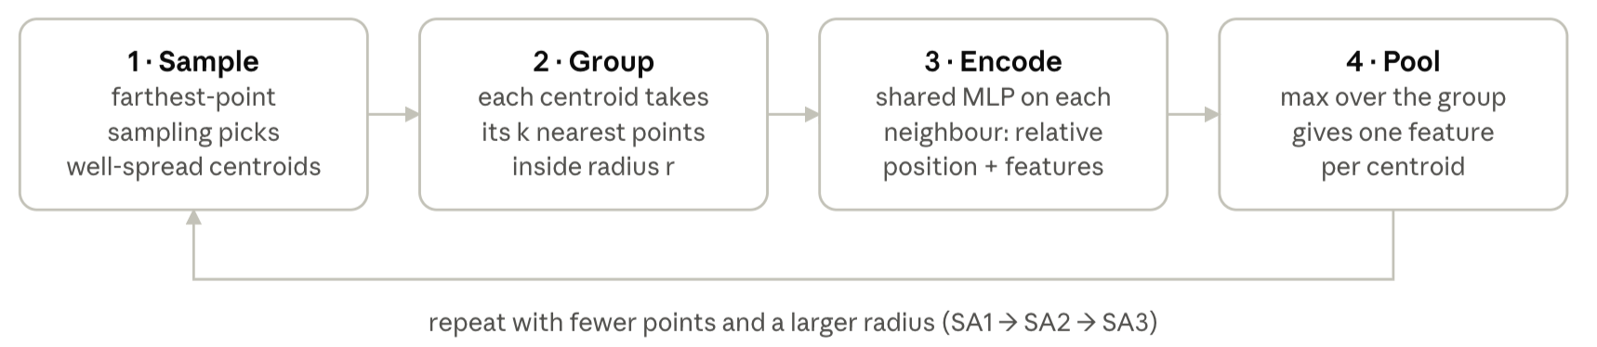
Figure 2.1. One set-abstraction level of PointNet++ (after Qi et al., 2017b). Max-pooling makes the result independent of point order, and stacking levels builds features at growing scales.
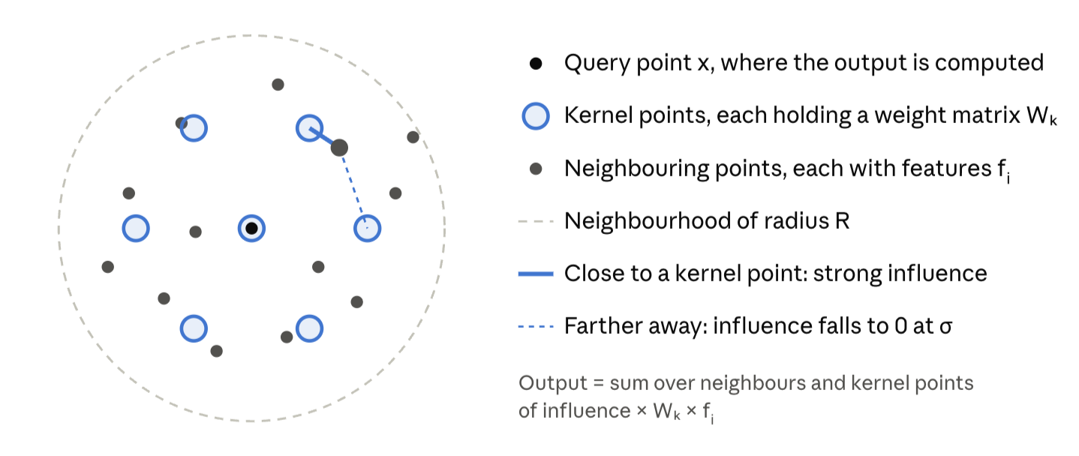
Figure 2.2. The KPConv operation in two dimensions (after Thomas et al., 2019). Weights are attached to kernel points arranged around the query point. Each neighbouring point contributes to every kernel point in proportion to how close it lies to it.

2.4 Knowledge distillation
Knowledge distillation (Hinton, Vinyals and Dean, 2015) trains a compact student to match the softened output distribution of a larger teacher. The teacher's probabilities over wrong classes carry information, sometimes called "dark knowledge", about which classes resemble each other. A student trained on these soft targets often generalises better than one trained on hard labels alone. Feature-based distillation extends the idea by asking the student to match the teacher's intermediate representations (Romero et al., 2015).
In face recognition, distillation must preserve the embedding space rather than only the classifier, because verification compares embeddings of identities the classifier never saw. Two difficulties recur in that literature, both examined in Case Study 5:
- The capacity gap. A much larger teacher's representation may be too complex for a small student to reproduce (Li et al., 2023).
- Selective transfer. Not all teacher knowledge is equally useful, so it should be transferred selectively (Zhao et al., 2023).
For point clouds, distillation has been studied mainly for object detection (Case Study 3), where respecting local geometric structure proved important (Zhang et al., 2023).
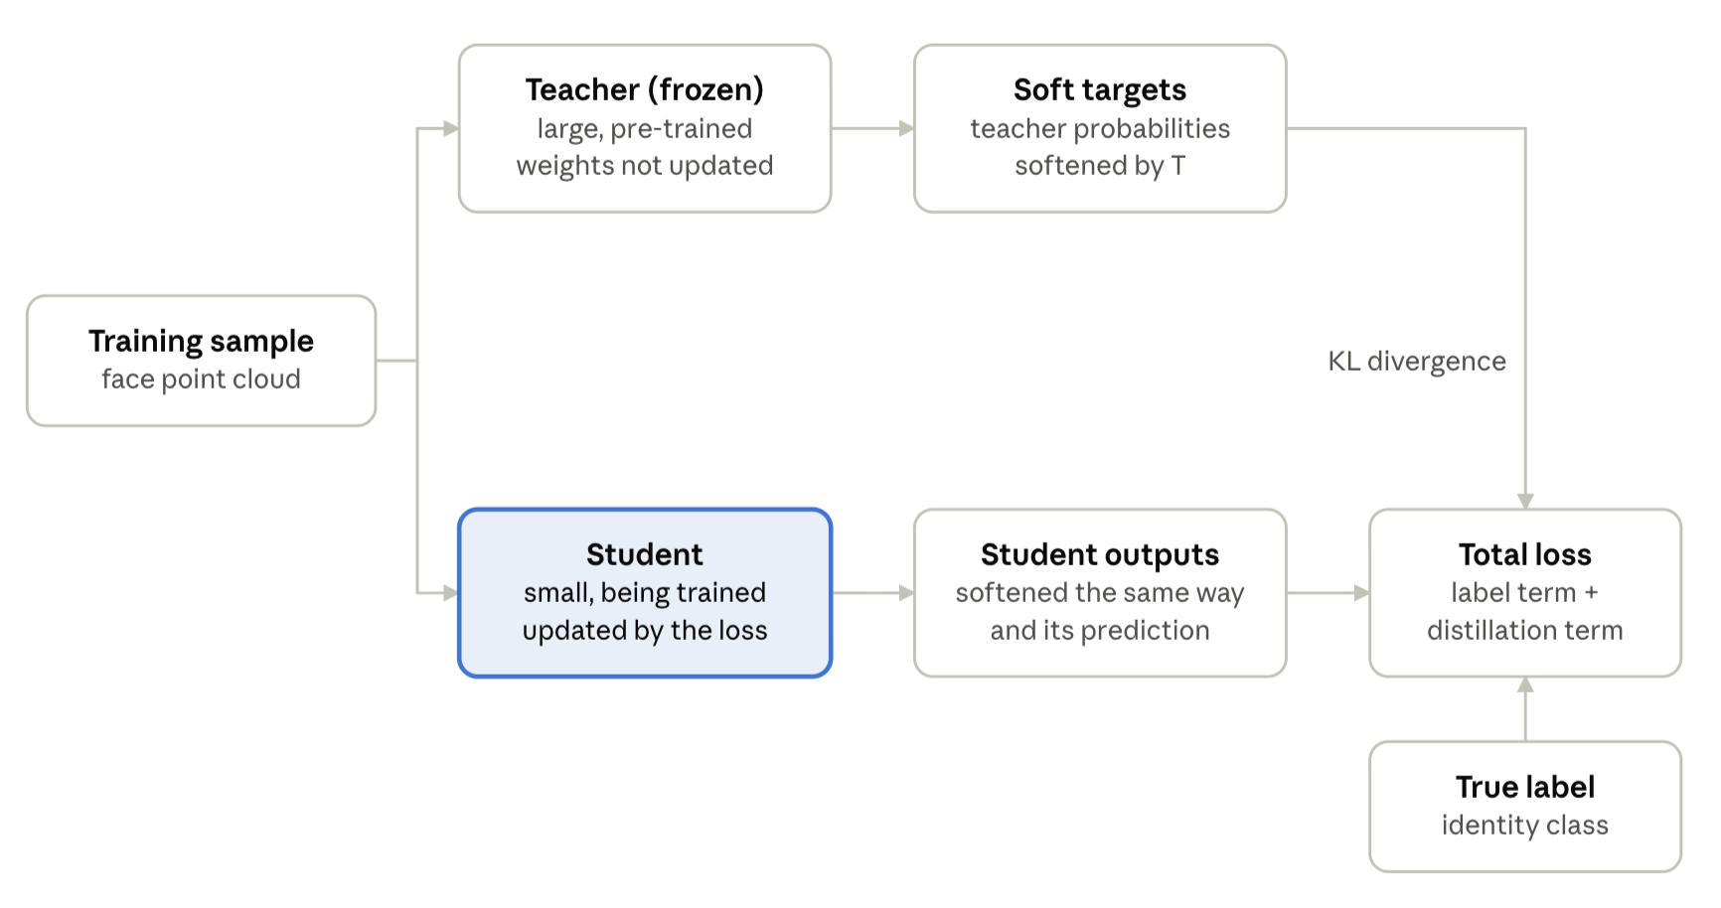
Figure 2.3. Classic knowledge distillation (Hinton, Vinyals and Dean, 2015). The frozen teacher's softened probabilities act as an extra training signal for the student, alongside the true labels; only the student's weights are updated.

2.5 Network pruning
Pruning removes parameters that contribute little to a trained network. Unstructured pruning zeroes individual weights, typically those of smallest magnitude (Han et al., 2015). It achieves high sparsity but needs specialised sparse kernels to realise any speed-up. Structured pruning removes entire filters or channels, producing a smaller dense network that runs faster on ordinary hardware. Li et al. (2017) pruned the filters with the smallest L1-norm, assuming that small filters matter least.
FPGM (He et al., 2019) challenged this "smaller-norm-less-important" assumption. It observed that a filter can have a large norm yet be redundant, if other filters in its layer already compute something similar. FPGM therefore removes filters that lie closest to the layer's geometric median in weight space, the filters whose function is best represented by the rest. It reported better accuracy than norm-based criteria at comparable compression on image classification. FPGM is the "geometric pruning" used in this thesis.
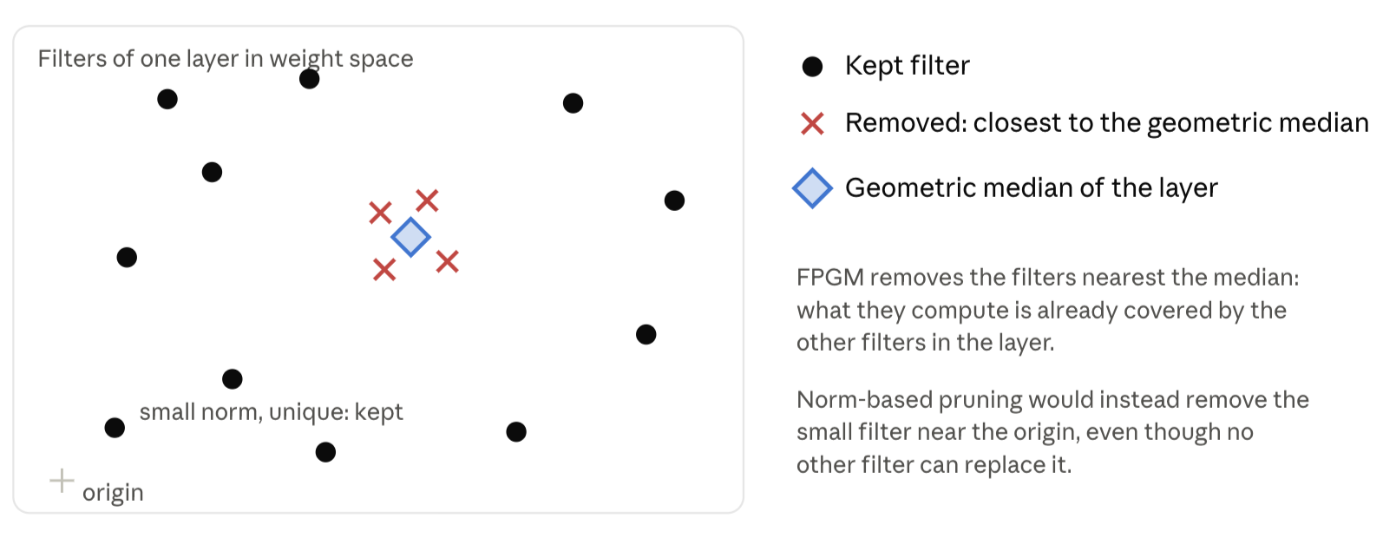
Figure 2.4. The FPGM criterion, sketched in two dimensions (after He et al., 2019). Filters closest to the layer's geometric median are removed because the remaining filters already represent them, whereas norm-based pruning targets the smallest filters.
Two gaps are relevant here. First, FPGM was developed and evaluated on 2D convolutional networks; its behaviour on point-cloud networks, whose layers are shared perceptrons applied to point neighbourhoods, is less studied. Second, pruning is usually followed by fine-tuning on labels alone. Combining it with distillation from a teacher, so that the pruned network recovers towards the teacher rather than only towards the labels, is a natural but less explored option for biometric models.

2.6 Synthetic training data and morphable face models
Large 3D face datasets are scarce and, because they contain biometric data, difficult to share. 3D morphable models, introduced by Blanz and Vetter (1999), represent faces as a mean shape plus a linear combination of principal components learned from registered scans. Sampling the components generates new, realistic faces.
The Basel Face Model (Paysan et al., 2009) made such a model publicly available for research. Its 2017 version, built on the Gaussian Process Morphable Model framework (Lüthi et al., 2018; Gerig et al., 2018), adds an expression model. Synthetic faces from such models provide unlimited identities with exact labels. Zhang et al. (2022) showed that a network trained on them can transfer to real benchmarks (Case Study 2). This makes morphable models a practical and privacy-preserving foundation for controlled experiments, at the cost of a domain gap to real sensor data.

2.7 Case Study 1: Kernel Point Convolution for Geometric Representation of Point Clouds
Thomas et al. (2019) introduced Kernel Point Convolution (KPConv) as a point-cloud convolution operation designed to process irregular 3D data directly, without converting point clouds into intermediate voxel or grid representations. The central motivation of KPConv is that conventional convolutional operations are naturally defined on regular Euclidean grids, whereas point clouds consist of unordered and irregularly distributed points. KPConv addresses this problem by positioning convolutional weights as kernel points in Euclidean space and aggregating information from input points located around those kernel points. Furthermore, the kernel-point locations can be learned, allowing the deformable version of KPConv to adapt its receptive field to local geometric structures (Thomas et al., 2019).
The distinction between rigid and deformable KPConv is particularly important for a 3D facial application. Rigid KPConv maintains fixed relative kernel-point positions, whereas deformable KPConv learns offsets that allow the kernel configuration to adapt to the underlying geometry. This is valuable for facial point clouds because facial surfaces are non-planar and contain local structures such as the nose, eye sockets, cheek contours and mouth regions. A convolution that can adapt its spatial support can therefore capture geometric relationships that may be difficult to represent using a fixed regular grid. Thomas et al. (2019) also incorporated a regular subsampling strategy to improve efficiency and robustness under varying point densities. Their experiments demonstrated strong performance for point-cloud classification and segmentation and included ablation studies examining the descriptive properties of deformable KPConv.
The primary strength of KPConv for this research is therefore its explicit geometric formulation. Rather than treating a point cloud as a simple collection of independent coordinates, KPConv establishes local relationships in Euclidean space and learns convolutional responses according to those spatial relationships. This makes it a logical candidate for a high-capacity teacher model whose learned representations contain detailed local geometric information. The teacher can potentially encode information about facial surface shape and spatial relationships that a smaller student model may otherwise fail to learn from limited training data.
However, the original KPConv study was not designed for 3D face authentication or model compression. Its experiments focused on general point-cloud classification and semantic segmentation rather than identity verification. In addition, the subsampling strategy used by KPConv should not be confused with pruning. Regular subsampling addresses computational and density considerations within one network, whereas pruning, as studied in this thesis, removes redundant capacity from a trained network so that a smaller model can be deployed.
Evidence from subsequent 3D face research provides additional justification for investigating KPConv as a teacher. You and Zhao (2025) directly compared PointNet, PointNet++, KPConv and a dual-branch KPConv architecture for 3D face recognition. On the Bosphorus dataset, their KPConv model achieved a 95.47% Rank-1 identification rate using point coordinates, compared with 92.03% for PointNet++. When XYZ coordinates and normals were used, KPConv achieved 96.75% compared with 94.10% for PointNet++. Their results therefore provide direct evidence that KPConv can learn highly discriminative facial point-cloud representations, and that geometric information such as normals can further improve recognition.
For this study, this establishes KPConv as a technically motivated teacher rather than an arbitrary architectural choice. Its ability to model local geometric relationships provides the high-capacity representation from which a lighter student can potentially learn. The unresolved issue is whether this geometric knowledge can be transferred efficiently to PointNet++, and whether the resulting student can then be compressed further without losing identity-discriminative information. Consequently, KPConv establishes the first component of the research gap: a strong geometric teacher exists, but its knowledge must be transferred to a computationally smaller authentication model.

2.8 Case Study 2: PointNet++ and synthetic point clouds for 3D face recognition
Zhang et al. (2022) investigated the use of point-cloud deep learning for 3D face recognition through a PointNet++-based architecture. Their research addresses two important problems in 3D facial recognition: the limited availability of large-scale 3D facial training data, and the difficulty of directly extracting discriminative facial representations from irregular point clouds. Instead of converting the facial scans into conventional range images or volumetric representations, the authors proposed learning directly from facial point clouds using a modified PointNet++ architecture.
A particularly important contribution of the study is its synthetic data generation strategy. The authors use a Gaussian Process Morphable Model (GPMM) to generate large-scale synthetic 3D facial scans. This approach allows the training set to contain substantial variation in facial identity and expression without requiring a correspondingly large collection of real 3D scans. The authors subsequently employ transfer learning to reduce the domain discrepancy between the synthetic training data and real-world test data. Their experiments on FRGCv2 and Bosphorus demonstrate that a model trained using synthetic facial point clouds can generalise to real 3D face-recognition benchmarks. The reported Rank-1 identification rates were 99.46% on FRGCv2 and 99.65% on Bosphorus.
Another contribution directly relevant to this research is the curvature-aware sampling (CPS) strategy. Conventional PointNet++ uses farthest-point sampling to select representative points, but the authors argue that geometrically important facial regions should receive greater consideration. Their curvature-aware strategy hierarchically downsamples feature-sensitive points that are important for transferring and aggregating discriminative facial information through the network. This is significant because it demonstrates that reducing the number of points does not necessarily have to mean selecting points randomly or uniformly. Instead, geometric characteristics can be used to guide which points are retained.
The paper therefore provides two important foundations for this research. First, PointNet++ is already demonstrated to be capable of learning useful identity representations directly from 3D facial point clouds. Second, the paper's use of a GPMM shows that synthetic faces from a morphable model are a credible training source, which directly motivates the use of the Basel Face Model 2017 in this thesis. These findings make PointNet++ a reasonable candidate for the lightweight student model.
Nevertheless, the method does not investigate knowledge transfer from a higher-capacity geometric network such as KPConv, nor compression of the trained network. Its curvature-aware sampling reduces the points processed according to a predefined geometric measure, rather than according to knowledge learned by a teacher. This distinction becomes important when considering the direct comparison by You and Zhao (2025), which found stronger Rank-1 recognition for KPConv than PointNet++ under comparable conditions, suggesting a capacity gap between the two architectures. Rather than treating this gap as a reason to discard PointNet++, this research asks whether the stronger KPConv representation can be transferred to PointNet++ through knowledge distillation, so that the lighter architecture closes the gap.

2.9 Case Study 3: PointDistiller and geometry-aware knowledge distillation for point clouds
Zhang et al. (2023) proposed PointDistiller to address the challenge of applying knowledge distillation to 3D point-cloud detection. Knowledge distillation generally transfers information from a high-capacity teacher network to a smaller student network, allowing the student to achieve competitive performance with lower computational cost. However, the authors identify an important difference between image data and point clouds: point clouds are sparse, irregular and geometrically structured. Consequently, conventional image-based distillation techniques may not adequately capture the spatial relationships that are important for point-cloud understanding.
PointDistiller addresses this problem through structured knowledge distillation. One of its central components is local distillation, which transfers local geometric structures using dynamic graph convolution and a reweighted learning strategy. The reweighting mechanism places greater emphasis on critical points or voxels, allowing the student to focus its learning capacity on information considered important for the task. This is particularly relevant to this research because it demonstrates that point-cloud knowledge distillation can benefit from weighting what is transferred, rather than simply forcing the student to reproduce the teacher's final predictions uniformly.
The experimental results demonstrate the potential of this approach for model compression. The authors report that a four-times-compressed PointPillars student trained using PointDistiller achieved improvements of 2.8 mAP for bird's-eye-view detection and 3.4 mAP for 3D detection relative to the corresponding student baseline. The compressed student also exceeded its teacher by 0.9 and 1.8 mAP in the reported settings. Experiments across voxel-based and raw-point-based detectors further demonstrate that structured knowledge transfer can improve compact point-cloud models.
The strength of PointDistiller for this research is therefore conceptual rather than directly application-specific. It demonstrates that a point-cloud student should not necessarily learn only from the final output of a teacher; richer representations and important structures can also be transferred, and a student can even surpass its teacher. There are, however, important limitations when transferring its conclusions. PointDistiller was developed for 3D object detection rather than biometric verification, and its target objects, representations and evaluation criteria differ substantially from those of a 3D facial authentication system.
This case study therefore establishes an important methodological principle: knowledge distillation for point clouds should go beyond output-level imitation. For the KPConv-to-PointNet++ framework, where teacher and student operate on irregular 3D point sets, this supports distilling the teacher's embedding representation alongside its predictions, and weighting the transfer rather than applying it uniformly.

2.10 Case Study 4: PointSurFace and the importance of fine-grained facial geometry
Yang et al. (2024) proposed PointSurFace, a 3D face-recognition architecture designed to exploit explicit local geometric information from facial point clouds. The authors argue that the geometric information contained in 3D facial data provides an important basis for robust recognition, and that existing point-cloud approaches do not fully exploit fine-grained facial surface information. Their SurF module explicitly extracts local surface features using information including centroid positions, normal vectors, spherical coordinates and surface-position relationships.
The architecture combines the surface feature extraction module with set-abstraction operations and InvResMLP modules. During training, the model uses both feature-similarity and classification losses to learn discriminative facial representations. This design is significant because it treats the facial point cloud not merely as a collection of XYZ coordinates, but as a geometric surface containing local relationships that may be informative for identity. On Lock3DFace, PointSurFace achieved 90.03% recognition accuracy and 80.01% verification accuracy, with the authors reporting improvements over previous methods.
For this research, the most important contribution of PointSurFace is its treatment of facial geometry, including surface normals, as discriminative information. This directly supports the decision to feed normals, not only coordinates, into both the teacher and the student. It also carries a caution for compression. If different regions of the face carry different amounts of identity information, then reducing the number of points indiscriminately could remove information required for reliable authentication. A student that reads fewer points than its teacher, as in this thesis, therefore needs a mechanism that compensates for the lost detail. Knowledge distillation from a teacher that saw the dense cloud is one such mechanism.
PointSurFace does not, however, investigate knowledge distillation from a stronger teacher into a lightweight student. Its objective is to design a stronger facial representation rather than to compress an existing model for constrained deployment. It therefore provides evidence for the geometric component of the proposed framework, but does not solve the compression problem. It also suggests a direction this thesis leaves open: using learned, identity-aware importance to decide which points a lightweight model should keep.

2.11 Case Study 5: knowledge distillation for face recognition and the teacher–student capacity gap
Li et al. (2023) investigated knowledge distillation specifically in the context of face recognition. They examined an important problem that arises when transferring information from a powerful teacher to a lightweight student: the capacity gap. The authors note that feature-based knowledge distillation is widely used in face recognition, but that simply removing identity supervision from student training can substantially reduce performance. They analyse this degradation through the concept of an intrinsic-dimensional gap between teacher and student representations.
The study proposes reverse distillation (ReFO) to constrain the teacher's representation space and make the teacher more compatible with the student. The authors argue that an extremely powerful teacher is not necessarily an ideal teacher if its learned representation is substantially more complex than the student can reproduce. They additionally introduce a student proxy intended to improve compatibility between teacher and student, and report consistent improvements across different teacher–student pairs and face-recognition benchmarks.
This case study is particularly relevant to the KPConv-to-PointNet++ architecture because it challenges a simplistic assumption: that the strongest possible teacher is automatically optimal. KPConv uses kernel points positioned in Euclidean space, whereas PointNet++ uses hierarchical set abstraction and local PointNet operations. Direct feature matching between corresponding layers may therefore be inappropriate unless a suitable projection or alignment mechanism is introduced. It also matters that Li et al. found removing identity supervision harmful. This supports keeping the ground-truth loss in the student's objective alongside the distillation terms.
A related face-recognition study by Zhao et al. (2023) further demonstrates that not all teacher knowledge is equally useful for a lightweight student. Their Grouped Knowledge Distillation separates teacher logits into primary and secondary groups. It reports that primary and binary knowledge are essential, whereas secondary knowledge can restrict the student at the distillation bottleneck. This provides additional evidence that effective face-recognition distillation requires selective transfer rather than indiscriminate reproduction of all teacher information.
These findings directly motivate the adaptive distillation used in this thesis. Rather than assuming that every teacher output deserves the same weight, distillation strength can depend on how reliable the teacher's guidance is. This thesis adopts the teacher's confidence in the correct identity as that signal (Section 3.8): the student imitates the teacher where the teacher is confident and correct, and relies on the labels where it is not. It also uses a learned projection between the two embedding spaces, rather than direct feature matching. The main limitation of Li et al. (2023) for this study is that their experiments use conventional image-based face recognition rather than 3D point clouds. Its analysis of teacher–student compatibility is nevertheless directly applicable to the compression problem.

2.12 Synthesis and research gap
The five case studies reveal a consistent progression:
- KPConv captures detailed local geometric structure directly in Euclidean space (Thomas et al., 2019).
- PointNet++ can learn facial identity from point clouds, including synthetic ones generated by a morphable model (Zhang et al., 2022).
- Point-cloud distillation benefits from transferring more than final predictions, and from weighting what is transferred (Zhang et al., 2023).
- Fine-grained surface geometry, including normals, is discriminative for 3D faces (Yang et al., 2024).
- Face-recognition distillation must respect the capacity gap between teacher and student and transfer knowledge selectively (Li et al., 2023; Zhao et al., 2023).
You and Zhao (2025) complete the architectural argument: under the same conditions, KPConv outperforms PointNet++ on 3D faces, so KPConv is the stronger representation learner while PointNet++ remains a viable lighter architecture.
Table 2.1. What each case study contributes, and how this thesis responds.
Case study | Contribution used | Left open | Response in L-3FAs
KPConv (Thomas et al., 2019) | Strong geometric convolution on points | Not evaluated for faces or compression | KPConv teacher, adapted to see facial layout (Section 3.6)
PointNet++ on synthetic faces (Zhang et al., 2022) | Lightweight facial student; GPMM synthetic data | No teacher, no compression | PointNet++ student; BFM 2017 synthetic dataset (Sections 3.3–3.4)
PointDistiller (Zhang et al., 2023) | Weighted, beyond-logit distillation | Detection, not biometrics | Embedding distillation plus per-sample weighting (Section 3.8)
PointSurFace (Yang et al., 2024) | Normals and surface geometry are discriminative | No compression | Normals as input features for both models (Section 3.5)
Face KD capacity gap (Li et al., 2023; Zhao et al., 2023) | Selective transfer; keep identity supervision; align spaces | Image-based, not 3D | Confidence-weighted KD, retained label loss, learned projection (Section 3.8)
The reviewed studies, however, address these issues largely independently:
- The 3D face literature demonstrates strong geometric models and effective point-cloud architectures, but does not establish whether a KPConv teacher can transfer its identity knowledge to a PointNet++ student.
- Point-cloud distillation research has focused on object detection rather than biometric verification.
- Face-recognition distillation research establishes the capacity-gap problem, but on 2D images rather than irregular 3D point clouds.
- Structured pruning methods such as FPGM have been developed and evaluated almost entirely on 2D convolutional networks. Whether they remain effective on a point-cloud student that has already been distilled is not established.
The research gap can therefore be stated as follows. Although existing studies separately demonstrate the effectiveness of KPConv for geometric point-cloud learning, PointNet++ for 3D face representation, structured point-cloud knowledge distillation, teacher–student compression for face recognition and geometric-median filter pruning, there is insufficient investigation of their integration for resource-constrained 3D face authentication. In particular, it is unclear:
- whether a KPConv teacher can transfer its geometric identity representation to a PointNet++ student that reads fewer points;
- whether that student can then be compressed further by geometric pruning while maintaining authentication performance on identities never seen in training.
This thesis addresses that gap with L-3FAs (Chapter 3), and evaluates it with authentication-specific measures: equal error rate, true acceptance rate at constrained false acceptance rates, and robustness to look-alike impostors, together with model size and latency.
One direction raised by the case studies remains outside the scope of the implementation: using a teacher to decide which input points a student should keep (teacher-guided point selection). This thesis reduces the student's input by resolution, with the student reading a random half of the teacher's points, and reduces its capacity by FPGM. Learned, identity-aware point selection is identified as future work (Chapter 6).

CHAPTER 3 - RESEARCH METHODOLOGY

3.1 Introduction and research approach
This study adopts a design science research approach, delivered through iterative agile sprints, to build and evaluate L-3FAs, a Light Three-Dimensional Face Authentication System. The research produces a working artefact: a compressed point-cloud model that verifies identity from facial geometry. It then evaluates that artefact against explicit, measurable criteria. Design science is appropriate because the research question is not only descriptive (how well do existing models perform?) but constructive (can a smaller model be built that performs almost as well?) (Hevner et al., 2004; Peffers et al., 2007).
The artefact has four components, each answering one part of the research aim:
- A clean, labelled synthetic dataset of 3D facial point clouds, generated entirely from the Basel Face Model 2017 (BFM 2017).
- A high-capacity teacher: a Kernel Point Convolution (KPConv) network (Thomas et al., 2019).
- A lightweight student: a PointNet++ network (Qi et al., 2017b), trained with adaptive knowledge distillation from the teacher.
- A geometrically pruned student, compressed with Filter Pruning via Geometric Median (FPGM) (He et al., 2019) and recovered through further distillation.
The research is quantitative and experimental. Every claim about the artefact is tested against a held-out test split and, critically, against identities that the networks never saw during training. This mirrors the operating condition of a real authentication system, which must verify people who were not part of its training data.
An agile, sprint-based process was used because the artefact could not be specified fully in advance. Several design decisions described in this chapter (the teacher's input features, the pruning schedule, BatchNorm recalibration) were not planned at the outset. They emerged from failures observed in earlier sprints and were then tested and adopted. Section 3.12 records these iterations, so that the reasons behind each design choice remain traceable rather than presented as if they were obvious from the start.
The chapter proceeds from the overall research design (3.2) and data source (3.3) through dataset generation and pre-processing (3.4–3.5), the three model stages (3.6–3.9), training and evaluation (3.10–3.11), the development record (3.12), tools (3.13), ethics (3.14) and finally validity and limitations (3.15).

3.2 Research design and system architecture
L-3FAs is built as a single, reproducible pipeline that runs from one input file (bfm.h5) to four evaluated models. Figure 3.1 shows the stages. Each stage writes its outputs to disk with a fingerprint of its configuration, so later stages can be re-run without regenerating earlier ones, and any result can be traced back to the exact data and settings that produced it.
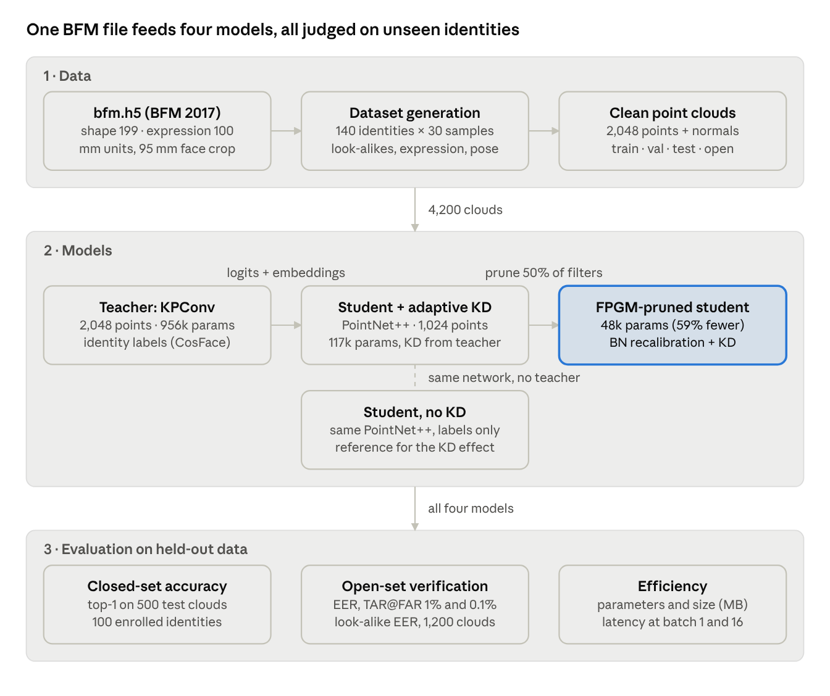
Figure 3.1 · L-3FAs pipeline: data, four models, evaluation
Figure 3.1. The L-3FAs pipeline. The teacher passes its logits and embeddings to the student during distillation. The pruned student is the final lightweight artefact. The baseline student shares its architecture but never sees the teacher.
The experimental design compares four models trained on the same data and evaluated on the same splits:
Model | Architecture | Training signal | Role in the experiment
Teacher | KPConv, 2,048 points | Identity labels (CosFace) | Upper reference: what a large model achieves
Student (no KD) | PointNet++, 1,024 points | Identity labels only | Baseline: what the small model achieves alone
Student + adaptive KD | PointNet++, 1,024 points | Labels + teacher logits + teacher embeddings | Tests whether distillation closes the gap
Student + KD + FPGM | Pruned PointNet++, 1,024 points | KD fine-tuning after pruning | Tests how much further the student can shrink
This design isolates the contribution of each technique. Comparing the baseline and the KD student isolates the effect of distillation, because the architecture and data are identical. Comparing the KD student and its pruned version isolates the cost of pruning.

Mapping research questions to evidence
The two research questions and hypotheses (Chapter 1) are answered with the measurements below. Two parts of the first research question cannot be measured with synthetic geometry alone, and the table states this explicitly rather than implying coverage.
Question | Measured by | Coverage in this study
RQ1: accuracy of a teacher-trained lightweight student | Closed-set accuracy; open-set EER, TAR@FAR = 1% and 0.1%; look-alike EER | Fully measured
RQ1: performance under varied lighting | Not measured directly | Inputs are 3D coordinates and surface normals, which carry no illumination. Robustness to lighting therefore holds for the representation by construction, but is not tested with a real sensor under changing light
RQ1: resistance to spoof attacks | Not measured | The dataset contains no presentation attacks (masks, prints, replays), so spoof resistance is argued from the literature, not tested
RQ2: suitability for low-resource devices | Parameter count, model size (MB), inference latency at batch sizes 1 and 16 | Measured as proxies on a GPU; not deployed on a mobile or embedded device
H1: the KD student approaches the teacher and beats the non-KD student | Comparison of the three unpruned models on all accuracy metrics | Fully measured
H2: acceptable performance on low-resource devices | Size and latency proxies, plus accuracy after pruning | Partially measured

3.3 Data source: the Basel Face Model 2017
All data in this study is generated from the Basel Face Model 2017, a statistical model of human face shape, expression and skin colour learned from real 3D scans (Paysan et al., 2009; Gerig et al., 2018). No images or scans of real individuals are collected, stored or processed. The decision to use a generative face model rather than a scanned dataset rests on three arguments.
Scarcity of labelled 3D faces. Public 3D face datasets such as FRGCv2 and Bosphorus contain a few hundred to a few thousand subjects. Each subject has only a handful of scans, which is too few to train and compare several deep networks under controlled conditions. A generative model can produce any number of identities, each with any number of samples.
Exact, controllable labels. Every generated face is defined by known coefficients for identity, expression and pose. Identity labels are therefore exact, and the difficulty of the task can be controlled deliberately, for example by creating look-alike identities at a chosen distance. This makes it possible to test hard negatives systematically, which scanned datasets do not allow.
Privacy by design. Facial geometry used to identify a person is biometric data, a special category of personal data under Article 9 of the UK and EU GDPR. Generating synthetic identities avoids collecting such data altogether. Zhang et al. (2022) established the precedent for this approach, training a PointNet++ face recogniser on synthetic scans from a Gaussian Process Morphable Model and transferring it successfully to real benchmarks.

The model
BFM 2017 is a Gaussian Process Morphable Model (Lüthi et al., 2018) stored in the statismo HDF5 format. Each of its three parts (shape, expression and colour) is a low-rank Gaussian model of the form:
$$x(α)=μ+U diag(σ) α$$
$$α∼N(0,I)$$
Here μ is the mean face (all vertex coordinates stacked), U holds orthonormal principal components, σ their standard deviations and α the coefficients that define one face. The shape model has 199 components, the expression model 100 and the colour model 199. A face instance is the mean shape plus an identity offset plus an expression offset, so identity and expression can be varied independently.

Loading and validation
The loader reads the shape, expression and color groups and checks that every required array exists and that the three parts share one mesh topology. It fails with an explanatory message if they do not. Three corrections are then applied automatically:
- Units are detected from the size of the mean face and converted to millimetres, so the pipeline works whether a model file is stored in millimetres, micrometres or metres.
- Triangle winding is checked, and flipped if needed, so that every surface normal points out of the face. This matters because normals are later used as input features.
- Cropping. The surface is cropped to a 95 mm sphere around the nose tip, the most frontal vertex near the symmetry plane. This removes the ears, neck and back of the head, which a frontal face sensor would not capture. Because every BFM face shares the same topology, the crop is applied once to the model's bases rather than to each generated face.
The SHA-256 hash of bfm.h5 is recorded in the dataset manifest. Any result can therefore be matched to the exact model file that produced it.

3.4 Synthetic point-cloud dataset generation
The dataset contains 4,200 facial point clouds: 140 synthetic identities with 30 samples each, every cloud holding 2,048 surface points with normals. Generation follows four steps: sampling identities, sampling each identity's appearances, converting each face to a point cloud, and splitting the result. Table 3.1 lists every setting.
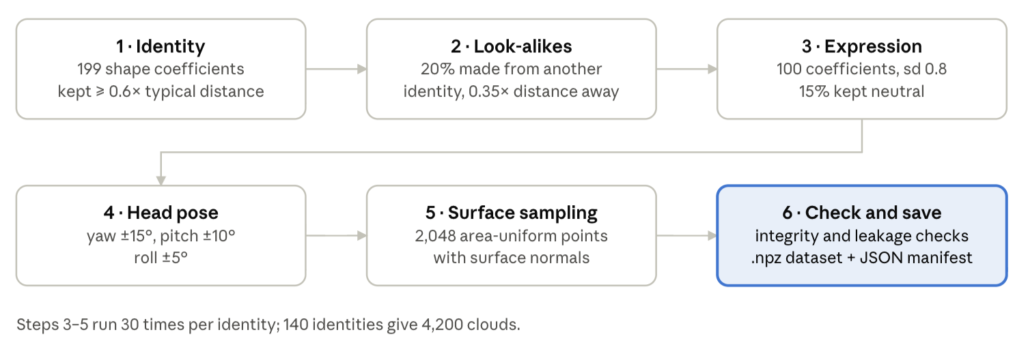
Figure 3.2. The six steps that turn a BFM identity into a stored, checked point cloud. Steps 1–2 define who a face is; steps 3–5 define one appearance of that face and are repeated 30 times per identity.

Step 1: identities, including deliberate look-alikes
An identity is one vector of 199 shape coefficients drawn from the model prior, clipped to ±3 standard deviations to exclude implausible faces. Two identities drawn this way differ, on average, by a distance of √(2k) ≈ 20 in coefficient space (k = 199). To guarantee that classes are genuinely distinct, each new identity is accepted only if it lies at least 0.6 times this expected distance from every earlier identity.
A realistic authentication system must also reject people who resemble an enrolled user. Twenty per cent of identities are therefore generated as look-alikes: an existing identity plus a random offset of exactly 0.35 times the expected distance. Each look-alike records its parent, so that look-alike pairs can be evaluated separately as hard negatives (Section 3.11).
Identities are generated in two disjoint groups:
- 100 closed-set identities, which are the classes the networks are trained to recognise.
- 40 open-set identities, which are never shown during training and are used only to test verification of unseen people.
Look-alikes are created within each group, so the open set also contains hard negatives.

Step 2: appearance variation per identity
Each identity is rendered 30 times. Every sample receives its own expression and head pose, so the networks must learn what stays constant about a face while its surface changes:
- Expression: 100 coefficients drawn with a standard deviation of 0.8. Fifteen per cent of samples are given a neutral expression.
- Head pose: a random rotation of up to ±15° yaw, ±10° pitch and ±5° roll about the face's centre, representing a subject who is not perfectly aligned with the sensor.

Step 3: from mesh to point cloud
Each posed face mesh is converted into a point cloud by area-uniform surface sampling. A triangle is chosen with probability proportional to its area, then a point is placed inside it using uniformly distributed barycentric coordinates:
$$p=(1-√(r_{1})) a+√(r_{1})(1-r_{2}) b+\sqrt{r_{1}} r_{2} c$$
$$r_{1},r_{2}∼U(0,1)$$
Here a, b and c are the triangle's corners. The surface normal at each point is interpolated from the vertex normals in the same way. Sampling the surface, rather than using mesh vertices directly, matters for two reasons. It gives every cloud a fresh, unbiased point distribution, as a real depth sensor would. It also prevents the networks from learning the fixed vertex ordering of the BFM mesh instead of the shape of the face.

Step 4: splits
Split | Identities | Clouds per identity | Clouds | Purpose
Train | 100 closed-set | 21 | 2,100 | Fitting all models
Validation | 100 closed-set | 4 | 400 | Early stopping and model selection
Test | 100 closed-set | 5 | 500 | Closed-set identification accuracy
Open | 40 unseen | 30 | 1,200 | Open-set verification (EER, TAR@FAR)
Closed-set samples are split within each identity, so every class appears in training, validation and test. The open split shares no identity with any other split. This separation is the central safeguard against over-optimistic results: verification is always measured on faces the models have never encountered.
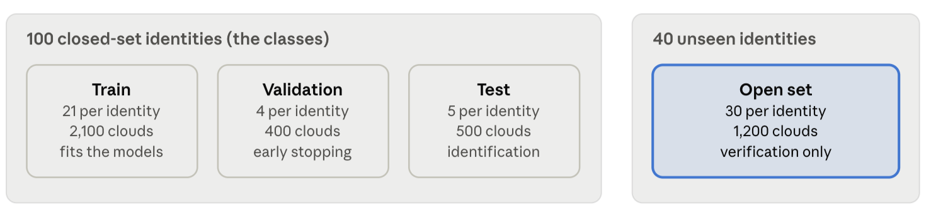
Figure 3.4. How the 140 identities are split. Closed-set identities appear in training, validation and test; the 40 open-set identities are used only for verification, so authentication is always measured on unseen people.

Settings and storage
Table 3.1. Dataset generation settings (standard configuration).
Setting | Value
Shape / expression components used | 199 / 100
Facial crop around nose tip | 95 mm
Closed-set / open-set identities | 100 / 40
Samples per identity | 30
Points stored per cloud | 2,048 (with normals)
Minimum identity separation | 0.6 × expected distance
Look-alike share / distance | 20% / 0.35 × expected distance
Expression standard deviation; neutral share | 0.8; 15%
Pose range (yaw / pitch / roll) | ±15° / ±10° / ±5°
Sensor noise added | none (clean data)
Random seed | 42
The dataset is deliberately clean: no sensor noise is baked in, and augmentation happens only on the fly during training (Section 3.5). It is saved as a single NumPy archive (bfm_pointclouds.npz) holding the points, normals, identity labels, split codes, and every identity, expression and pose coefficient. A JSON manifest records the configuration, the BFM file hash, array shapes and split sizes. The dataset is regenerated only when the configuration or the BFM file changes, which is detected through a fingerprint of both.
Before any training, an automated quality check confirms that:
- all coordinates and normals are finite;
- normals have unit length;
- every identity has exactly 30 samples;
- open-set identities appear only in the open split;
- every closed-set identity appears in train, validation and test;
- no two clouds are duplicates;
- all cloud sizes fall within a plausible range for human faces (40–200 mm radius).

3.5 Pre-processing and the data pipeline
Every cloud is centred and divided by a single fixed scale before it enters a network. The choice of a fixed scale (100 mm) rather than per-cloud normalisation is deliberate. Many point-cloud pipelines rescale each object to the unit sphere, but for faces this would erase head size, which is genuine identity information. With a fixed scale, a broader face remains broader after normalisation:
$$(p̃)_{i}=\frac{p_{i}-\overline{p}}{s}$$
$$s=100\text{mm}$$
Here p̄ is the centroid of the cloud.

Two input densities: dense teacher, sparse student
Each model consumes a fixed number of points. The teacher sees 2,048 points, the full stored cloud. The student sees 1,024, half as many. This difference is intentional and is referred to in this study as resolution distillation. It reflects the intended deployment: a large model trained offline on high-resolution scans transfers its knowledge to a small model that must work from a cheaper, sparser sensor. During knowledge distillation, each batch is drawn at the teacher's density and the student receives a random half of the same points, so both models always describe the same face at the same moment.
Because surface sampling was independent and identically distributed, any subset of a cloud is itself a uniform sample of that face. During training a fresh random subset is taken each time, which acts as an additional augmentation. During evaluation the first n points are used, which keeps evaluation deterministic and repeatable.

On-the-fly augmentation (training only)
Three augmentations are applied to each training batch, and never to validation, test or open data:
- Random point subset, as above.
- Small random rotation: up to ±5° about a random axis, applied to both points and normals, on top of the pose variation already in the data.
- Coordinate jitter: Gaussian noise with a standard deviation of 0.3 mm.
Scaling augmentation is not used, for the same reason that normalisation keeps size: rescaling a face would change its identity.

Input features and batching
Besides their coordinates, points carry their unit surface normal as a three-value feature. Normals describe local surface orientation, which helps distinguish facial structures, and You and Zhao (2025) found that adding normals improved 3D face recognition for both KPConv and PointNet++. Per-point colour from the BFM colour model is supported but disabled, so that the models authenticate from geometry alone.
Batches hold 16 clouds. A final incomplete training batch is dropped, because BatchNorm statistics become unreliable for very small batches. All arrays are converted to 32-bit floating point tensors on the selected device: a CUDA GPU, Apple Silicon (MPS) or the CPU, chosen automatically.

3.6 Teacher model: KPConv
The teacher is a rigid KPConv network with 956,128 parameters that maps a 2,048-point face to a 256-dimensional identity embedding. KPConv was chosen because it convolves directly on irregular 3D points, without converting them to voxels or images, and because it outperformed PointNet++ in a direct comparison on 3D faces (You and Zhao, 2025). These properties make it a strong source of geometric knowledge for a smaller student (Chapter 2, Case Study 1).

The kernel point convolution
KPConv places its learnable weights at fixed kernel points around each query point, rather than on a regular grid. A neighbouring point influences each kernel point in proportion to how close it lies to that kernel point. For a query point x with neighbours xᵢ carrying features fᵢ, the convolution is (Thomas et al., 2019):
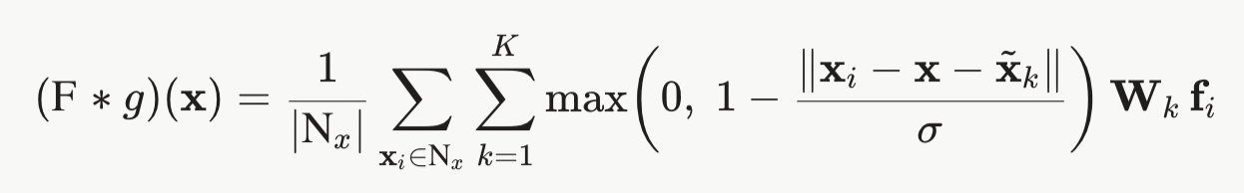
Here x̃ₖ are the K kernel points and Wₖ their weight matrices. The influence term falls linearly from 1 at a kernel point to 0 at distance σ. This implementation uses:
- K = 15 kernel points: one at the centre and 14 spread evenly on a sphere (a Fibonacci lattice) at 0.6 times the neighbourhood radius R;
- influence distance σ = 0.5R;
- a neighbourhood of the 24 nearest points, restricted to those within radius R. The sum is averaged over valid neighbours, so regions of different point density produce comparable responses.
The rigid variant, with fixed kernel positions, was chosen over the deformable variant, which learns per-point offsets. The rigid form is cheaper and more stable to train, and a teacher's role here is to learn a strong identity representation, not to adapt its receptive field to arbitrary geometry. This matches the design choice stated in Chapter 1.

Architecture
The network follows the residual design of the original KPConv. Its first stage works at full resolution, and two further stages each reduce the point count by a factor of four using farthest-point sampling (FPS) while doubling the radius.
Table 3.2. Teacher architecture (standard configuration, width 64).
Stage | Points | Radius R | Operation | Channels
Input | 2,048 | – | Features: constant 1, centred xyz, normal | 7
Stem | 2,048 | 15 mm | KPConv + BatchNorm + LeakyReLU | 32
Block 0 | 2,048 | 15 mm | Residual KPConv block | 64
Stage 1 | 512 | 30 mm | Strided residual block, then residual block | 64 → 128
Stage 2 | 128 | 60 mm | Strided residual block, then residual block | 128 → 256
Global | 128 → 1 | – | Position-aware layer on [centred xyz, features], then max + mean pooling | 512 → 1,024
Embedding | – | – | Linear + BatchNorm | 256
Head | – | – | Cosine classifier (CosFace), 100 classes | 100
Each residual block is a bottleneck. A linear layer narrows the channels by half, a KPConv aggregates the neighbourhood, and a second linear layer restores the width. The result is added to a shortcut path. In a strided block, the shortcut takes the maximum feature among each new point's neighbours, so information is not lost when the resolution drops. All activations are LeakyReLU with a slope of 0.1.

Two additions for facial identity
Two departures from the standard KPConv classifier were introduced after the first teacher learned too slowly (Section 3.12, Sprint 3). Both address the same weakness: KPConv's operations are purely local, while facial identity lives largely in the global layout of features, such as the spacing of the eyes or the height of the nose relative to the chin.
- Centred coordinates as input features. The original KPConv feeds only a constant 1 into its first layer, so absolute position is never seen directly. Here the stem also receives each point's position relative to the cloud centroid. Because the centroid is subtracted inside the network, the model remains invariant to translation.
- A position-aware global layer. Before pooling, a linear layer combines each of the final 128 points' features with that point's centred position. Pooling then summarises where features occur, not only which features occur.
With these changes the teacher's open-set error rate became lower than the student's (0.18 against 0.21 in a 20-identity diagnostic run during development; Section 3.12), the precondition for meaningful distillation.

3.7 Student model: PointNet++
The student is a single-scale-grouping PointNet++ with 116,736 parameters, 8.2 times fewer than the teacher, and it reads half as many points. PointNet++ was chosen for three reasons established in the literature review. It has learned identity directly from synthetic facial point clouds (Zhang et al., 2022). Its building blocks, shared multilayer perceptrons and max-pooling, map onto simple dense operations that run efficiently on modest hardware. And it is measurably weaker than KPConv on 3D faces (You and Zhao, 2025), which creates the capacity gap that distillation is meant to close.

Hierarchical set abstraction
PointNet++ learns features at increasing scales through set abstraction levels (Qi et al., 2017b). Each level performs three steps:
- Sampling: farthest-point sampling selects well-spread centroid points.
- Grouping: each centroid gathers its 32 nearest neighbours within a ball of fixed radius. Neighbours outside the ball are replaced by the nearest neighbour, so every group has the same size.
- Local feature learning: each neighbour's position relative to its centroid, divided by the radius, is concatenated with its features. A shared multilayer perceptron (1×1 convolutions with BatchNorm and ReLU) is applied to every neighbour, and a max-pool over the group produces one feature vector per centroid.
Max-pooling is a symmetric function, so the output does not depend on the order in which points are listed. This property is verified empirically in the self-test (Section 3.13).
Table 3.3. Student architecture (standard configuration).
Level | Centroids | Ball radius | Input channels | Shared MLP widths
SA1 | 1,024 → 256 | 15 mm | 3 (relative xyz) + 3 (normal) | 32, 32, 64
SA2 | 256 → 64 | 30 mm | 3 + 64 | 64, 64, 128
SA3 (global) | 64 → 1 | all points | 3 (centred xyz) + 128 | 128, 256
Embedding | – | – | 256 | Linear + BatchNorm → 128
Head | – | – | 128 | Cosine classifier (CosFace), 100 classes
The final level groups all remaining centroids together with their centred coordinates. This gives PointNet++ the same access to global facial layout that the teacher obtains from its position-aware layer (Section 3.6).
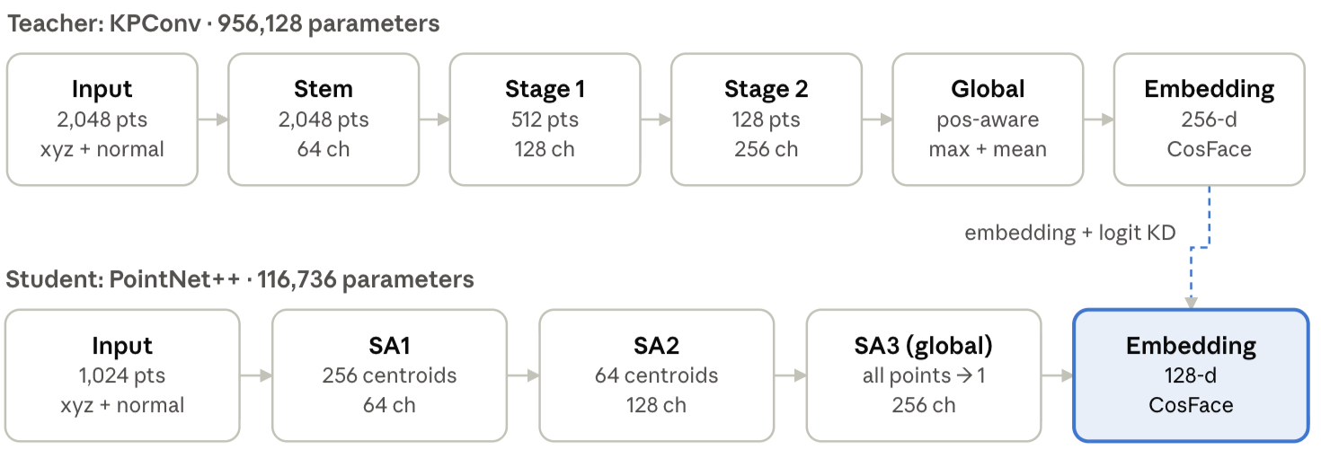
Figure 3.5. The teacher and student, stage by stage (details in Tables 3.2 and 3.3). The dashed link marks where knowledge is transferred during training; it is not used at inference.

Designed to be pruned
All eight shared-MLP widths are stored in the model's configuration rather than fixed in code. A pruned student is therefore the same network class with smaller widths, and a saved checkpoint carries enough information to rebuild itself exactly. This keeps the pruned model a normal, portable PyTorch model with no masks or special runtime code, which is essential if the size reduction is to be realised on a deployment device.

3.8 Adaptive knowledge distillation
The student is trained with a three-part loss: the ground-truth identity loss, the teacher's softened predictions, and the teacher's embedding geometry. The weight given to the teacher changes per sample according to how confident and correct the teacher is. The teacher is frozen throughout: it runs in evaluation mode, its weights receive no gradients, and it sees the dense 2,048-point version of each cloud while the student sees a random 1,024-point subset (Section 3.5).

The loss
For a training sample i with identity label yᵢ, let z_s and z_t be the student's and teacher's cosine logits, f_s and f_t their embeddings, and p_t the teacher's softmax distribution. The student minimises:
$$L_{i}=(1-α_{i})CE_{cosface}(z_{s},y_{i})+α_{i}T^{2}\text{KL}(σ(z_{t}/T)‖σ(z_{s}/T))+β(1-cos⁡(Pf_{s},f_{t}))$$
where the per-sample distillation weight is
$$α_{i}=α_{(}max )p_{t}(y_{i}∣x_{i})$$
The three terms serve different purposes:
- Ground-truth term. The CosFace classification loss (Section 3.10) keeps the student anchored to the true labels.
- Logit term. This is classic knowledge distillation (Hinton, Vinyals and Dean, 2015). At temperature T = 4 the teacher's predictions are softened, exposing which other identities the teacher considers similar to the input. The factor T² keeps gradient magnitudes comparable across temperatures.
- Embedding term. A learnable linear projection P maps the 128-dimensional student embedding into the teacher's 256-dimensional space. The term rewards the student for pointing in the same direction as the teacher there, with weight β = 1.
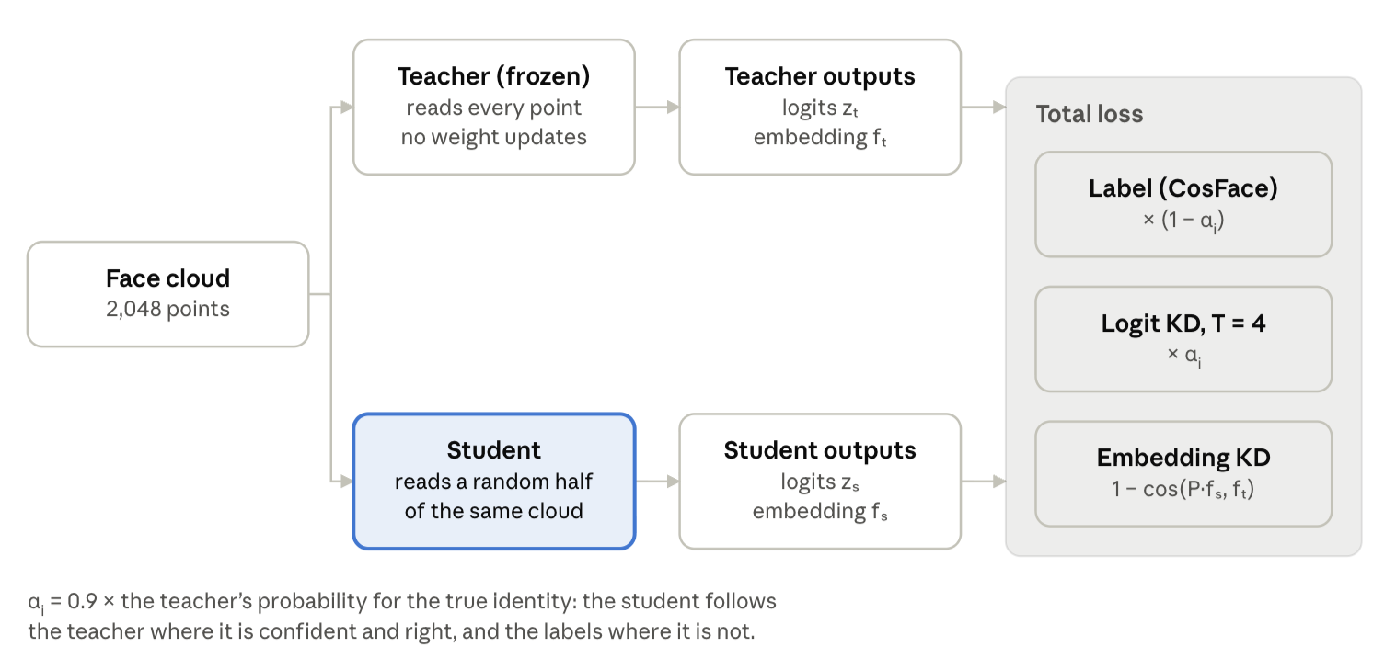
Figure 3.6. One training step of adaptive knowledge distillation. The teacher sees the full cloud and the student a random half of it; the three loss terms are weighted per sample by the teacher's confidence.

Why the weighting is adaptive
Standard distillation trusts the teacher equally on every sample. The weight αᵢ instead scales with the probability the teacher assigns to the correct identity, up to a maximum of α_max = 0.9:
- where the teacher is confident and right, the student mostly imitates it;
- where the teacher is uncertain or wrong, αᵢ falls towards zero and the ground-truth term dominates.
This prevents the teacher's mistakes from being copied into the student. The design follows two findings from the literature review: that face-recognition distillation benefits from transferring knowledge selectively rather than indiscriminately (Zhao et al., 2023), and that point-cloud distillation gains from reweighting what is transferred (Zhang et al., 2023). Case Study 5 left the exact adaptive mechanism open; teacher confidence was chosen because it is cheap, needs no extra annotation, and directly measures how reliable each teacher signal is.

Why embeddings are distilled as well as logits
Authentication compares embeddings, not class predictions. The open-set identities used for verification have no class in the classifier at all, so logit distillation alone could improve closed-set accuracy without improving verification. The embedding term transfers the teacher's metric structure, the arrangement of faces in its embedding space, which is what verification relies on.
The projection P is needed because the two networks produce embeddings of different sizes from different internal mechanisms. Direct feature matching between such different architectures is unreliable (Li et al., 2023). P exists only during training and is discarded afterwards, so it adds nothing to the deployed student's size or latency.

3.9 Geometric pruning with FPGM
The distilled student is compressed by removing half of the filters in every prunable layer, reducing it from 116,736 to 47,744 parameters (59% fewer). Filters are chosen by Filter Pruning via Geometric Median (FPGM) (He et al., 2019). The pruned network is then recovered by a further round of adaptive distillation.
A note on terminology. In this study, geometric pruning means FPGM: pruning network filters according to their geometry in weight space. It does not mean removing input points according to facial geometry, the idea of teacher-guided point selection discussed in Case Studies 2 and 4. The two are complementary. Point-level pruning reduces the input a network reads, whereas FPGM reduces the network that reads it. Point-level pruning was not implemented and is identified as future work (Section 3.15).

The FPGM criterion
FPGM treats each filter in a layer as a point in weight space. Filters that lie close to the layer's geometric median are the most replaceable, because what they compute is largely shared by the other filters. FPGM therefore removes those, rather than the filters with the smallest weights as norm-based pruning does. For filter j among the filters F₁ … F_n of a layer, the score is its total distance to all others:
$$s_{j}=\sum_{i=1}^{n}{||F_{j}-F_{i}||2}$$
The filters with the lowest scores, those nearest the geometric median, are removed until the target width is reached. The ratio is 0.5 in each of the eight shared-MLP layers, with a floor of four filters per layer. The widths change as follows:
Level | Widths before | Widths after
SA1 | 32, 32, 64 | 16, 16, 32
SA2 | 64, 64, 128 | 32, 32, 64
SA3 | 128, 256 | 64, 128

Structural removal
Pruning is structural: the selected filters are physically deleted, not masked with zeros. For each pruned layer:
- its convolution weights and BatchNorm parameters and statistics are reduced to the kept filters;
- the matching input channels of the next layer are deleted, so the network remains consistent;
- the three relative-coordinate input channels at the start of each set-abstraction level are never pruned, because they carry geometry rather than learned features;
- the embedding layer's inputs are reduced to the final level's kept filters.
The network is then rebuilt with the smaller widths. Because of this, the reductions in parameters and memory are real, not nominal.

BatchNorm recalibration
Removing filters changes the inputs that every later layer receives. The running means and variances stored in its BatchNorm layers then describe a network that no longer exists. Early experiments showed that this mismatch alone can collapse accuracy to chance immediately after pruning (Section 3.12, Sprint 4). After pruning, all BatchNorm statistics are therefore reset and re-estimated as a cumulative average over up to 50 training batches. No gradients are computed and no weights change: only the normalisation statistics are refreshed.

Recovery procedure
The default procedure is one-shot pruning: prune once, recalibrate, then fine-tune the pruned student with the same adaptive distillation loss (Section 3.8). Fine-tuning runs for up to 25 epochs at half the initial learning rate, with early stopping. A one-shot sensitivity sweep, pruning 10%, 25% and 50% before any fine-tuning, is reported alongside, to show how much accuracy each ratio removes before recovery.
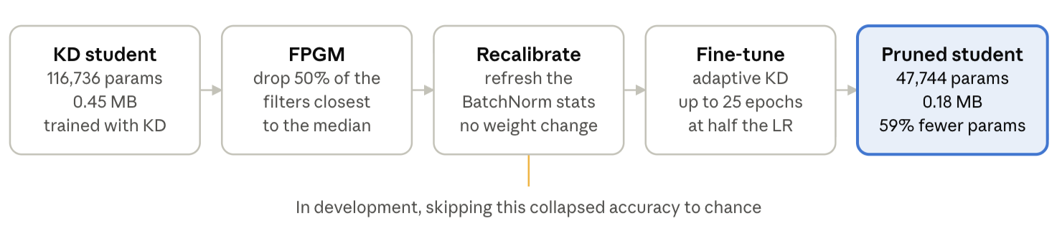
Figure 3.7. The default one-shot pruning procedure. FPGM removes half of each layer's filters, BatchNorm statistics are re-estimated without changing any weight, and adaptive distillation recovers accuracy.
An alternative soft procedure, closer to the original FPGM paper, is implemented as an option. During fine-tuning, a growing share of filters is masked at the end of each epoch, ramping up to the target over the first 60% of epochs. The masks are re-applied after every optimiser step, so masked filters output exactly zero, and at the end the masked filters are removed losslessly. One-shot pruning was adopted as the default because it performed better at an equal fine-tuning budget in development tests (Section 3.12, Sprint 4).

Verifying the pruning code
Structural pruning is error-prone, because a single misaligned channel index corrupts the network silently. Its correctness is therefore tested independently. A pruned network must produce the same output as the original network with the removed filters' outgoing weights set to zero. The two agree to within 5 × 10⁻⁷, and this test runs automatically in the notebook's self-test (Section 3.13).

3.10 Training protocol and implementation details
All four models share one training procedure, so differences in their results come from architecture and training signal, not from unequal optimisation. The models are trained in a fixed order, because each stage depends on the previous one: teacher, student baseline, KD student, then pruning and KD fine-tuning.

Identity loss: CosFace
Both networks end in a cosine classifier. The embedding f and each class weight vector Wⱼ are normalised to unit length, so a logit is a scaled cosine of the angle θⱼ between them. Training uses the large-margin cosine loss, CosFace (Wang et al., 2018), which subtracts a margin m from the true class's cosine:
$$L_{(}CosFace)=-log\frac{e^{ s(\cos{θ_{y}}-m)}}{e^{ s(\cos{θ_{y}}-m)}+\sum_{j≠y}{e^{ s\cos{θ_{j}}}}}$$
The margin forces embeddings of the same identity to cluster more tightly than plain classification would require. This matters for authentication: the classifier is discarded at verification time, and only the angular separation of embeddings remains. Label smoothing of 0.1 is applied to reduce overconfidence. The margin is used only during training; logits used for distillation and evaluation carry no margin.

Optimisation
Table 3.4. Training settings, identical for all models unless stated.
Setting | Value
Optimiser | AdamW (Loshchilov and Hutter, 2019)
Initial learning rate | 2 × 10⁻³ (1 × 10⁻³ for pruned-model fine-tuning)
Weight decay | 1 × 10⁻⁴
Learning-rate schedule | Linear warm-up over the first epoch, then cosine decay
Batch size | 16 clouds
Gradient clipping | Global norm 5.0
Maximum epochs | 50 (teacher and students); 25 (pruned-model fine-tuning)
Early stopping | After 10 epochs without improvement in validation accuracy, never before epoch 15
Model selection | Weights from the epoch with the best validation accuracy are restored
Random seed | 42, with a fixed offset per training stage
Warm-up avoids large, destabilising updates while BatchNorm statistics and the cosine classifier settle. Gradient clipping guards against occasional large gradients from the margin-based loss. Early stopping was added after the first full-scale runs showed that the teacher reaches about 99% validation accuracy within roughly 20 epochs, so most later epochs would consume GPU time without benefit. Validation accuracy decides both early stopping and model selection. The test and open splits are never consulted during training, so they remain untouched estimates of performance.

Hardware and reproducibility
The reported experiments ran on Google Colab with an NVIDIA T4 GPU, where one teacher epoch took about 18 seconds. The same notebook also runs on Apple Silicon (MPS) and on a CPU, selecting the device automatically. Several mechanisms make each run reproducible and recoverable:
- every random choice (identities, expressions, poses, point sampling, augmentation, weight initialisation) derives from the configured seed;
- each checkpoint stores the model's architecture configuration, its weights, its metrics and a fingerprint of the full configuration and dataset;
- if a Colab session disconnects, re-running the notebook reloads any stage whose fingerprint matches instead of retraining it;
- outputs are written to Google Drive, so they survive the end of a Colab session.
The present results come from a single seed. Repeating the full experiment with further seeds, and reporting means and standard deviations, is part of the planned evaluation (Section 3.15).

3.11 Evaluation framework
Each model is evaluated on three axes: whether it recognises enrolled identities, whether it verifies people it has never seen, and what it costs to run. The second axis is the primary measure of authentication quality, because a deployed system must verify users who were not in its training data.

Closed-set identification
Top-1 accuracy on the 500 test clouds is the share for which the highest-scoring class is the correct identity. It shows how well a model has learned the 100 training identities. On its own, however, it says little about authentication.

Open-set verification
Verification asks a yes/no question: do two face scans belong to the same person? Every one of the 1,200 open-split clouds is embedded and its embedding normalised to unit length. All 719,400 possible pairs are then scored by cosine similarity:
- 17,400 genuine pairs, where both clouds show the same person;
- 702,000 impostor pairs, where they show different people.
A pair is accepted when its similarity exceeds a threshold τ. Two error rates follow:
$$FAR(τ)=\frac{\#\{\text{impostor pairs with score}≥τ\}}{\#\{\text{impostor pairs}\}}, FRR(τ)=\frac{\#\{\text{genuine pairs with score}<τ\}}{\#\{\text{genuine pairs}\}}$$
Sweeping τ across all observed scores traces the full receiver operating characteristic. Three summary figures are reported:
- Equal error rate (EER): the error rate at the threshold where FAR equals FRR. A single, threshold-free summary; lower is better.
- TAR @ FAR = 1%: the share of genuine users accepted when the system is tuned to admit at most 1 impostor in 100. This is typical of convenience applications.
- TAR @ FAR = 0.1%: the same at 1 impostor in 1,000. This is closer to security-critical settings, and it is where differences between strong models usually become visible.

Look-alike robustness
A look-alike EER repeats the EER calculation with impostors restricted to look-alike pairs, an identity and the identity derived from it (Section 3.4). This isolates the hardest realistic case, rejecting someone who resembles an enrolled user. It shows whether compression costs disproportionately on hard negatives, which an average over all impostors would hide.

Efficiency
The efficiency measures serve as proxies for the low-resource deployment addressed by the second research question:
- Parameters, counted exactly.
- Model size in megabytes, at 4 bytes per parameter (32-bit floating point).
- Inference latency: the mean time of 10 forward passes at batch sizes 1 and 16, after two warm-up passes, with the device synchronised before and after timing so that asynchronous GPU work is fully counted.
Latency is measured on the training GPU, not on a mobile or embedded processor. It is therefore a relative comparison between models, not a prediction of on-device speed. It also includes the sampling and neighbour-search operations, which pruning does not change (Section 3.15).

Interpreting differences
The open split contains 40 identities, so a difference of a few thousandths in EER corresponds to a small number of identities behaving differently. Conclusions about which technique helps are therefore drawn only where the pattern is consistent across metrics. The comparison will be repeated over several random seeds, with each seed regenerating both the dataset and all four models, and results will be reported as mean ± standard deviation.

3.12 Iterative development: sprint record
The final design emerged over six sprints, and three of its central features were responses to observed failures rather than initial plans:
- the teacher's coordinate inputs;
- BatchNorm recalibration;
- one-shot pruning with KD recovery.
Recording these iterations serves two purposes. It justifies each design decision with evidence, and it documents negative results that would otherwise be lost, which other researchers can use to avoid the same dead ends.
Each sprint followed the same cycle: set a goal, build the smallest change that tests it, run the self-test and a diagnostic experiment, then keep, revise or discard the change. The diagnostic experiments in Sprints 2–4 used a reduced configuration (20 identities, 25 epochs) so that a design could be tested in minutes rather than hours. During development and debugging, a stand-in model file with the same HDF5 layout and dimensions as BFM 2017 was used. All experiments reported in Chapter 4 use the licensed BFM 2017 file. The diagnostic figures below therefore justify design choices; they are not results.
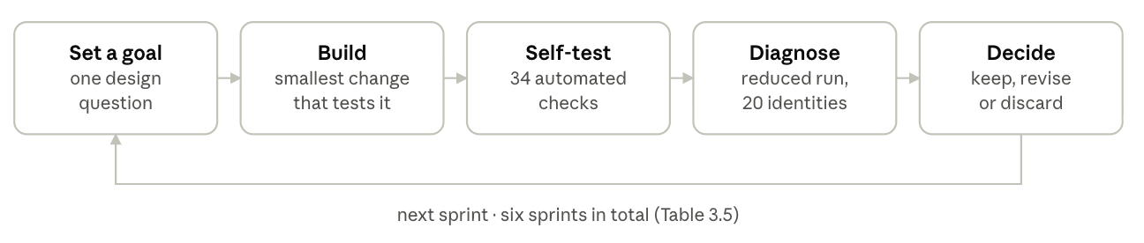
Figure 3.8. The cycle followed in every development sprint. Each change was checked by the automated self-test and a reduced diagnostic run before it was kept.
Table 3.5. Development sprints.
Sprint | Goal | What was observed | Decision
1 | Understand Gaussian Process Morphable Models | A GPMM built from first principles (procedural reference face, kernels, Nyström approximation) generated plausible but stylised faces | Use the real BFM 2017 for realistic geometry; keep the GPMM work as background understanding
2 | End-to-end pipeline: BFM loading, dataset, teacher, student, KD, pruning | Pipeline ran and passed its self-test, but the smallest configuration learned nothing (chance accuracy) | Introduce size presets; treat the smallest only as a smoke test
3 | A teacher stronger than its student | The KPConv teacher reached 62% validation accuracy against the student's 95% in the diagnostic run | Add centred-coordinate inputs and a position-aware global layer; widen neighbourhoods (radius 15 mm, 24 neighbours); raise the learning rate to 2 × 10⁻³; give the teacher denser clouds (resolution distillation). Teacher open-set EER then 0.181 against the student's 0.212
4 | Prune the student without destroying it | Pruning only 25% of filters dropped accuracy to chance. An equivalence test showed the pruning code was correct; FPGM, L1-norm and random selection behaved alike | Add BatchNorm recalibration (25% pruning: 5% → 18% accuracy before fine-tuning). Compare recovery strategies at 50% pruning (next rows)
4a | Gradual hard pruning (3 steps) | 35% test accuracy after 9 epochs of fine-tuning | Rejected
4b | Soft FPGM | First version collapsed training: zeroed filters gave BatchNorm zero variance, causing huge gradients, and optimiser momentum revived them. A masked version was stable: 60% after 20 epochs | Kept as an option (prune_mode = "soft")
4c | One-shot FPGM + recalibration + KD fine-tuning | 82% test accuracy after 20 epochs, against 95% unpruned | Adopted as default
5 | Portability: Apple Silicon and Google Colab | Training failed on Apple's MPS backend with a memory-layout error in the student's backward pass | Make tensors contiguous before convolutions; remove in-place activations; add a pre-training device check that falls back to CPU; save outputs to Google Drive
6 | Full-scale experiment | The teacher reached about 99% validation accuracy within roughly 20 of 50 epochs | Add early stopping (patience 10, minimum 15 epochs). Plan repeated seeds and a milder 30% pruning ratio
Two lessons from this record shape the interpretation of the results. First, a distillation teacher must be verified to be stronger on the target metric before distillation is attempted; architectural size alone did not guarantee it. Second, a compact student has little redundancy. Pruning such a network is mainly a question of how much re-training budget is available, rather than of which filters are chosen.

3.13 Tools and technologies
The whole pipeline is one Jupyter notebook written in Python on open-source libraries, with no compiled extensions. It therefore runs unchanged on a laptop CPU, Apple Silicon or a cloud GPU. Both KPConv and PointNet++ were implemented directly in PyTorch rather than taken from their reference repositories. Those repositories depend on custom CUDA kernels that do not run on Apple Silicon and are difficult to install on Colab, whereas a pure-PyTorch implementation keeps every operation inspectable and portable.
Table 3.6. Software and platforms.
Tool | Version tested | Used for | Why it was chosen
Python | 3.13 and 3.14 | All code | Standard language of the deep-learning ecosystem
PyTorch | 2.x | Networks, training, distillation, pruning | Dynamic graphs make structural pruning and custom losses straightforward; one code path runs on CUDA, MPS and CPU
NumPy | 2.x | Dataset generation, surface sampling, metrics | Fast vectorised geometry; the BFM bases are NumPy arrays
h5py | 3.x | Reading bfm.h5 | BFM 2017 is distributed in the HDF5-based statismo format
Matplotlib, Plotly | current | Figures; interactive 3D views of point clouds | Static figures for the thesis; rotatable views for inspecting data
Jupyter, Google Colab | – | Development and execution | Code, outputs and explanation in one document; free T4 GPU access
Google Drive | – | Storing datasets, checkpoints and results | Persists across Colab sessions

Automated self-testing
The notebook ends with a self-test of 34 automated checks that runs after every full execution. A run is accepted only if every check passes. The checks cover:
- Data integrity: the quality checks of Section 3.4, plus a check that the saved dataset reloads byte for byte.
- Geometric operations: k-nearest-neighbour search matches a brute-force computation; farthest-point sampling returns unique points.
- Model properties: both networks give the same output when the cloud is translated or its points reordered, as the theory requires.
- Distillation: with distillation switched off, the KD loss reduces exactly to the CosFace loss.
- Pruning: pruning with ratio 0 changes nothing; a pruned network equals the original with removed filters masked; masked soft-pruning filters stay exactly zero; BatchNorm recalibration changes no weights.
- Metrics: perfectly separated scores give an EER of 0, and random scores an EER near 0.5.
- Persistence: a pruned model saved to disk reloads to identical outputs.
The notebook was additionally executed end to end, without errors, on Python 3.13 and 3.14 using Jupyter's own execution engine, both from scratch and when reloading saved stages. The full-scale experiment was then executed in full on Google Colab.

3.14 Ethical considerations in the methodology
No human participants were recruited and no personal data was collected or processed: every face in the dataset is a synthetic identity sampled from a statistical model. This was a deliberate design choice (Section 3.3), but it does not remove ethical responsibility. Five considerations shaped how the study was designed and how its results should be used.
Biometric privacy. Facial geometry used for identification is special-category personal data under the UK and EU GDPR. By generating identities instead of scanning people, the study avoids consent, storage and breach risks entirely during development. A deployed system would not avoid them. It would process real biometric data, and should keep templates on the device, store embeddings rather than raw scans, and obtain explicit consent at enrolment.
Representativeness and bias. Synthetic does not mean neutral. The Basel Face Model was learned from scans of 200 adults (100 female and 100 male), most of them European (Paysan et al., 2009). Every identity in this dataset is therefore a variation within that population, and faces that differ systematically from it, by ethnicity or age for example, are under-represented. The synthetic identities carry no demographic labels, so per-group error rates cannot be measured here. Results should not be read as evidence of equal performance across populations; this must be tested on diverse real data before any deployment.
Licensing. BFM 2017 is released for non-commercial research after registration with the University of Basel. The model file is not redistributed with this work. Data derived from it, such as the point-cloud dataset and trained weights, is shared only under compatible non-commercial research terms.
Dual use. Lightweight face authentication lowers the cost of running biometrics on cheap devices. That serves the intended purpose, consent-based 1:1 verification such as unlocking a device or recording office attendance. It also makes covert identification easier. The methodology is scoped to verification (comparing a probe with one enrolled identity), not large-scale identification. Its documentation states that the models are research artefacts, not certified security components.
Honest claims about security. The first research question mentions spoof resistance, but no presentation attacks were tested (Section 3.2). The study therefore makes no empirical claim that the student resists spoofing. Overstating security properties of an authentication system could lead to unsafe deployments, so the boundary between what was measured and what is argued from the literature is kept explicit throughout.
Computational cost was also kept proportionate. Early stopping ends training once validation accuracy stops improving, and stages already completed are reused rather than retrained, which reduces GPU time without affecting results.

3.15 Validity, reliability and limitations
The design protects internal validity well, but external validity, generalisation from synthetic to real faces, remains the study's main open question. This section states what the methodology can and cannot support.

Internal validity
All four models are trained on identical data, splits, augmentation, optimiser and stopping rules. Differences between them can therefore be attributed to architecture, distillation or pruning. Model selection uses only the validation split. Verification is measured only on identities absent from training, which removes the most common source of inflated biometric results: testing on people seen during training. The pruning, distillation and metric code is verified by the automated self-test (Section 3.13).

Reliability
Every stochastic step derives from a recorded seed. Datasets and checkpoints carry fingerprints of their configuration and of the BFM file, so a result can be regenerated exactly. The current results, however, come from one seed. With 40 open-set identities, small differences in EER may fall within run-to-run variation. Repeating the experiment over at least three seeds, each regenerating the dataset and all models, and reporting mean ± standard deviation is planned before final conclusions are drawn.

External validity and limitations
- Synthetic-to-real gap. BFM faces are smooth, complete and noise-free. Real depth sensors produce noise, holes, occlusions (hair, glasses) and lower resolution, so performance on real scans is likely to be lower. Validation on a real 3D face benchmark such as FRGCv2 or Bosphorus, following Zhang et al. (2022), is the most important next step.
- A relatively easy task. The teacher approaches perfect closed-set accuracy, which suggests that clean synthetic data may be easier than real-world authentication. Differences between models are therefore expected mainly in the strict metrics (TAR at FAR = 0.1% and the look-alike EER). Adding sensor noise or stronger expression variation would increase difficulty.
- Lighting and spoofing not measured. These parts of the first research question are addressed by argument, not by experiment (Section 3.2).
- Efficiency measured by proxy. Size and latency are measured on a cloud GPU, not on a mobile or embedded device. Latency also includes farthest-point sampling and neighbour search, which pruning does not shrink. Pruning therefore reduces parameters and memory substantially but may change latency little in this implementation. Floating-point operation counts, or on-device measurements, would better reflect deployment cost.
- Filter pruning, not point pruning. The teacher-guided point selection motivated in the case studies was not implemented. It remains a promising extension that would reduce the input as well as the network.
- Demographic coverage. Inherited from BFM 2017 and not measurable with unlabelled synthetic identities (Section 3.14).

Summary
This chapter has described how L-3FAs was designed, built and evaluated:
- A clean dataset of 4,200 point clouds was generated entirely from BFM 2017, with controlled identities, look-alikes, expressions and poses, and with unseen identities held out for verification.
- A KPConv teacher, adapted to see the global layout of the face, was trained on dense clouds.
- A PointNet++ student was trained on sparse clouds, first alone and then with adaptive knowledge distillation that weights the teacher's guidance by its confidence and transfers its embedding geometry.
- The distilled student was compressed with structural FPGM pruning, BatchNorm recalibration and distillation-based recovery.
- All models are compared on closed-set accuracy, open-set verification, look-alike robustness and efficiency.
Chapter 4 presents the results of this design.

CHAPTER 4 - RESULTS
Adaptive knowledge distillation brought the PointNet++ student level with its KPConv teacher on unseen identities, at one-eighth of the teacher's size. Geometric pruning then removed a further 59% of the student's parameters, at the cost of returning its verification error to the level of a student trained without a teacher. This chapter reports these results without interpretation; Chapter 5 discusses them. All figures come from one full run of the standard configuration (Table 3.1) with seed 42, on Google Colab with an NVIDIA T4 GPU.

4.1 Dataset
The generator produced 4,200 point clouds (140 identities × 30 samples, 2,048 points each) and passed every data-quality check of Section 3.4. The splits were 2,100 training, 400 validation and 500 test clouds over the 100 closed-set identities, and 1,200 open-set clouds over 40 unseen identities. The open set yields 17,400 genuine and 702,000 impostor pairs for verification.

4.2 Training behaviour
The teacher learned quickly and stably:
- Early epochs. Validation accuracy rose from 5.8% after the first epoch to 96.8% after the sixth.
- Plateau. It passed 99% by epoch 18, reached 99.5% at epoch 21 and later 100%. Training was then ended by early stopping, and the best checkpoint was kept.
- Fit. Training accuracy reached 100%, while validation accuracy remained within half a percentage point of it, so there was no sign of substantial overfitting.
- Speed. An epoch took about 18 seconds.
The student trained without distillation took about 7.7 seconds per epoch. Its validation accuracy plateaued at 99.5–99.8% from around epoch 32, and it stopped early at epoch 47.

4.3 Comparison of the four models
Table 4.1. Results of the four models (seed 42). EER: lower is better; all other accuracy measures: higher is better. Latency at batch size 1 on a T4 GPU. TBC = to be copied from results.json.
Model | Parameters | Size (MB) | Closed-set accuracy | Open-set EER | TAR @ FAR 1% | TAR @ FAR 0.1% | Look-alike EER | Latency (ms)
Teacher (KPConv) | 956,128 | 3.65 | 0.998 | 0.0062 | 0.9992 | 0.6491 | TBC | TBC
Student, no KD | 116,736 | 0.45 | 0.992 | 0.0150 | 0.9718 | TBC | TBC | TBC
Student + adaptive KD | 116,736 | 0.45 | 0.994 | 0.0062 | 0.9992 | 0.7116 | 0.2774 | 34.3
Student + KD + FPGM | 47,744 | 0.18 | 0.990 | 0.0145 | 0.9720 | 0.4868 | 0.3670 | 32.9

4.4 Effect of knowledge distillation
Distillation changed nothing about the student's size; it changed only how the student was trained. Compared with the same architecture trained on labels alone, the distilled student:
- reduced the open-set equal error rate from 0.0150 to 0.0062, a relative reduction of 59%, matching the teacher's 0.0062;
- raised the true acceptance rate at a 1% false acceptance rate from 0.9718 to 0.9992, again matching the teacher;
- reached a true acceptance rate of 0.7116 at the stricter 0.1% false acceptance rate, higher than the teacher's 0.6491;
- improved closed-set accuracy slightly, from 0.992 to 0.994.

4.5 Effect of geometric pruning
One-shot FPGM pruning at a ratio of 0.5, followed by BatchNorm recalibration and adaptive-KD fine-tuning, reduced the student from 116,736 to 47,744 parameters (−59%) and from 0.45 to 0.18 MB. Relative to the unpruned distilled student:
- closed-set accuracy fell slightly, from 0.994 to 0.990;
- the open-set EER rose from 0.0062 to 0.0145, close to the non-distilled student's 0.0150;
- TAR at a 1% false acceptance rate fell from 0.9992 to 0.9720, again close to the non-distilled student (0.9718);
- TAR at a 0.1% false acceptance rate fell from 0.7116 to 0.4868;
- the look-alike EER rose from 0.2774 to 0.3670;
- latency at batch size 1 changed little, from 34.3 to 32.9 ms (−4%).
The one-shot sensitivity sweep and the per-epoch fine-tuning log for this run are recorded in the notebook output (TBC).

4.6 Model size relative to the teacher
The student has 8.2 times fewer parameters than the teacher, and the pruned student 20 times fewer (956,128 against 47,744). The pruned student reads 1,024 points per face, half the teacher's 2,048.

4.7 Experiments still to be reported
Two planned experiments (Section 3.15) have not yet been run and will be added to this chapter:
- repetitions with seeds 1, 2 and 3, reported as mean ± standard deviation;
- a milder pruning ratio of 0.3.

Chapter 5 - Discussion
The results support the central idea of L-3FAs: a small point-cloud network can inherit most of a large network's ability to authenticate faces it has never seen. They also show where the idea currently stops. Distillation transferred the teacher's verification performance almost completely, whereas aggressive pruning traded that gain back for size. This chapter interprets both findings, answers the research questions, tests the hypotheses and relates the results to the literature. All conclusions are provisional until the multi-seed repetitions are complete (Section 4.7).

5.1 Research Question 1: what a teacher-trained student achieves
On the measures this study could test, a teacher-trained lightweight student achieves the teacher's authentication performance. The distilled PointNet++ matched the KPConv teacher's open-set equal error rate (0.0062) and its true acceptance rate at a 1% false acceptance rate (0.9992), with 8.2 times fewer parameters and half the input points. Without distillation, the same network erred more than twice as often (EER 0.0150). Distillation, not architecture, therefore accounts for the difference.
The most striking result is at the strictest operating point. At a 0.1% false acceptance rate the distilled student accepted 71% of genuine users, compared with the teacher's 65%. A student exceeding its teacher is unusual but not without precedent. PointDistiller's compressed detector also surpassed its teacher (Zhang et al., 2023), and Hinton, Vinyals and Dean (2015) describe soft targets as a regulariser that can improve generalisation beyond hard labels. Two features of this study's design plausibly contribute:
- Embedding distillation pulls the student towards the teacher's arrangement of faces in embedding space, while the student's own CosFace loss still tightens each identity's cluster.
- Adaptive weighting stops the student from copying the teacher's least reliable predictions.
This single-seed result needs confirmation before it can be claimed as a finding.
The other two parts of RQ1, robustness to varied lighting and resistance to spoofing, could not be measured with synthetic geometry (Section 1.9). The results do establish that the authentication decision is made entirely from geometry (coordinates and normals). Such inputs carry no illumination and cannot be reproduced by a flat photograph or screen, so the student inherits the general advantages of 3D authentication described in Section 2.2. Whether these advantages survive real sensors, real lighting and real 3D masks is an empirical question this thesis leaves open.

5.2 Research Question 2: suitability for low-resource devices
The evidence is encouraging on memory and inconclusive on speed. At 0.45 MB for the distilled student and 0.18 MB after pruning, both models are small enough to fit comfortably in the memory of any current smartphone or embedded board. Parameter count fell 20-fold from teacher to pruned student.
Latency, however, barely moved: 34.3 ms for the distilled student and 32.9 ms after pruning, on a T4 GPU. This is not a failure of pruning but a feature of where the time goes. Every forward pass performs farthest-point sampling, implemented as a sequential loop over the points it selects, and several neighbour searches. Neither operation depends on the network widths that pruning reduces. The practical implication is clear: on a constrained device, the speed of a point-cloud authenticator will be governed as much by its sampling and grouping operations as by its parameter count. Faster sampling (Section 6.3) would likely deliver larger speed gains than further pruning.
Because no model was run on a physical mobile or embedded processor, RQ2 can only be answered conditionally. The models are small enough for low-resource devices, and their accuracy is acceptable for authentication. Their real-time behaviour on such devices remains to be measured.

5.3 Hypotheses
H1 is supported for this run. The distilled student achieved accuracy comparable to the teacher (identical EER and TAR at a 1% false acceptance rate; closed-set accuracy 0.994 against 0.998). It also outperformed the student trained without a teacher on every reported measure.
H2 is partially supported. After pruning, the student kept acceptable authentication performance (EER 0.0145; TAR 0.972 at a 1% false acceptance rate) while shrinking to 0.18 MB. The hypothesis's claim about deployment on low-resource devices, however, rests on size proxies rather than on-device measurement.

5.4 Why Pruning gave back the Distillation Gain
Pruning half of every layer returned the student's verification error to almost exactly the level of the student trained without a teacher (EER 0.0145 against 0.0150). One reading is that capacity removed by pruning took the extra knowledge distillation had added, while the knowledge any PointNet++ can learn from labels survived. This is consistent with the development record (Section 3.12). The student, at about 117,000 parameters, is already compact and has little redundant capacity. Removing half its filters therefore removes useful function whichever filters are chosen, and FPGM, L1-norm and random selection behaved alike in development.
Two factors may soften this outcome. First, a ratio of 0.5 is aggressive for so small a network; the planned 0.3 ratio will show whether a milder cut preserves the distillation gain. Second, recovery was limited to 25 epochs with early stopping, whereas the student itself was trained for up to 50. Even as it stands, the result has practical value. The pruned, distilled student matches the accuracy of a conventionally trained student at 41% of its size, so distillation and pruning together buy a 2.4-fold reduction for no loss relative to the baseline.
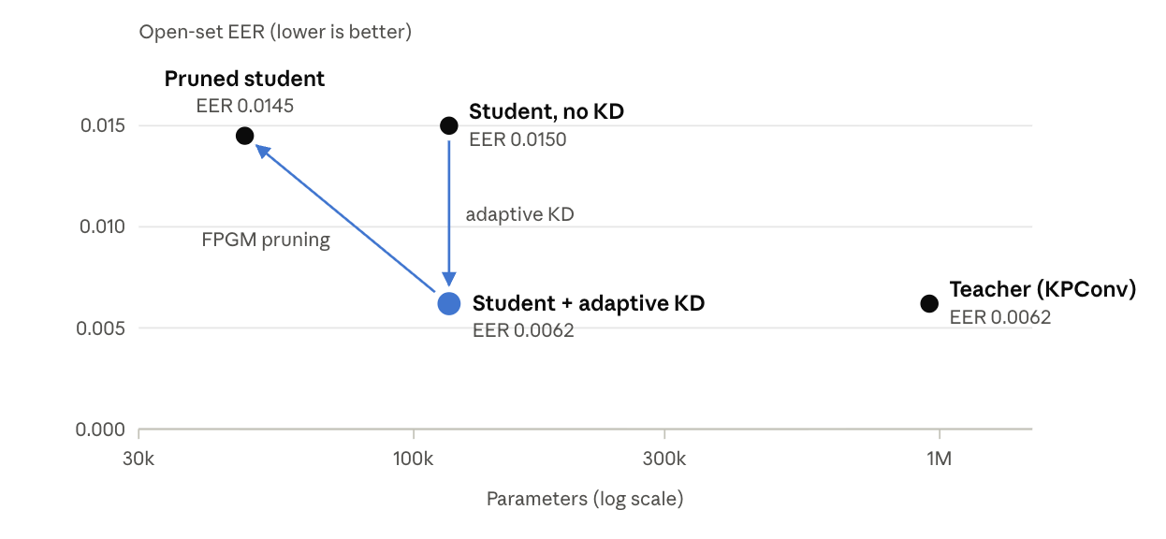
Figure 5.1. Model size against open-set equal error rate (seed 42, values from Table 4.1). Distillation moves the student down to the teacher's error level at the same size; pruning moves it left, to a smaller size, but back up to the error of the non-distilled student.
The experience with BatchNorm also generalises beyond this study. Without recalibration, pruning even a quarter of the filters collapsed accuracy to chance. Recalibration is rarely emphasised in the pruning literature, which was developed largely on larger 2D networks (He et al., 2019). For compact point-cloud networks, this study suggests it should be treated as a required step rather than a detail.

5.5 Look-Alike Impostors
Look-alike pairs remained far harder than ordinary impostors. Their equal error rate was 0.28 for the distilled student and 0.37 after pruning, compared with an overall EER below 0.015. This is expected: a look-alike was generated at only 35% of the typical distance between two random identities, deliberately closer than most real strangers. The result is nonetheless the clearest warning in the data. Overall error rates on a population of mostly dissimilar faces can look excellent while the hardest realistic threats, such as relatives, twins or deliberately selected impostors, are handled poorly. It also shows that compression costs disproportionately on hard negatives. Pruning raised the overall EER by 0.008, but the look-alike EER by 0.09. A deployment decision should therefore weigh look-alike performance explicitly, not only averaged error rates.

5.6 Relation to the Literature
The results align with the literature at several points:
- Teacher choice. The teacher outperformed the non-distilled student on unseen identities, consistent with You and Zhao's (2025) finding that KPConv is the stronger architecture for 3D faces. Development also showed that this advantage was not automatic: the first teacher was weaker than its student until it was given access to the global facial layout (Section 3.12).
- Synthetic data. Synthetic morphable-model faces supported effective training, as in Zhang et al. (2022), although transfer to real scans was not tested here.
- Capacity gap. The gap described by Li et al. (2023) did not prevent distillation from KPConv to PointNet++. The projection between embedding spaces and the retained label loss may be why, and both follow their recommendations.
One caution applies to all of these comparisons. Clean synthetic faces appear to be an easier task than real authentication, given the teacher's near-perfect closed-set accuracy. On harder, real data, the gaps between models are likely to widen, and the relative benefits of distillation and pruning may change.

5.7 Limitations of the findings
The findings rest on one seed, one synthetic dataset and a 40-identity open set. Small differences, such as the teacher and distilled student sharing an identical EER, may partly reflect chance. The limitations set out in Section 3.15 apply in full: the synthetic-to-real gap, the unmeasured lighting and spoofing aspects, latency measured on a GPU, and demographic coverage inherited from the Basel Face Model. None of them invalidates the comparison between the four models, which share data and protocol. They do limit how far the absolute numbers can be expected to carry over to a real deployment.

CHAPTER 6 - CONCLUSION AND FUTURE WORK

6.1 Conclusion
This thesis set out to design and develop a lightweight 3D face authentication model by applying knowledge distillation and geometric pruning to a larger model, and to evaluate it on synthetically generated facial data. That aim has been met. L-3FAs consists of three parts:
- a reproducible pipeline that turns the Basel Face Model 2017 into a clean, labelled dataset of facial point clouds, with deliberate look-alike identities and a strict separation of unseen identities;
- a KPConv teacher;
- a PointNet++ student trained by adaptive knowledge distillation and then compressed by FPGM geometric pruning.
The central finding is that distillation transferred the teacher's authentication ability to a model one-eighth its size. On identities never seen in training, the distilled student matched the teacher's equal error rate (0.0062) and halved the error of the same network trained without a teacher (0.0150). Geometric pruning then reduced the student to 47,744 parameters (0.18 MB, 20 times smaller than the teacher), but returned its verification error to the level of the non-distilled student. Pruning a compact point-cloud network succeeded only with BatchNorm recalibration and distillation-based recovery, and the choice of which filters to remove mattered far less than the budget for re-training them.
For the research questions, the work shows that a teacher-trained student can reach the teacher's accuracy (RQ1, H1 supported in the run reported). It also shows that the resulting models are small enough for constrained devices, while their speed there remains to be measured (RQ2, H2 partially supported). Robustness to lighting and resistance to spoofing follow from the geometric representation in principle, but were not tested. These conclusions rest on one random seed and on synthetic data. They should be read as strong evidence that the approach works under controlled conditions, not yet as a measure of real-world performance.

6.2 Contributions
The thesis contributes:
- a privacy-preserving, reproducible synthetic 3D face dataset pipeline with controlled hard negatives;
- a KPConv-to-PointNet++ distillation design for 3D faces that combines confidence-weighted logit distillation, embedding distillation and resolution distillation;
- an evaluation of FPGM on a distilled point-cloud student, identifying BatchNorm recalibration and recovery budget as the decisive factors;
- a documented development record, including the negative results that shaped the final design.

6.3 Future work
- Complete the statistical evaluation. Repeat the full experiment over at least three further seeds, report means and standard deviations, and run the milder 0.3 pruning ratio.
- Validate on real scans. Evaluate the models on real 3D face benchmarks such as FRGCv2 and Bosphorus, with and without fine-tuning, to measure the synthetic-to-real gap (following Zhang et al., 2022).
- Make the synthetic task harder. Add sensor noise, holes, partial views and occlusions to the generated clouds, so that model differences are tested under realistic conditions.
- Teacher-guided point selection. Use the teacher's learned importance to decide which points the student reads, instead of a random subset. This is the point-level pruning motivated by the case studies (Section 2.12).
- Accelerate sampling and measure on device. Replace sequential farthest-point sampling with a parallel or grid-based alternative, add quantisation (for example 8-bit weights), and benchmark latency, memory and energy on a smartphone and an embedded board, with floating-point operation counts alongside.
- Test lighting and spoofing empirically. Capture real depth data under varied illumination, and evaluate against presentation attacks, including 3D masks, using established presentation-attack detection protocols.
- Assess fairness. Measure error rates across demographic groups on diverse real data, since the Basel Face Model's training population is predominantly European.

6.4 Closing remarks
The security advantages of 3D face authentication have so far come at a computational price that has kept them off the cheapest devices. This thesis shows that much of that price can be removed: a large model's ability to verify faces can be taught to a model small enough for constrained hardware. The remaining work is to show that this holds on real sensors, for real people of every background, and against real attacks.

References
- Blanz, V. and Vetter, T. (1999) 'A morphable model for the synthesis of 3D faces', Proceedings of the 26th Annual Conference on Computer Graphics and Interactive Techniques (SIGGRAPH '99), pp. 187–194.
- Bowyer, K.W., Chang, K. and Flynn, P. (2006) 'A survey of approaches and challenges in 3D and multi-modal 3D + 2D face recognition', Computer Vision and Image Understanding, 101(1), pp. 1–15.
- Gerig, T., Morel-Forster, A., Blumer, C., Egger, B., Lüthi, M., Schönborn, S. and Vetter, T. (2018) 'Morphable face models – an open framework', 13th IEEE International Conference on Automatic Face and Gesture Recognition (FG 2018), pp. 75–82.
- Han, S., Pool, J., Tran, J. and Dally, W.J. (2015) 'Learning both weights and connections for efficient neural networks', Advances in Neural Information Processing Systems (NeurIPS), 28, pp. 1135–1143.
- He, Y., Liu, P., Wang, Z., Hu, Z. and Yang, Y. (2019) 'Filter pruning via geometric median for deep convolutional neural networks acceleration', IEEE/CVF Conference on Computer Vision and Pattern Recognition (CVPR), pp. 4340–4349.
- Hevner, A.R., March, S.T., Park, J. and Ram, S. (2004) 'Design science in information systems research', MIS Quarterly, 28(1), pp. 75–105.
- Hinton, G., Vinyals, O. and Dean, J. (2015) 'Distilling the knowledge in a neural network', arXiv preprint arXiv:1503.02531.
- Li, H., Kadav, A., Durdanovic, I., Samet, H. and Graf, H.P. (2017) 'Pruning filters for efficient ConvNets', International Conference on Learning Representations (ICLR).
- Li, J., Guo, Z., Li, H., Han, S., Baek, J., Yang, M., Yang, R. and Suh, S. (2023) 'Rethinking feature-based knowledge distillation for face recognition', IEEE/CVF Conference on Computer Vision and Pattern Recognition (CVPR).
- Loshchilov, I. and Hutter, F. (2019) 'Decoupled weight decay regularization', International Conference on Learning Representations (ICLR).
- Lüthi, M., Gerig, T., Jud, C. and Vetter, T. (2018) 'Gaussian process morphable models', IEEE Transactions on Pattern Analysis and Machine Intelligence, 40(8), pp. 1860–1873.
- Paysan, P., Knothe, R., Amberg, B., Romdhani, S. and Vetter, T. (2009) 'A 3D face model for pose and illumination invariant face recognition', Sixth IEEE International Conference on Advanced Video and Signal Based Surveillance (AVSS), pp. 296–301.
- Peffers, K., Tuunanen, T., Rothenberger, M.A. and Chatterjee, S. (2007) 'A design science research methodology for information systems research', Journal of Management Information Systems, 24(3), pp. 45–77.
- Qi, C.R., Su, H., Mo, K. and Guibas, L.J. (2017a) 'PointNet: deep learning on point sets for 3D classification and segmentation', IEEE Conference on Computer Vision and Pattern Recognition (CVPR), pp. 652–660.
- Qi, C.R., Yi, L., Su, H. and Guibas, L.J. (2017b) 'PointNet++: deep hierarchical feature learning on point sets in a metric space', Advances in Neural Information Processing Systems (NeurIPS), 30, pp. 5099–5108.
- Ramachandra, R. and Busch, C. (2017) 'Presentation attack detection methods for face recognition systems: a comprehensive survey', ACM Computing Surveys, 50(1), Article 8.
- Romero, A., Ballas, N., Kahou, S.E., Chassang, A., Gatta, C. and Bengio, Y. (2015) 'FitNets: hints for thin deep nets', International Conference on Learning Representations (ICLR).
- Thomas, H., Qi, C.R., Deschaud, J.-E., Marcotegui, B., Goulette, F. and Guibas, L.J. (2019) 'KPConv: flexible and deformable convolution for point clouds', IEEE/CVF International Conference on Computer Vision (ICCV), pp. 6411–6420.
- Wang, H., Wang, Y., Zhou, Z., Ji, X., Gong, D., Zhou, J., Li, Z. and Liu, W. (2018) 'CosFace: large margin cosine loss for deep face recognition', IEEE/CVF Conference on Computer Vision and Pattern Recognition (CVPR), pp. 5265–5274.
- Wang, Y., Sun, Y., Liu, Z., Sarma, S.E., Bronstein, M.M. and Solomon, J.M. (2019) 'Dynamic graph CNN for learning on point clouds', ACM Transactions on Graphics, 38(5), Article 146.
- Yang et al. (2024) PointSurFace - complete from your case-study sources.
- You and Zhao (2025) - complete from your case-study sources.
- Zhang et al. (2022) PointNet++ with GPMM synthetic data and curvature-aware sampling - complete from your case-study sources.
- Zhang, L., Dong, R., Tai, H.-S. and Ma, K. (2023) 'PointDistiller: structured knowledge distillation towards efficient and compact 3D detection', IEEE/CVF Conference on Computer Vision and Pattern Recognition (CVPR).
- Zhao, W., Zhu, X., Guo, K., Zhang, X.-Y. and Lei, Z. (2023) 'Grouped knowledge distillation for deep face recognition', AAAI Conference on Artificial Intelligence.

