**PostMan –Response- Validation**

**🡺Inorder the validate response in postMan , we have to go for snippets**

🡺Assert / Snippets(tests) : Assertion is feature available in all postMan tool which is used to validate expected result of the API response or API test Case

Assertion available in postMan

1. status code is 200 : used to verify the status Code the get request
2. status code for Post Request 201 :

used to verify the status Code the Post request

1. status code name has String : used to verify the status Code String

EG : 200 Successful

201 Created

204 No Content

422 Unprocessable Entity

1. Response Body Contains String : used to verify the expected data at least available in response body
2. Response body Json value Check : used to navigate to specific location using JSONXpath & verify the expected data available or not ?
3. ResponseBody is less than 200 : used to the time taken between the request & response
4. SendRequest : used to perform request chaining

**How to verify the Complex Response?**

In order to verify the complex response, we have to write “JSONPATH” to navigate to specific data in response body then verify the expected result using “JASON value check” assert

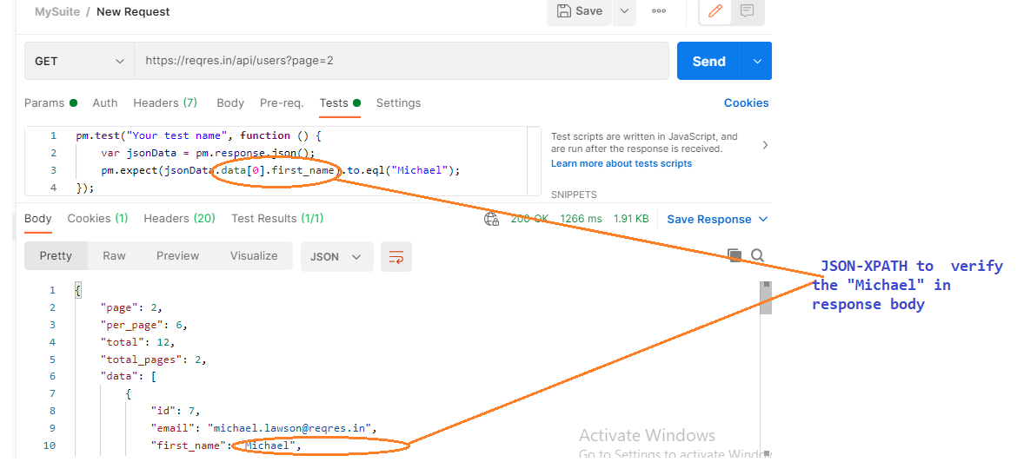

EG 2:

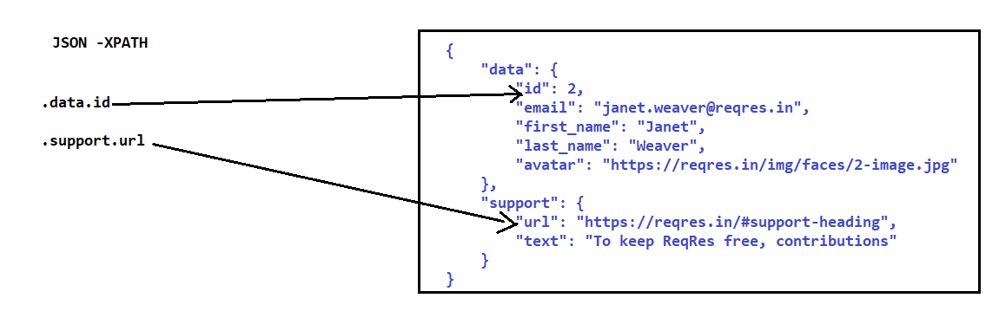

EG:3

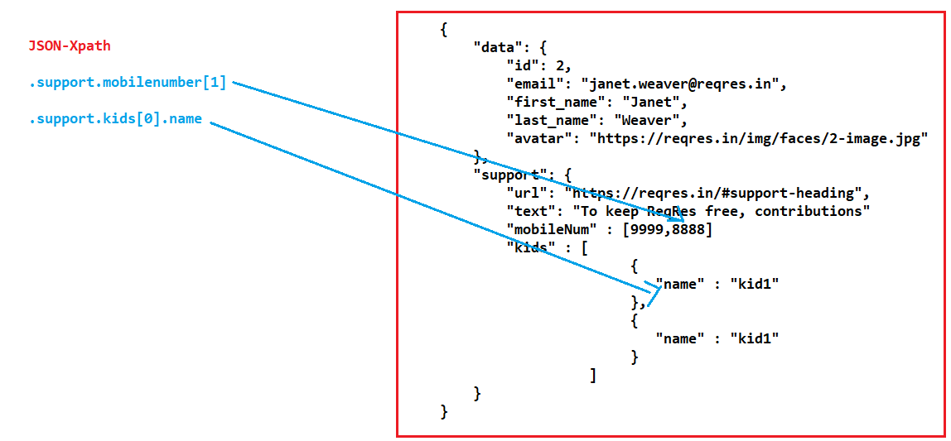

**What is Request chaining or Properties transfer or API Chaining?**

**How to Automate End-2 End Scenario in API testing?**

Getting the data from one response API & pass same data to another request API is called Request Chaining

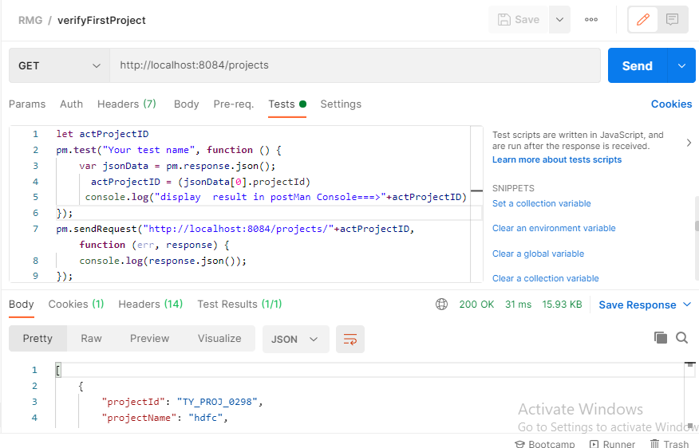

EG : 2

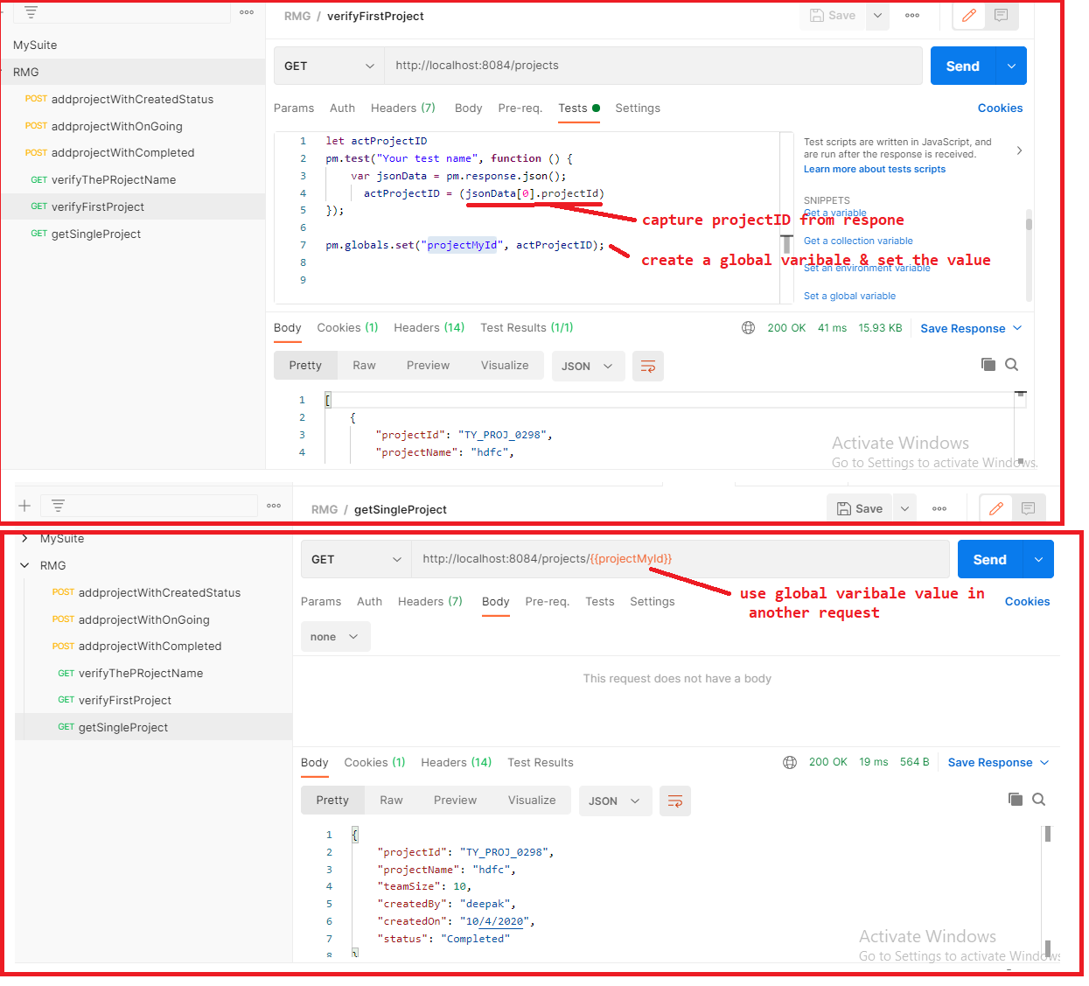

EG :3

