**Request Data Parameters**

**There are 2 types of parameter**

1. Path parameter: used to set the resource path / End point, then we can execute API request with different values

2. Query parameter: used to set the query string, then we can execute API request with different filter criteria.

3. form Parameter : used to set the request body in the from key & value pair

* **Path parameter**: it is used to set the recourse path or end point in the URI. Using path parameter, we can execute same API with different parameter/values.

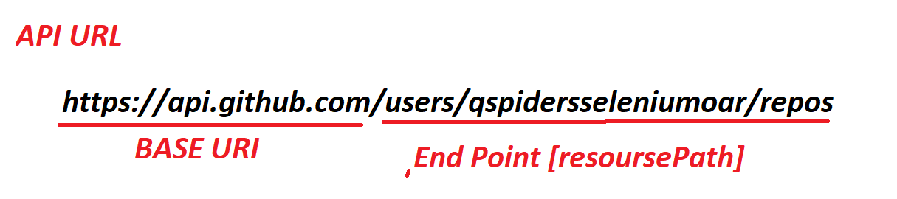

EG 1 : API Request without path parameter



API request after using Path parameter :

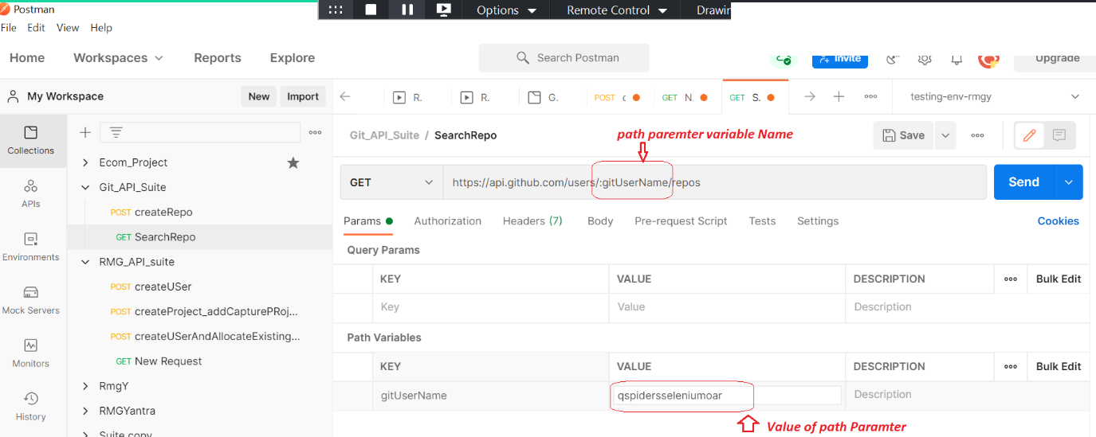

Advantages: without changing the URI, we can execute same API request with different data

EG 2 :

<https://api.github.com/search/repositories?q=DeepakHR&sort=updated>

<https://api.github.com/search/users/?q=qs;pidersseleniumoar>

After Path Parameter

EG : <https://api.github.com/search/:pathPram?q=DeepakHR&sort=updated>

* **Query parameter**: It always in the form of key value pair followed by ‘?’. It is always present at the end of the URL. It’s used to search & filter the recourse via API

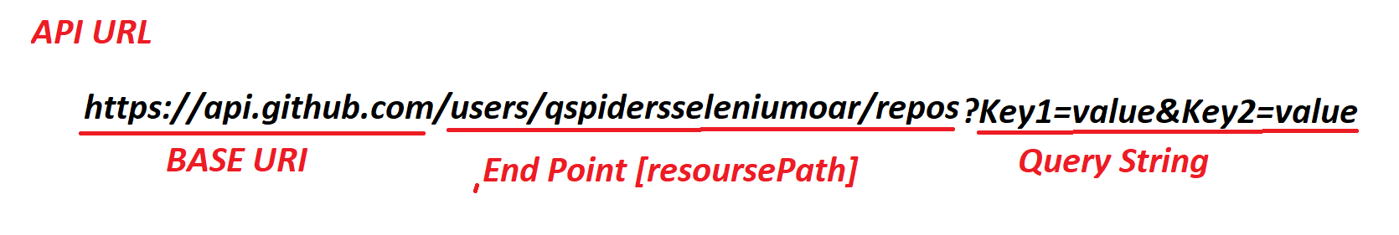

EG 1 :

<https://api.github.com/users/qspidersseleniumoar/repos?sort=created>

: its should list all the repository based on creation

<https://api.github.com/users/qspidersseleniumoar/repos?sort=fullname>

: its should list all the repository based on alphabetical order

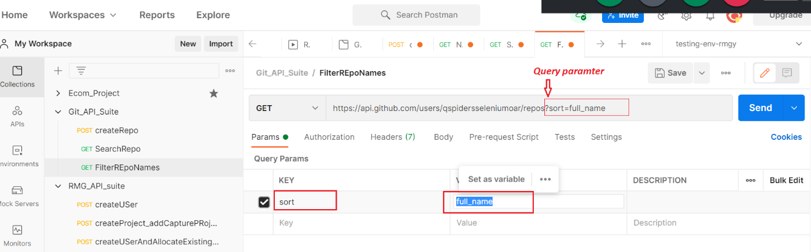

EG : https://api.github.com/search/users

QueryParam1 = DeepakHR

sort = updated

**In below Example , We can see the API where we can have both Path Parameter & Query Parameter**

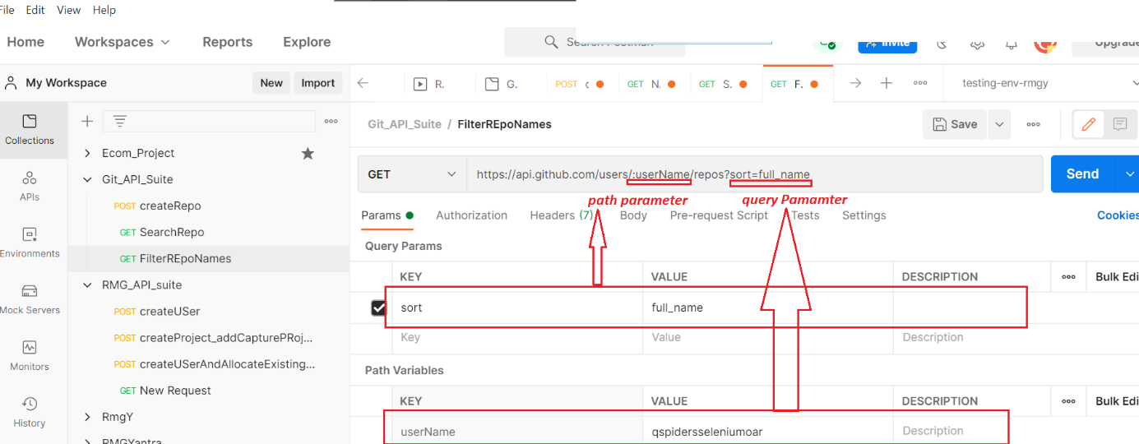

* **Form Parameter:** to pass completer request body in the form of form parameter , & form parameter will be always set in the form key & value pairs

