**Http Structure**

* Http protocol also as structure and its consists of header & body part separated by empty line
* In order the view the http request & response structure we go for Fiddler tool (developer debug tool)

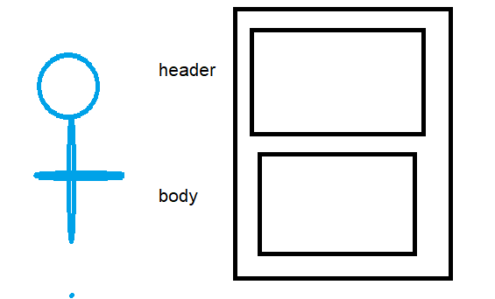

**Key Elements of Http-request & Http-response**

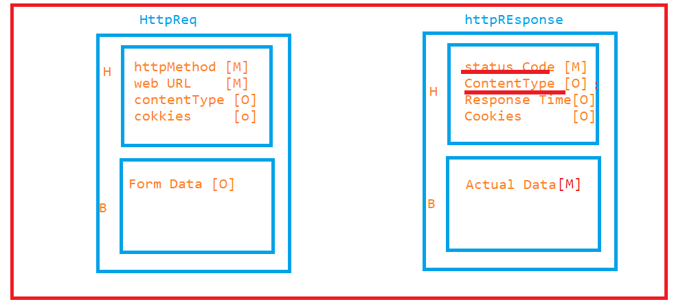

**Http method:**

* It is a mandatory information present in the header of the http Request
* http method is the first element in the http request, used to specify the type of the request which is sent by client(Browser) to Server(Application)
* http-1.0 has 3 methods, but in http-1.1 five more methods got introduced
* Get 🡪 get resource from the server
* Post 🡪 create resource inside the server
* Put 🡪 complete update resource inside the server
* Patch 🡪 partial update the update resource inside the server
* Delete 🡪 delete the existing resource inside the server
* Trace
* Option
* Head
* Connect

**Note: First http methods play major role in WebService testing**

**WebURL:**

* Mandatory information in header of the request
* It’s used to identify the specific web Resource inside the web application
* In get : Query will be present in URL
* In Post : Query will be present in the Body of the Request

Syntax

protocal://<domainName>:port/resourcePath?queryString#fragementId

EG :

<http://localhost:8888/index.php>

<http://google.com/search?q=iphone11>

<http://172.217.160.142/search?q=iphone11>

**Form data :**

* Data collected using htmlForm is called form data **or** datacollected from browser to server
* Size of the form will vary form to form
* Get -> will not have form data
* Post-> will have form data

**Status Code**

* It is a mandatory information present in header of the response.
* Status code represent the status of the http request

EG

|  |  |
| --- | --- |
| **Status Code** | **Description** |
| 100 | Continue |
| 200 | Server successfully the handled the request |
| 300 | Re direction request |
| 400 | Client side error(requested resource not found at server side) |
| 500 | Server side error(Server encounter an unexpected condition) |

**Content type:**

* Its an optional information present in the response body
* Used the specify the content of the data present in the response body
* Every file will have dedicated contentType (MimeType)

EG :

application/json : .json

application/xml : .xml

application/zip : .zip

image/png :.png

……

**Actual data:**

* It’s an optional information present in the response body
* Actual data responded by server, if in case request is successful. otherwise server provides error message in the body of the request

**Fiddler Tool [API debugging tool ]**

* ***The Fiddler tool helps you debug web applications by capturing network traffic between the Internet and test computers. The tool enables you to inspect incoming and outgoing data to monitor and modify requests and responses before the browser receives them.***
* ***It is a debugging tool where we can view http request and response data/property.***

***Download from***

[**https://www.telerik.com/download/fiddler/fiddler4**](https://www.telerik.com/download/fiddler/fiddler4)