

Department of Systemics

School Of Computer Science

UNIVERSITY OF PETROLEUM & ENERGY STUDIES,

DEHRADUN- 248007. Uttarakhand

**Project Title**

**HomeBites:** Home Cooked Food Ordering Service

**Submitted By**

**Name:** Radhika Khanna

**SAP ID:** 500086925

**Roll Number:** R2142201848

**Batch:** B4 (CCVT)

**Submitted To**

Prof. Saurabh Shanu

***CONCEPT NOTE***

**Introduction:**

We all miss our mom when we are away from them, or when we are in our hostels and a major part of that is because we don't get flavourful suppers prepared by our mothers in our grounds. This undertaking will be a Food Delivery Service, which conveys and advances just home prepared food. There are such countless motivations to eat food which has been cooked at home, it's amazing that we aren't all doing it at minimum a portion of the time. First of all, research shows that consistently eating home-prepared dinners is connected to healthier and more joyful life. Apart from college students, our focus is also on bachelors who have to stay away from their hometown on account of their working environment imperatives, so even grown-ups receive impressive rewards from eating home-prepared suppers. Research finds that individuals who eat home prepared dinners consistently will generally be more joyful and better and devour less sugar and handled food sources, which can bring about higher energy levels and better psychological wellness.

The objectives of this project are to:

* Develop a food delivery application that delivers home cooked meals to the customers.
* Deployment of the application on cloud.

**Technical Specification:**

Frontend: HTML + CSS + JavaScript

Backend / Server-Side Scripting: Node.js

Database Design and Administration: MongoDB

Software Requirement: Visual Studio Code

**Cloud support:**

Reasons for using cloud support in this project are detailed below:

* Scalability: Cloud computing allows for easy scaling of resources as the need arises, which can be important for this as it may require large amount of processing power and storage capacity for example, when large amount of orders are being placed at the same time.
* Reliability: Cloud-based systems are often more reliable than on-premise systems, as they have built-in redundancy and are fault tolerant.
* Flexibility: Cloud computing allows the use of different types of resources, such as virtual machines, containers, and serverless functions, which can be useful for this project as it may require different types of resources at different times.
* Cost-effective: Cloud computing can be more cost-effective than on-premise systems, as it allows for the use of resources on a pay-as-you-go basis, without the need for large upfront investments.
* Security: Cloud providers offer a variety of security options that can be used to protect data. This is important for our application because it consists of as it may involve personal details of the customers.

***LITERATURE REVIEW***

In [1] An online food ordering system has been proposed to the audience, which provides a food menu as well as ways to keep track of the orders placed by them. It provides feedback as well as payment interface where the payments can be made online as well as through pay-on-delivery. The proposed system has used a dynamic Database System and Internet of things.

In [2] A simple web-based application has been developed where the restaurants as well as the customers can keep track of the orders. The proposed model has used PHP, HTML, JavaScript for their development with MySQL as the database.

In [3] The goal of this research project is to streamline the restaurant patrons' dining experience by automating the ordering of meals. The design and implementation of an automated food ordering system for restaurants that includes real-time consumer feedback (AOS-RTF) are covered in this essay. The wireless data access to servers is implemented by this system.

In [4] The design and execution of digital dining using Android technology in restaurants is covered in this article. The system retrieves all the data from a centralized database and is a simple dynamic database utility system. This technology is less expensive because it just requires a one-time investment in devices and successfully addresses the shortcomings of past automated meal ordering systems.

In [5] It is demonstrated how to integrate hotel management systems using web services technology. The Digital Hotel Management holds the ordering system, billing system, and customer relationship management system (CRM) together. This approach made it possible to add or extend hotel software systems in environments with any size hotel chains.

In [6] The proposed system is a food ordering web-based application. PHP and JavaScript-based application software for PDA user interface and connectivity with a centralized database on a server or PDA client.

***FLOWCHART***

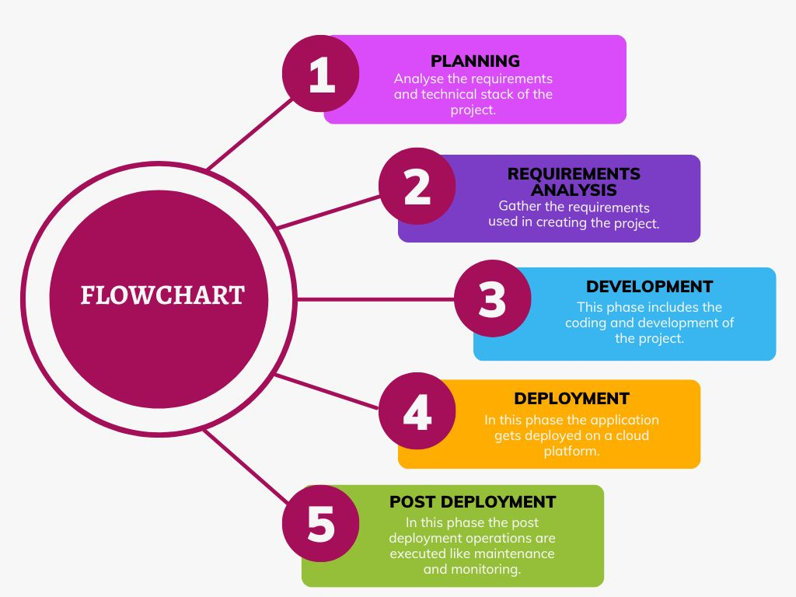

***REFERENCES***

[1]. Adithya, Roshan & Singh, Abhishek & Pathan, Salma & Kanade, Vaishnav. (2017). Online Food Ordering System. International Journal of Computer Applications. 180. 22-24. 10.5120/ijca2017916046.

[2]. Riddy, Jannat & Rajee, Alimul & prokashpal752@gmail.com, & abdulhashem109904@gmail.com,. (2022). ONLINE FOOD ORDERING SYSTEM.

[3]. Tanpure, Shweta Shashikant, Priyanka R. Shidankar and Madhura Joshi. “Automated Food Ordering System with Real-Time Customer Feedback.” (2013).

[4]. Shinde, Resham, Babasaheb Bhimrao Ambedkar, Priyanka Thakare, Neha Dhomne and Sushmita Sarkar. “Design and Implementation of Digital dining in Restaurants using Android.” (2014).

[5].  Ashutosh Bhargave, Niranjan Jadhav, Apurva Joshi, Prachi Oke, Prof. Mr. S. R Lahane. “Digital Ordering System for Restaurant Using Android” International Journal of Scientific and Research Publications, 2013.

Prachi Oke, S. R Lahane,“Digital Ordering System for

Restaurant Using Android”, International Journal of

Scientiﬁc and Research Publications 2013.

Prachi Oke, S. R Lahane,“Digital Ordering System for

Restaurant Using Android”, International Journal of

Scientiﬁc and Research Publications 201

[6]. Khairunnisa K., Ayob J., Mohd. Helmy A. Wahab, M. Erdi Ayob, M. Izwan Ayob, M. Afif Ayob. “The Application of Wireless Food Ordering System.” MASAUM Journal of Computing, September 2009.