Technical Design Document (TDD)
Scheme Rule Simulation Engine (SRSE)
Standalone eligibility simulation and data-reconciliation product
Version 1.3 | 22 September 2026 | Status: For review
Editable diagrams: docs/SRSE_Functional_Workflows.pptx
Business requirements: docs/SRSE_BRD.docx
(First deployed in the Rajasthan SMART programme; readable without prior SMART knowledge.)

1. Purpose and audience
This Technical Design Document (TDD) explains what the Scheme Rule Simulation Engine (SRSE) is, how it is built, and how it behaves at runtime. It is written so that readers who are not part of the SMART programme—and who may never have seen the SMART web portal—can still understand SRSE as an independent software product.
SRSE can be deployed against any Presto-compatible lakehouse and operational database that meets the interfaces described here. Its first production use is in the Government of Rajasthan SMART initiative, but the architecture deliberately avoids tight coupling to portal code or release trains.
Primary readers: enterprise architects, security reviewers, integration teams, vendor engineers, and programme managers. Secondary readers: backend/frontend developers and lakehouse administrators performing installation and configuration.

2. About SRSE — system overview
SRSE (Scheme Rule Simulation Engine) is a self-contained web application that helps government departments estimate how many citizens would qualify for a welfare or subsidy scheme if eligibility rules or numeric thresholds were changed—for example lowering an income cap or adding an age band. Instead of requesting custom database scripts or spreadsheet extracts for every policy question, authorised users compose rules in a guided user interface and receive counts and breakdowns within minutes.
The product has two major capabilities. Rules simulation lets users build boolean eligibility conditions from a curated list of citizen attributes (age, income, domicile, social category, and similar fields), run what-if previews, save named scenarios, and compare two scenarios side by side. Analysis (record matching) lets users align two registered datasets—such as a source register and a golden beneficiary table—using exact or fuzzy column matching, including multi-column name logic, to support reconciliation and quality checks at scale.
SRSE is delivered as two cooperating containers: a browser-facing application (Next.js) and an API server (Java Spring Boot). It maintains its own small operational database for configuration, saved scenarios, and lakehouse registration metadata. All heavy counting and matching work executes as SQL inside the lakehouse query engine (Presto over Iceberg tables), so national-scale populations are handled without loading entire tables into the application server.
Privacy and proportionality are built into the design: routine simulation returns aggregates only (totals and fixed breakdown dimensions). A separate, strictly capped API can return a small sample of matching individuals for sanity checks—not the full eligible population.

2.1 Who uses SRSE
Role | Typical tasks
Policy / scheme officer | Adjust thresholds, preview beneficiary counts, save and compare scenarios
Data steward / administrator | Register lakehouse tables, map business fields to physical columns, export/import configuration
Integration engineer | Connect DB2 and Presto endpoints, deploy containers, configure SSO

2.2 Deployment modes
Mode | Setting | Behaviour
Local synthetic | DATA_MODE=synthetic | Docker Presto + seeded Iceberg beneficiary table; field mappings from DB2/seed YAML
Client live | DATA_MODE=live | On-prem Presto (watsonx.data) + Golden Layer; mappings must use four-part column paths
Auth (dev) | SRSE_AUTH_MODE=mock | POST /api/auth/mock-login issues JWT for STATE_OFFICER
Auth (prod) | SRSE_AUTH_MODE=rajsewadwar | RajSewadwar filter (payload parsing seam; fails closed until configured)

2.3 Repository layout (implementation)
- backend/ — Java 17 Spring Boot fat JAR (gov.rajasthan.smart.srse.*)
- frontend/ — Next.js App Router pages: /rules, /analysis, /admin456
- docker-compose.yml — local stack (DB2, Presto, MinIO, seed job, both app containers)
- docker-compose.client-dev.yml — profile override for live endpoints

3. Architecture diagrams
The figures in this section summarise how SRSE fits into a typical deployment. Each subsection explains the diagram in plain language. Editable versions of these views (for workshops or customer-specific naming) are in docs/SRSE_Functional_Workflows.pptx, Part B.

3.1 Logical deployment
At the highest level, users interact only with the SRSE web application in a browser. That application calls the SRSE API over HTTPS. The API is the single integration point for business logic; it never expects callers to run SQL directly.
The API server connects outward to two data stores. The operational store (DB2 in the reference deployment) holds SRSE-owned configuration: which fields exist, how they map to lakehouse columns, which tables officers may use, and saved simulation scenarios. The analytical connection targets Presto, which reads Iceberg tables that hold citizen/beneficiary data at scale.
Identity is provided by the organisation's SSO platform (RajSewadwar in the Rajasthan reference deployment). SRSE validates tokens and roles before allowing rule simulation. For laptop demos, a built-in mock login can stand in for SSO.
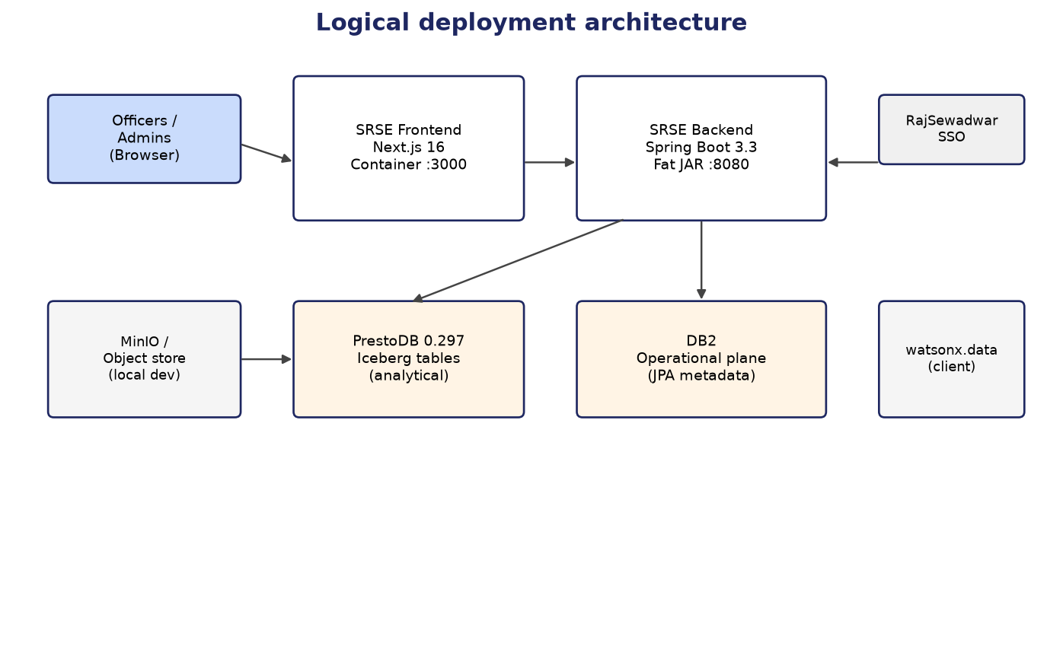
Figure 3-1: Containers and external systems

Figure 3-1 emphasises that SRSE is not embedded inside a larger portal container: it ships and scales as its own frontend and backend pair, which simplifies independent versioning and security review.

3.2 Dual data plane
A central design choice is the strict separation between operational data and analytical data. Operational data is small, transactional, and entity-shaped—ideal for an object-relational mapper (JPA). Analytical workloads are large set-oriented queries that must stay in the lakehouse engine.
Mixing these planes—for example, attempting to run beneficiary counts through JPA—would pull too much data into the application tier and break performance guarantees. SRSE therefore uses Spring Data JPA only for DB2 and raw JDBC (JdbcTemplate) only for Presto.
Officers and administrators never choose which plane to query; the product routes each request automatically. Saving a scenario touches DB2; previewing a ruleset touches Presto (after compiling the rule tree to SQL).
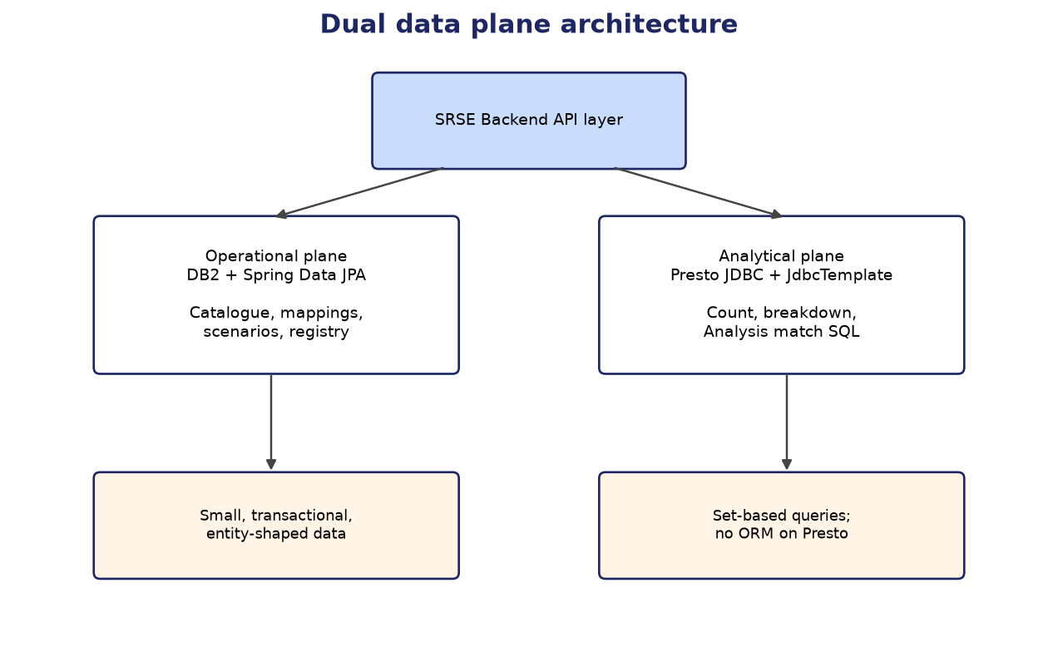
Figure 3-2: Operational vs analytical separation

Figure 3-2 should be read as a hard boundary: credentials, backup policies, and scaling characteristics differ per plane, and only the API layer spans both.

3.3 Backend modules
Inside the API server, responsibilities are grouped into modules (Java packages) rather than a monolithic service class. REST controllers accept HTTP requests and perform authentication checks; they delegate to domain services that encode business rules.
The compiler module turns JSON rule trees into SQL. The execution module runs that SQL on Presto. Metadata and lakehouse modules enforce which columns and tables are legal to reference. The analysis module builds match queries for the reconciliation UI. Security and configuration modules wire datasources, timeouts, and authentication filters.
This modular layout keeps the rule engine testable in isolation (unit tests compile real scheme examples without a browser) and allows future replacement of individual pieces—such as swapping the REST decision surface for an external rules engine—without rewriting unrelated code.
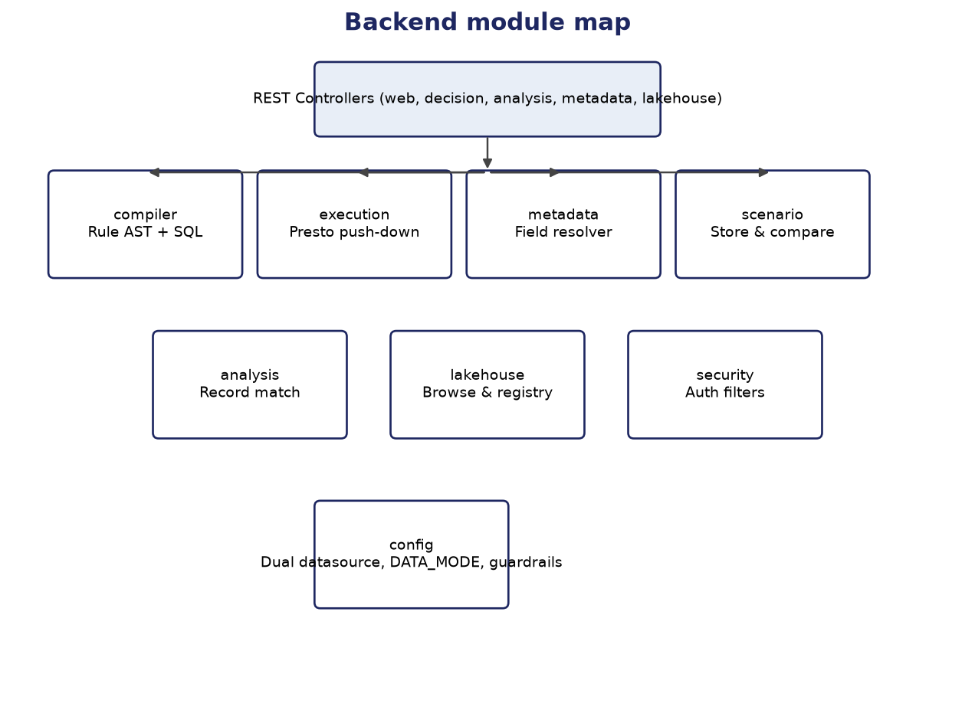
Figure 3-3: Spring Boot package responsibilities

Figure 3-3 is a logical map, not a deployment diagram: all modules run in one JVM process in the standard fat-JAR deployment.

3.4 Rule preview flow
Rule preview is the most frequent path through SRSE. A user adjusts a threshold in the Rules screen and asks for an updated count. The browser sends the entire ruleset JSON to the preview API; nothing is written to the operational database unless the user explicitly saves a scenario.
The server compiles the ruleset to a parameterised SQL statement. Field names in the UI (for example annual_income) are resolved to physical lakehouse columns through mappings stored in DB2. User-entered threshold values are sent to Presto as bound parameters, not as text embedded in SQL, which prevents injection of officer input.
Presto returns a single aggregate count and, optionally, grouped totals by district, gender, and age band. Those dimensions are fixed by product policy so that every scheme uses comparable breakdown views in the UI.
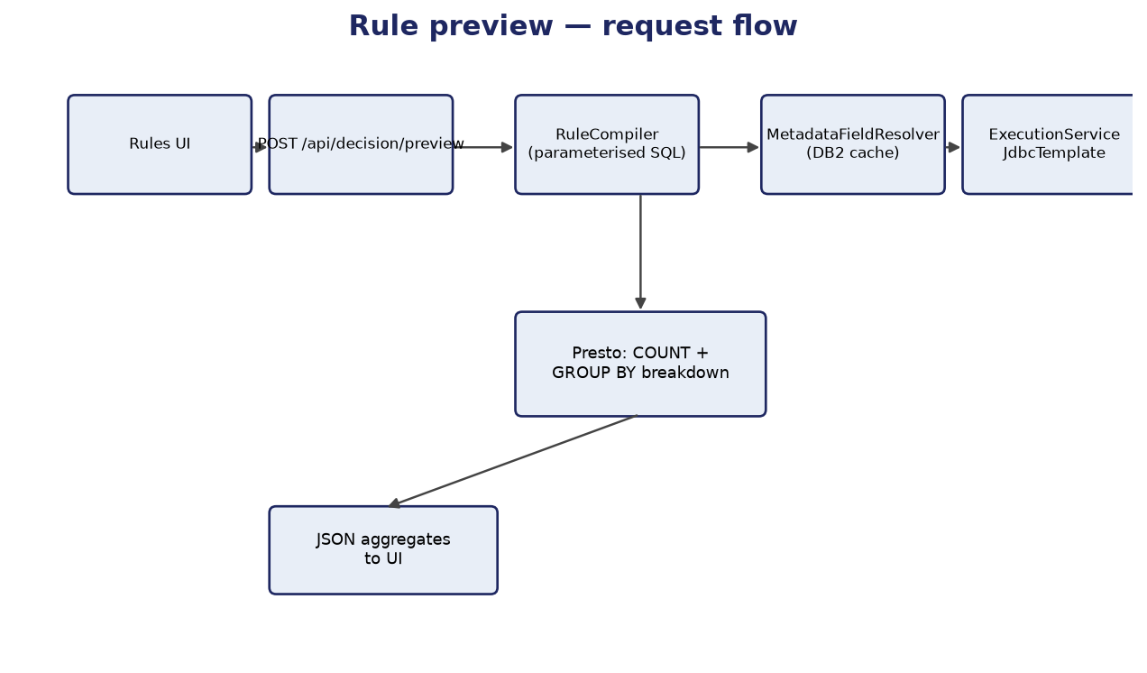
Figure 3-4: Preview request path

Figure 3-4 highlights that DB2 participates in preview only for metadata lookup, not for scanning beneficiary rows; all row-level scanning happens in Presto.

4. Technology stack

4.1 Application tier
Layer | Technology | Version / notes
Frontend | Next.js | 16.1.x
UI | React, HeroUI, Tailwind | 19.2.x / 2.4.x / 4.1.x
Client | TypeScript, Zustand, TanStack Table, Recharts | 5.6 / 5 / 8 / 2
Backend | Spring Boot | 3.3.4
Runtime | Java | 17 (enforced by Maven enforcer)
API docs | springdoc | /swagger-ui.html

4.2 Data tier
Component | Technology | Usage
Operational | DB2 + IBM JCC 11.5.8 | Spring Data JPA repositories
Analytical | PrestoDB 0.297 + presto-jdbc | JdbcTemplate only — no Hibernate dialect
Lakehouse | Iceberg on object storage | Silver/Gold beneficiary and related tables

5. Service catalog
This catalog lists the HTTP APIs, server-side services, and user-interface modules that constitute SRSE. It serves as the integration contract for teams connecting monitoring, API gateways, or alternate frontends. Method and path names match the implemented Spring Boot controllers unless noted in Section 5.7.

5.1 REST API — decision and scenarios
Method | Path | Controller | Purpose
POST | /api/decision/preview | DecisionController | Compile ruleset + count + optional breakdown (no persist)
POST | /api/decision/cohort | DecisionController | Capped row-level cohort sample (only row-level beneficiary API)
POST | /api/decision/scenarios | DecisionController | Save scenario + evaluate once + snapshot results
GET | /api/decision/scenarios | DecisionController | List scenarios for schemeId
GET | /api/decision/scenarios/{id} | DecisionController | Load scenario detail + ruleset JSON
GET | /api/decision/compare | DecisionController | Pairwise compare (a, b) — count and breakdown deltas

5.2 REST API — analysis and lakehouse (officer)
Method | Path | Controller | Purpose
GET | /api/analysis/limits | RecordMatchController | Server caps (targets, groups, columns)
POST | /api/analysis/match | RecordMatchController | Single match — NDJSON stream
POST | /api/analysis/match.csv | RecordMatchController | Full CSV re-run from Presto
POST | /api/analysis/match-multi | RecordMatchController | Hub vs N targets — NDJSON with per-target progress
POST | /api/analysis/match-multi.csv | RecordMatchController | Multi-target CSV (all-or-nothing)
GET | /api/analysis/lakehouse/catalogs/... | LakehouseCatalogController | Officer picker: registered cluster subset
GET/PUT/DELETE | /api/analysis/column-metadata | AnalysisColumnMetadataController | Per-column business name, fuzzy, compare-as, visibility

5.3 REST API — metadata and schemes
Method | Path | Controller | Purpose
GET/POST/PUT/DELETE | /api/metadata/fields | FieldCatalogController | Officer-facing field catalogue CRUD
GET/PUT/DELETE | /api/metadata/mappings | FieldColumnMappingController | fieldKey → physicalExpression per DataMode
GET/POST | /api/schemes | SchemeController | Welfare scheme tags for scenarios

5.4 REST API — administration
Method | Path | Controller | Purpose
GET | /api/admin/connections | ConnectionInfoController | Masked view of JDBC settings
PUT | /api/admin/connections/operational | ConnectionUpdateController | Update DB2 pool (+ optional override file)
PUT | /api/admin/connections/analytical | ConnectionUpdateController | Update Presto pool
GET | /api/admin/lakehouse/browse/... | LakehouseAdminController | Live cluster browse (admin only)
GET/POST/PUT/DELETE | /api/admin/lakehouse/registrations | LakehouseAdminController | Officer-visible table registry
GET | /api/admin/config/export | AdminConfigController | Download full JSON bundle
POST | /api/admin/config/import | AdminConfigController | Upsert bundle; ?testConnections=true default
GET | /api/health/planes | HealthController | operational + analytical UP/DOWN
POST | /api/auth/mock-login | MockJwtIssuer | Dev-only JWT (when auth-mode=mock)

5.5 Application services (backend)
Service class | Responsibility
RuleCompiler | Walk AST; emit parameterised SQL + ordered bind values
MetadataFieldResolver | Resolve fieldKey → physical column/expression; Caffeine cache; type coercion
ExecutionService | count(), breakdown(), cohortSample(); applies timeout and cohort cap
ScenarioService | Persist ruleset JSON; record/load/compare snapshots
RecordMatchService | Plan/build match SQL; single-target NDJSON/CSV; display columns; column groups
MultiTargetRecordMatchService | Validate hub; stream meta/progress/row/done; budget enforcement
LakehouseBrowseService | SHOW CATALOGS / information_schema with identifier validation
LakehouseRegistryService | Registered tables; validateColumn (registry + live)
FieldColumnMappingService | Upsert mappings; evict cache on change
AdminConfigService | Export/import JSON bundle; connection merge
OperationalConnectionService / AnalyticalConnectionService | Runtime Hikari reconfiguration
ConnectionOverrideStore | Persist connection-overrides.properties on disk

5.6 Frontend modules
Artifact | Role
app/rules/page.tsx | Rule builder, preview, scenarios UI
app/analysis/page.tsx | Match criteria, multi-target, streaming grid, CSV
app/admin456/page.tsx | Connections, lakehouse, mappings, JSON backup UI
lib/decisionApi.ts | preview, scenarios, compare; attaches mock JWT when needed
lib/analysisApi.ts | match, match-multi, limits, CSV helpers

5.7 Outstanding design and delivery activities
The following items are part of the target product design but require completion, external input, or formal sign-off before a production cut-over. They are listed here so programme and integration stakeholders can track dependencies without reading source code.
- Production SSO integration — configure RajSewadwar (or equivalent) JWT claim mapping to the STATE_OFFICER role; security filter shell exists and fails closed until completed.
- Officer cohort drill-down experience — server API enforces a hard row cap; user-interface workflow to invoke and interpret cohort samples to be finalised in the Rules module.
- Live lakehouse field bindings — populate LIVE-mode physical column paths once golden-layer table and column names are confirmed by the data platform team.
- Client integration testing and UAT — execute formal test packs against client Presto/DB2 endpoints and obtain departmental sign-off (see BRD acceptance criteria).

6. Runtime configuration (YAML and environment)
Primary file: backend/src/main/resources/application.yml. Spring profiles: local (ddl-auto update for dev), client-dev (no ddl-auto against real DB2). Environment variables override defaults at container start.

6.1 srse.* application properties
Property / env | Default | Meaning
srse.data-mode / DATA_MODE | synthetic | Selects FieldResolver bindings (SYNTHETIC vs LIVE)
srse.auth-mode / SRSE_AUTH_MODE | mock | mock | rajsewadwar
srse.datasource.operational.* / SRSE_DB2_* | local DB2 URL | JPA datasource (Hikari)
srse.datasource.analytical.* / SRSE_PRESTO_* | local Presto URL | JdbcTemplate datasource
srse.datasource.analytical-ssl.* | disabled | SSL trust store — only applied when enabled=true
srse.frontend-origins / SRSE_FRONTEND_ORIGINS | http://localhost:3000 | CORS allow-list
srse.guardrails.cohort-cap / SRSE_COHORT_CAP | 1000 | Hard ceiling for cohort drill-down rows
srse.guardrails.preview-sample-size / SRSE_PREVIEW_SAMPLE_SIZE | 50 | Default Rules UI sample size (not a second cap; clamped to cohort cap)
srse.env-label / SRSE_ENV_LABEL | (optional) | Display-only banner override (e.g. UAT)
srse.guardrails.query-timeout-seconds | 30 | Presto statement timeout
srse.analysis.max-target-sets | 5 | Multi-target limit
srse.analysis.multi-match-budget-seconds | 120 | Wall clock budget for multi match stream
srse.analysis.max-group-columns | 4 | Columns per side per match group
srse.analysis.max-any-of-groups-per-side | 2 | ANY_OF UNNEST cap per side
srse.breakdown.age-band-column | age_band | Physical column for fixed age_band breakdown
srse.connection-override-path | connection-overrides.properties | File for admin JDBC overrides

6.2 connection-overrides.properties
When an administrator updates JDBC settings via the UI or imports a JSON bundle with testConnections=false, ConnectionOverrideStore merges keys operational.* and analytical.* (jdbc-url, username, password, driver-class-name) into this file. ConnectionOverrideEnvironmentPostProcessor loads the file at boot so overrides survive restarts without storing credentials inside DB2 (which would be circular for the operational datasource). Operational plane changes may require application restart (ImportResult.operationalRestartRequired).

6.3 Boot seed (synthetic catalogue)
FieldCatalogSeedRunner upserts field_catalog and field_column_mapping from backend/src/main/resources/metadata/field-catalog-seed.yml on startup. LIVE-mode expressions may contain CHANGE_ME until Golden Layer names are supplied.

6.4 Environment display labels vs DATA_MODE
DATA_MODE (synthetic | live) is the only switch that changes which field_column_mapping rows the resolver uses and which Presto cluster answers analytical queries. It is unchanged on the wire and in application.yml.
- The UI banner (Development, UAT, Production (Live), or a custom label via SRSE_ENV_LABEL) is display-only — it must not be confused with DATA_MODE or with the Admin mapping editor's SYNTHETIC/LIVE binding-set radios, which select which mapping set is edited, not which environment the container runs in.
- Local laptops default to DATA_MODE=synthetic; client Dev uses live against on-prem Presto/DB2.

6.5 Lakehouse registration and officer addressing
Lakehouse objects are addressed as catalog.schema.table.column in LIVE bindings and Analysis SQL. The JDBC URL is catalog-agnostic; every identifier is fully qualified.
- Admin registration is per table with a mandatory layer tag (BRONZE/SILVER/GOLD/…) for new rows — layer is a display and registry filter tag, not a hierarchy level in SQL.
- Officer Analysis cascade: Layer → Catalog → Schema → Table → Column. Layer filters the registered-table list only; submitted match payloads carry catalog.schema.table, never layer.
- Legacy registrations with null layer remain reachable under the UNTAGGED sentinel in the officer cascade (filter only — not stored as a tag name).
- Admin live-browse (LakehouseBrowseService) reaches the whole cluster; officer pickers use LakehouseRegistryService only.

7. Admin JSON configuration bundle
The admin456 page exports and imports a single JSON document (AdminConfigBundle) via GET /api/admin/config/export and POST /api/admin/config/import. The bundle uses natural keys only (no DB2 surrogate ids) so it round-trips across fresh volumes and redeployments.

7.1 Schema version and top-level fields
JSON field | Type | Description
schemaVersion | string | Must be "1.0" (AdminConfigBundle.CURRENT_SCHEMA_VERSION)
exportedAt | ISO-8601 instant | Export timestamp
dataMode | string | DATA_MODE at export time (informational)
connections | object | operational + analytical ConnectionPlane
fieldCatalog | array | Active catalogue entries
fieldColumnMappings | array | fieldKey + dataMode + physicalExpression
registeredTables | array | catalog, schema, table, layer (SILVER/GOLD tag)
analysisColumnMetadata | array | Four-part column + business metadata
schemes | array | code, name, description for active schemes

7.2 Nested record definitions
Record | Fields
ConnectionPlane | jdbcUrl, username, password, driverClassName
FieldCatalogEntry | fieldKey, displayLabel, tier, dataType, groupName, allowedValues[], fuzzyMatchable
FieldColumnMappingEntry | fieldKey, dataMode (SYNTHETIC|LIVE), physicalExpression
RegisteredTableEntry | catalog, schema, table, layer
AnalysisColumnMetadataEntry | catalog, schema, table, column, businessName, fuzzyMatchable, visible, compareAs (AUTO|NUMBER|TEXT)
SchemeEntry | code, name, description

7.3 Export behaviour
- Connections: merges live Hikari settings with connection-overrides.properties if present.
- fieldCatalog: active rows only.
- registeredTables: all rows from registered_table entity.
- Response Content-Disposition: srse-admin-config-{date}.json

7.4 Import behaviour and ordering
Import runs in a single transaction (mapping cache evicted after). Order of application:
- 1. Validate schemaVersion.
- 2. connections — if testConnections=true (default query param), test and apply via connection services; else write override file only.
- 3. fieldCatalog — upsert by fieldKey.
- 4. registeredTables — LakehouseRegistryService.importRegistration per entry.
- 5. fieldColumnMappings — skip blank physicalExpression; require existing active field.
- 6. analysisColumnMetadata — upsert by qualified column.
- 7. schemes — upsert by code.
Response body: ImportResult with counts and lists of imported keys; operationalRestartRequired when operational JDBC changed.

7.5 Security and operational notes
- JSON contains database passwords in plain text — treat exports as confidential; restrict file storage.
- Import does not delete catalogue entries absent from the file; it upserts listed keys only.
- Re-import on production should use testConnections=true in a maintenance window.

7.6 Example skeleton (illustrative)
{
"schemaVersion": "1.0",
"exportedAt": "2026-09-20T10:00:00Z",
"dataMode": "live",
"connections": {
"operational": { "jdbcUrl": "jdbc:db2://...", "username": "...", "password": "***", "driverClassName": "com.ibm.db2.jcc.DB2Driver" },
"analytical": { "jdbcUrl": "jdbc:presto://...", "username": "srse", "password": "", "driverClassName": "com.facebook.presto.jdbc.PrestoDriver" }
},
"fieldCatalog": [ { "fieldKey": "age_years", "displayLabel": "Age (years)", "tier": "TIER1", "dataType": "NUMBER", ... } ],
"fieldColumnMappings": [ { "fieldKey": "age_years", "dataMode": "LIVE", "physicalExpression": "iceberg.gold.beneficiary.age_years" } ],
"registeredTables": [ { "catalog": "iceberg", "schema": "gold", "table": "beneficiary", "layer": "GOLD" } ],
"analysisColumnMetadata": [ { "catalog": "...", "column": "full_name", "compareAs": "AUTO", "visible": true, ... } ],
"schemes": [ { "code": "EKAL_NAARI", "name": "Ekal Naari Pension", "description": "..." } ]
}

8. Rule compiler and execution pipeline

8.1 AST model (compiler/Ast.java)
Rulesets serialise as JSON polymorphic nodes: GROUP (AND/OR + children) and PREDICATE (fieldKey, operator, value). Operators include EQ, NE, comparisons, IN, NOT_IN, BETWEEN, IS_TRUE/FALSE, IS_NULL/NOT_NULL, FUZZY_MATCH. No join nodes — flat catalogue only.

8.2 Compilation and execution
- RuleCompiler resolves each fieldKey through MetadataFieldResolver for current DATA_MODE.
- Emitted SQL uses ? placeholders; officer literals never appear in SQL text.
- ExecutionService runs COUNT query and optional GROUP BY breakdown (district, gender, age_band).
- cohortSample applies effectiveCohortLimit — caller cannot exceed SRSE_COHORT_CAP.
- Query timeout from GuardrailProperties applied to JdbcTemplate execution.

8.3 Preview count, cohort sample, and row shape
Preview (/api/decision/preview) returns aggregates only — total count and optional fixed breakdown dimensions (district, gender, age_band). Cohort (/api/decision/cohort) is the only endpoint that returns row-level beneficiary data, hard-capped by SRSE_COHORT_CAP; the response states the limit applied and whether the sample was truncated.
- The Rules UI default sample size is SRSE_PREVIEW_SAMPLE_SIZE (default 50), clamped to SRSE_COHORT_CAP — it is not a separate server ceiling.
- Cohort and preview sample queries deliberately use SELECT * on the beneficiary row for departmental users who need to sanity-check real records; narrowing projection requires an explicit product decision.

8.4 Scheme official criteria vs officer scenarios
Each scheme may nominate one saved scenario as its official template (scheme.template_scenario_id). Officers loading that template into the Rules builder start from official criteria but Save always creates a new scenario — existing scenario rulesets are write-once; there is no PUT/PATCH on /api/decision/scenarios/**. Only SRSE_ADMIN may change which scenario is the template (PUT /api/schemes/{id}/template).

9. Analysis design — record matching engine
The Analysis capability answers a different question from Rules simulation. Where Rules asks how many people satisfy a policy ruleset, Analysis asks which rows in dataset A correspond to rows in dataset B—and where they differ. Typical uses include reconciling a departmental register against a golden beneficiary table, finding duplicates under spelling variation, or validating that two lakehouse layers (often labelled Silver and Gold) refer to the same individuals.
From a stakeholder perspective, Analysis is a guided join builder: the user selects two registered tables, defines one or more match criteria (exact equality or fuzzy name match), optionally adds columns that should appear in the result but not affect matching, and runs the job. Results stream back progressively for responsiveness; very large result sets are downloaded as CSV generated directly from Presto so the user receives the complete match set, not merely what the browser could hold in memory.
The Analysis engine is implemented as server-side services (RecordMatchService for single source–target pairs, MultiTargetRecordMatchService when one hub table is compared against several targets in one session). Both share the same safety model: only administrator-registered tables and live-confirmed columns may appear in SQL; cross-type comparisons follow documented coercion rules so that, for example, numeric IDs stored as text still match sensibly.

9.1 What users can do in Analysis
- Match on one column per side, or on column groups (combined name fields, or match-if-any-of several columns).
- Choose exact match or fuzzy match (string similarity score exposed in results).
- Add display-only columns for context (e.g. show district on both sides without using it in the join key).
- Run multi-target mode: one central (hub) table matched independently to many target tables, with combined progress reporting.
- Export full results to CSV when on-screen grids would be impractical at crore scale.

9.2 Engine pipeline (technical)
Each run begins with validation: tables must be registered, columns must still exist in Presto, and group sizes must respect configured caps (maximum groups, ANY_OF groups, multi-target count, and wall-clock budget for long multi-target streams).
The planner constructs a two-table SQL query (never an N-way join for multi-target—each target is a separate query plan). Column groups emit specialised SQL: COMBINE folds multiple columns into one comparable string; ANY_OF uses an UNNEST pivot so Presto retains efficient join plans. Identifiers and catalog names pass allow-list checks before being embedded in SQL text; literal match values use parameter binding.
Execution streams newline-delimited JSON events to the client: metadata first, then progress, row payloads, completion or per-target errors. CSV endpoints discard the streaming UI path and pipe Presto output straight to the download. Emitted SQL shapes are validated in automated tests against the Presto 0.297 grammar parser to reduce risk of runtime syntax surprises.

9.3 Presentation-layer behaviour
- Browser grid and charts render up to 10,000 rows; beyond that the UI directs users to CSV.
- NDJSON consumption stops after 200,000 rows for browser stability; displayed counts may show as a lower bound while CSV remains complete.
- Multi-target CSV export is all-or-nothing—one failed target aborts the file so partial exports are not mistaken for full reconciliation.

9.4 Two-table join types (single match)
POST /api/analysis/match accepts joinType INNER (default), LEFT, RIGHT, or FULL for exactly two registered tables. Self-join is supported by picking the same table on both sides — no separate mode. POST /api/analysis/match.sql plans and returns display SQL without executing. Outer-join predicate routing (fuzzy and ANY_OF in ON, not WHERE) follows RecordMatchService; dedup is rejected with RIGHT/FULL.
- Multi-target mode (match-multi) remains INNER only — N independent hub↔target joins; arbitrary N-way joins are deferred.

9.5 Multi-target join canvas (Phase A)
The Analysis UI offers a join canvas view over the existing MultiTargetRecordMatchRequest — no new SQL or backend records. Hub node centre, target nodes, ordered edges (one per join criterion). Serialisation derives hubCriteria and each target's joinCriteria from the same ordered slot list so index alignment cannot drift. Per-target SQL appears on progress events with phase started (never on meta); planning failures may emit error without started; shared multiMatchBudgetSeconds may skip later targets with reason time budget.

9.6 Join-key suggestions
POST /api/analysis/suggest-keys returns metadata-first column pair hints (name/type heuristics). With probe=true the service samples the source table (TABLESAMPLE BERNOULLI), scans the target in full per pair, and ranks overlap — bounded by SRSE_ANALYSIS_MAX_PROBED_PAIRS and query timeout.

10. Operational data model (DB2 / JPA)
Entity | Purpose
FieldCatalogEntry | Officer-visible field definitions (tier, data type, allowed values)
FieldColumnMapping | Composite key: fieldKey + dataMode → physicalExpression
RegisteredTable | Admin-registered lakehouse table (catalog, schema, table, layer tag)
AnalysisColumnMetadata | Overrides per lakehouse column for Analysis UI
Scenario | Named ruleset JSON + linked scheme ids + result snapshot fields
Scheme | Scheme code/name; optional templateScenarioId for official criteria

Scenario ruleset stored as JSON using Ast.Node polymorphism for round-trip with the UI.

11. Security and authentication
Production access uses RajSewadwar SSO mapped to Spring authorities. SRSE_ADMIN gates live lakehouse browse, registration, field catalogue, JSON backup, and scheme template assignment. STATE_OFFICER reaches decision preview/scenarios, officer Analysis APIs, and read-only metadata needed to build rules.
- SecurityConfig enforces per-path roles; SecurityConfigRbacTest guards drift.
- SRSE_AUTH_MODE=mock is a development seam only (?role=admin mints tokens) — not production access control. Production role mapping binds in RajSewadwarAuthenticationFilter.grantedAuthoritiesFromSsoRoles (Aadhaar OTP / project dev team integration point).
- CORS: srse.frontend-origins must match browser origin (not Docker internal hostname).
- LakehouseIdentifiers + SHOW CATALOGS allow-list before interpolating catalog/schema in SQL.
- Analysis: registered table + live column existence required before column reaches SQL.

12. Locked architectural decisions
Decision | Rationale
Standalone microservice | Decoupled portal release cycle
Two data planes | JPA for metadata; JdbcTemplate for Presto set queries
PrestoDB 0.297 driver | watsonx.data lineage — not Trino
Flat catalogue / no JOINs in compiler | Tier-3 fields pre-materialised upstream
REST decision seam | DMN-shaped API; swappable authoring backend
Push-down execution | Counts never pull full populations into JVM

13. Related documents
- docs/SRSE_BRD.docx
- docs/SRSE_Functional_Workflows.pptx
- docs/CONFIGURATION_GUIDE.md
- CLAUDE.md
- docs/SRSE_PROJECT_PLAN.xlsx

14. Document history
Version | Date | Change
1.0 | 2026-09-20 | Initial TDD with architecture figures and stack tables
1.1 | 2026-09-20 | Detailed services, YAML/env config, JSON bundle spec; removed guardrails section
1.2 | 2026-09-20 | Stakeholder-oriented §2; narrative for §3 diagrams; Service catalog wording; Analysis engine intro; §5.7 delivery activities
1.3 | 2026-09-22 | Lakehouse layer filter; env labels; preview/cohort sample; join types; join canvas Phase A; suggest-keys probe; RBAC; scheme templates

