UNIVERSITY OF NORTHAMPTON
(NAMI COLLEGE)

REPORT ON WEB DEVELOPMENT (TERM 1)

NAME:ANMOL ADHIKARI
UNID=17425098

CONTENTS
- PROJECT DESCRIPTION
- WIREFRAMES
- DESIGNS
- PROJECT DEVELOPMENT
- GOOD PRACTICE
- CONCLUSION
- REFERENCE

PROJECT DESCRIPTION

THE PROJECT GIVEN TO US BY THE UNIVERSITY OF NORTHAMPTION ID THE ASSIGNMENT FOR TERM 1.THE PROJECT IS ABOUT THE DEVELOPMENT OF WEB PAGES THAT INCLUDE A HOMEPAGE, PORTFOLIO PAGE, BIO PAGE AND CONTACT PAGE WITH A FORM IN IT ALONG WITH ITS RESPECTIVE CSS FILES.THE PROJECT IS TO CREATE THE PAGES WITH THE REQUIREMENT FULFILLED AS GIVEN BY THE UNIVERSITY.FOR THE DEVELOPMENT OF THE PROJECT I LOOKED MANY PLACES PRIMARILIY THE SLIDES PROVIDED TO US BY THE UNIVERSITY IN THE LECTURE.I USED HTML5 AND CSS3 TECHNIQUE TO DEVELOPE THE PAGES AND ATOM WAS USED FOR THE CREATION.THE FIRST PART OF CREATING A WEBPAGE WAS TO CREATE THE WIREFRAMES SO TO GET THER BETTER IDEA OF HOW THE WEBPAGE WILL LOKE LIKE.

WIREFRAMES

THE WIREFRAME THAT WERE CREATED SO AS TO GET BETTER IDEA OF HOW MY PAGE WILL LOOK LIKE ARE PRESENTED BELOW

DESIGNS

AFTER THE WIREFRAME BEING DEVELOPED THE DESIGN WERE MADE MY BE REFERENCING DIFFERENT SITES AND PLACES.THE DESIGNS OF MY PAGES ARE GIVEN BELOW.

HOMEPAGE(INDEX.HTML)

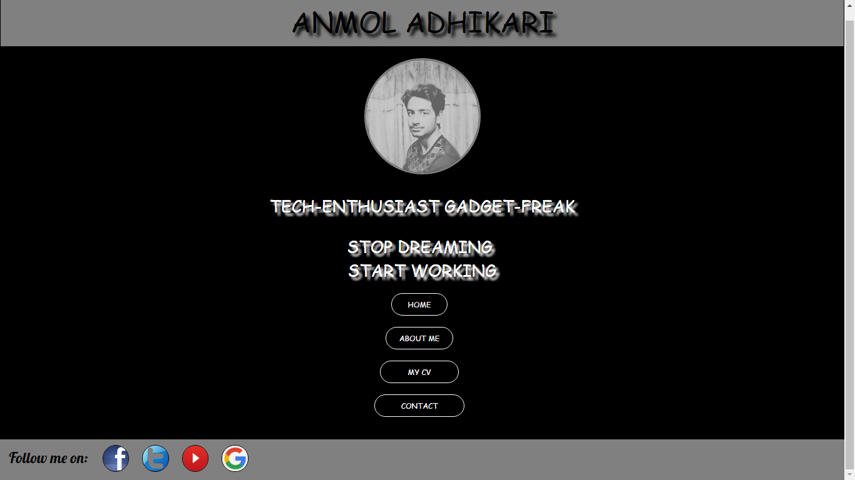

ABOUTME(BIO.HTML)

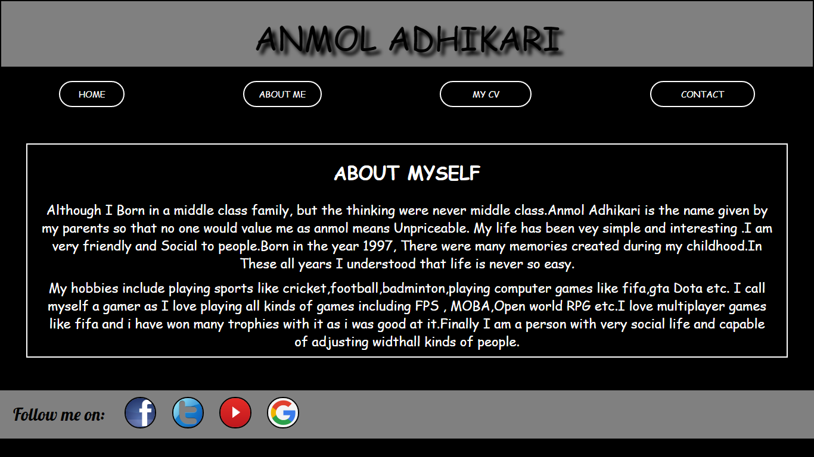

PORTFOLIO(CV.HTML)

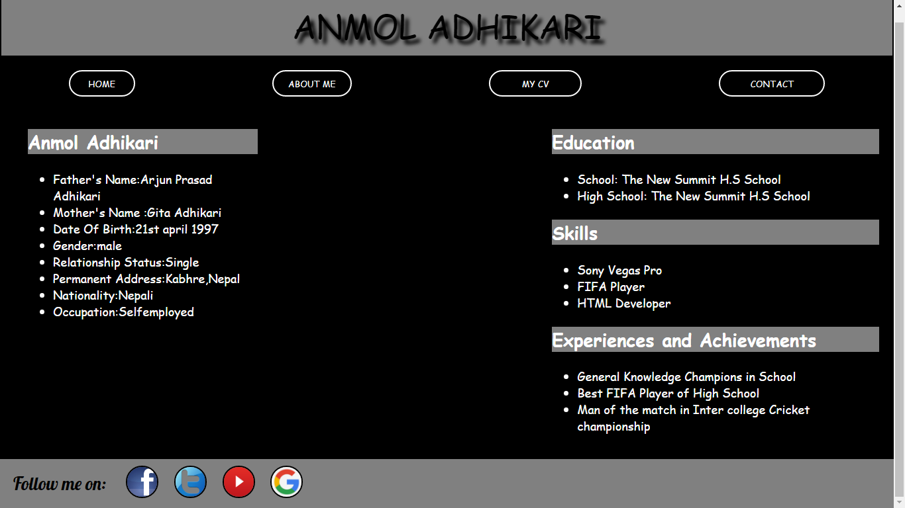

CONTACT ME (CONTACT.HTML)

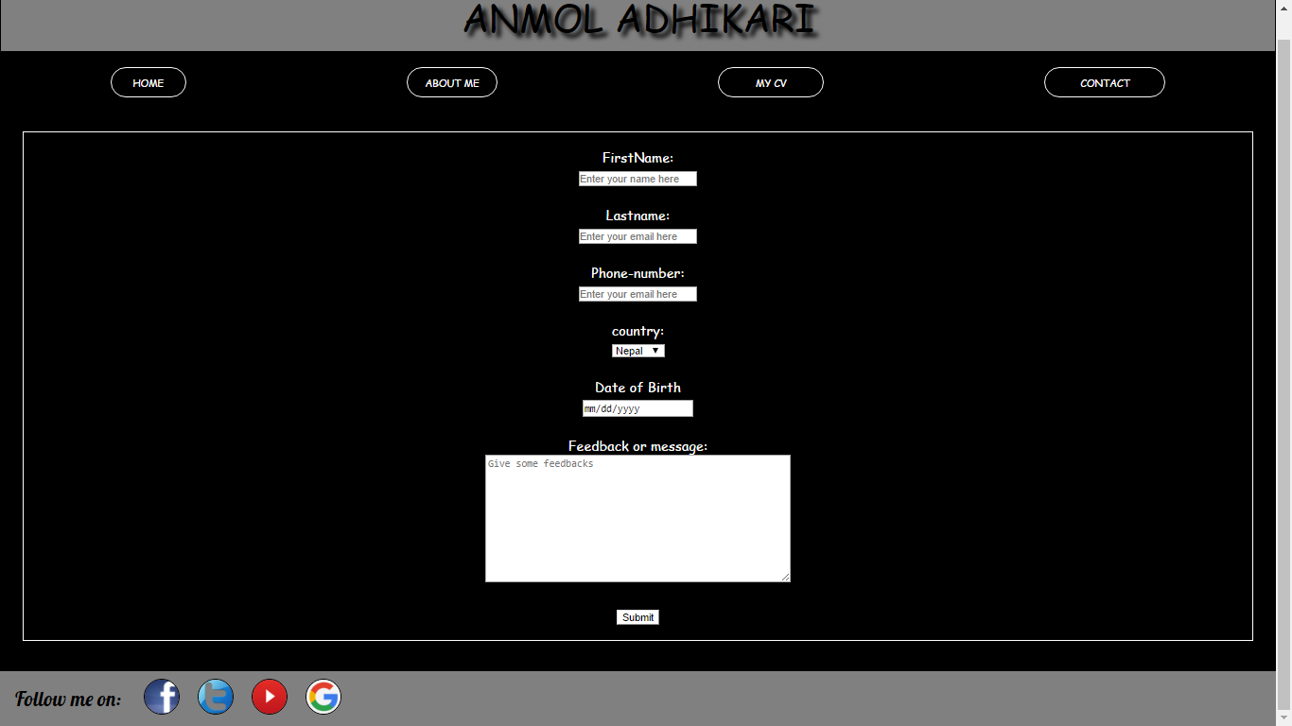

PROJECT DEVELOPMENT

THIS PROJECT WAS GIVEN TO US SO WE CAN DEVELOPE OURSELF AND BE SKILLFUL IN WEBPAGE DESIGNING AND GITHUB COMMANDS.FOR THE DEVELOPMENT OF THIS PROJECT I CREATED A REPOSITORY FIRST IN THE GITHUB WITH MY USERNAME AND THEN INITIALIZED THE FILES INTO THAT REPOSITORY.THEN I STARTED WORKING ON MY PROJECT BY CREATING HOME PAGE AT FIRST.DURING THIS PROCESS I HAD TO LOOK FOR MANY OTHER SITES LIKE W3SCHOOLS.COM,YOUTUBE.COM
AND OTHER SITED TO GET BETTER IDEA AND DEVELOP MY SITED NICELY.I TRIED TO INCLUDE MANY THINGS LIKE MATERIAL DESIGN CONCEPTS, NEW CSS3 ELEMENTS SO MY PAGES WILL LOOK GOOD.I TOOK HELP FROM MY FRIENDS AND MY LECTURER AS WELL.

WHEN I FIRST STARTED THE PROJECT, THE FIRST WEEK WAS TOUGH FOR ME AS THESE KINDS OF PROJECTS WERE NOT NEVER DONE BY BE DURING MY SCHOOL DAYS AND I HAD NO IDEA ABOUT DOING IT.THEN AFTER SOME TIME I BECAME USED TO THESE THINGS AND THE WORK WAS IN FLOW.FIRSTLY AFTER THE DEVELOPMENT OF MY WIREFRAME I MADE A DESIGN THAT WAS NOT SO APPEALING AND GOOD SO I CONSIDERED FOR ANOTHER DESIGN WHICH CAME OUT TO BE MY FINAL DESIGN.
THE TOTAL TIME TAKEN TO COMPLETE MY PROJECT WAS APPROXIMATELY 40HOURS.AFTER SEVERAL DIFFICULTY AND PROBLEMS I WAS ABLE TO CREATE MY FINAL MY WEB PAGE.

GOOD PRACTICE

- SPEEDTEST

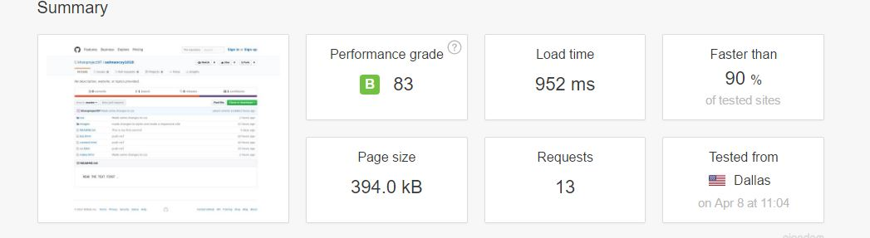

(PINGDOM.COM,2017)

- SOCIAL LINKS IN MY PAGE

IN MY SITE I HAVE INCLUDED THE LINKS TO SOCIAL SITED SO THE VISITORS CAN CONNECT TO OUR SOCIAL SITED AND FOLLOW US THERE

- VALIDATION TEST

TO FIND THE ERRORS IN THE HTML AND CSS FILES CREATED BY ME I CHECKED MY PAGES IN HTML VALIDATOR AT HTTPS://VALIDATOR.W3.ORG/ AND HTTPS://JIGSAW.W3.ORG/CSS-VALIDATOR/

CONCLUSION

SO FINALLY THE PROJECT WAS COMPLETED WITH THE GIVEN REQUIREMENT OF THE UNIVERSITY .MY PROJECT FULFILLS ALL THE REQUIREMENT AND NECESSARY COMPONENTS.

REFERENCE

W3SCHOOLS(2017).AVAILABLE FROM:HTTP//:WWW.W3SCHOOLS.COM.[ ACCESSED 8TH MARCH 2017]

PINGDOM(2016).AVAILABLE FORM:HTTP//:TOOLS.PINGDOM.COM[ACCESSED 15TH MARCH 2017]

GTCODING(2016).HTML5 AND CSS3 TUTORIL.AVAILABLE FORM HTTP//:YOUTUBE.COM/GTCODING (ACCESSED 8TH MARCH 2017)

