AWS: Lambda
Step1:- Open Lambda dashboard and click right on create function
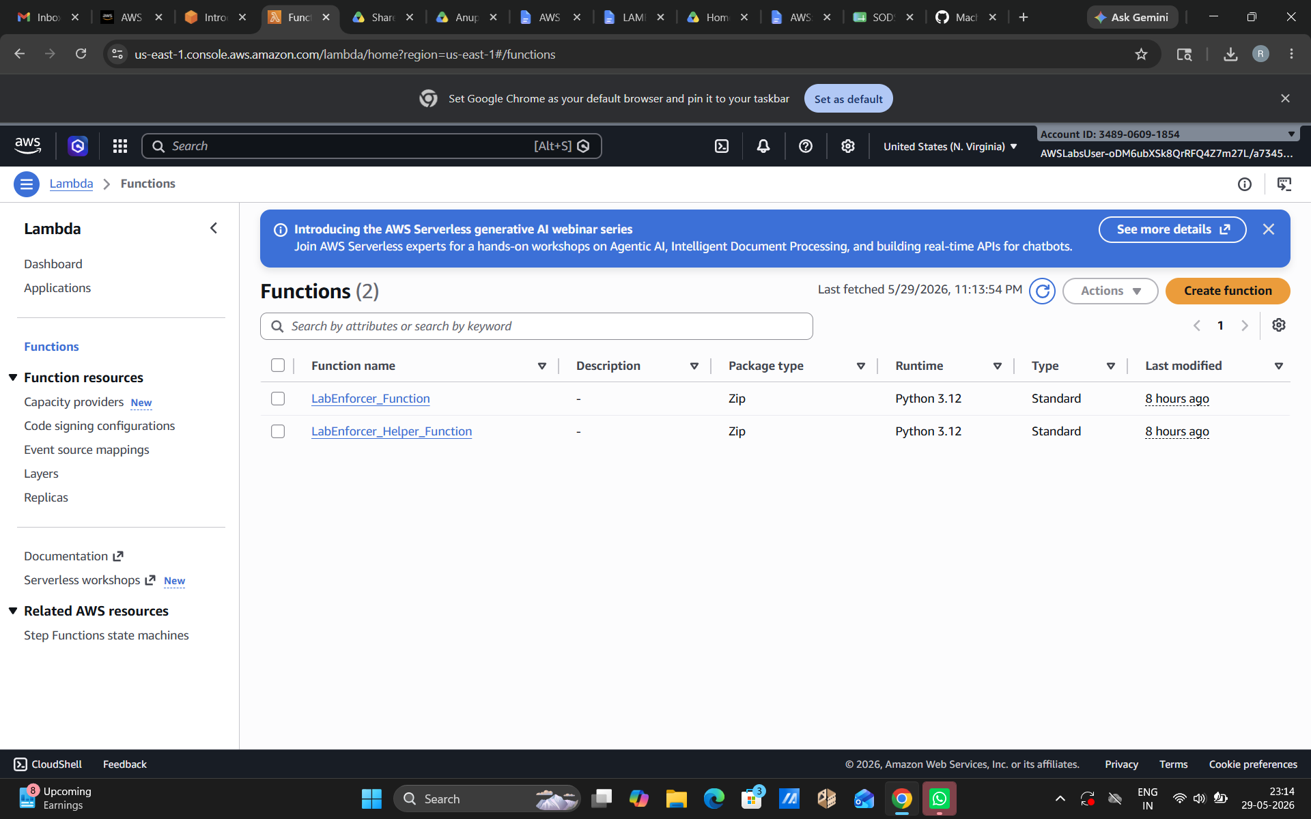

step2
Create your function. We will select ‘Author from scratch’ in which we have to create the code for it from scratch. Then fill the name which you want to your function and then select the runtime.
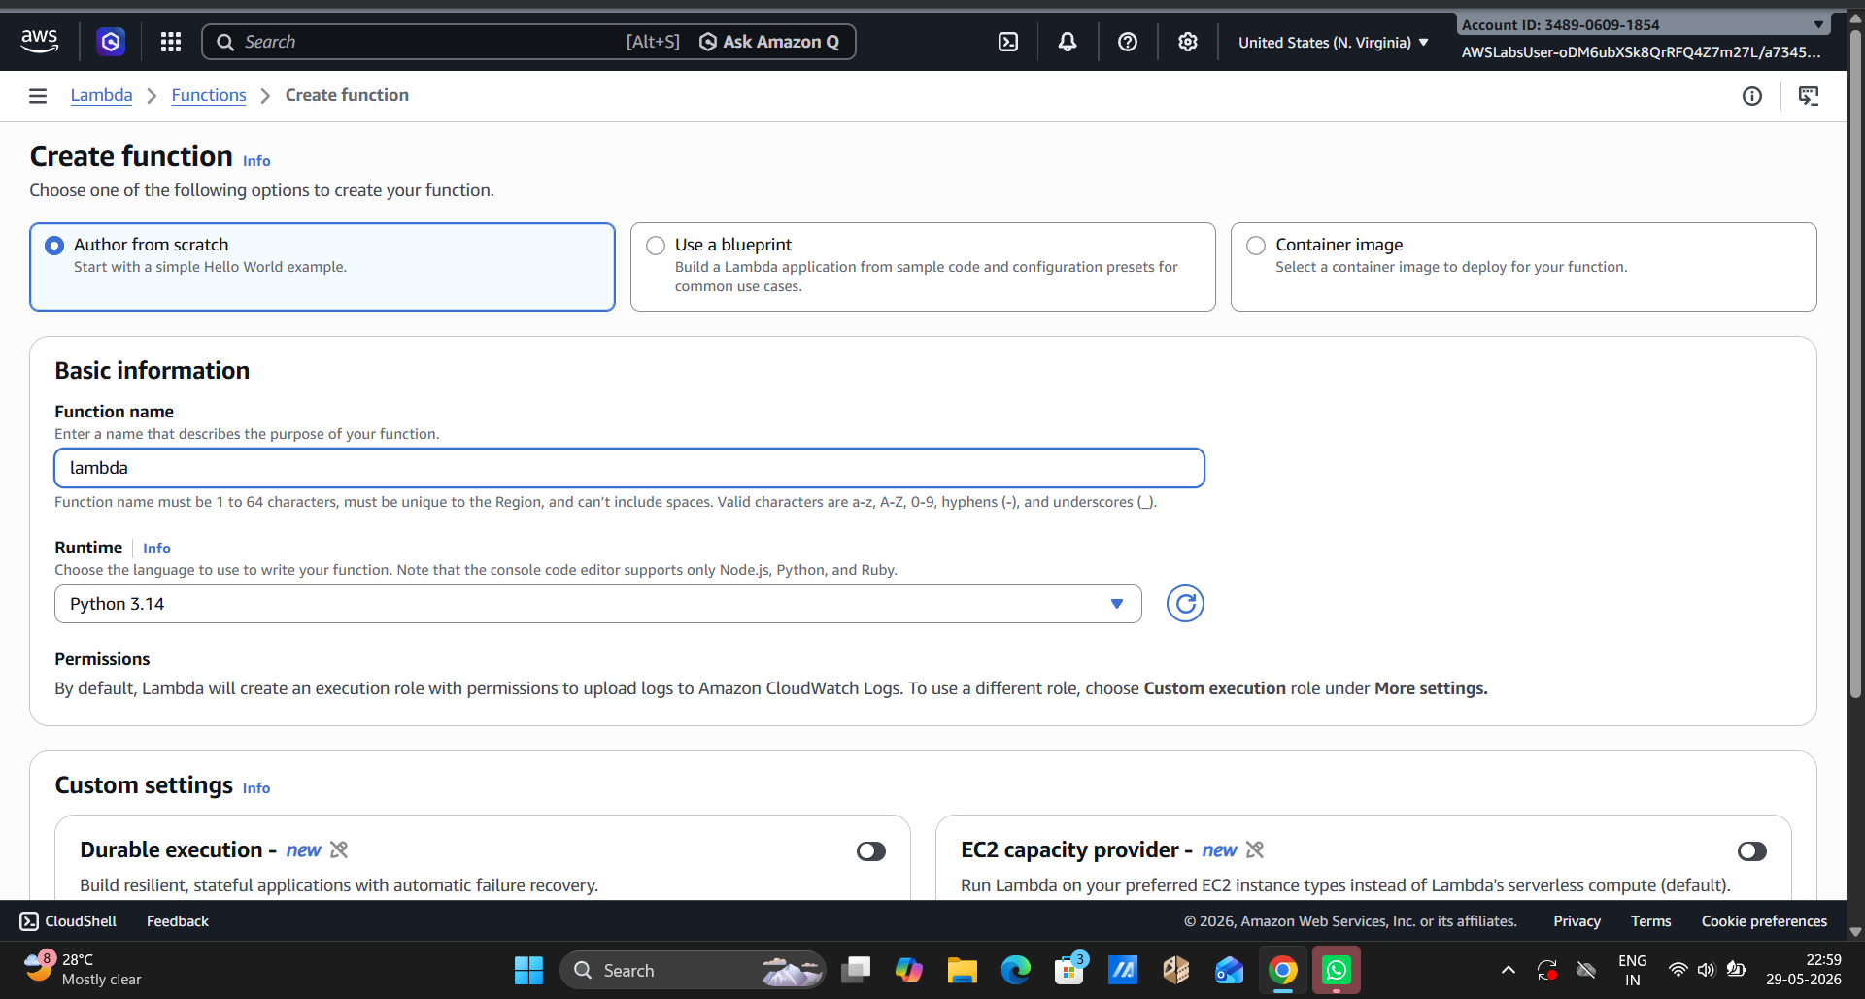

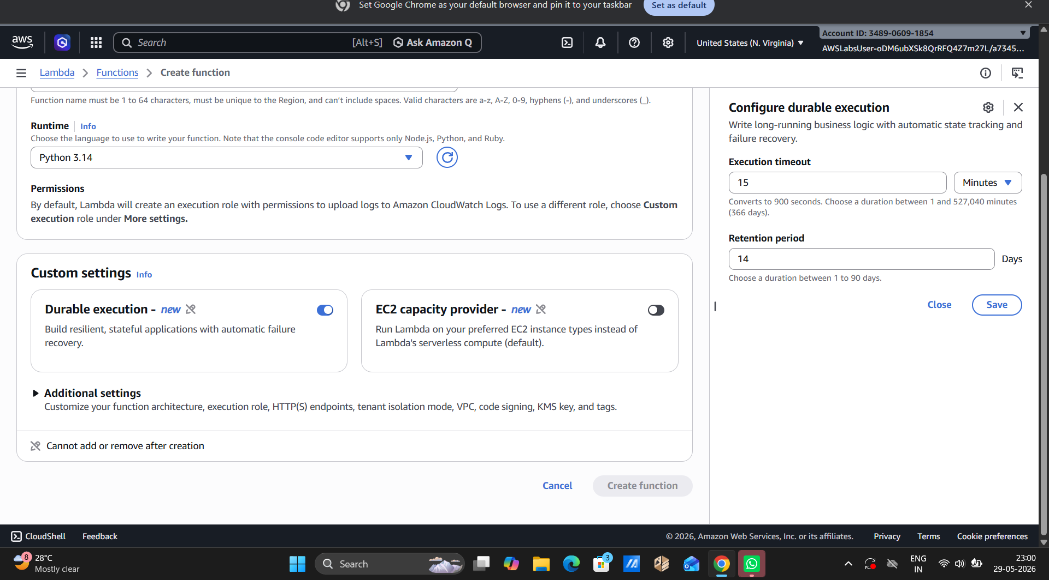

Step 2:
After the function was created successfully, a getting started popup appeared, click on dismiss. Then you can see the Code Source Editor which had a default Hello World code already written in it using Python.
Step 3:
create a Test Event by giving it a name and selecting the Hello World template. The event JSON was auto-filled with some sample key-value pairs. Save the test event and it will be confirmed with a green success message.
Step 4:
Invoke the function using the test event. The output panel will showe the execution result with status Succeeded and a text which says:
{ "statusCode": 200, "body": "Hello from Lambda!" }
This will confirm you that the Lambda function is working correctly and deployed successfully.

1. Author from Scratch
You write the entire function code yourself from scratch
Best when you want full control and custom logic
2. Blueprint
AWS gives you a pre-written sample code as a starting template
Best when you're a beginner or need a quick starting point for common tasks (like S3 triggers, DynamoDB, etc.)
3. Container Image
You upload your function as a Docker container image
Best when your code has heavy dependencies or you want to package everything together

AWS Lambda is used to run code automatically in response to events, without managing any server, making it ideal for APIs, file processing, scheduled tasks, and real-time applications.

