AWS: SES (Simple email service)
Step 1-
Go to your SES dashboard . To add an user then go to ‘identities’ and click ‘create identity
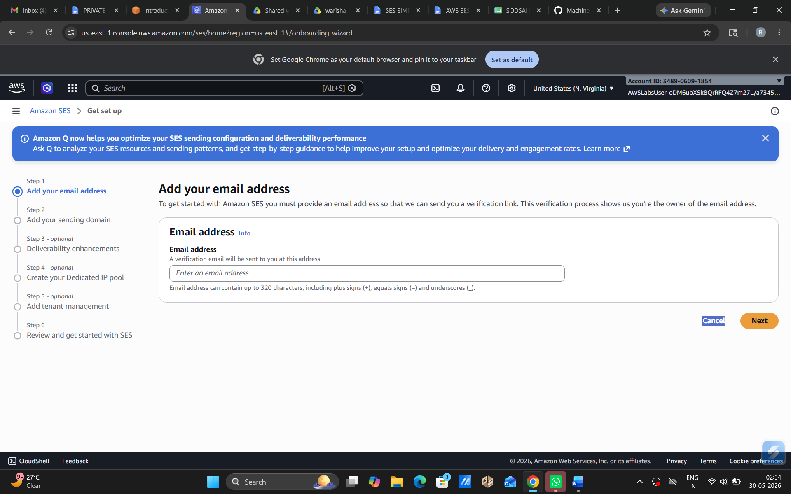

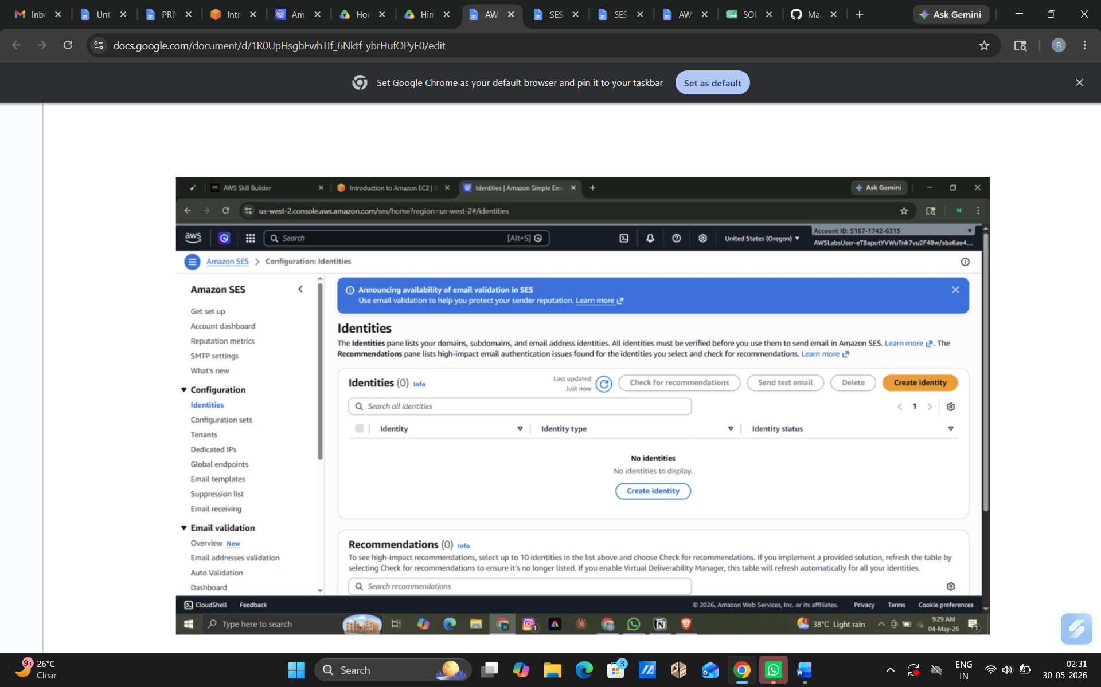

STEP 2-
Now select all the identity details. If you have a domain of your own then you can select domain as the option and fill the details. If you don’t have a domain you can use email address. Select email as option and then write down the email to which you want to send the email to. Then click on ‘create identity’.
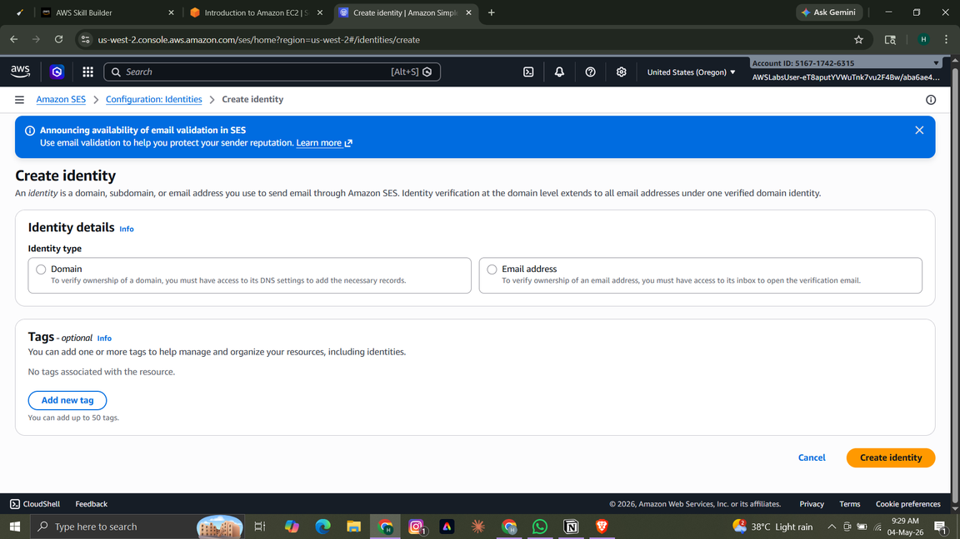

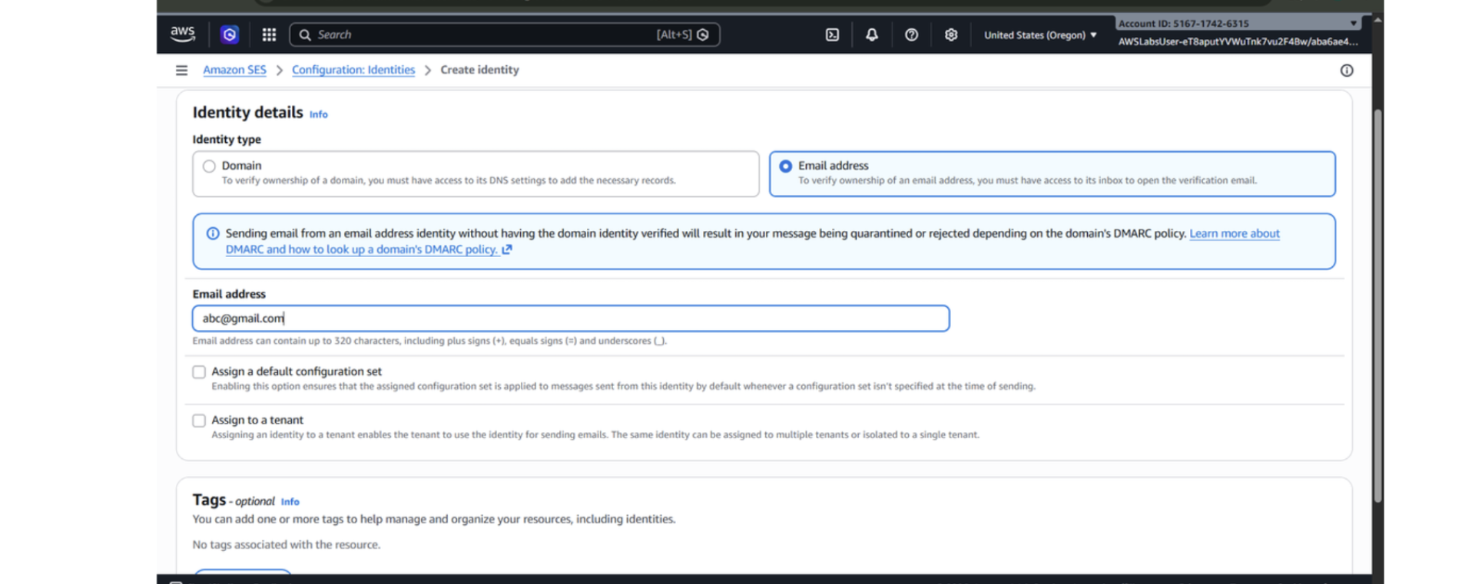
STEP 3-
The person who’s email is added will get the confirmation email which they are supposed to confirm . We can only send the email if the user confirms it using the email he/she would’ve received for it.
STEP 4-
Now go back to ‘identity’ and select the emails to which you wan to send the email to. And then click on ‘send test email’. We are sending test email because we don’t have much identities added , after we add numerous identities we can modify it accordingly.
STEP 5-
Now we select what kind of email we are willing to send , ‘Formatted’ or ‘Raw’. After that we can also select which scenario we want, we can also send it in raw format. After that fill the required places and body of the letter and send the email.

