Simple Storage Service(s3)- Private Bucket
Objectives
- Create a bucket in Amazon S3
- Add an object to a bucket
- Manage access permissions on an object and a bucket
- Create a bucket policy
- Use bucket versioning
Step 1: Creating a Bucket
Go to Amazon S3 and click on “Create bucket.” Enter a unique bucket name, choose your preferred region, and make sure “Block all public access” remains enabled. Finally, click on “Create bucket” to set up your private bucket.
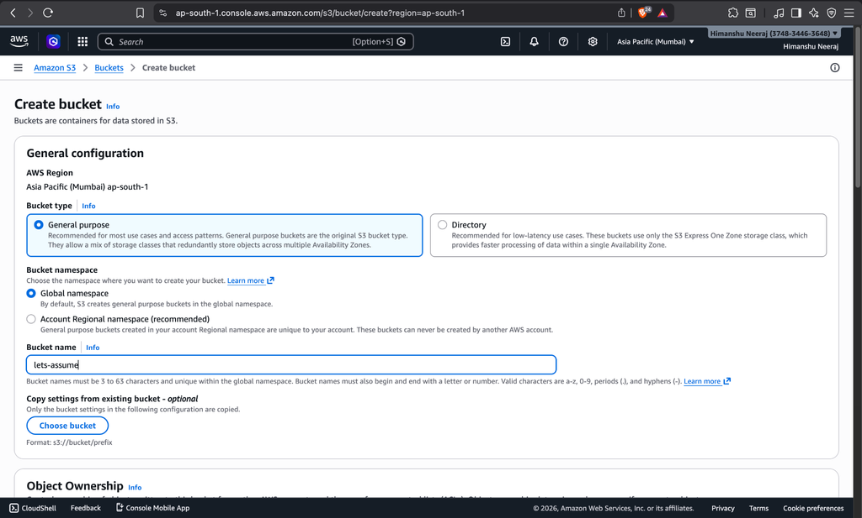
Step 2: Encryption Settings
In Amazon S3, enable default bucket encryption to keep your data protected. Choose options like server-side encryption to ensure all files are securely stored.
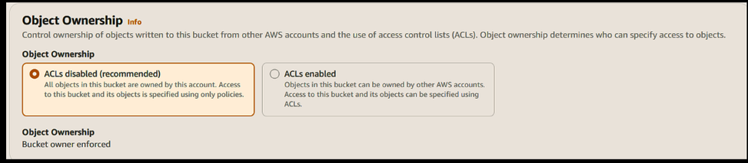
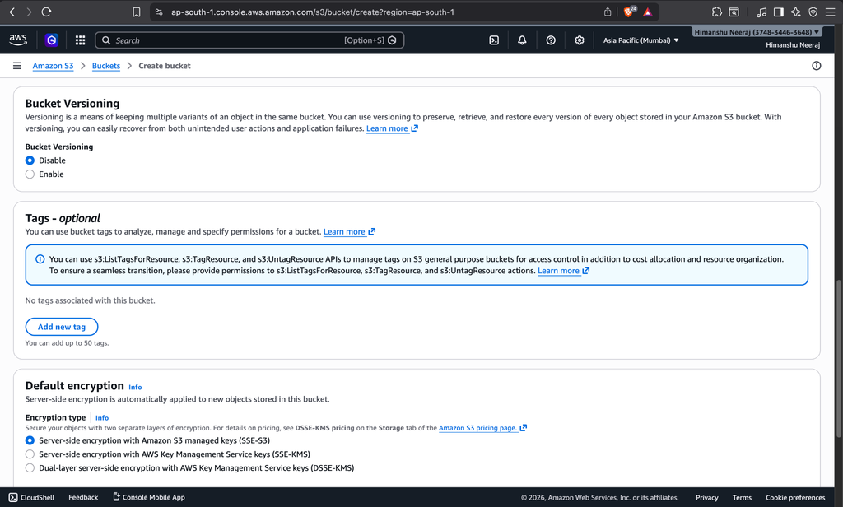
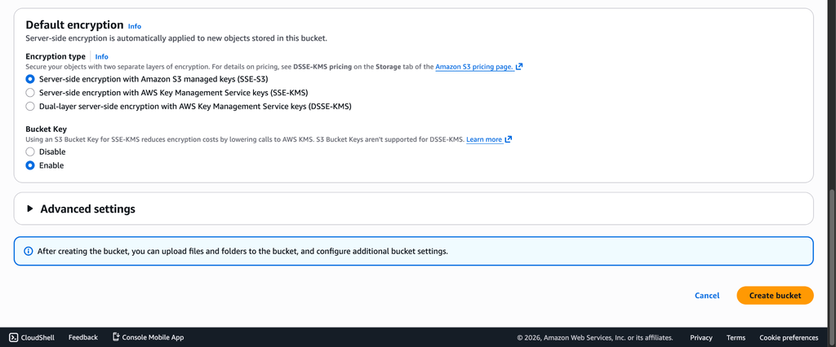
Step 3: The Bucket’s Dashboard
Open your private S3 bucket to access its dashboard, where you can view objects, manage settings, and handle access controls securely.
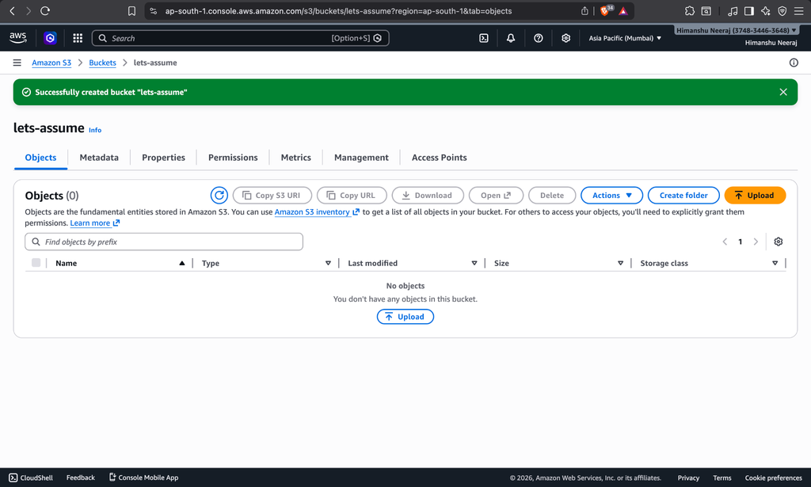
Step 4: Uploading Files
In your private S3 bucket, click on “Upload,” choose files from your system, and add them securely to the bucket.
