Simple Storage Service(s3)- Public Bucket
Objectives
- Create a bucket in Amazon S3
- Add an object to a bucket
- Manage access permissions on an object and a bucket
- Create a bucket policy
- Use bucket versioning
Step 1: Creating a Bucket
Note that ACL stands for Access Control List. In the Amazon S3 section of the AWS Management Console, click on “Create bucket.” Enter a unique name, choose a region, adjust the settings as shown, and then click “Create bucket” to complete the setup.
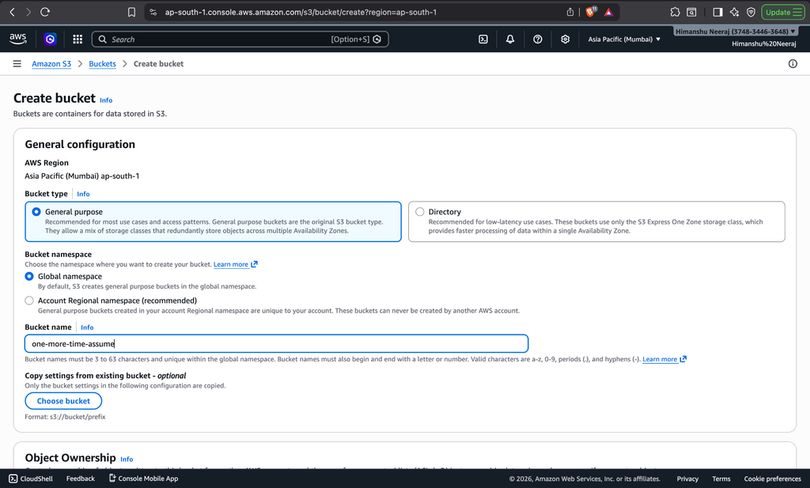
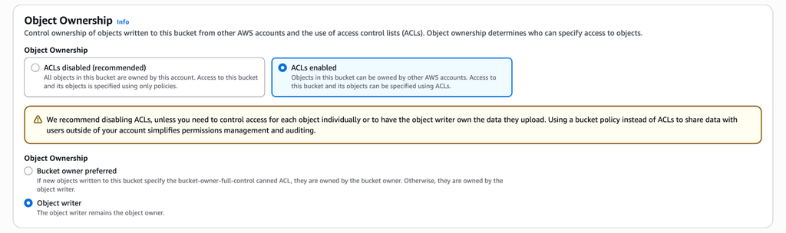
Step 2: Configure Bucket Settings
While creating the bucket in Amazon S3, configure the required settings. Optionally set Bucket Versioning as per requirement. You can skip tags if not needed. Enable default encryption (SSE-S3) to secure the data, and keep advanced settings like Object Lock disabled unless required. Finally, proceed with the configuration.
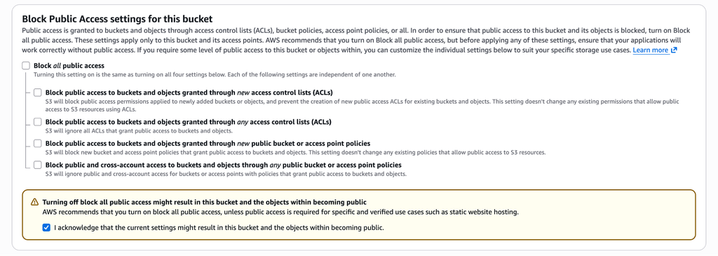
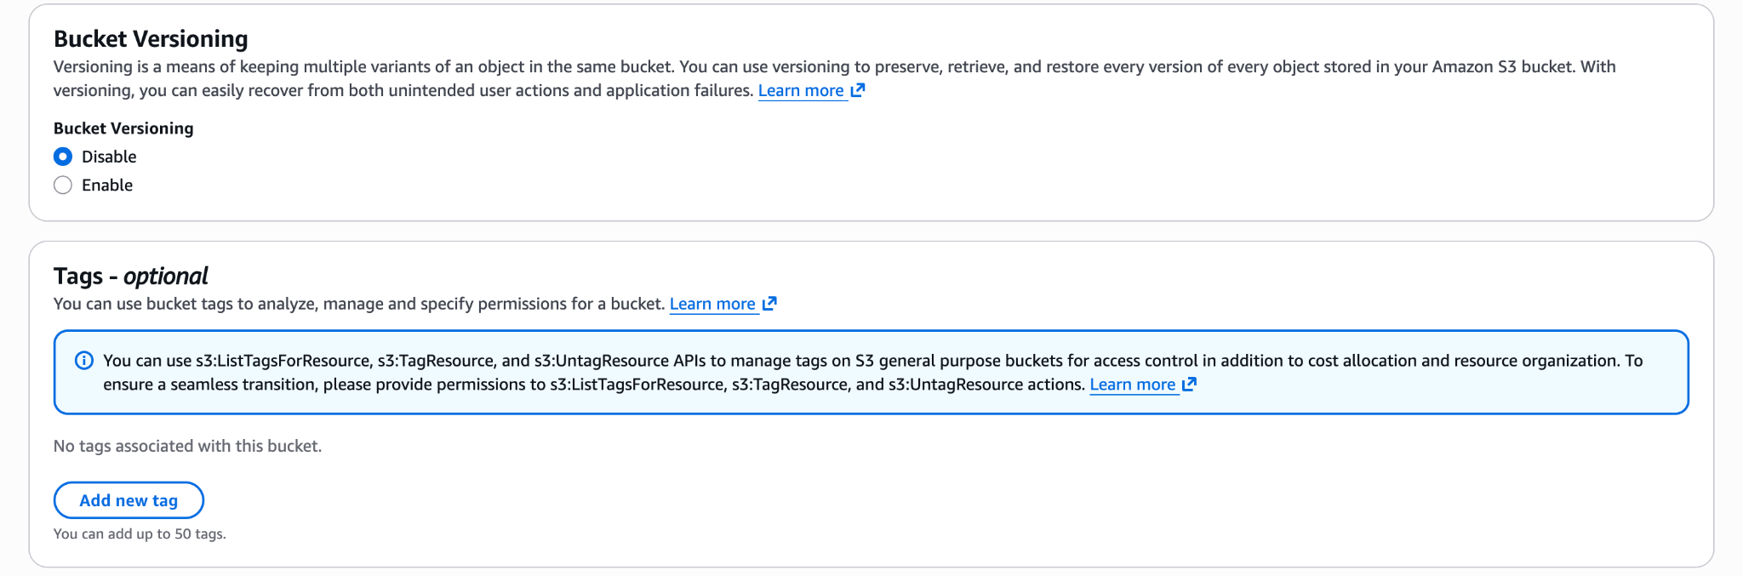
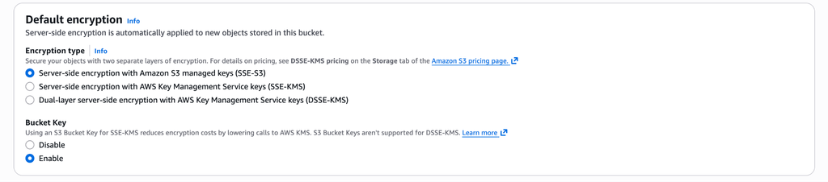
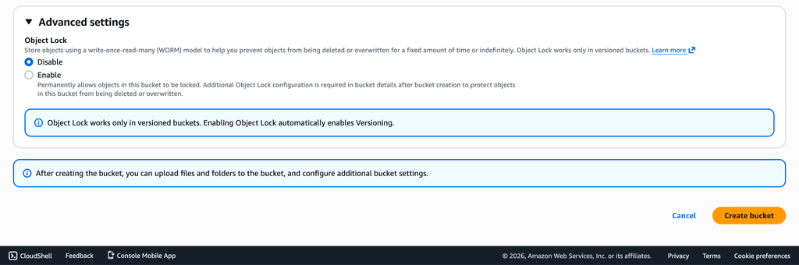
Step 3 : The Bucket’s Dashboard
After creating the bucket, open one-more-time-assume in Amazon S3 to access its dashboard, where you can view files and manage permissions and settings.
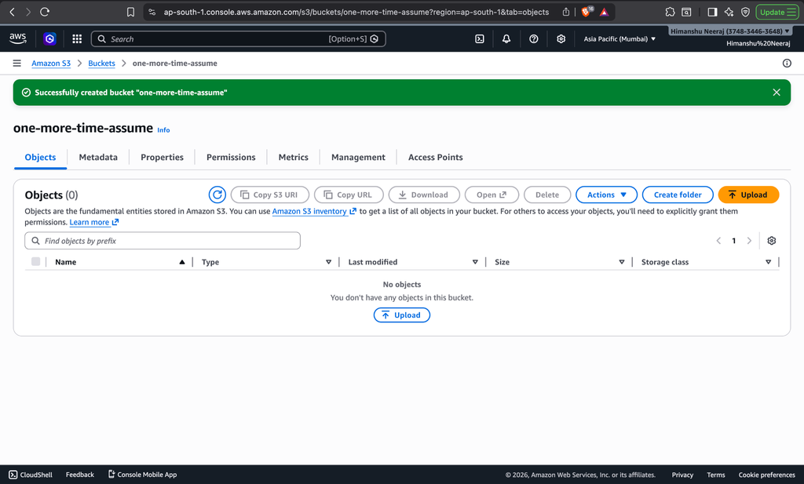
Step 4 :Uploading a File
Open the one-more-time-assume bucket in Amazon S3, click on “Upload,” choose a file from your system, and upload it to the bucket.
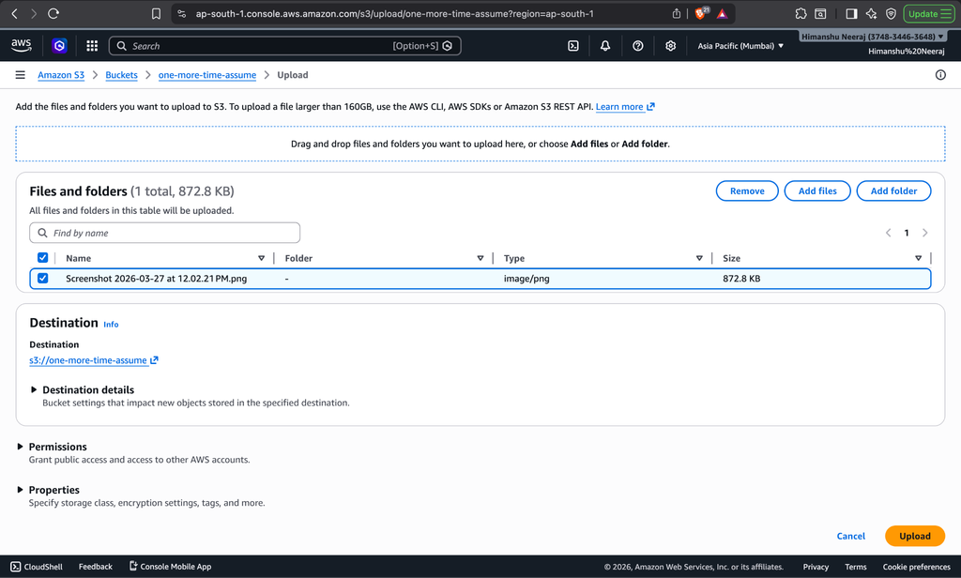
Step 5: File Upload Confirmation
Once the upload is complete, the file appears in the one-more-time-assume bucket in Amazon S3, confirming a successful upload.
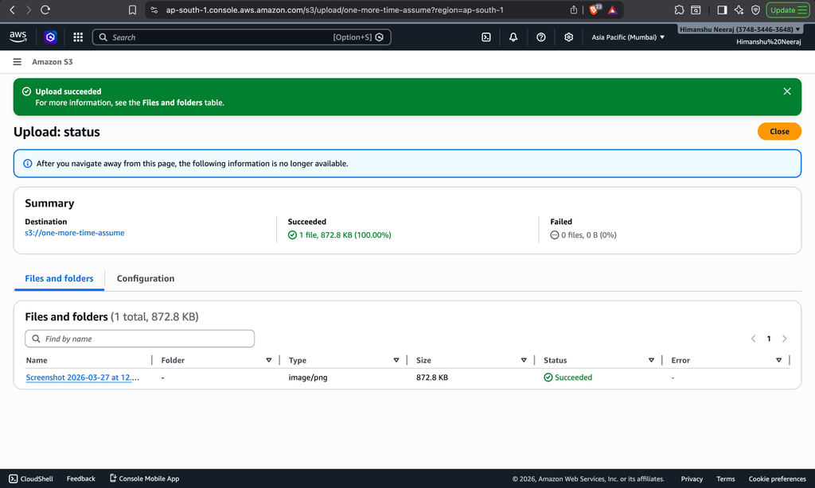
Step 6: Object’s Dashboard
In the one-more-time-assume bucket, click on the uploaded file to open its object dashboard, where you can view details and manage the file.
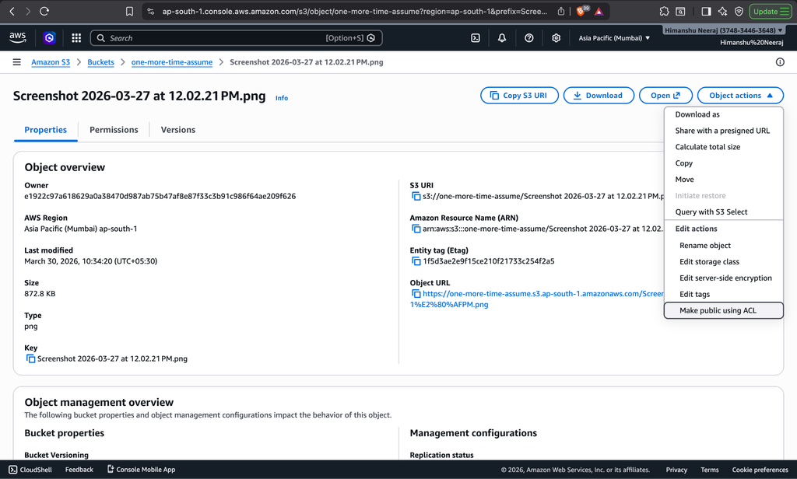
Step 7: Making the Object Public
In the object dashboard, go to “Permissions” and make the file public to allow access through its link.
