Identity And Management (IAM)
Objectives
- Exploring pre-created IAM Users and Groups
- Inspecting IAM policies as applied to the pre-created groups
- Following a real-world scenario, adding users to groups with specific capabilities enabled
- Locating and using the IAM sign-in URL
- Experimenting with the effects of policies on service access
Step 1: Open IAM Dashboard
The AWS IAM Dashboard is opened to manage identity and access resources.
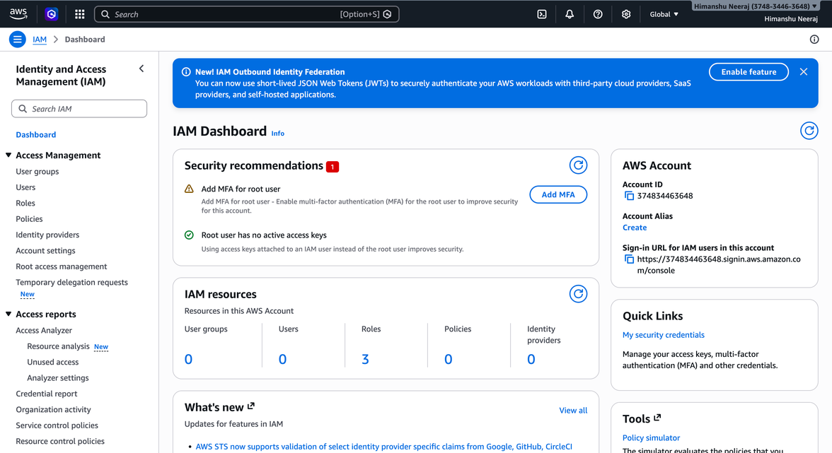
Step 2: Open Users Section
The Users section in IAM is opened to manage IAM users.
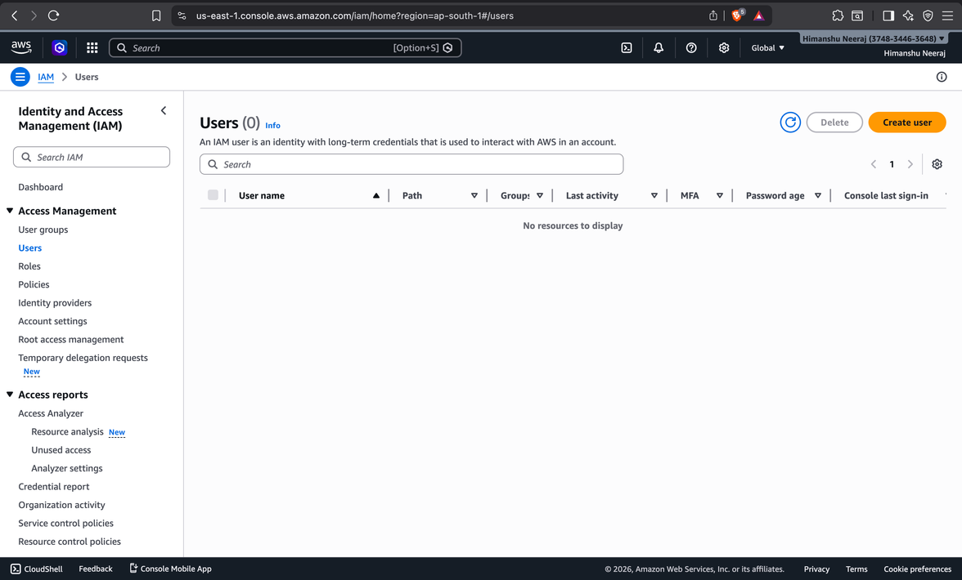
Step 3: Enter New User Details
The user creation form is used to enter a new username once-upon-a-time.
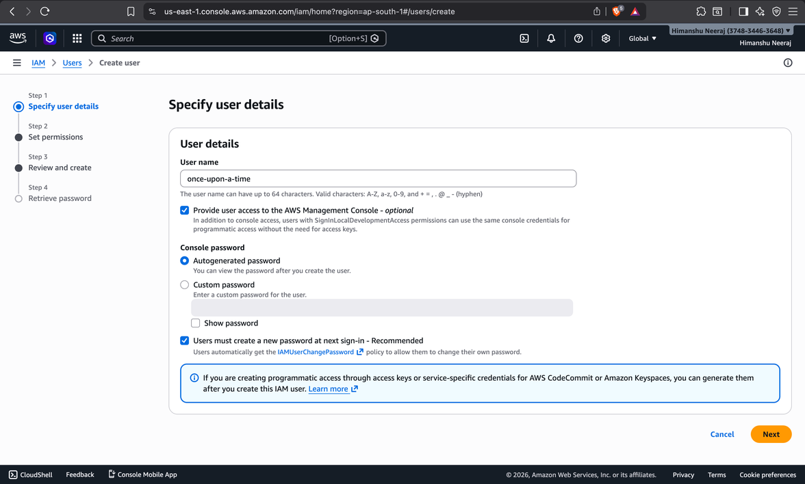
Step 4: Assign Permissions to User
The AmazonS3FullAccess policy is selected under “Attach policies directly” to grant S3 access.
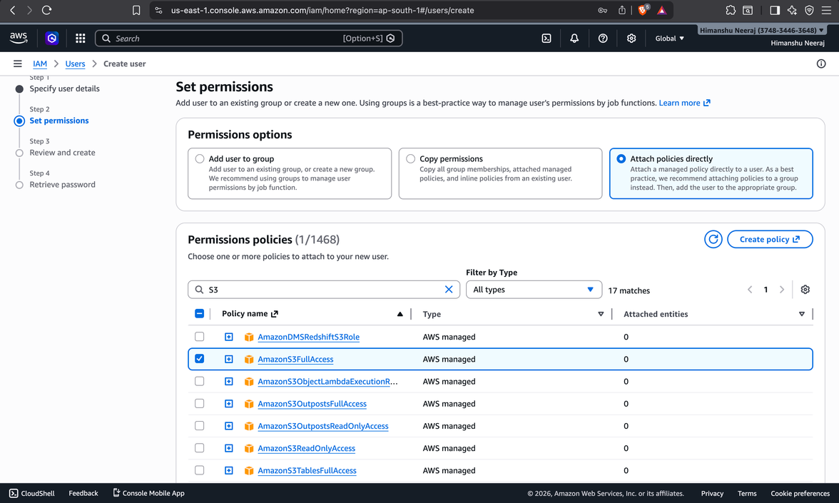
Step 5: Review User Details
All configurations are reviewed before creating the user.
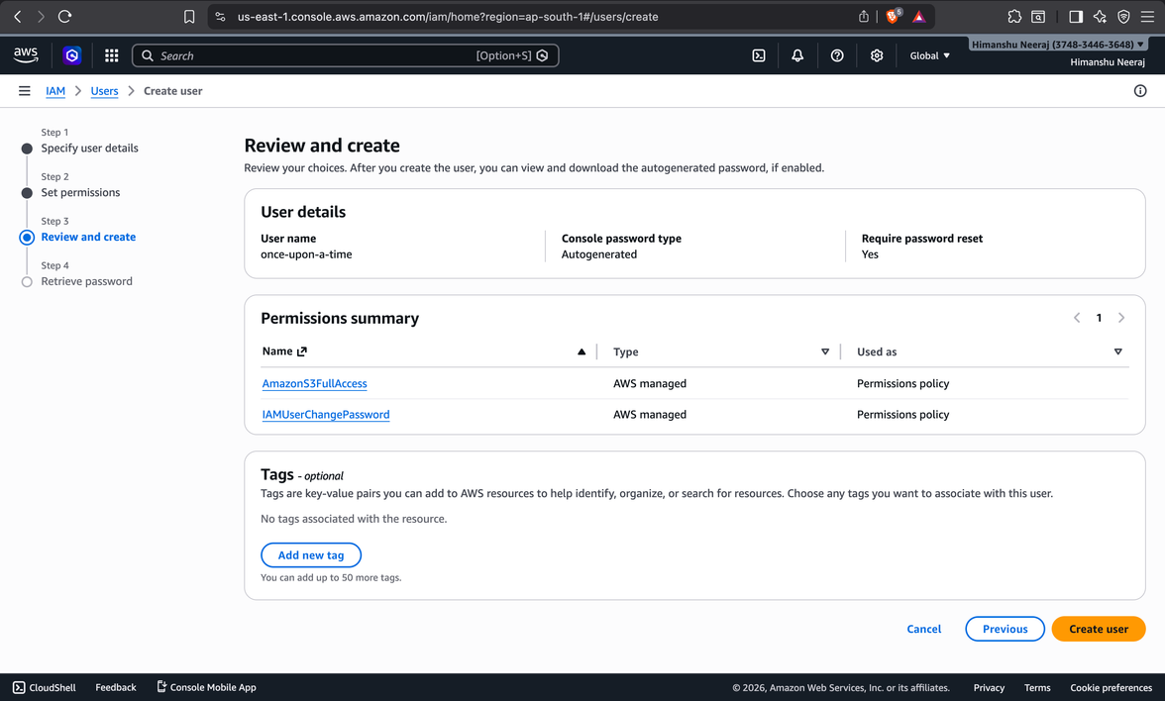
Step 6: User Created & Password Retrieved
The IAM user is successfully created and login credentials are displayed.
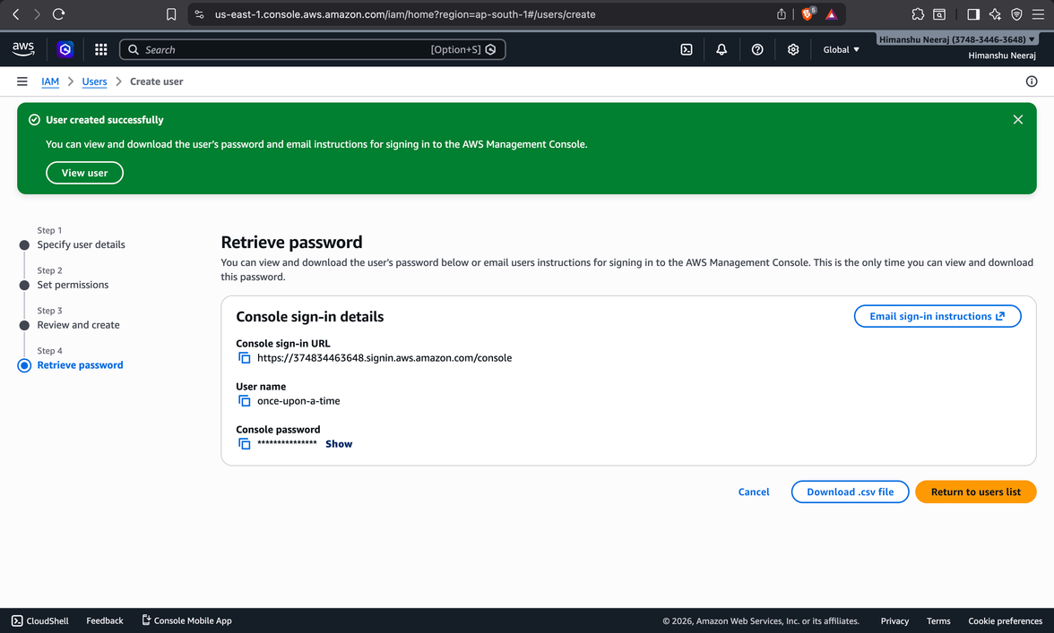
Step 7: IAM User Login
The created IAM user logs into the AWS console using credentials.
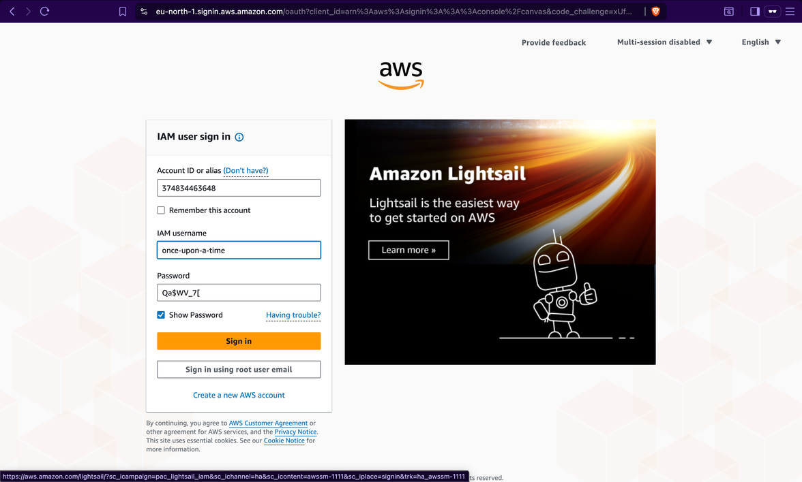
Step 8: Reset User Password
The user is required to set a new password on first login.
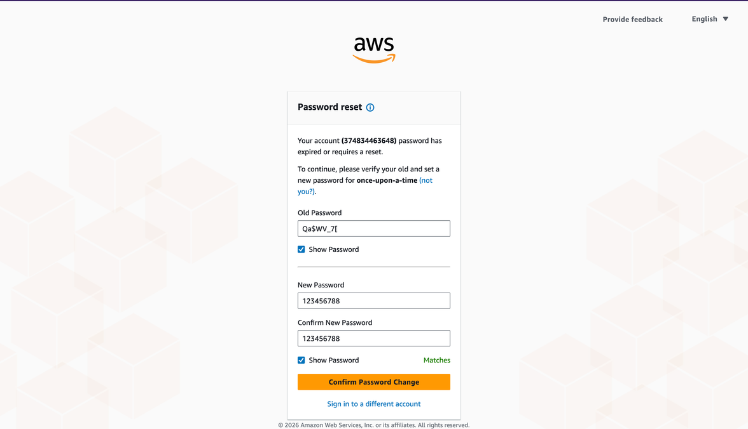
Step 9: Password Reset Successful
The system confirms that the password has been updated successfully.
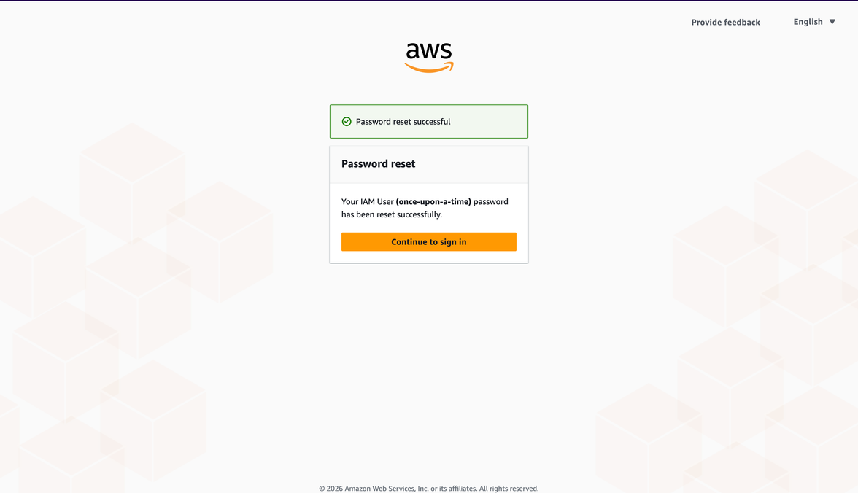
Step 10: Access AWS Console
The IAM user successfully logs into the AWS Console dashboard.
