**ROLL N0: 213064**

**NAME: KHANSA**

**LAB_4**

1. **Implement HTTP Protocol in Cisco Software | HTTP Protocol | HTTP | Cisco Packet Tracer :**

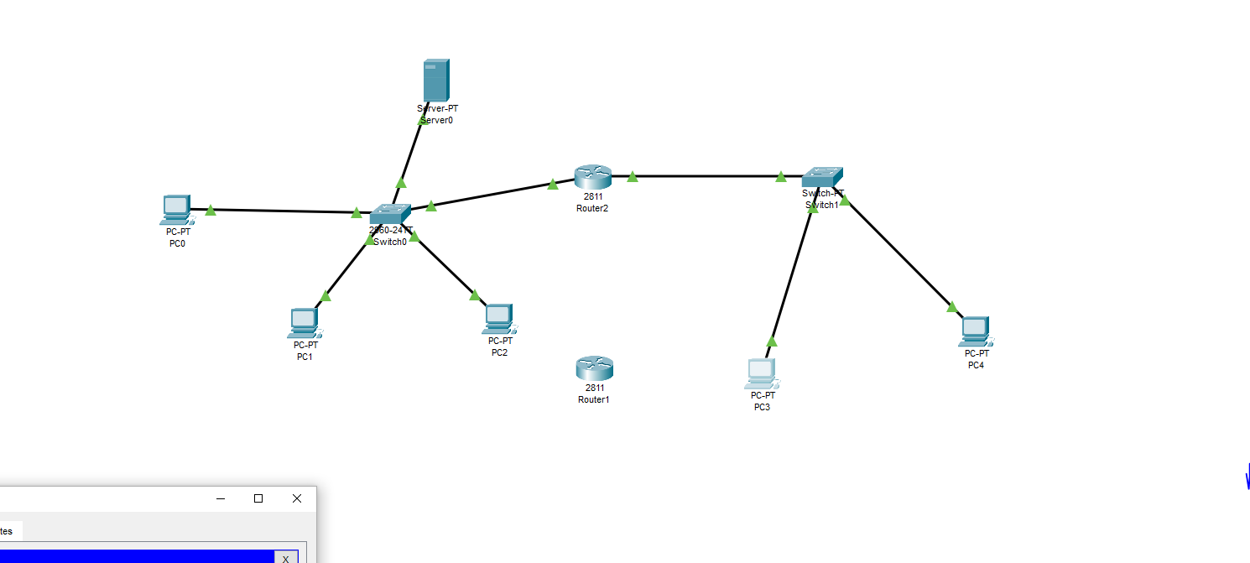

1. **IMPLEMENTED THE HTTP PROTOCOL :**

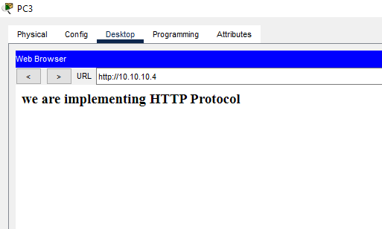

1. **IPS OF SWITCHIES:**

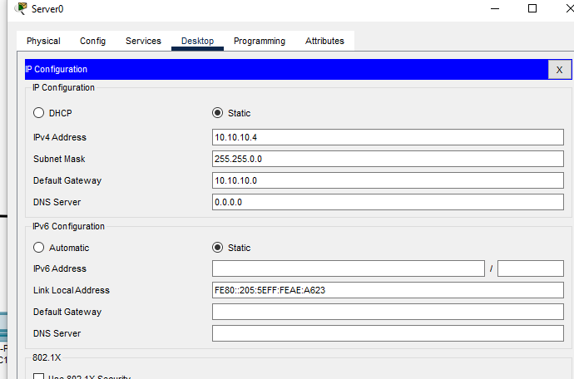

1. **ROUTER :**

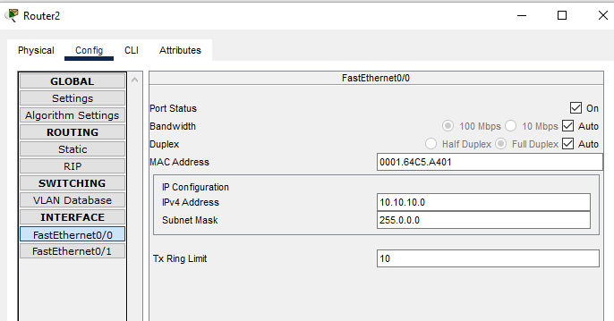

1. **SWITCHIES :**

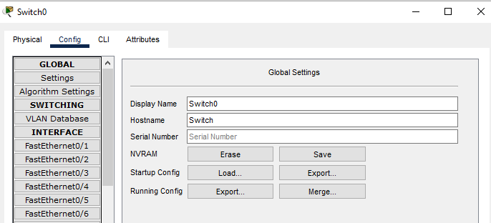

1. **SERVER :**

