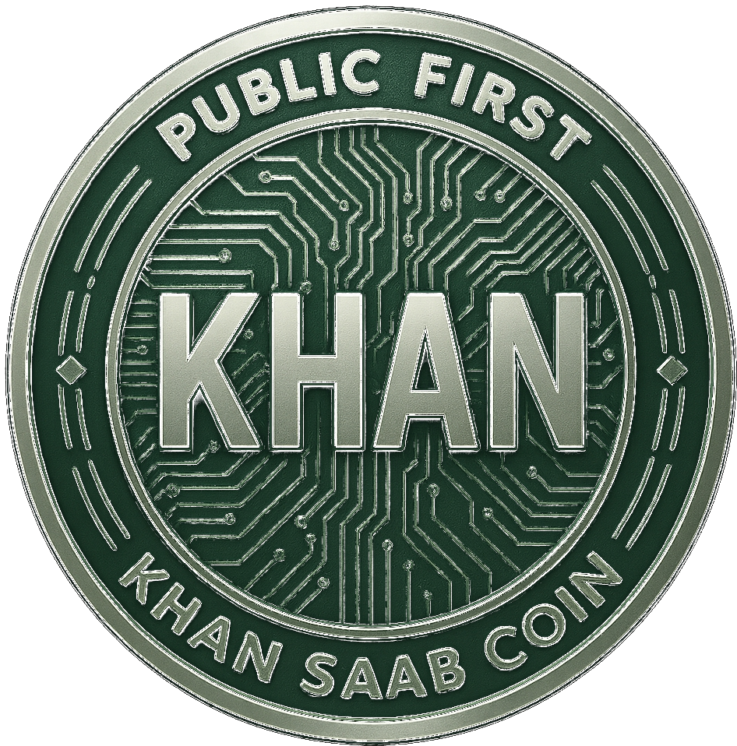
KHAN SAAB Coin
Official Whitepaper
Binance Smart Chain (BEP-20)
A Public-First Cryptocurrency Built for Transparency, Fairness, and Long-Term Growth

Token Name | KHAN SAAB Coin
Token Symbol | KHAN
Founder Identity | Captaan
Blockchain | Binance Smart Chain (BEP-20)
Total Supply | 750,000,000 KHAN Coin
Initial Public Pricing | 1 PKR = 1 KHAN Coin
khansaabcoin@gmail.com
This whitepaper is provided for informational purposes only and does not constitute financial, legal, or investment advice. See Section 16 for the full disclaimer.

Table of Contents

Executive Summary
KHAN SAAB Coin is a public-first cryptocurrency project built around one clear idea: crypto should be understandable, accessible, and transparent for ordinary people.
The project is designed to remove the confusion, unfairness, and hidden structures common in many token launches. Instead of building only for insiders or whales, KHAN SAAB Coin is being developed with a focus on:
- Simple participation
- Clear tokenomics
- Visible supply logic
- Public trust
- Long-term ecosystem development
KHAN SAAB Coin is not positioned as a short-term hype token. It is being developed as a structured digital asset project with a phased rollout model and a future path toward broader blockchain utility. This whitepaper explains the project's mission, supply structure, pricing logic, launch model, development roadmap, and long-term ecosystem vision.

1. Introduction & Project Philosophy
The digital finance world is growing quickly, but for many people, cryptocurrency still feels complicated, risky, or built only for a small number of insiders. Many projects launch with unclear supply systems, hidden wallet behavior, unfair early access, and unrealistic promises — creating a trust gap between crypto projects and ordinary people.
KHAN SAAB Coin is being developed to take a different path. Instead of confusing structures and private advantages, it is being built with a public-first philosophy that prioritizes clarity, fairness, simple access, visible planning, and gradual growth — a token system people can understand without needing advanced technical knowledge or insider access.

2. Project Philosophy
KHAN SAAB Coin is built around the belief that digital finance should not be limited to a small group of early insiders. The project philosophy rests on five core pillars:
Pillar | What It Means
Transparency | Every serious crypto project must earn trust through visible structure and honest communication.
Fair Access | Participation should not depend on secret groups, hidden presales, or private manipulation.
Simplicity | A token should be understandable to the public, especially first-time participants.
Long-Term Thinking | A strong project is built gradually, not through temporary hype.
Public Empowerment | The project is designed to benefit the wider community rather than only early holders.

3. Mission Statement
To build a cryptocurrency that is clear, affordable, transparent, and accessible — allowing ordinary people to participate in digital finance with confidence.

4. Vision Statement
To grow KHAN SAAB Coin into a trusted blockchain ecosystem that can eventually support community participation, wallet integration, token utility, cross-chain expansion, and long-term decentralized tools.

5. The Problem in Today's Token Launches
Most token launches follow a similar pattern: early buyers get an unfair advantage, public buyers enter too late, token supply is not clearly explained, and the project often depends more on hype than real structure. This leaves the public at a disadvantage. KHAN SAAB Coin is being developed to solve several of these common problems:
- Unclear Token Distribution — many projects do not clearly explain total supply, reserves, locked tokens, or how future releases affect holders.
- Hidden or Confusing Wallet Structures — unlabeled wallets create uncertainty and distrust; KHAN is designed around a visible, understandable allocation structure.
- Overcomplicated Pricing — technical, internationally-framed pricing discourages new users; KHAN uses a simple, local-first pricing approach.
- Short-Term Launch Mentality — many projects focus only on launch excitement; KHAN is structured in phases for controlled, sustainable growth.

6. Why KHAN SAAB Coin Is Different
KHAN SAAB Coin is built with a more grounded and transparent launch structure:
- Public-Friendly Pricing — a simple initial model (1 PKR = 1 KHAN Coin) that is easy for everyday users to understand.
- Clear Supply Planning — a fixed total supply structured into clearly defined categories.
- Lock-Based Trust Model — a meaningful portion of supply is locked or released gradually to improve confidence and reduce sudden imbalance.
- Roadmap-Based Growth — development follows a phased roadmap with a long-term utility direction, rather than relying only on hype.

Tokenomics

7. Tokenomics Overview
KHAN SAAB Coin has a fixed total supply of 750,000,000 tokens, with no further minting after genesis. The tokenomics model is designed to support public participation, exchange liquidity, ecosystem promotion, and long-term project development.
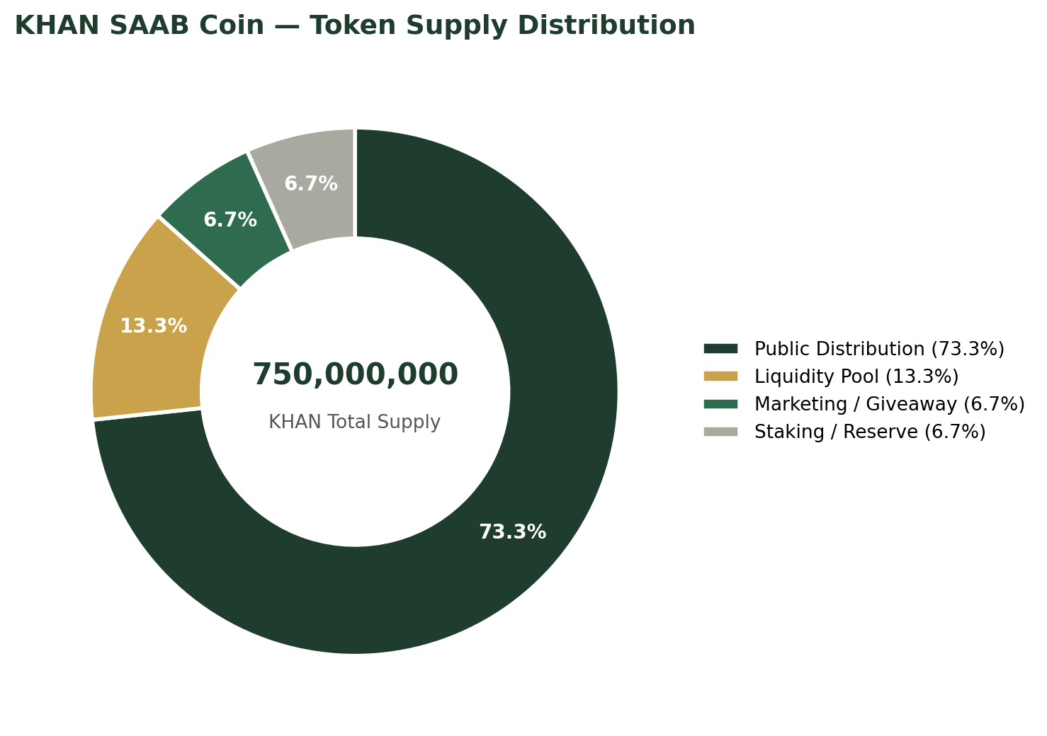
Allocation | Amount (KHAN) | % | Purpose
Public Distribution | 550,000,000 | 73.3% | Community access and structured public sale
Liquidity Pool | 100,000,000 | 13.3% | DEX liquidity and trading support
Marketing / Giveaway | 50,000,000 | 6.7% | Controlled promotions and public campaigns
Staking / Reserve | 50,000,000 | 6.7% | Long-term ecosystem support and reserve
Total Supply | 750,000,000 | 100% | Fixed — no further minting after genesis

7.3 Allocation Purpose Explained
- Public Distribution (550,000,000 KHAN) — the largest share, reserved for public participation, ensuring the majority of tokens go to community-facing distribution rather than hidden concentration.
- Liquidity Pool (100,000,000 KHAN) — supports future decentralized exchange liquidity, helping the token trade smoothly after listing.
- Marketing / Giveaway (50,000,000 KHAN) — supports controlled promotional growth: community campaigns, engagement incentives, referral activity, and awareness expansion. This allocation is intended for strategic use, not careless spending.
- Staking / Reserve (50,000,000 KHAN) — supports the future ecosystem, providing flexibility for staking systems, utility expansion, or structured ecosystem support as development progresses.
KHAN SAAB Coin is committed to a structure where allocations are purpose-based and clearly defined, avoiding hidden-reserve confusion by keeping key token categories openly explained.

8. Public-First Pricing Model
One defining feature of KHAN SAAB Coin is its initial pricing structure: 1 PKR = 1 KHAN Coin — designed to keep participation simple and accessible.

8.1 Why This Pricing Model Matters
- Simple for Everyone — people understand the value relationship without complex conversion calculations.
- Accessible for Small Holders — ordinary participants can enter more comfortably.
- Community-Friendly — the token is designed to feel reachable rather than exclusive or elite.

8.2 Why PKR-Based Pricing Was Chosen
A local-first pricing structure makes the project easier to understand for the wider public. Instead of forcing first-time users to think only in volatile international pricing terms, the project introduces a direct, simple local unit reference — supporting clearer communication, easier participation, and stronger trust among early users.

8.3 Multi-Phase Distribution Structure
KHAN SAAB Coin is planned to be distributed in multiple phases rather than all at once. Each phase is expected to have a limited token batch, a defined participation structure, and a gradual progression model — supporting fairer access, better public visibility, and more controlled project growth.
The launch will follow a phased, batch-based distribution model to maintain orderly release and prevent sudden supply concentration.

8.4 International Participation
Although pricing begins with PKR-based simplicity, equivalent pricing references may also be shown for international participants when required — keeping the project accessible both locally and globally.

9. Lock Strategy & Supply Stability
A major part of KHAN SAAB Coin's trust model is its planned lock-based token structure. Locking reduces concerns around sudden supply release and helps create a more stable, transparent launch environment. The project is structured around three broad supply control categories:
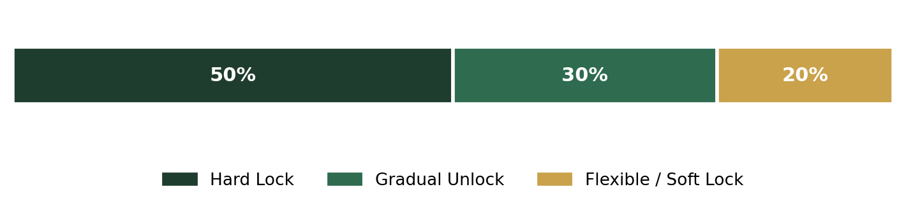
Category | Share | Purpose
Hard Lock | 50% | Improve confidence, reduce early dumping risk, support launch stability.
Gradual Unlock | 30% | Avoid sudden supply pressure, maintain healthier token flow, support phased growth.
Flexible / Soft Lock | 20% | Operational adaptability, liquidity timing, future utility-related support.

9.2 Why Locking Builds Trust
Locking gives the public a clearer picture of how supply is intended to behave over time — what is immediately available, what is reserved, and what is intended for future use — improving project credibility and reducing uncertainty.

9.3 Responsible Release Philosophy
KHAN SAAB Coin is designed around the idea that token release should be structured, understandable, and responsible. The goal is not simply to distribute supply quickly, but to build a healthier, more sustainable ecosystem over time.

10. Ecosystem Vision
KHAN SAAB Coin is not positioned only as a token sale project. The long-term goal is to gradually expand into a broader ecosystem that can support useful blockchain-based functions over time.

10.1 Future Utility Direction
As the project matures, KHAN SAAB Coin aims to explore utility in wallet integration, token-based access systems, reward structures, decentralized tools, and digital ecosystem participation — developed in stages, based on project readiness and technical capacity.

10.2 Community-Centered Development
The ecosystem is designed with a public-first mindset: future development aims to support participation, accessibility, and usability. The objective is to create a project that grows with its community, not away from it.

10.3 Cross-Chain Potential
While KHAN SAAB Coin is launching on Binance Smart Chain (BEP-20), the broader vision includes potential future expansion toward cross-chain compatibility — supporting broader accessibility, increased ecosystem flexibility, and long-term technical growth.

10.4 Long-Term Identity
The long-term objective is for KHAN SAAB Coin to evolve from a basic token into a more complete digital ecosystem with visible use cases and structured development.

11. Development Roadmap
KHAN SAAB Coin is being developed through a phased roadmap rather than an uncontrolled single-event launch. This staged model creates a clearer path from early awareness to long-term ecosystem growth.
Phase | Title | Key Focus Areas | Objective
1 | Foundation & Public Presence | Website launch, project presentation, brand identity, awareness building, whitepaper finalization. | Establish a clear, credible project foundation.
2 | Community Growth & Launch Prep | Structured visibility, public growth campaigns, launch readiness, participation planning. | Prepare the community for wider engagement.
3 | Token Launch & Liquidity Activation | Token deployment, liquidity preparation, DEX trading functionality, market visibility. | Move from pre-launch planning to active token presence.
4 | Utility Expansion & Technical Growth | Utility development, ecosystem tools, smart integrations, technical evolution. | Expand beyond token identity into functional value.
5 | Long-Term Ecosystem Development | Ecosystem maturity, broader adoption strategies, application support, sustainability. | Build a complete blockchain-based digital ecosystem.

Transparency, Governance & Community Direction

12. Transparency Commitment
Transparency is one of the project's core values. KHAN SAAB Coin aims to build trust not through exaggerated claims, but through visible planning, declared supply structure, honest communication, and responsible rollout. The project's credibility depends on long-term consistency between what is said and what is actually delivered.

12.1 Public Communication Approach
The project intends to maintain a communication style based on clarity, regular progress visibility, and realistic development expectations — aiming to avoid misleading messaging and build trust gradually over time.

12.2 Governance Direction
As the project evolves, KHAN SAAB Coin may gradually explore limited community participation models in future decision-making areas where practical and appropriate — such as ecosystem priorities, future utility ideas, and community-focused development direction. This is intended as a future-stage concept rather than an immediate launch feature.

12.3 Community Role
The community is expected to play an important role in the long-term identity of KHAN SAAB Coin. The project aims to build not just holders, but a broader support ecosystem of people who believe in transparent, fair, and accessible digital participation.

Smart Contract, Risk & Disclaimer

13. Smart Contract Position
KHAN SAAB Coin is intended to operate as a BEP-20 token on Binance Smart Chain. Once fully finalized and deployed, the smart contract is expected to support public on-chain visibility, allowing participants to review relevant blockchain data directly — including token transfers, supply visibility, wallet movement, and on-chain activity.

14. Risk Awareness
Participation in cryptocurrency projects always involves risk. These risks may include, but are not limited to, market volatility, regulatory uncertainty, technical risks, liquidity changes, ecosystem delays, and adoption uncertainty. No blockchain project should be treated as risk-free. Participants should always make independent decisions based on their own understanding and research.

15. No Guaranteed Returns
KHAN SAAB Coin does not promise guaranteed profits, fixed returns, or assured price performance. The purpose of the project is to build a transparent and structured digital asset ecosystem — not to make unrealistic promises. Any future value, adoption, or growth depends on real-world development, market conditions, community strength, and execution over time.

16. Legal & General Disclaimer
This whitepaper is provided for informational and educational purposes only. Nothing in this document should be interpreted as financial advice, investment advice, legal advice, tax advice, or a guarantee of performance. The information presented reflects the intended structure and direction of the project at the time of writing and may evolve as development progresses. Participants are strongly encouraged to conduct their own independent research before engaging with any digital asset project.

Final Statement

17. Final Commitment
Crypto should be honest, understandable, and accessible to ordinary people.
KHAN SAAB Coin is being built around this principle, designed to prioritize public-first access, transparent planning, responsible supply structure, and long-term ecosystem growth. Rather than depending on confusion or hype, KHAN SAAB Coin aims to earn trust through structure, clarity, and consistency.
This is not only a token concept — it is the beginning of a broader effort to build a more visible and community-centered digital asset model. As the project evolves, its long-term success will depend not only on launch mechanics, but on the strength of its transparency, development discipline, and public trust.
Official Contact
khansaabcoin@gmail.com

