HEALTHCARE ANALYTICS
Doctor Visits Analysis
Python • Pandas • NumPy • Matplotlib

Project Report
Prepared by Sabina Khan
Based on the uploaded Doctor Visits dataset and analysis notebook

1. Executive Summary
This project analyzes 5,190 healthcare records to understand patterns in doctor visits across demographic, illness, health, insurance, and chronic-condition variables. The analysis was performed using Python with Pandas, NumPy, and Matplotlib.
The dataset contains 5,190 records, 1,566 total recorded doctor visits, and an average of 0.30 visits per record. 1,049 records (20.21%) have at least one recorded doctor visit, while the remaining records have zero visits.
The report is descriptive: it identifies patterns and associations in the available data and does not establish causal relationships.

2. Project Objectives
- Understand the structure and quality of the doctor-visits dataset.
- Measure overall doctor-visit utilization.
- Compare average visits across gender and encoded age/income categories.
- Examine relationships between doctor visits, illness, health, and reduced activity.
- Compare visit patterns across insurance and healthcare-support variables.
- Analyze chronic-condition categories.
- Create clear visualizations and summarize data-driven findings.

3. Dataset Overview
The uploaded CSV contains 5,190 records and 13 columns. The analysis notebook uses the following variables:
Variable | Description
visits | Number of doctor visits
gender | Patient gender
age | Encoded age category/value
income | Encoded income category/value
illness | Illness category
reduced | Number of days activity was reduced due to illness
health | Health category/value
private | Private insurance status
freepoor | Free healthcare coverage for low-income individuals
freerepat | Free/repatriation healthcare coverage
nchronic | Chronic-condition status
lchronic | Long-term/chronic-condition status
Note: age and income are represented as encoded numeric values in this dataset. They should not be interpreted as literal age in years or currency amounts without a separate codebook.

4. Data Quality and Preparation
Check | Result
Total records | 5,190
Total columns in source CSV | 13
Missing values | 0
Duplicate rows | 0
Total doctor visits | 1,566
The source dataset contains no missing values and no duplicate rows. The notebook also treats the 'Unnamed: 0' field as an index/identifier rather than an analytical variable.

5. Methodology
- Loaded the CSV dataset into a Pandas DataFrame.
- Inspected dimensions, column names, data types, missing values, duplicates, and descriptive statistics.
- Examined unique values to understand categorical/encoded variables.
- Calculated visit distributions, averages, totals, and the share of records with at least one visit.
- Used group-by aggregations to compare average visits across key variables.
- Created bar and line charts using Matplotlib.
- Calculated correlations for selected numerical variables as an exploratory measure.

6. Key Performance Indicators
KPI | Value
Total healthcare records | 5,190
Total doctor visits | 1,566
Average doctor visits per record | 0.30
Records with ≥1 doctor visit | 1,049
Share of records with ≥1 visit | 20.21%

7. Doctor Visit Distribution
The most common observation is zero doctor visits: 4,141 records. There are 782 records with one visit. The distribution is therefore concentrated at the lower end of visit counts.
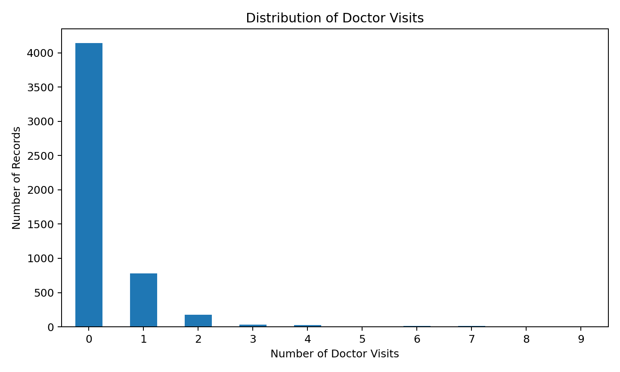
Figure 1. Distribution of recorded doctor visits.

8. Gender Analysis
Gender | Records | Total Visits | Average Visits
female | 2702 | 978 | 0.362
male | 2488 | 588 | 0.236
In the dataset, female records have an average of 0.362 visits, compared with 0.236 for male records. This is a descriptive difference within the sample and does not by itself explain why the difference occurs.
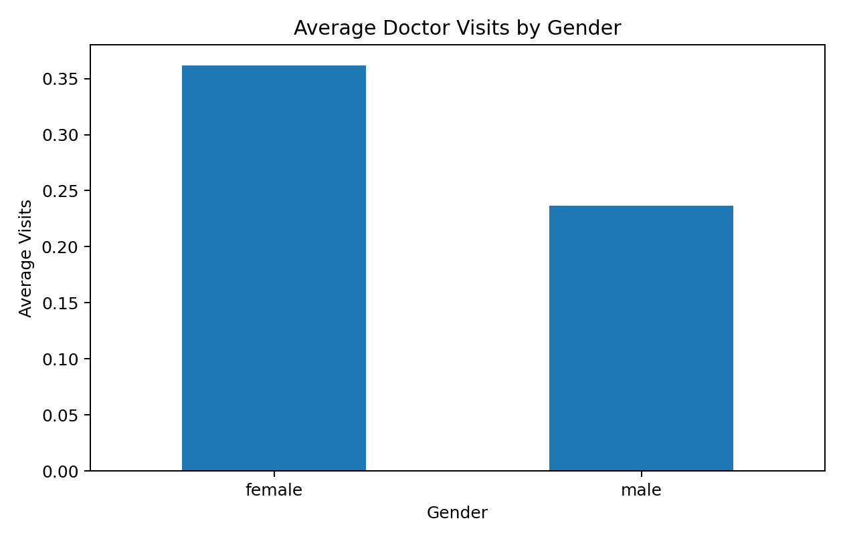
Figure 2. Average doctor visits by gender.

9. Illness Analysis
Illness Category | Records | Total Visits | Average Visits
0 | 1554 | 122 | 0.079
1 | 1638 | 484 | 0.295
2 | 946 | 382 | 0.404
3 | 542 | 228 | 0.421
4 | 274 | 158 | 0.577
5 | 236 | 192 | 0.814
Average visits rise across the illness categories in this dataset, from 0.079 for category 0 to 0.814 for category 5. This pattern indicates an association between the illness-category variable and visit frequency in the sample.
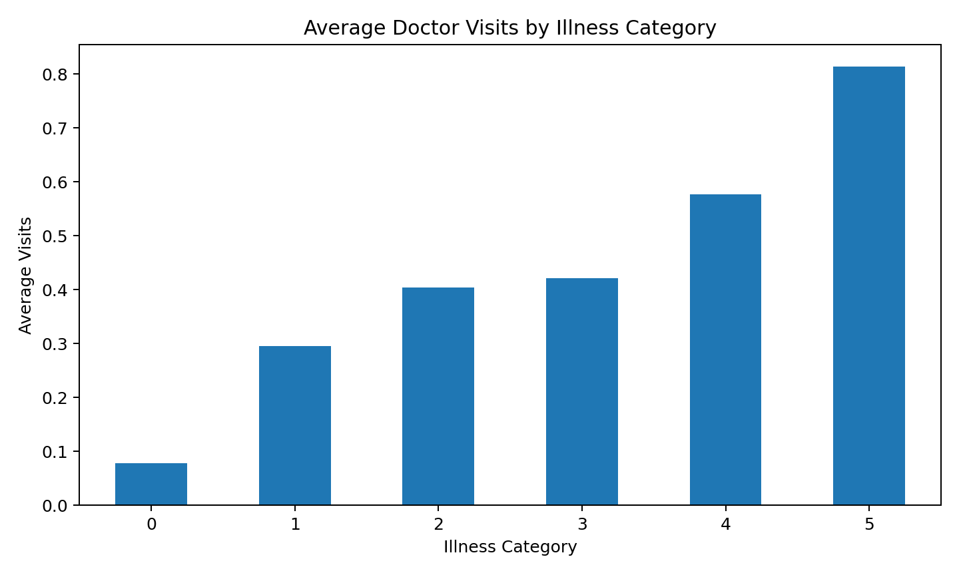
Figure 3. Average doctor visits by illness category.

10. Health Analysis
Health Category | Records | Total Visits | Average Visits
0 | 3026 | 603 | 0.199
1 | 823 | 276 | 0.335
2 | 446 | 170 | 0.381
3 | 273 | 114 | 0.418
4 | 187 | 100 | 0.535
5 | 132 | 70 | 0.530
6 | 104 | 65 | 0.625
7 | 61 | 56 | 0.918
8 | 42 | 20 | 0.476
9 | 32 | 21 | 0.656
10 | 21 | 32 | 1.524
11 | 24 | 20 | 0.833
12 | 19 | 19 | 1.000
The average number of visits varies across health categories. Because the health field is encoded, the report uses category codes rather than assigning subjective labels such as 'good' or 'poor' without a codebook.
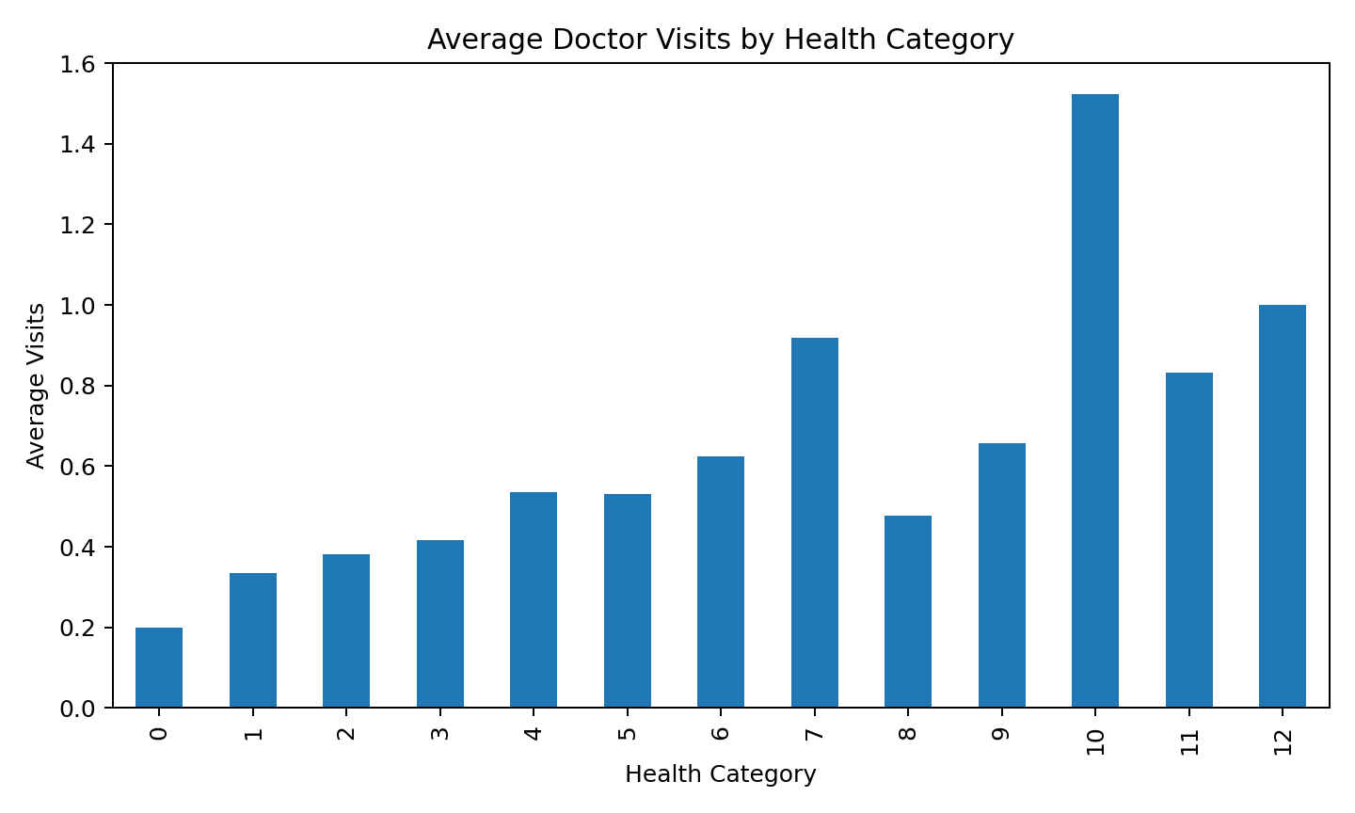
Figure 4. Average doctor visits by health category.

11. Chronic Condition Analysis
nchronic | Records | Total Visits | Average Visits
no | 3098 | 843 | 0.272
yes | 2092 | 723 | 0.346
Records marked 'yes' for nchronic have an average of 0.346 visits, while records marked 'no' have an average of 0.272. The second chronic-condition variable, lchronic, shows an average of 0.603 visits for 'yes' and 0.262 for 'no'.
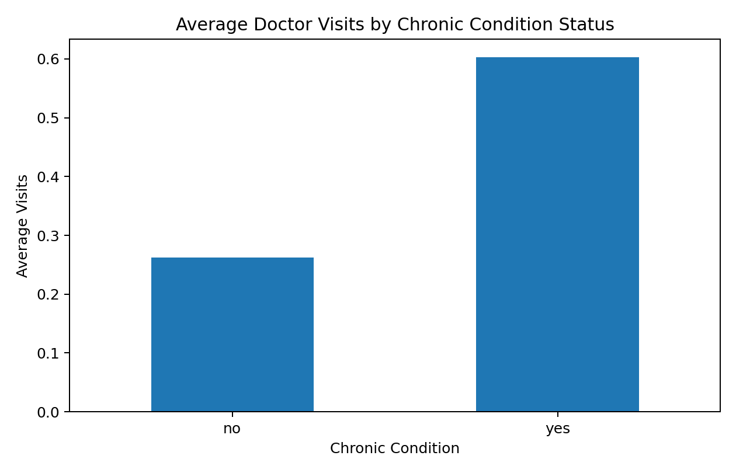
Figure 5. Average doctor visits by lchronic status.

12. Insurance and Healthcare Support Analysis
Private Insurance | Records | Total Visits | Average Visits
no | 2892 | 889 | 0.307
yes | 2298 | 677 | 0.295
Freerepat | Records | Total Visits | Average Visits
no | 4099 | 1057 | 0.258
yes | 1091 | 509 | 0.467
Average visits are 0.295 for private-insurance records and 0.307 for non-private-insurance records. For freerepat, the corresponding averages are 0.467 for 'yes' and 0.258 for 'no'.

13. Reduced Activity Analysis
The reduced variable represents the number of days activity was reduced due to illness. The notebook compares its values with average doctor visits to explore whether greater activity reduction co-occurs with higher visit frequency.
Reduced Activity Days | Records | Average Visits
11 | 2 | 5.000
13 | 5 | 4.000
10 | 12 | 2.000
12 | 6 | 2.000
9 | 7 | 1.714
14 | 188 | 1.548
5 | 40 | 1.275
7 | 38 | 1.184
6 | 17 | 1.176
8 | 17 | 1.176

14. Correlation Analysis
Variable | Correlation with Visits
reduced | 0.419
illness | 0.224
health | 0.193
age | 0.125
income | -0.077
Among the selected numerical variables, reduced has the strongest positive linear correlation with visits (r = 0.419), followed by illness (r = 0.224) and health (r = 0.193). Income shows a small negative correlation (r = -0.077), while age shows a small positive correlation (r = 0.125). Correlation is descriptive and does not establish causation.

15. Key Data-Driven Insights
- The dataset contains 5,190 records and 1,566 recorded doctor visits.
- The average number of doctor visits is 0.30 per record.
- 1,049 records (20.21%) have at least one recorded doctor visit.
- The visit distribution is highly concentrated at zero, with 4,141 records having no recorded visit.
- Female records have a higher sample average of visits (0.362) than male records (0.236).
- Illness category averages increase from 0.079 at category 0 to 0.814 at category 5.
- The lchronic variable shows 0.603 average visits for 'yes' compared with 0.262 for 'no'.
- Reduced activity has the strongest positive linear correlation with visits among the selected numerical variables (r = 0.419).

16. Analytical Interpretation
For a healthcare analytics use case, the results demonstrate how patient-level data can be segmented by demographic, illness, health, insurance, and chronic-condition variables. Such analysis can support exploratory reporting and help identify groups or variables that warrant deeper investigation.
The results should not be used alone to make clinical, policy, or individual patient decisions. Additional context, validated definitions, longitudinal information, and appropriate clinical expertise would be needed.

17. Limitations
- The dataset variables age, income, and health are encoded; their precise real-world meanings require the original codebook.
- The analysis is descriptive and cross-sectional in nature.
- Observed associations do not prove causation.
- The dataset alone does not establish whether healthcare access, disease severity, or other external factors caused the observed patterns.
- The report uses the uploaded dataset and notebook; no external codebook or additional source was supplied.

18. Conclusion
The Doctor Visits Analysis project demonstrates a complete exploratory healthcare analytics workflow using Python. The project covers data loading, quality checks, descriptive statistics, group-based analysis, visualization, correlation analysis, KPI creation, and interpretation. The analysis highlights clear variation in doctor-visit frequency across several patient-related variables while maintaining a distinction between observed association and causation.

19. Tools and Technologies
- Python
- Jupyter Notebook
- Pandas
- NumPy
- Matplotlib
- CSV dataset

20. Appendix – Project Files
Notebook: SABINA_DOCTOR_VISITS_ANALYSIS.ipynb
Dataset: 1776250375-P2-Healthcare Analytics for Doctor Visits(1).csv

