**NUST SCHOOL OF MECHANICAL AND MANUFACTURING ENGINEERING, SMME**

**FUNDAMENTALS OF PROGRAMMING**

**ASSIGNMENT#01**

Section:AE-01

Course Code: CS-109

Department of Aerospace Engineering

Submitted to:

Ma’am Laiba

Submitted by:

Khansa Malik

CMS ID:

453832

**(Question#01)**

Write a C++ program, take two strings as input from user and check if both strings are equal or not. If they are equal make them unequal by rotating string. e.g., Hello is turned into olleH etc.

**CODE:**

#include <iostream>

#include <string>

using namespace std;

int main()

{

string str1, str2;

cout << "Enter the first string: ";

cin >> str1;

cout << "Enter the second string: ";

cin >> str2;

if (str1 == str2)

{

char firstChar = str1[0];

for (int i = 0; i < str1.length() - 1; i++)

{

str1[i] = str1[i + 1];

}

str1[str1.length() - 1] = firstChar;

cout << "Both strings are equal and rotated 1st string is: " << str1 << endl;

}

else

{

cout<<"Strings are not equal."<< endl;

}

return 0;

}

**OUTPUT:**

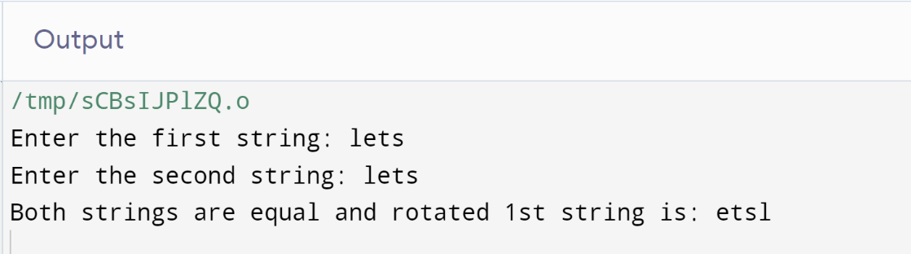

**(Question#02)**

Write a C++program for a string which may contain lowercase and uppercase characters. The task is to remove all duplicate characters from the string and find the resultant string.

**CODE:**

#include <iostream>

#include <string>

using namespace std;

int main()

{

string str;

cout << "Enter a string: ";

cin >> str;

for (int i = 0; i < str.length(); ++i)

{

char x = str[i];

for (int j = i + 1; j < str.length();)

{

if (str[j] == x)

{

str.erase(j, 1);

}

else

{

++j;

}

}

}

cout << "Resultant string after removing duplicates: " << str << endl;

return 0;

}

**OUTPUT:**

**(QUESTION#03)**

Suppose an integer array a[5] = {1,2,3,4,5}. Add more elements to it and display them in C++.

**CODE:**

#include <iostream>

using namespace std;

int main()

{

int a[5] = {1, 2, 3, 4, 5};

int n;

cout << "Original array: ";

for (int i = 0; i < 5; ++i)

{

cout << a[i] << " ";

}

cout << endl;

cout << "Enter the number of additional elements: ";

cin >> n;

int newSize = 5 + n;

int newArray[newSize];

for (int i = 0; i < 5; i++) {

newArray[i] = a[i];

}

for (int i = 5; i < newSize; i++) {

cout << "Enter element " << (i - 4) << ": ";

cin >> newArray[i];

}

cout << "Elements in the array: ";

for (int i = 0; i < newSize; i++) {

cout << newArray[i] << " ";

}

return 0;

}

**OUTPUT:**

**(Question#04)**

Write a C++ program that uses a while loop to find the largest prime number less than a given positive integer N. Your program should take the value of N as input from the user and then find the largest prime number less than or equal to N. You are not allowed to use any library or pre-existing functions to check for prime numbers.

**CODE:**

#include <iostream>

using namespace std;

int main() {

int num;

cout << "Enter a positive integer: ";

cin >> num;

int largestPrime = num - 1;

while (largestPrime >= 2)

{

bool isPrime = true;

for (int i = 2; i * i <= largestPrime; i++)

{

if (largestPrime % i == 0)

{

isPrime = false;

break;

}

}

if (isPrime)

{

break;

}

largestPrime--;

}

cout << "The largest prime number less than or equal to positive integer is: " << largestPrime << endl;

return 0;

}

**OUTPUT:**

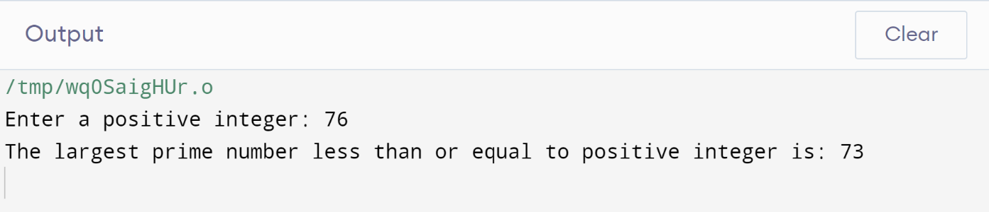

**(Question#05)**

Implement Bubble Sort on an array of 6 integers.

**CODE:**

#include <iostream>

using namespace std;

int main()

{

int a[6];

cout << "Enter 6 integers: ";

for (int n = 0; n < 6; n++)

{

cin >> a[n];

}

int tmp;

for (int i=0; i<5 ; i++)

{

for (int j=0; j<=5-i;j++)

{

if (a[j]>a[j+1])

{

tmp=a[j];

a[j]=a[j+1];

a[j+1]=tmp;

}

}

}

for(int k=0; k<6; k++)

{

cout<<a[k]<<endl;

}

return 0;

}

**OUTPUT:**

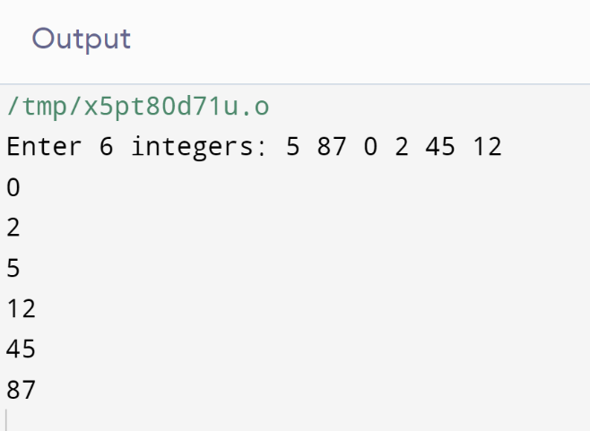

**(Question#06)**

Solve any Aerospace/Real Life Problem using C++ Programming.

**SOLUTION:**

Here's a simple code that calculates the fuel consumption of an aircraft using a basic fuel flow model:

**CODE:**

#include <iostream>

using namespace std;

double calculateFuelConsumption(double thrust, double specificFuelConsumption)

{

return thrust * specificFuelConsumption;

}

int main()

{

// Thrust of the aircraft (N)

double thrust;

// Specific fuel consumption of the aircraft (kg/N)

double specificFuelConsumption;

cout << "Aircraft fuel consumption estimation:\n";

cout << "Enter the thrust (N): ";

cin >> thrust;

cout << "Enter the specific fuel consumption (kg/N): ";

cin >> specificFuelConsumption;

double fuelConsumption = calculateFuelConsumption(thrust, specificFuelConsumption);

cout << "Estimated fuel consumption: " << fuelConsumption << " kg\n";

return 0;

}

**OUTPUT:**

