CYBER AWARENESS CAMPAIGN FOR RURAL COMMUNITIES

Submitted By
Mr. SAMIULLAH MANAUWAR BAGWAN
Roll No. 302
T.Y.B.Sc.(Information Technology)

Under the Guidance of
Dr. RUPALI MISHRA

PRAHLADRAI DALMIA LIONS COLLEGE
OF COMMERCE & ECONOMICS
SUNDAR NAGAR, S.V. ROAD, MALAD (WEST)
MUMBAI 400 064

ACADEMIC YEAR – 2026-27


Prahladrai Dalmia Lions College of Commerce & Economics
Sunder Nagar, Malad (West), Mumbai, 400 064
Re-accredited with ‘A’ Grade in III Cycle of NAAC
ISO 21001: 2018 Certified

CERTIFICATE

I hereby certify that Mr. SAMIULLAH MANAUWAR BAGWAN Student of Prahladrai Dalmia Lions College of Commerce & Economics studying in T.Y.B.Sc.(Information Technology) Semester V, has completed a project titled “CYBER AWARENESS CAMPAIGN FOR RURAL COMMUNITIES” in the area of AI / IT / ML / DS for the academic year 2026-27. To the best of my knowledge the work of the student is original and the information included in the project is correct.

Internal Examiner Head of the
Department

______________
Principal

DECLARATION

I, Mr. SAMIULLAH MANAUWAR BAGWAN, Student of Prahladrai Dalmia Lions College of Commerce & Economics studying in T.Y.B.Sc.(Information Technology) Semester III, hereby declare that I have completed the field project entitled “CYBER AWARENESS CAMPAIGN FOR RURAL COMMUNITIES” during the academic year 2026-2027.
The report work is original and the information/data included in the report is true emerging from the primary and/ secondary data gathered and analyzed as part of this project.
Due credit is extended on the work of Literature/Secondary Survey by endorsing it in the Bibliography as per prescribed format.

Signature

SAMIULLAH MANAUWAR BAGWAN

Date___________

ACKNOWLEDGEMENT

To list who all helped me is difficult because they are so numerous and the depth is so enormous.
I would like to acknowledge the following as being an idealistic channel and fresh dimension and completion of project.
I take this opportunity to thank the University of Mumbai for giving me the chance to do this project.
I would like to thank my Principal Prof. (Dr.) D. N. Ganjewar and our Vice-Principal Ms. Subhashini Naikar for providing the necessary facilities required for completion of this project.
I take this opportunity to thank our coordinator CA Durgesh Y. Kenkre for his moral support and guidance.
I would also like to express my sincere gratitude towards my project guide Dr. Rupali Mishra whose guidance and care made the project successful.
I would like to thank my college library for having provided various reference books and magazines related to my project.
Lastly I would like to thank each and every person directly or indirectly who helped me in the completion of the project, especially my Parents and my peers who supported me throughout my project.

ABSTRACT

The “Cyber Awareness Campaign for Rural Communities” is a web-based awareness platform designed to improve cybersecurity knowledge and digital safety among people living in rural areas. With the increasing use of smartphones, the internet, online banking, UPI, and digital government services, rural users are becoming more exposed to various cyber threats. Limited awareness about these threats can increase the risk of online fraud, scams, and misuse of personal information.
The proposed system provides simple and easy-to-understand cybersecurity information through educational videos, images, examples, quizzes, and awareness materials. It focuses on common cyber threats such as phishing, OTP fraud, UPI scams, fake websites, fake job offers, malware, identity theft, and password attacks. The platform also provides guidance on creating strong passwords, using two-factor authentication, identifying suspicious links, protecting personal information, and following safe online practices.
To make the campaign more interactive, users can participate in online quizzes and awareness activities to test and improve their cybersecurity knowledge. The system can also support multiple languages, making the information easier to understand for users from different rural communities.
The main objective of this project is to increase digital literacy, promote safe internet usage, and reduce the risk of cybercrime through accessible cybersecurity education. The platform aims to create a safer digital environment by helping rural users recognize common online threats and make informed decisions while using digital services.

Chapter 1. INTRODUCTION

1.1 Objectives
The main objectives of the Cyber Awareness Campaign are:
- To create awareness among rural communities about common cyber threats.
- To educate users about safe internet and smartphone usage.
- To help people identify phishing messages, fake calls, suspicious links, and online scams.
- To promote safe practices while using UPI, online banking, and other digital payment services.
- To educate users about protecting passwords, OTPs, PINs, and personal information.
- To encourage responsible use of social media and other online platforms.
- To provide basic guidance on what to do and where to report cyber fraud.
- To improve digital confidence and cybersecurity knowledge among rural users.

1.2 Background Information
The growth of digital technology has provided many opportunities for rural communities. People can now use online banking, digital payments, e-commerce, education platforms, healthcare services, and government services without having to travel long distances. While these services make life easier, they also expose users to different types of cyber threats.
Cybercriminals use various methods to deceive users. For example, they may send fake messages containing suspicious links, make fraudulent phone calls pretending to be bank officials, or offer fake jobs and prizes. Some scammers may ask users to share an OTP or PIN or make them scan a fraudulent QR code. Users who are not familiar with these techniques may unknowingly become victims.
Therefore, cybersecurity awareness is important, especially for new or less-experienced internet users. Providing information in simple language, using practical examples, and conducting awareness activities can help people recognize threats and take appropriate precautions.

1.3 Scope of the Project
The scope of this project is to develop a simple and user-friendly cyber awareness platform for rural communities. The platform will focus mainly on prevention, education, and awareness rather than investigating cybercrime.
The proposed website can include information about different types of cyber threats, cybersecurity tips, examples of scams, interactive quizzes, educational videos, and a section explaining how to respond to cyber fraud. The website can also provide content in regional languages such as Marathi and Hindi to make cybersecurity information easier to understand.
The project can be used as an awareness tool in rural schools, colleges, community centres, digital literacy programmes, and local awareness campaigns. Through this initiative, users can develop better cybersecurity habits and become more careful while using digital services.
Overall, the Cyber Awareness Campaign for Rural Communities aims to reduce the risk of cyber fraud by improving people's knowledge, awareness, and confidence in using digital technology safely.

Chapter 3. LITERATURE REVIEW

3.1 Cybersecurity Awareness
Previous studies show that lack of cybersecurity awareness is a major reason people become victims of online fraud and cyberattacks.

3.2 Digital Literacy in Rural Areas
The use of smartphones, internet, online banking, UPI, and government services is increasing in rural communities. However, many users still have limited knowledge about digital safety.

3.3 Common Cyber Threats
Research highlights threats such as phishing, OTP fraud, fake websites, UPI scams, fake job offers, malware, and identity theft as common risks faced by internet users.

3.4 Importance of Cyber Education
Studies suggest that educating users about strong passwords, two-factor authentication, suspicious links, OTP protection, and safe browsing can reduce the risk of cyber fraud.

3.5 Interactive Learning
Interactive methods such as quizzes, videos, real-life scam examples, and demonstrations can make cybersecurity education easier and more effective.

3.6 Multilingual Awareness
Providing cybersecurity information in regional languages can help rural users understand important safety practices more easily.

3.7 Research Gap
There is a need for a simple, accessible, interactive, and multilingual cybersecurity awareness platform specifically focused on the needs of rural communities.
Chapter 4. METHODOLOGY

4.1. Requirement Collection
Information was collected about common cyber threats affecting users, such as phishing, OTP fraud, UPI scams, fake links, online shopping fraud, and social media scams.

4.2. Research and Content Collection
Research papers, government cybersecurity resources, and other reliable sources were studied to collect accurate information about cyber safety and online fraud.

4.3. Website Development
A simple and user-friendly cyber awareness website was developed to provide information about different cyber threats, prevention methods, safety tips, and reporting guidance.
https://cybrsecuritys.netlify.app/

4.4. Awareness Videos
Educational cyber awareness videos were created to explain cyber threats in a simple and understandable way. The videos demonstrate common scams and provide practical safety precautions.

4.5. Google Forms
Google Forms were created to conduct a cyber awareness quiz and collect responses from users. The forms help measure users' existing knowledge and their understanding after viewing the awareness content.
https://docs.google.com/forms/d/e/1FAIpQLSdDuRTjV0F_ZZ8bu18fRFM5u-zt9ayCiqbl5Ly6yxn4SKmwug/viewform?usp=header

4.6. Awareness Campaign
The website and videos were shared with users to spread awareness about cybersecurity. Users were encouraged to learn about cyber threats and follow safe digital practices.

4.7. Data Collection and Analysis
Responses collected through Google Forms were analyzed to understand users' cybersecurity awareness. The results help identify common knowledge gaps and evaluate the effectiveness of the campaign.

Chapter 5. Description of the community interactions, Observations and Analysis

5.1. Community Interaction
As part of the Cyber Awareness Campaign for Rural Communities, a community interaction was conducted to understand people's awareness and knowledge of cybersecurity. A Google Form questionnaire was prepared and shared with participants to collect information about their use of digital services and their awareness of common cyber threats.
The questionnaire included questions related to smartphone and internet usage, UPI and online banking, phishing, OTP fraud, suspicious links, fake websites, fake job offers, password security, and protection of personal information.
5.2. Observations and Analysis
Table:1
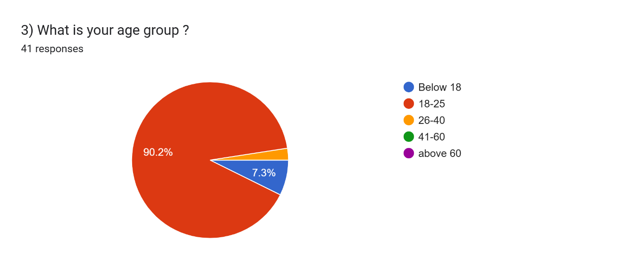
The pie chart shows that the majority of respondents (90.2%) belong to the 18–25 age group. Only 7.3% of respondents are below 18 years, while a very small proportion is above 60 years. This indicates that the survey mainly represents young adults. Therefore, cyber-awareness activities can particularly focus on the digital habits and safety needs of young users.

Table:2
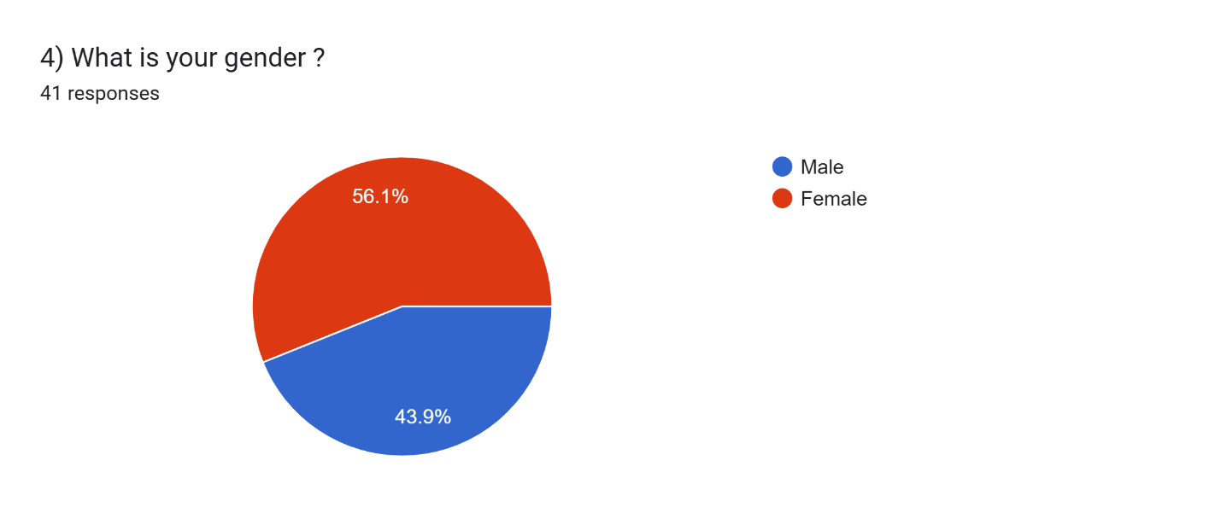
The gender distribution shows that 56.1% of respondents are male and 43.9% are female. The difference between the two groups is relatively small. This indicates participation from both male and female respondents. Cyber-awareness programs can therefore be designed to address the needs of the community as a whole.
Table:3
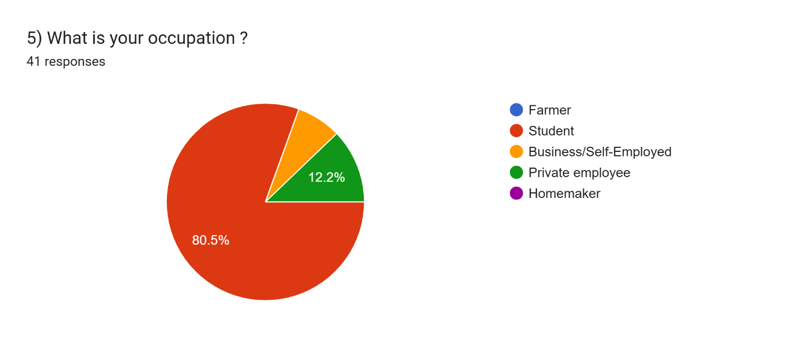
The occupation chart shows that 80.5% of respondents are students. Around 12.2% are private employees, while 7.3% are business/self-employed individuals. No significant responses were recorded from farmers or homemakers. This shows that the survey population is largely made up of students and young working individuals

Table:4
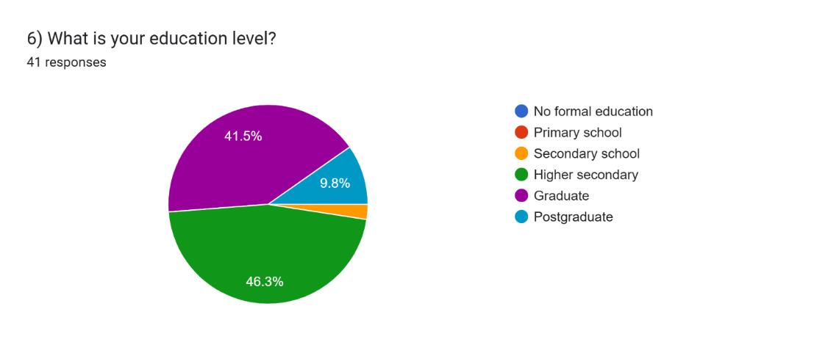
The chart indicates that 46.3% of respondents have completed higher secondary education. A further 41.5% are graduates, while 9.8% are postgraduates. Only about 2.4% of respondents have secondary-level education. Overall, the respondents have a relatively high level of formal education.
Table:5
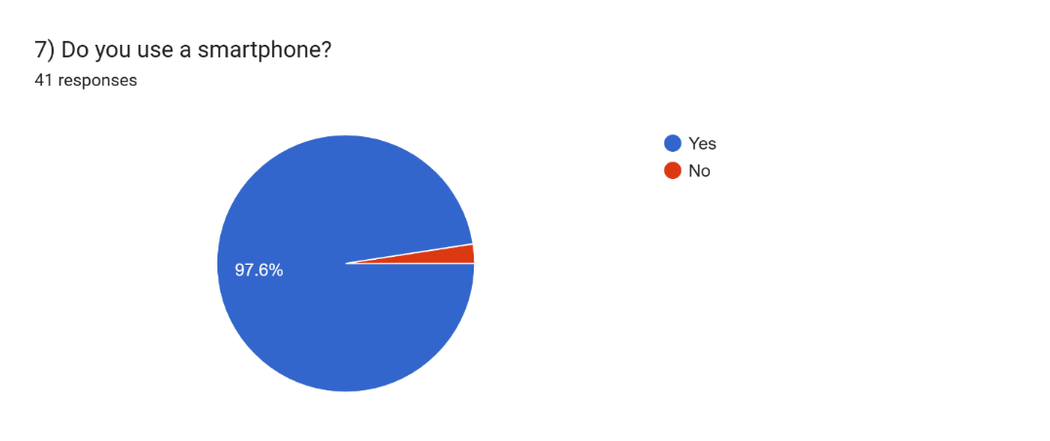
The pie chart shows that 97.6% of respondents use a smartphone, while only 2.4% do not. This demonstrates that smartphones are almost universally used among the surveyed participants. Smartphones are therefore an important medium for accessing digital services. Cyber-awareness campaigns can use mobile-based communication to reach this population effectively.

Table:6
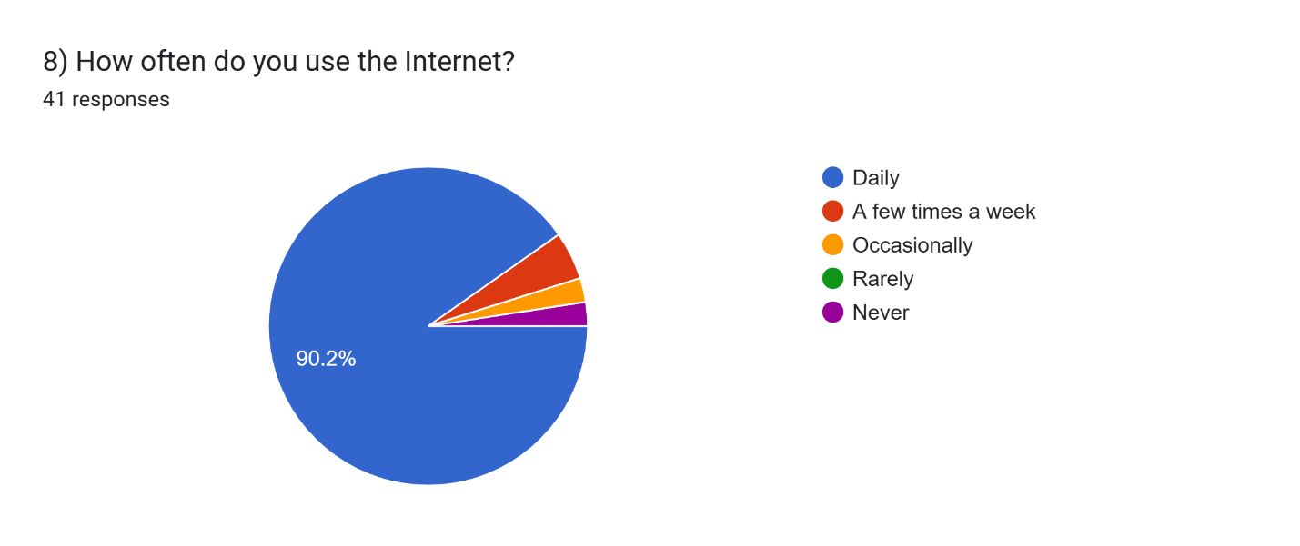
The chart shows that 90.2% of respondents use the Internet daily. Only a small proportion use the Internet a few times a week or occasionally. This indicates a high level of regular Internet usage among participants. Consequently, awareness about online safety, scams and privacy is important for these users.
Table:7
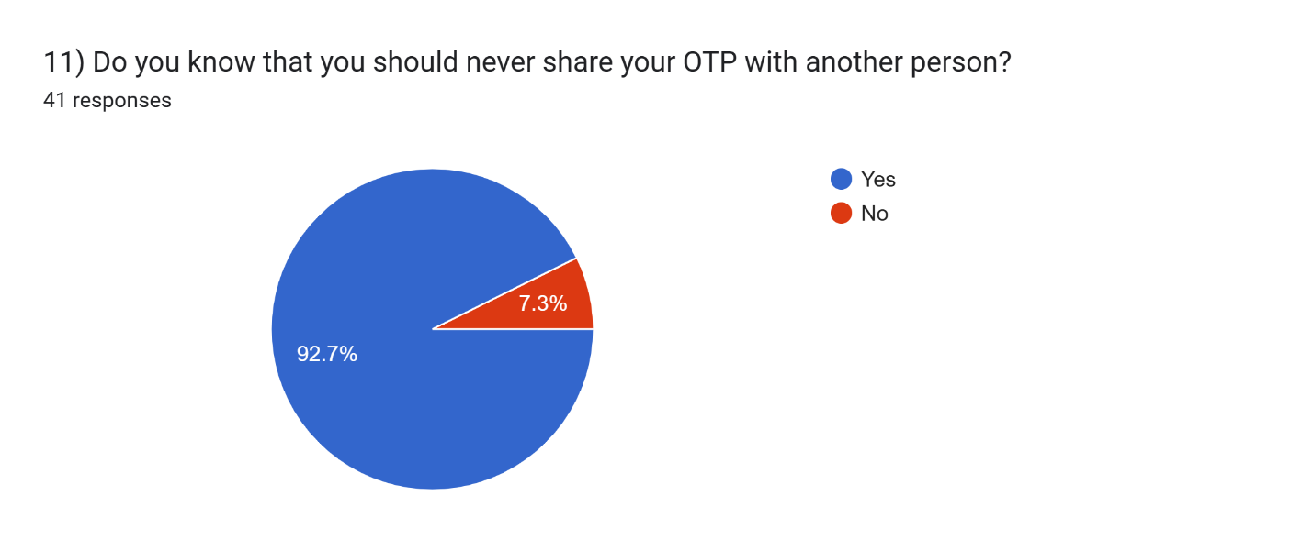
The pie chart shows that 92.7% of respondents know that OTPs should never be shared with another person. Only 7.3% do not have this awareness. This indicates that most respondents understand this basic aspect of digital security.

Table:8
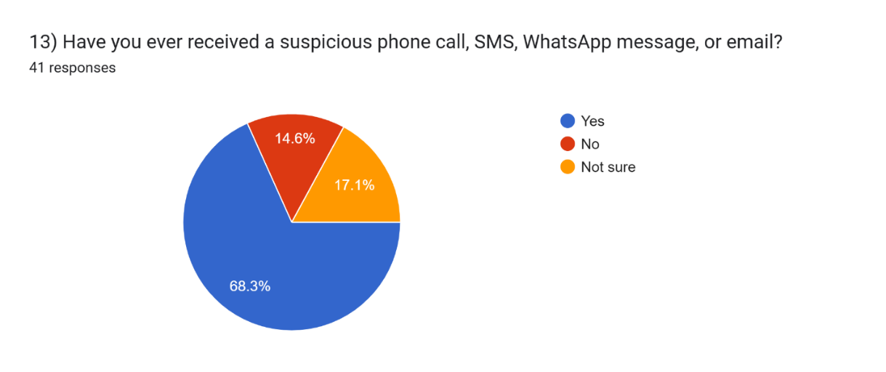
The chart shows that 68.3% of respondents have received a suspicious phone call, SMS, WhatsApp message or email. About 17.1% were not sure, while 14.6% reported that they had not received one. This indicates that suspicious digital communication is common among the respondents.
Table:9
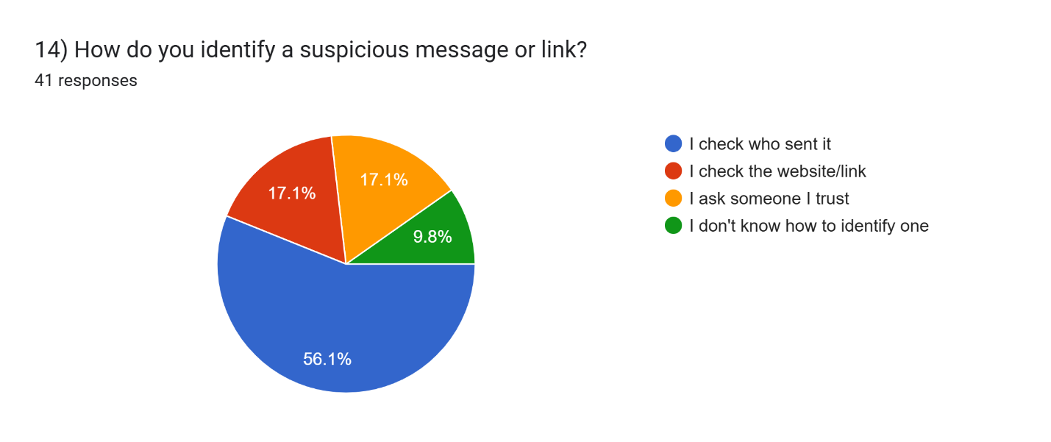 The chart shows that 56.1% of respondents check who sent a suspicious message or link. Another 17.1% check the website/link, while 17.1% ask someone they trust. Around 9.8% do not know how to identify a suspicious message.

Table:10
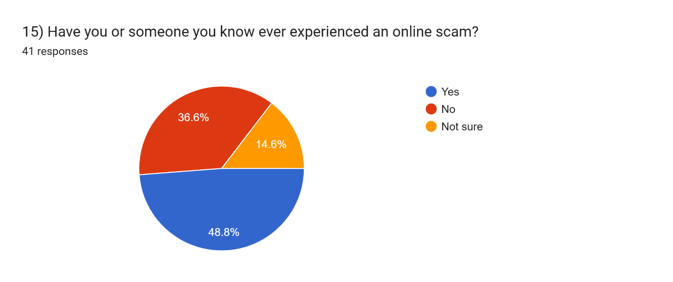
The pie chart indicates that 48.8% of respondents or someone they know have experienced an online scam. Around 36.6% reported no such experience, while 14.6% were unsure.
The results show that online scams are a relevant issue for a considerable portion of the respondents.
Table:11
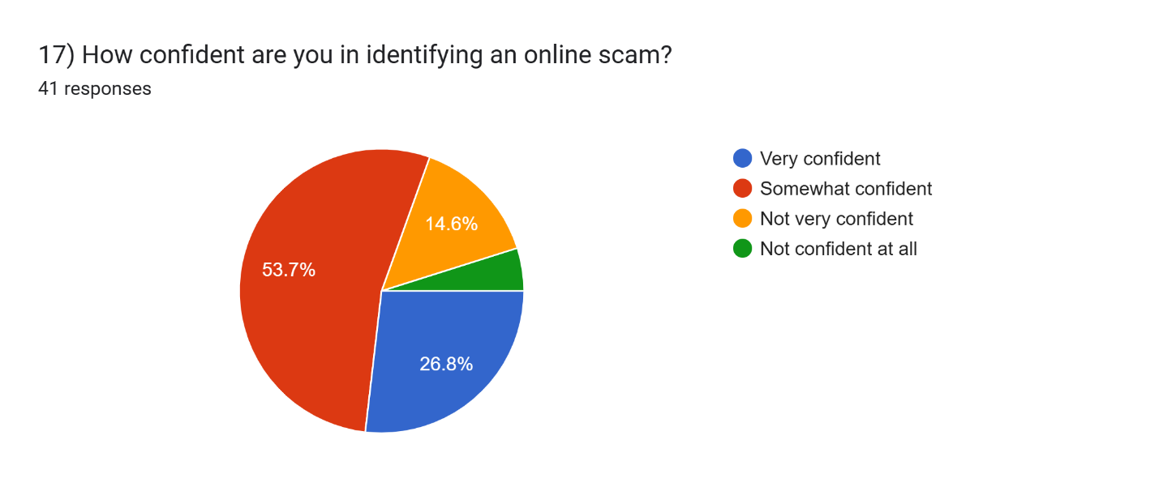 The chart shows that 53.7% of respondents are somewhat confident in identifying an online scam. About 26.8% are not very confident, while 14.6% are very confident. A small percentage are not confident at all.

Table:12
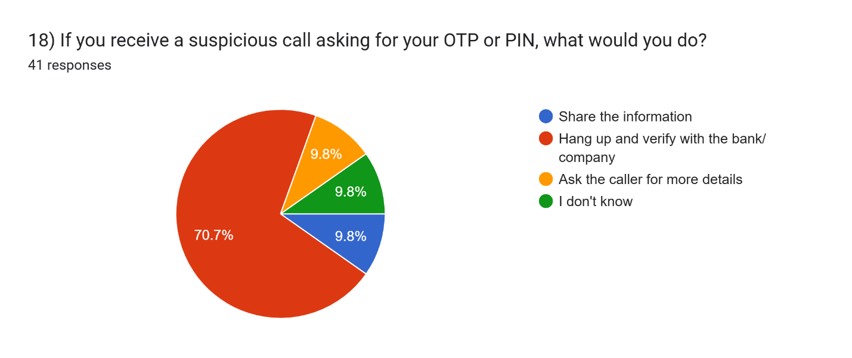
The chart shows that 70.7% of respondents would hang up and verify with the bank/company if they received a suspicious OTP or PIN call. About 9.8% would share the information, ask the caller for more details, or report that they do not know what to do. The majority therefore show a cautious approach toward suspicious calls.

Table:13
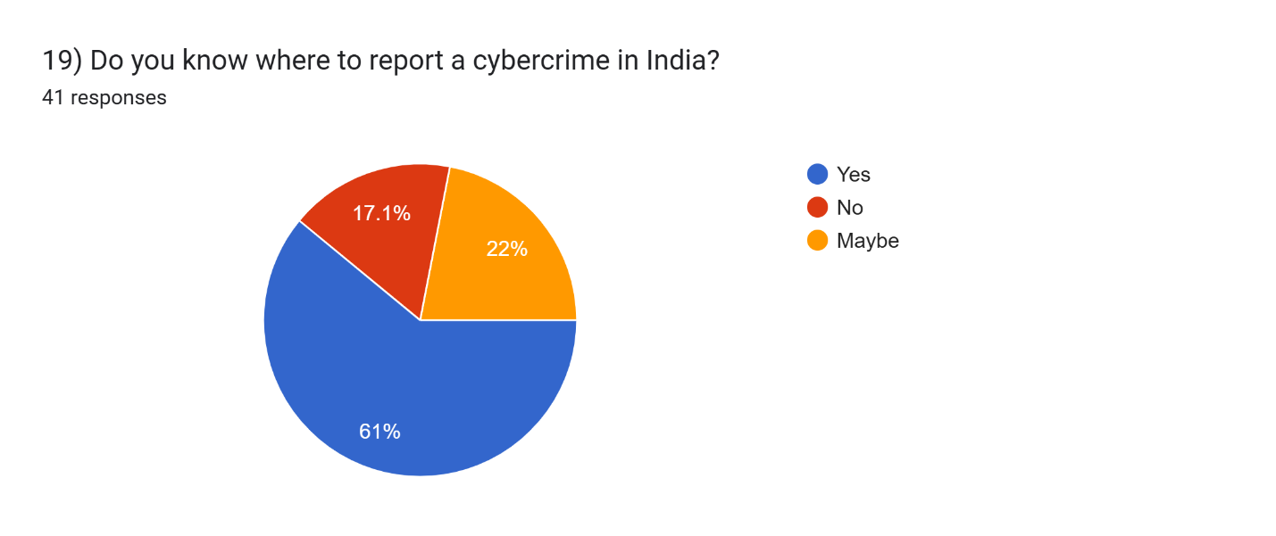The pie chart shows that 61% of respondents know where to report a cybercrime in India.
About 22% are unsure, while 17.1% do not know where to report it. This indicates that awareness of cybercrime reporting procedures is present but not universal.

Table:14
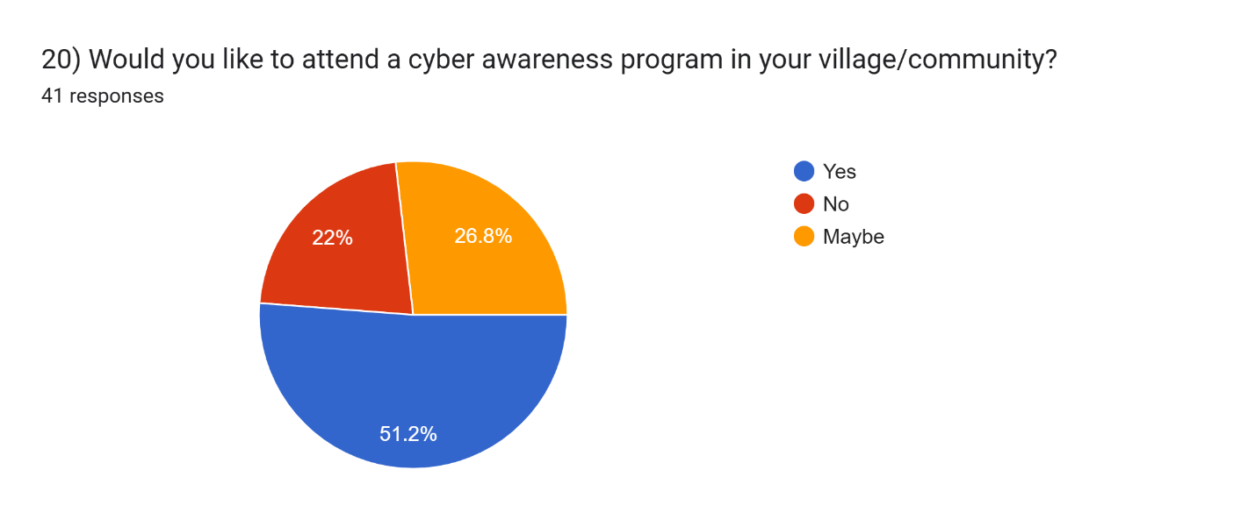
The chart shows that 51.2% of respondents would like to attend a cyber awareness program in their village or community. Another 26.8% selected “Maybe,” while 22% were not interested. Thus, a considerable number of respondents are open to participating in awareness activities. Community level programs could provide practical knowledge about online safety and fraud prevention.
Table:15
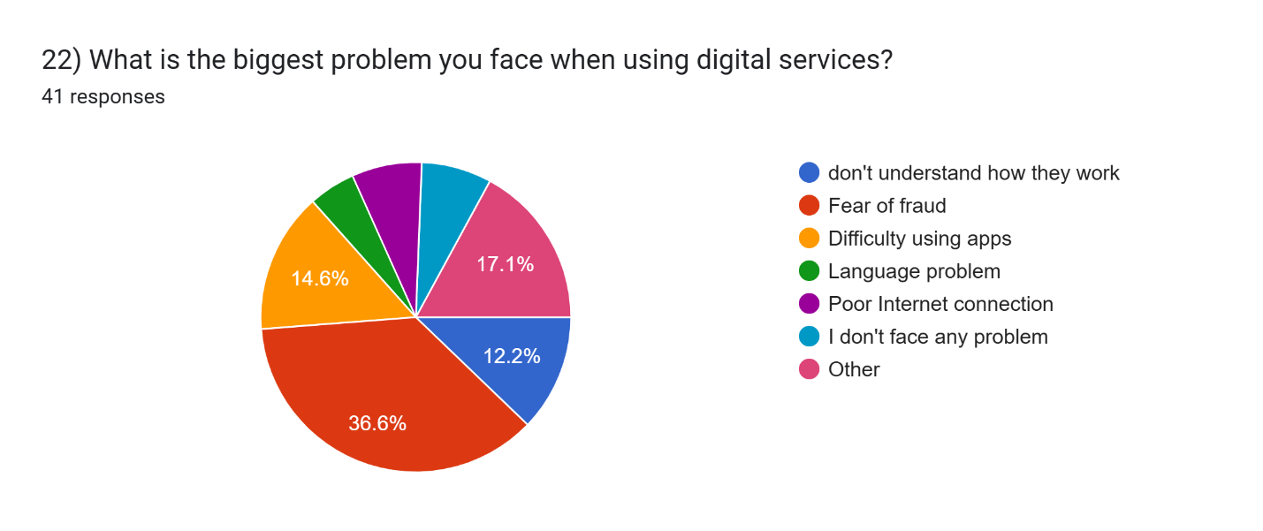
The chart shows that fear of fraud is the biggest problem, reported by 36.6% of respondents. Difficulty in using apps accounts for 14.6%, while 12.2% do not understand how digital services work. Other respondents mentioned language problems, poor Internet connectivity and other difficulties.

Table:16
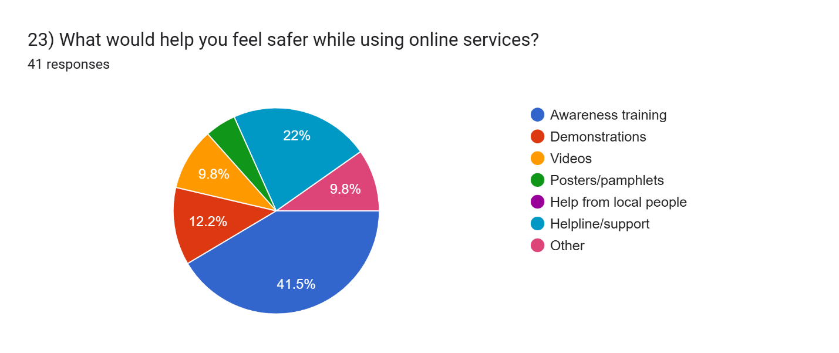
The chart shows that 41.5% of respondents believe awareness training would help them feel safer online. About 22% selected helpline/support, while demonstrations received 12.2%. Videos and other methods were also selected by smaller portions of respondents.
This indicates that practical training and accessible support are important for improving users' confidence.

Table:17
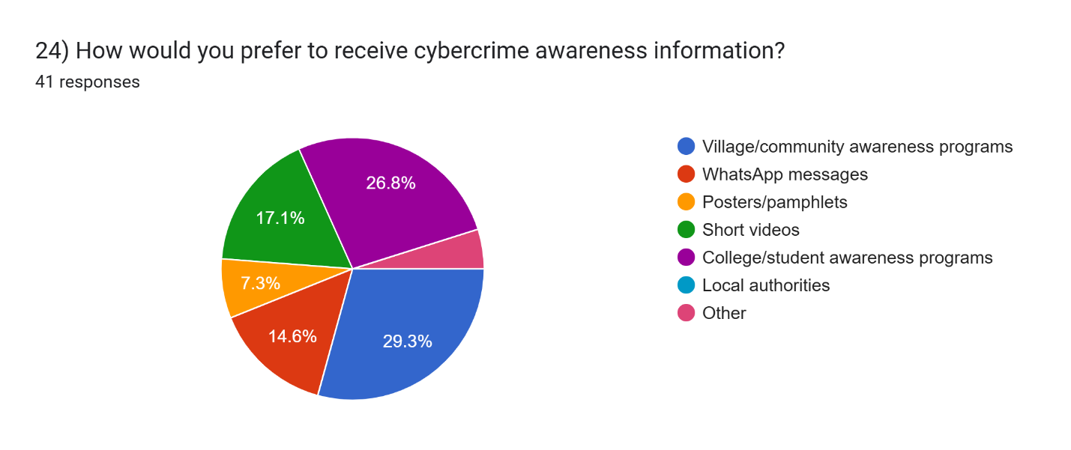
The chart shows that 29.3% prefer village/community awareness programs. About 26.8% prefer college/student awareness programs, while 17.1% prefer short videos.
WhatsApp messages and posters/pamphlets were selected by 14.6% and 7.3% respectively.

Table:18
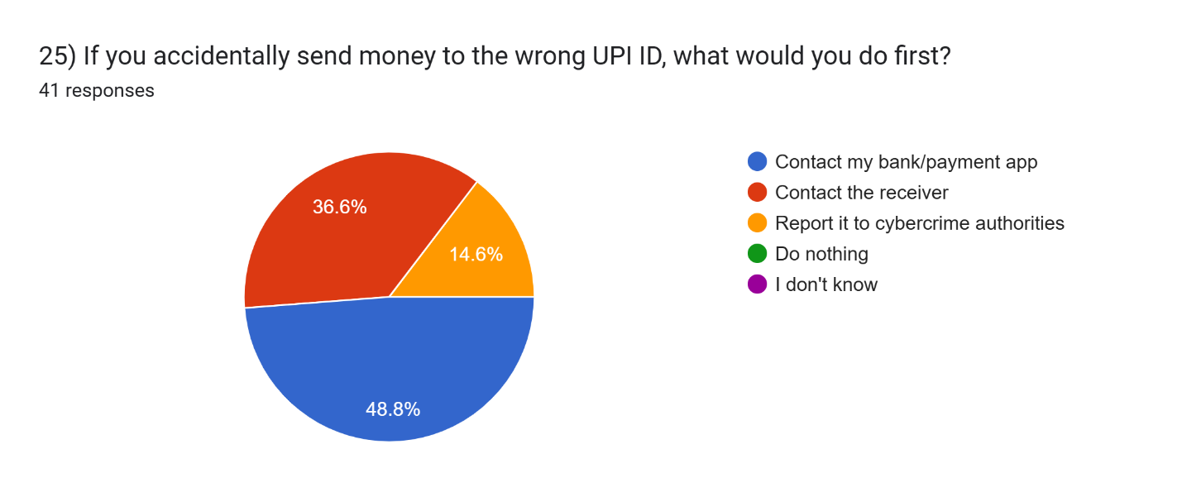 Report:
The chart shows that 48.8% of respondents would first contact their bank/payment app after sending money to the wrong UPI ID. Around 36.6% would contact the receiver, while 14.6% would report the incident to cybercrime authorities. No significant percentage selected “Do nothing” or “I don't know.” This indicates that most respondents would take some action after making an incorrect UPI transaction

Chapter 5. Conclusion and Recommendations
5.1. Conclusion
The “Cyber Awareness Campaign for Rural Communities” project was developed to spread awareness about safe and responsible use of digital technology among rural communities. The campaign focuses on common cyber threats such as “phishing, OTP fraud, UPI scams, fake websites, fake job offers, malware, and identity theft”. Through awareness content, videos, examples, quizzes, and a questionnaire using Google Forms, the project helps users understand common online risks and the precautions they can take.
The analysis of the collected responses helps identify the level of “digital literacy and cybersecurity awareness” among participants. Overall, the project highlights the importance of educating people about safe online practices and encouraging them to verify information before sharing personal or financial details.

5.2. Recommendations
1. “Conduct regular awareness campaigns” in rural communities to explain new and common cyber threats.
2. Provide cybersecurity information in “local and regional languages” so that it is easy to understand.
3. Teach people “never to share OTPs, PINs, passwords, or banking details” with anyone.
4. Encourage the use of “strong passwords and two-factor authentication (2FA)”.
5. Teach users to identify “fake links, phishing messages, fake websites, and fraudulent job offers”.
6. Use “videos, images, real-life examples, and quizzes” to make cybersecurity education easier and more engaging.
7. Encourage people to “verify suspicious calls, messages, and payment requests” before taking any action.
8. Continue collecting feedback through “Google Forms or surveys” to measure changes in cybersecurity awareness.
9. Organize awareness sessions through “schools, colleges, community centers, and local organizations”.
10. Keep the campaign content “updated regularly” as new types of cyber fraud and online scams emerge.

References
1. “Indian Computer Emergency Response Team (CERT-In), Ministry of Electronics and Information Technology, Government of India”.’Awareness Booklets and Cyber Security Best Practices.’ ([CERT-In][1])
2. “National Cyber Crime Reporting Portal, Ministry of Home Affairs, Government of India’. ‘Cyber Awareness and Safety Resources.’ The portal provides awareness material on financial fraud, job fraud, social media safety, and cyber hygiene. ([Cyber Crime Portal][2])
3. “National Cyber Crime Reporting Portal.” ‘Online Safety Tips.* Information on safe browsing, software updates, privacy, secure devices, and protection against online threats. ([Cyber Crime Portal][3])
4. “National Cyber Crime Reporting Portal.” ‘Cyber Crime Reporting and Citizen Services.’ Information about reporting cybercrime and financial fraud through the national reporting system. ([Cyber Crime Portal][4])
5. “Indian Computer Emergency Response Team (CERT-In).” ‘Cyber Security Awareness Resources.’ Government resources for educating citizens about safe and secure Internet usage. ([CERT-In][1])
6. “National Cyber Crime Reporting Portal.” ‘Training Resources.’ Resources related to cybersecurity education and awareness training. ([Cyber Crime Portal][5])

Websites
CERT-In Indian Computer Emergency Response Team
(https://www.cert-in.org.in/?utm_source=chatgpt.com)
National Cyber Crime Reporting Portal
(https://www.cybercrime.gov.in/?utm_source=chatgpt.com)
[1]: https://cert-in.org.in/AwarenessBooklets.jsp?utm_source=chatgpt.com "Booklets"
[2]: https://cybercrime.gov.in/Webform/CyberAware.aspx?utm_source=chatgpt.com "Cyber Crime Portal"
[3]:https://www.cybercrime.gov.in/Webform/Crime_OnlineSafetyTips.aspx?utm_source=chatgpt.com "Cyber Crime Portal"
[4]:https://www.cybercrime.gov.in/Accept.aspx?utm_source=chatgpt.com "Cyber Crime Portal"
[5]:https://cybercrime.gov.in/Webform/training-resource.aspx?utm_source=chatgpt.com "Cyber Crime Portal"

Appendices
QUESTIONARIES FOR GOOGLE FORM
Section 1: Basic Information
- What is your age group?
- What is your gender?
- What is your occupation?
- What is your education level?
Section 2: Digital Usage
- Do you use a smartphone?
- How often do you use the Internet?
- What do you mainly use the Internet for?
- Which digital payment methods do you use?
- Have you heard the term “cybercrime”?
- Do you know that you should never share your OTP with another person?
- What information should you NOT share with strangers?
- Have you ever received a suspicious phone call, SMS, WhatsApp message, or email?
- Have you or someone you know ever experienced an online scam?
- Which types of online scams have you heard about?
Section 4: Awareness Needs
- How confident are you in identifying an online scam?
- If you receive a suspicious call asking for your OTP or PIN, what would you do?
- Do you know where to report a cybercrime in India?
- Would you like to attend a cyber awareness program in your village/community?
- Which topics would you like to learn about?
- What is the biggest problem you face when using digital services?
- What would help you feel safer while using online services?



