REPORT ON MIX DESIGN OF DBM GRADE II
New Data Import Test
Pavement Laboratory • Report Date: 13-May-2026
Project Information
Item | Detail
Name of Work | Test Import Report
Client | Test Client
1. Materials
2–5. Gradation, Blend & Specific Gravities
This report was generated from an imported summary table. Raw gradation, blend proportions and specific-gravity test data are not available in this file.
Estimated Gsb (from VMA back-calc): 2.7200
6. Marshall Mix Design Summary
Pb % | Gmm | Gmb | VIM % | VMA % | VFB % | Stab. kN | Flow mm | MQ
3.5 | 2.593 | 2.321 | 10.50 | 17.70 | 40.50 | 9.88 | 2.10 | 4.71
4.0 | 2.563 | 2.349 | 8.30 | 17.10 | 51.20 | 11.25 | 2.29 | 4.91
4.5 | 2.524 | 2.376 | 5.90 | 16.60 | 64.60 | 12.52 | 2.79 | 4.49
5.0 | 2.493 | 2.401 | 3.70 | 16.10 | 77.20 | 10.76 | 2.97 | 3.62
5.5 | 2.441 | 2.394 | 1.90 | 16.80 | 88.60 | 9.32 | 3.17 | 2.94
7. Optimum Bitumen Content (OBC)
OBC = 4.93% (at target 4.0% air voids — method: interpolated)
Mix Parameters at OBC vs Specification
Property | Value at OBC | Requirement | Status
Stability (kN) | 11.00 | ≥ 9.0 | PASS
Flow (mm) | 2.95 | 2.0 – 4.0 | PASS
Air Voids (%) | 4.00 | 3.0 – 5.0 | PASS
VMA (%) | 16.17 | ≥ 13.25 | PASS
VFB (%) | 75.48 | 65.0 – 75.0 | FAIL
Marshall Quotient | 3.73 | 2.0 – 5.0 | PASS
Gmb at OBC | 2.398 | — | —
Gmm at OBC | 2.497 | — | —
Overall compliance (DBM Grade II): FAIL

9. Marshall Design Curves
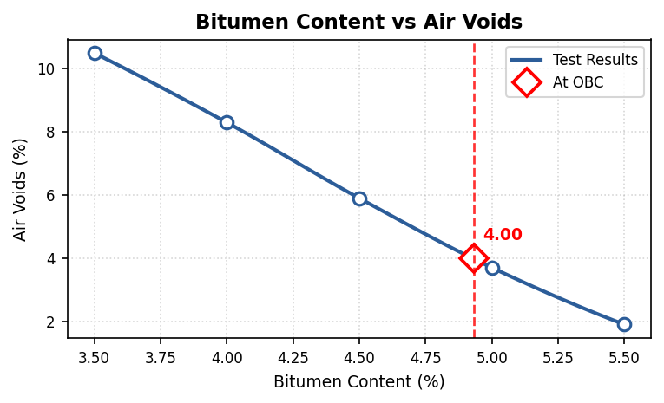 | 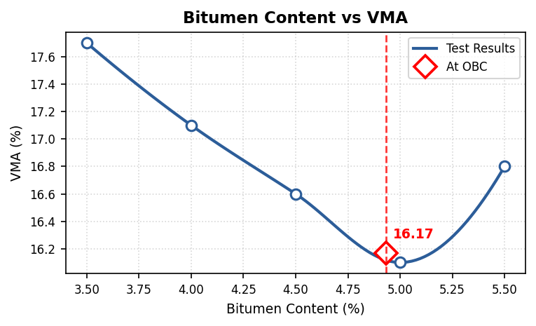
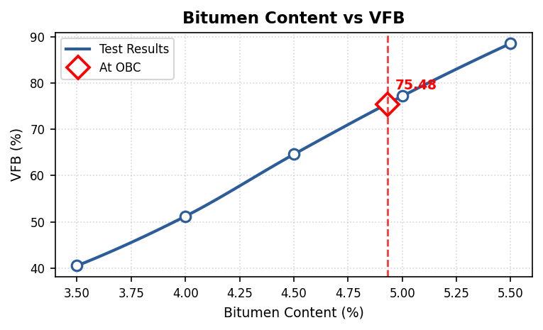 | 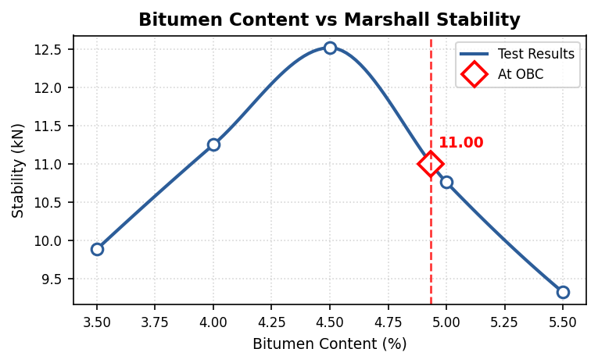
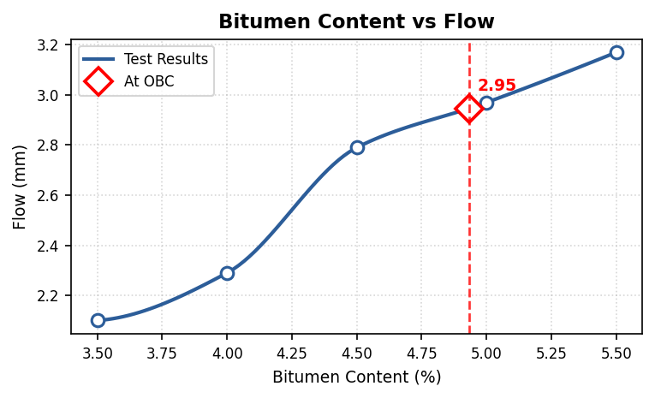 | 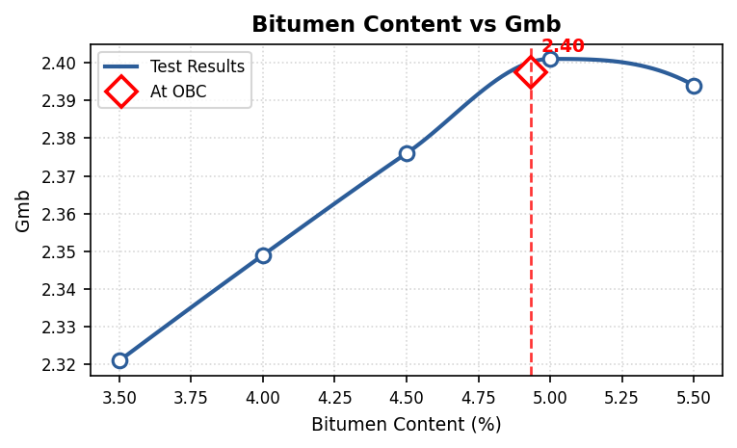

Prepared By  ______________________ | Approved By  ______________________

