REPORT ON MIX DESIGN OF DBM GRADE I
Shirdi Airport DBM Trial
Pavement Laboratory • Report Date: 13-May-2026
Project Information
Item | Detail
Name of Work | Shirdi Airport DBM Trial
Client | Shri Sai Construction
Agency | Arcstone Infrastructure
1. Materials
2. Aggregate Gradation (% Passing)
IS Sieve (mm) | 25mm | 20mm | 6mm | SD | Cement
37.5 | 100.0 | 100.0 | 100.0 | 100.0 | 100.0
26.5 | 96.6 | 100.0 | 100.0 | 100.0 | 100.0
19 | 44.5 | 89.8 | 100.0 | 100.0 | 100.0
13.2 | 4.0 | 5.2 | 100.0 | 100.0 | 100.0
4.75 | 0.0 | 0.0 | 38.6 | 99.8 | 100.0
2.36 | 0.0 | 0.0 | 8.1 | 92.3 | 100.0
0.3 | 0.0 | 0.0 | 0.0 | 33.8 | 100.0
0.075 | 0.0 | 0.0 | 0.0 | 9.5 | 42.2
3. Blend Proportions
Aggregate | Proportion
25mm | 23.0%
20mm | 11.0%
6mm | 32.0%
SD | 32.0%
TOTAL | 98.0%
Aggregates are mixed in the proportions above to meet the combined gradation specified for DBM Grade I (MoRTH).
4. Combined Gradation vs Specification
IS Sieve (mm) | Combined % Passing | MoRTH Spec | Status
37.5 | 98.00 | 100 – 100 | Out
26.5 | 97.21 | 90 – 100 | Within
19 | 84.12 | 71 – 95 | Within
13.2 | 65.49 | 56 – 80 | Within
4.75 | 44.27 | 38 – 54 | Within
2.36 | 32.11 | 28 – 42 | Within
0.3 | 10.81 | 7 – 21 | Within
0.075 | 3.03 | 2 – 8 | Within
5. Specific Gravities of Materials
Material | Bulk Sp. Gr. | Water Absorption
Coarse 25mm | 2.718 | 2.51%
Coarse 20mm | 2.695 | 3.02%
Fine 6mm | 2.803 | —
Fine SD | 2.758 | —
Bitumen (VG-30) | 1.011 | —
Combined aggregate (Gsb) | 2.756 | —
6. Marshall Mix Design Summary
Pb % | Gmm | Gmb | VIM % | VMA % | VFB % | Stab. kN | Flow mm | MQ
3.5 | 2.589 | 2.443 | 5.66 | 14.45 | 60.84 | 12.22 | 3.36 | 3.64
4.0 | 2.569 | 2.452 | 4.54 | 14.58 | 68.86 | 14.03 | 3.44 | 4.08
4.5 | 2.548 | 2.460 | 3.48 | 14.76 | 76.43 | 16.26 | 3.62 | 4.49
5.0 | 2.528 | 2.446 | 3.23 | 15.66 | 79.38 | 14.43 | 3.76 | 3.84
5.5 | 2.508 | 2.436 | 2.89 | 16.47 | 82.44 | 13.59 | 3.88 | 3.50
7. Optimum Bitumen Content (OBC)
OBC = 4.25% (at target 4.0% air voids — method: interpolated)
Mix Parameters at OBC vs Specification
Property | Value at OBC | Requirement | Status
Stability (kN) | 15.16 | ≥ 9.0 | PASS
Flow (mm) | 3.53 | 2.0 – 4.0 | PASS
Air Voids (%) | 4.00 | 3.0 – 5.0 | PASS
VMA (%) | 14.67 | ≥ 14.0 | PASS
VFB (%) | 72.71 | 65.0 – 78.0 | PASS
Marshall Quotient | 4.30 | 2.0 – 5.0 | PASS
Gmb at OBC | 2.456 | — | —
Gmm at OBC | 2.558 | — | —
Overall compliance (DBM Grade I): PASS
8. Material Calculation for Sample Preparation
Quantities to weigh out when preparing a Marshall specimen of the standard sample (left bitumen content) and the target preparation sample (right bitumen content), with dry-material breakdown by aggregate fraction.
Block | Pb % | Aggregate % | Aggregate wt (g) | Bitumen wt (g) | Total mix wt (g)
Standard sample | 4.50 | 95.50 | 1200.00 | 56.54 | 1256.54
Target sample | 4.00 | 96.00 | 1206.28 | 50.26 | 1256.54
Dry Material — Standard Sample
Particle Size | Blend Ratio | Weight (g)
25mm | 23.0% | 276.00
20mm | 11.0% | 132.00
6mm | 32.0% | 384.00
SD | 32.0% | 384.00
Cement | 2.0% | 24.00
TOTAL | 100.0% | 1200.00
Dry Material — Target Sample
Particle Size | Blend Ratio | Weight (g)
25mm | 23.0% | 277.45
20mm | 11.0% | 132.69
6mm | 32.0% | 386.01
SD | 32.0% | 386.01
Cement | 2.0% | 24.13
TOTAL | 100.0% | 1206.28

9. Marshall Design Curves
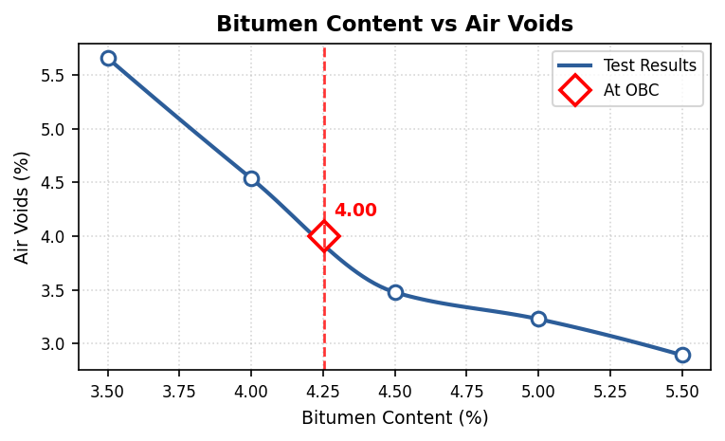 | 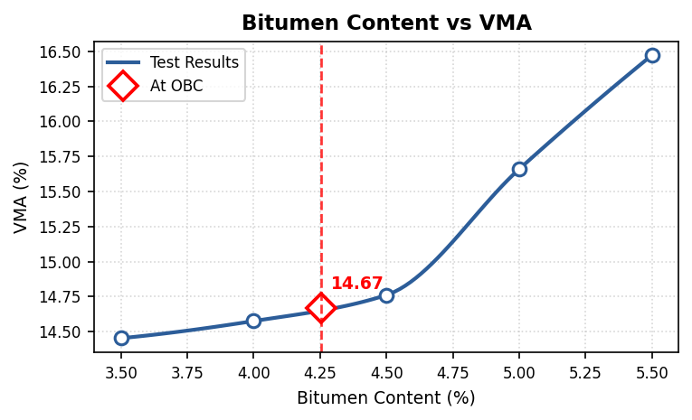
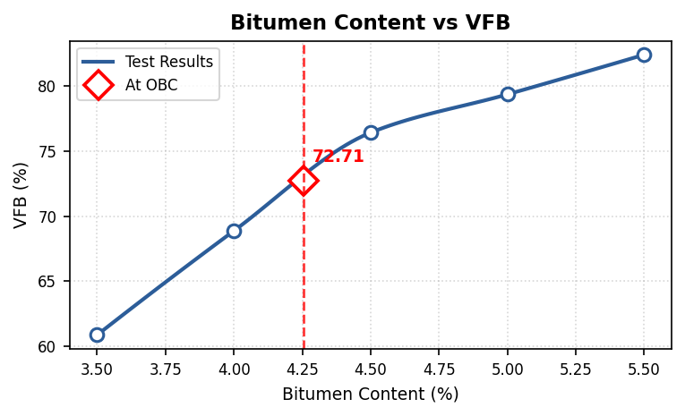 | 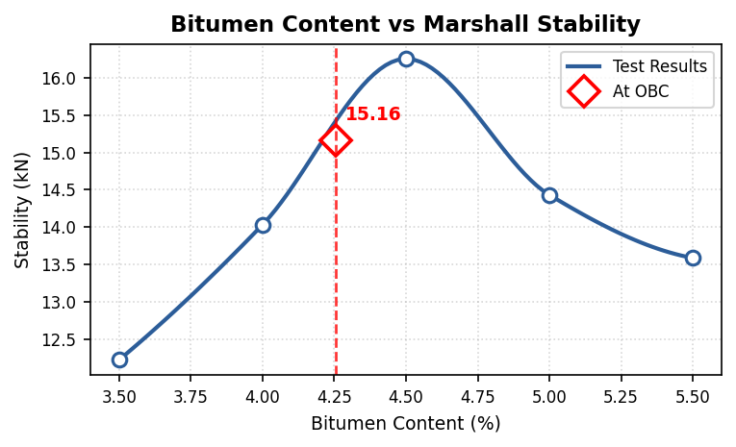
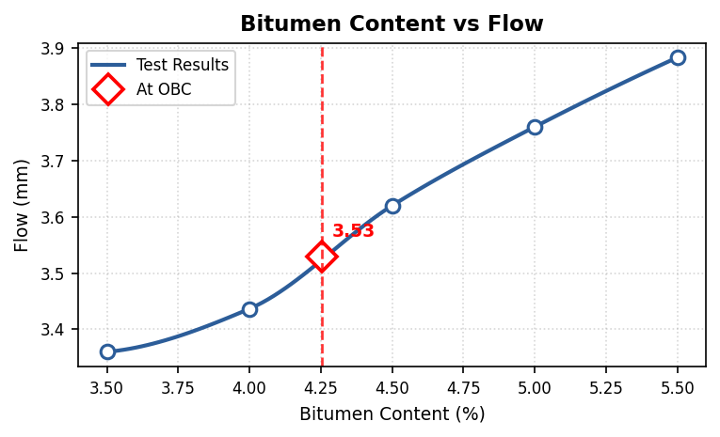 | 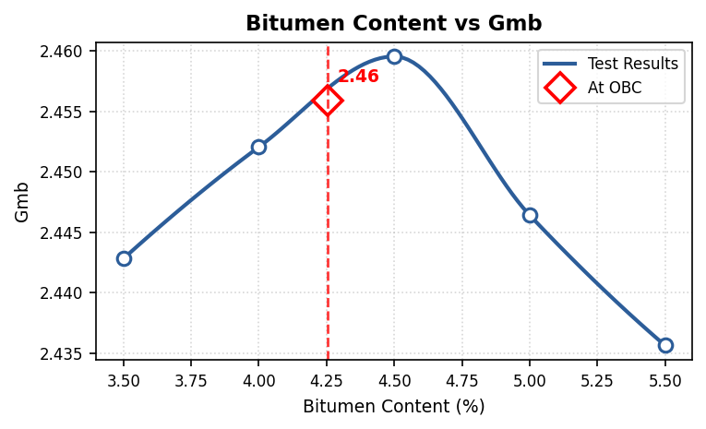

Prepared By  ______________________ | Approved By  ______________________

