**General Conference Packet – October 2023**

Hark, mortals of the earthly plane, for I am Reginald Thornfield, a soul now steeped in the shadows of Hollowbrook's darkest secrets. Once, I reveled in earthly mischief, but on a fateful All Hallows' Eve, I succumbed to a ghastly fate. Twisted by malevolent forces, I became a spectral presence, forever imprisoned in this spectral plane.

I now stand as the spectral guardian of enigmatic conundrums and eerie riddles, haunting the very town I once called home. Beware, for my challenges are cloaked in otherworldly mysteries, and my laughter now echoes with a haunting wail. Dare you venture forth on my spectral odyssey, where the line between the living and the spectral is eternally blurred?

As you dare to tune in to the ethereal echoes of General Conference, please take heed and partake in this enigmatic packet. Within its spectral pages lie activities that I, the mischievous ghostly author, have meticulously concocted to keep you entertained throughout each mystifying session. Behold, there are bewitching coloring pictures, cryptic word searches, enigmatic crosswords, and eerie spaces to transcribe the messages of the spectral speakers.

But beware, dear mortals, for the night of Halloween draws nigh, and I have devised a fiendish twist. There exists an obligatory activity, a haunting enigma to unravel, to be undertaken during a specific session, and it is not to be unraveled beforehand. This darkly cunning riddle shall thwart any attempt to hasten toward your coveted reward. I shall grant the privilege of a prize to the first brave soul who conquers all these ghostly tasks, whether it be a cauldron of their favorite candy or a paltry $10 gift card to a restaurant of their choice.

However, heed my spectral warning, for this endeavor must remain dormant until the very conclusion of the conference, and no sooner. Let the anticipation chill your mortal bones as the time for Halloween's ghastly arrival creeps ever closer. Mwhahahaha! Before you depart from this eerie endeavor, I beseech you to record at least two lines of your thoughts and reflections, for only those who do so shall be considered for the prize, and I shall delight in reading your musings from the shadowy realms beyond.

**Session One: Coloring**

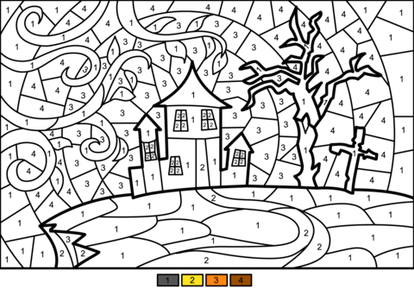**Activity 1: Color by number. There are ___ spaces with 4’s in them.**

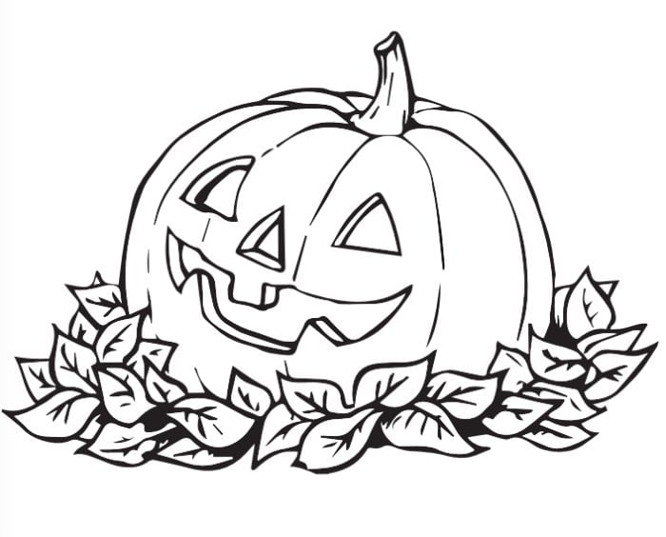**Activity 2: Color the pumpkin. A common name for a pumpkin is ____.**

C – W = __

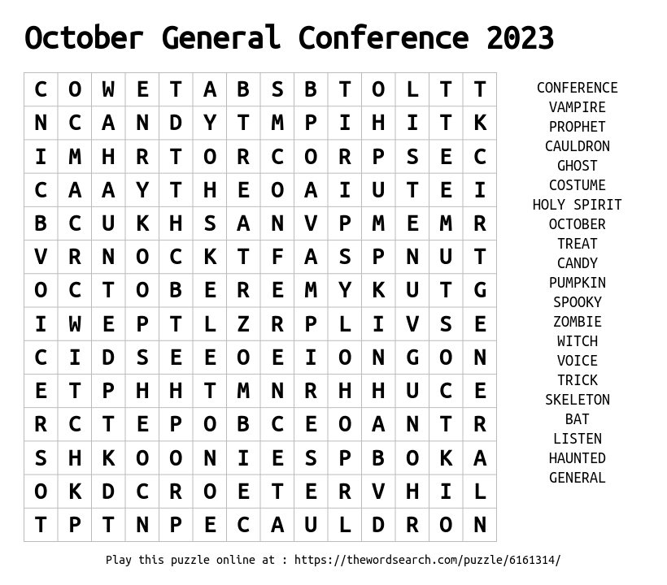

**Session Two: Test your word skills.**

**Activity 3: A Ghastly Word Search**

W = There are __ T’s in this puzzle.

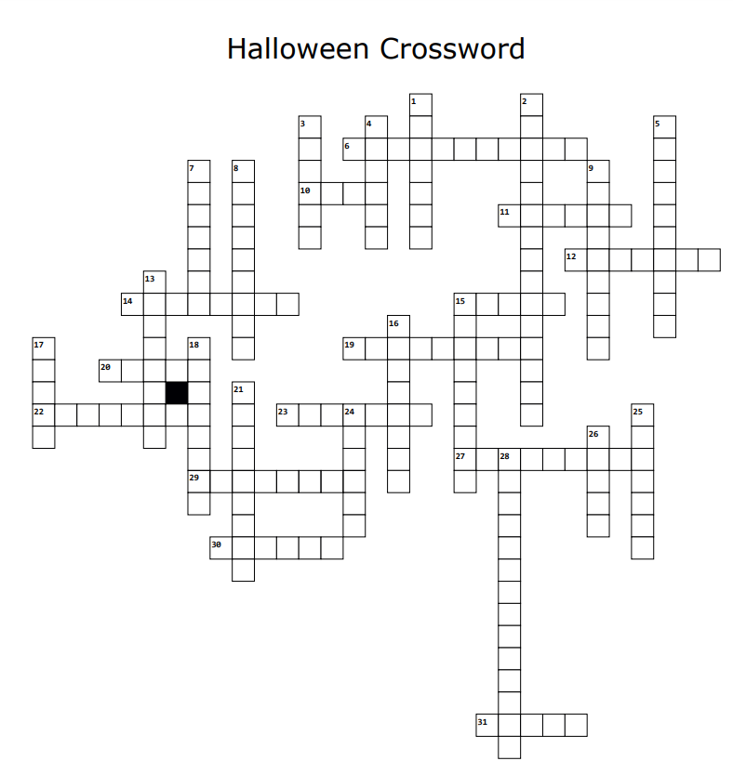

**Activity 4: Halloween Crossword**

14. A mythical creature that transforms into a wolf during a full moon.

15. skull A colorful, decorated skull used in el Dia de los Muertos.

19. The eerie glow of Earth's natural satellite.

20. hat A pointed hat often worn by witches.

22. Witches stir potions in this bubbling vessel.

23. A wailing female spirit from Irish folklore.

27. Ghostly residue often seen in paranormal investigations.

29. The framework of bones in a human or animal body.

30. A religion involving witchcraft and spirit worship.

31. corn Tri-colored Halloween treat.

C = There are __ clues in this puzzle.

Down

1. house A spooky, often abandoned, building said to be inhabited by ghosts.

2. A carved pumpkin with a candle inside.

3. A box used for burying the deceased.

4. Small, mischievous creature known for causing trouble.

5. A marker placed on a grave to memorialize the deceased.

7. A mythical creature that drinks blood to survive.

8. A book containing magical incantations and rituals.

9. Something that inspires fear or dread.

13. A place where the dead are buried.

15. The intricate structure spun by arachnids.

16. One who practices dark magic or sorcery.

17. cat Often considered a symbol of bad luck on Halloween.

18. A ghostly or supernatural apparition.

21. A figure used in agriculture to frighten away birds.

24. A gathering to communicate with the spirit world.

25. patch A field where pumpkins are grown for Halloween.

26. A stack of stones often used as a marker or memorial.

28. The Halloween tradition of visiting houses for candy

Across

6. A magical incantation or trickery.

10. moon A lunar phase associated with werewolf transformations.

11. A reanimated corpse often associated with a desire for brains.

12. Pertaining to spirits or phantoms.

**Session 3: Stories**

**Activity 5: Adlib Madness**

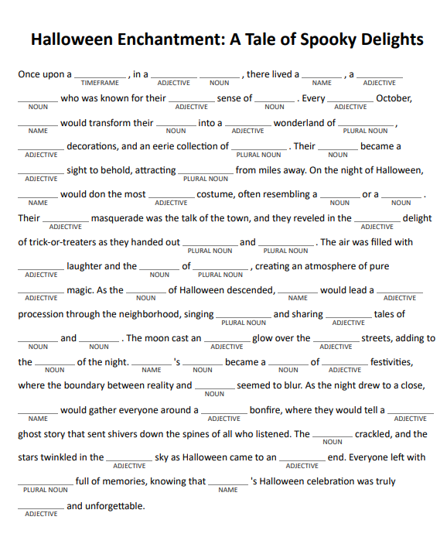

There are __ fill in the blank nouns

The section(s) abbreviation up to this point: ___ CTR

**Session 4: Reflection**

**Activity 6: Write at least one sentence about what you learned.**

**Session 1: ______________________________________________________________________________________________________________________________________________________________________________________________________________________________________________________________________________________________________________________________________________________________________________________________________________________________________________________________________________**

**Session 2: ______________________________________________________________________________________________________________________________________________________________________________________________________________________________________________________________________________________________________________________________________________________________________________________________________________________________________________________________________________**

**Session 3: ______________________________________________________________________________________________________________________________________________________________________________________________________________________________________________________________________________________________________________________________________________________________________________________________________________________________________________________________________________**

**Session 4: ______________________________________________________________________________________________________________________________________________________________________________________________________________________________________________________________________________________________________________________________________________________________________________________________________________________________________________________________________________**

When done, go to this link (fill in the blank with your question answers from each page):

https://github.com/khansen213/gcapril2023/blob/main/activities/images/______________.png