Shahnia I khan

OOP Java

Fall 2022

**Part 3 Screenshots**

I am doing two things in this homework

1) Creating a program to calculate circle area with a radius

2) Another program displays details about the planet that the user is interested in such as planet area, planet star, and planet position.

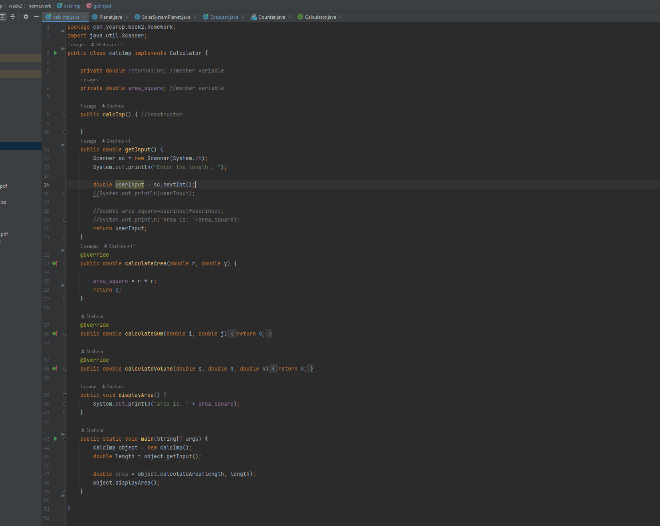

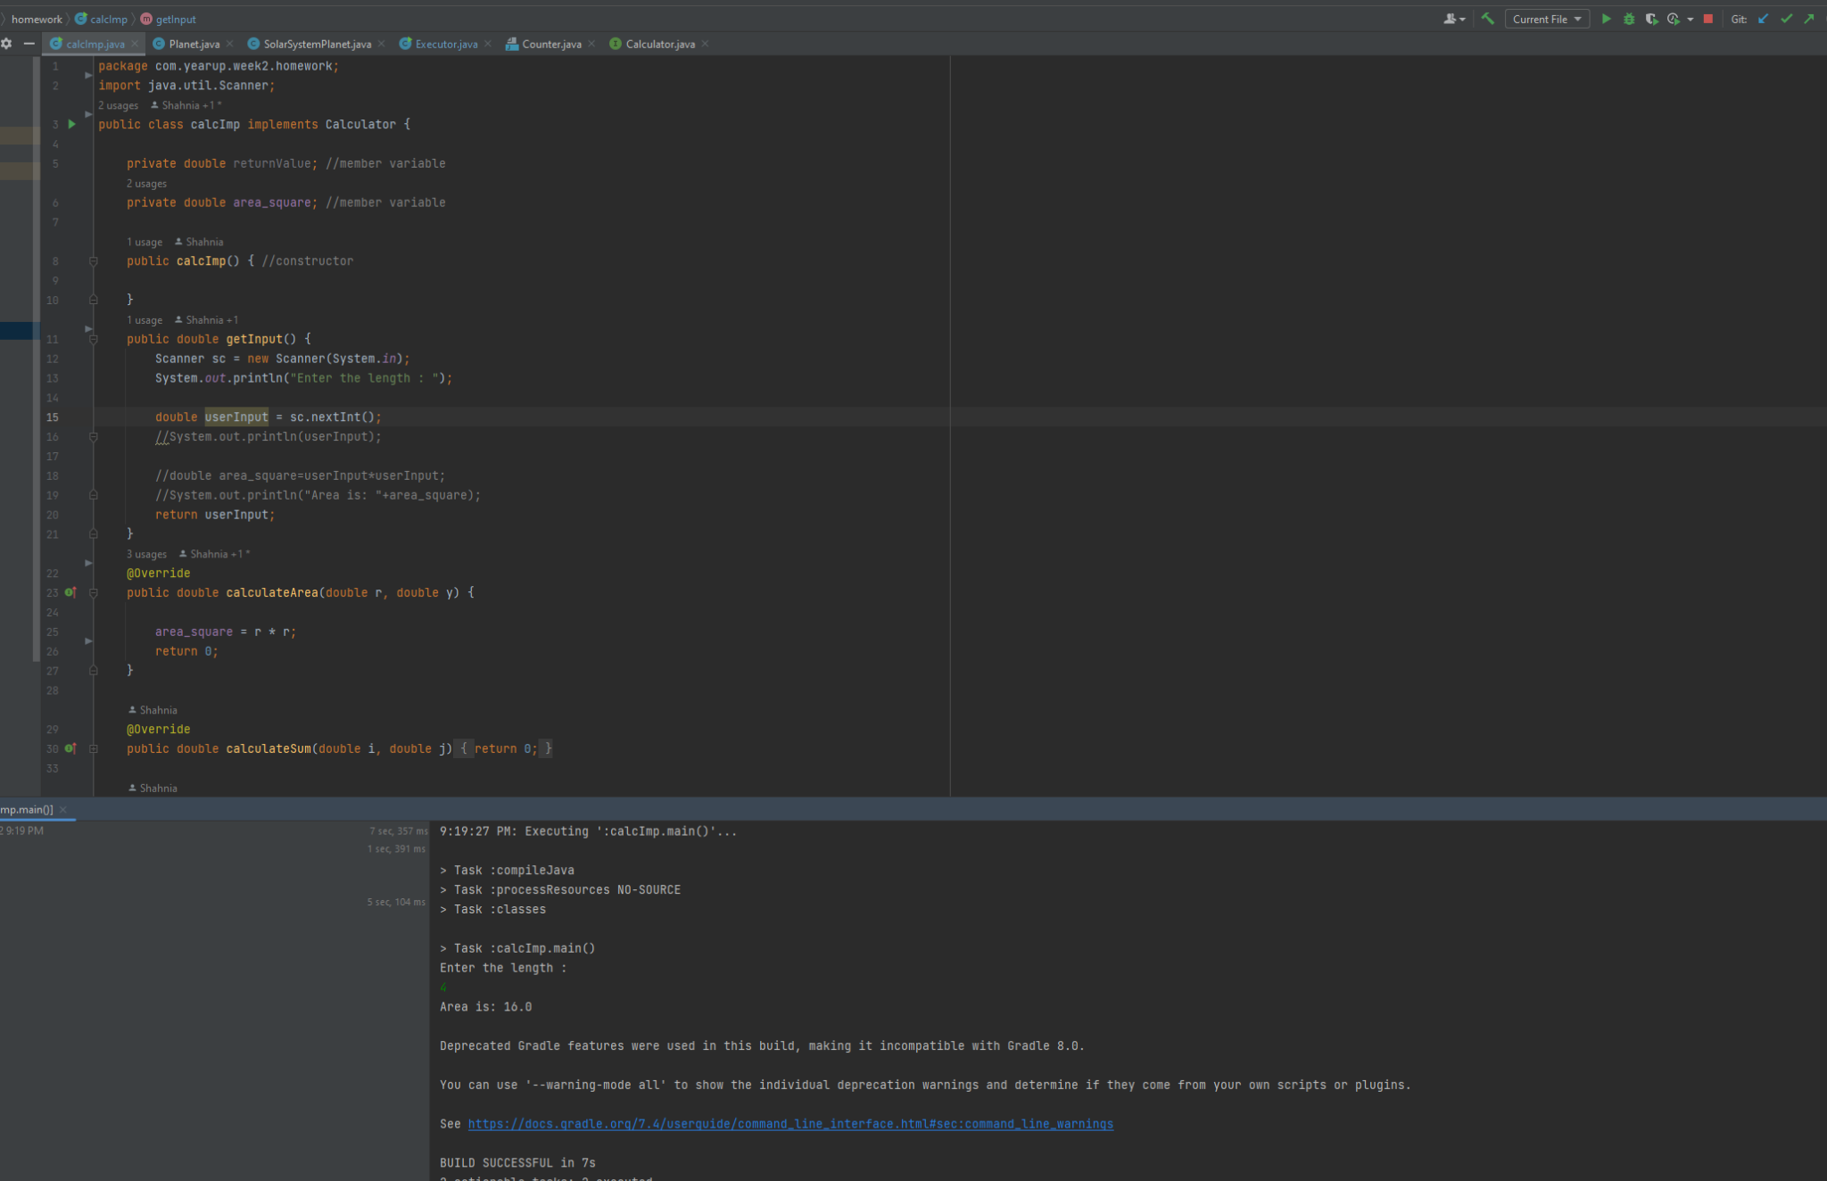

**Part 6 Screenshots**

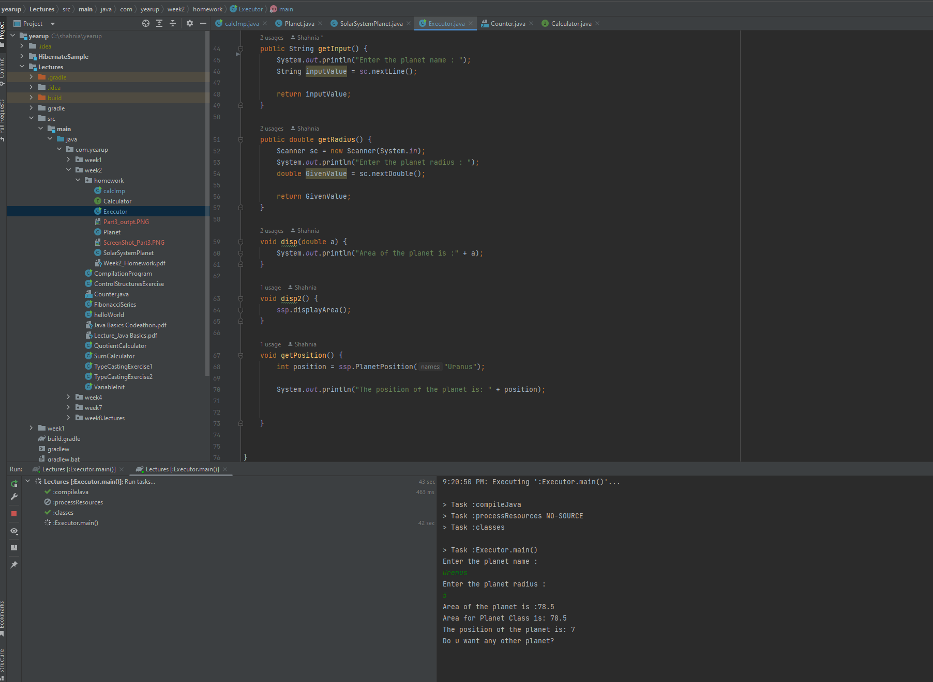

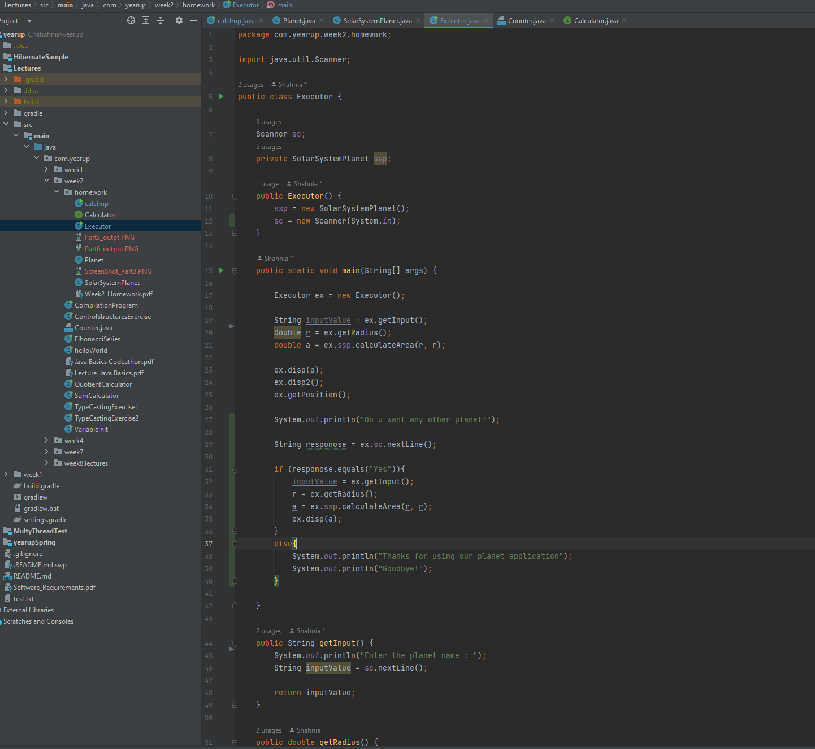

**GitHub Link to see all my committed works:**

https://github.com/khanshahnia/YearUpJava/tree/student/khan/Lectures/src/main/java/com/yearup/week2/homework