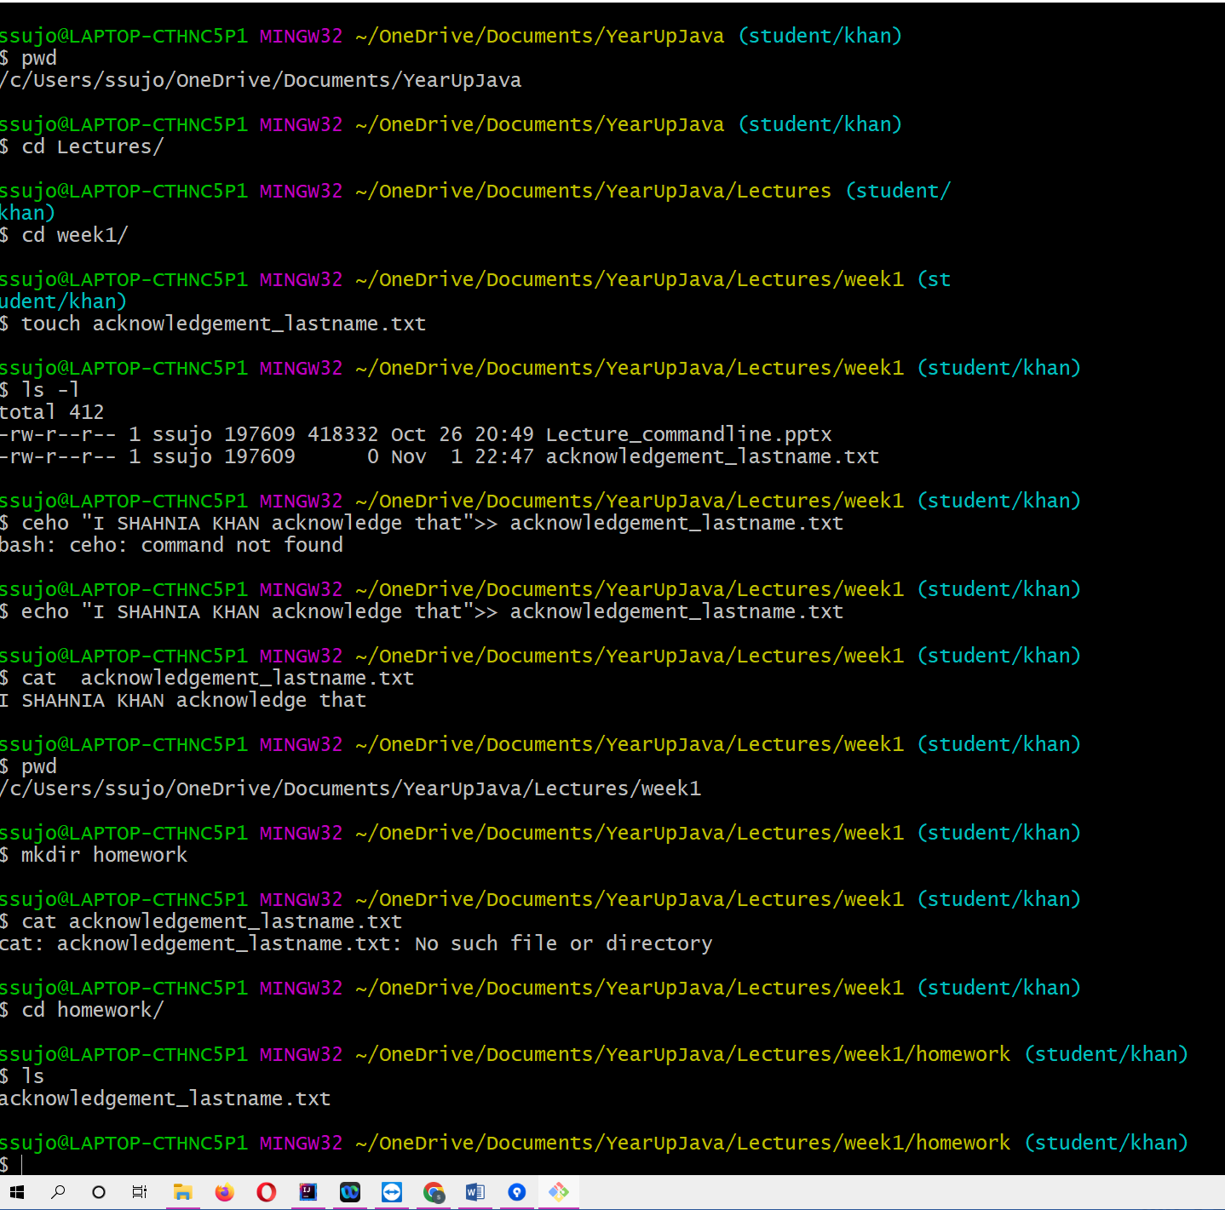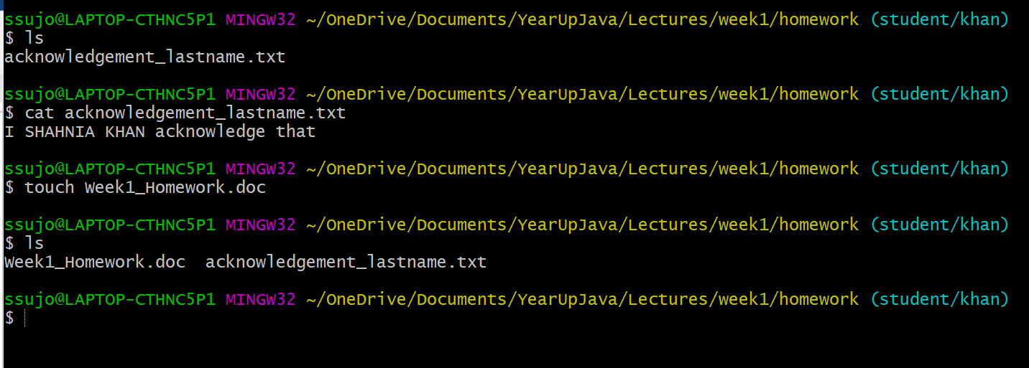
Homework 1
This homework will cover terminal commands and git basics. For some of the questions you will be asked to push certain changes and that is what we will be checking for. For other problems, you will be asked to paste the commands/results that you see in your terminal.

- Navigate to your forked project in local machine.
- Checkout your student/lastname branch. From your terminal, create a file name acknowledgement_lastname.txt in the directory called Lectures/week1.
- Add the following text “I YOUR NAME acknowledge that” to the file using your terminal.(you can do both file creation and adding text to the file at one go).
- Create a new directory named homework inside week1 directory and move the acknowledgement_lastname.txt file inside this directory.
- View the contents of the file in your terminal. Add a screenshot to Week1_Homework.doc showing the commands and the content of the file in your terminal.

- Following is the link to see the screenshots that I have added
https://github.com/khanshahnia/YearUpJava/blob/student/khan/Lectures/week1/homework/Week1_Homework.doc

- Commit your work (2 files1) your newly created text file 2) Week1_homework.doc with the screenshot) after staging with a commit message “Added acknowledgement file” & “Completed step 5 in homework”
- Create a new branch called homework_branch, and checkout your new branch (homework_branch).
- Create a file acknowledgement_lastname.txt file in a directory week1/homework directory. Add the following text “ this assignment is my own work”. Notice that adding a text to a file from the terminal and opening the file to type the text has the same result!
- Commit your work after staging with a message “Appending text to acknowledgement file from homework branch”.
- Switch back to your branch student/lastname.
- Try to merge the changes from homework_branch into student/lastname branch, and resolve the merge conflicts. The final version of your file should have the following text: “I YOURNAME acknowledge that this assignment is my own work”. Why did we see merge conflicts? Answer below.

These are lines that I have seen when I clicked to merge:
-Merge branch 'homework_branch' into student/khan

# Conflicts:
# Lectures/week1/homework/acknowledgement_lastname.txt
Reason:
When I tried to merge the homework branch into the student/lastname branch it showed me conflict because these branches had two different lines. So I right clicked to resolve the conflict and selected conflict resolved.

- Push your code to your forked project on branch student/lastname, specifying the branch and the remote. What is your remote name? Answer below.

Remote: student/khan
https://github.com/khanshahnia/YearUpJava/tree/student/khan

- Navigate back to your home directory using the shortcut symbol. Paste the command you ran below.

Ans: cd ~

- Commit & Push the week1_Homework.doc file from student/lastname branch after completing steps 11, 12 & 13.

