Name- Shahnwaz Khan

Roll :- Ac-1272

Practical : 1

Q-1: Display your systems IP Address, Subnet mask using ipconfig, and find out the network address and the maximum number of systems possible on your network and range of IP addresses available to these systems.

For IP address and Subnet mask: ipconfig

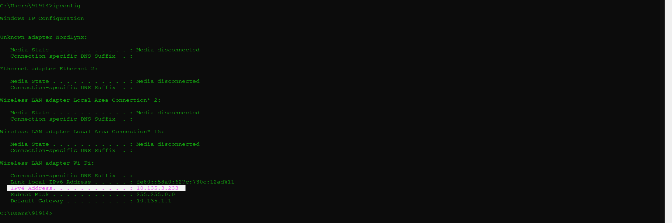

For network address: arp -a

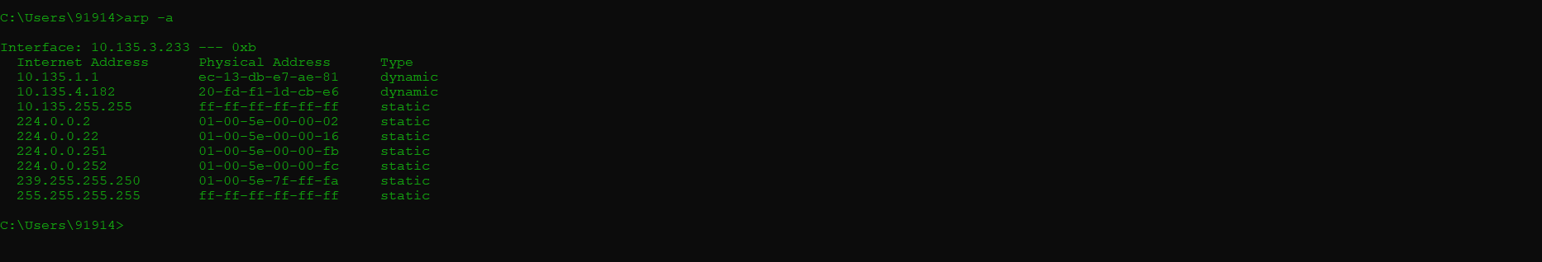

Maximum number of system possible on your network:

Subnet mask: 255.255.0.0

Binary of the subnet mask will be: 11111111.11111111.00000000.00000000

No. of zeros in the subnet mask =16

Maximum number of system possible: 216 -2=65536-2=65534

Range of IP address available to the systems:

Class B IP address range from 128.0.0.0 to 191.255.255 with default subnet mask of 255.255.0.0