With help of ping, check if you are connected to other systems of your network and find the route to connect to that system using tracert. List all the processes which are using ports for TCP protocol.

Name: Shahnwaz Khan

Roll: AC-1272

Lab:2

With help of ping, check if you are connected to other systems of your network

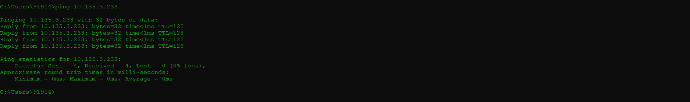

Find the route to connect to that system using tracert



List all the processes which are using ports for TCP protocol

