Homework-01 – After mid
Embedded IOT Systems Fall2025
AI 5th
23-NTU-CS-1284
Shamaim khan
Question-1 ESP32 Webserver (webserver.cpp)
Part A: Short Questions
1-What is the purpose of WebServer server(80); and what does port 80 represent?
This creates a web server object that listens on port 80
Port 80 is the default HTTP port (like how websites use port 80)
When you type an IP without specifying a port, it automatically uses port 80
2. Explain the role of server.on("/", handleRoot); in this program.
This sets up routing - it tells the server what to do when someone visits the root URL (/)
When a browser requests "http://ESP32_IP/", it will call the handleRoot() function
Think of it like a receptionist directing visitors to different rooms
3. Why is server.handleClient(); placed inside the loop() function? What will happen if it is removed?
This checks for incoming HTTP requests continuously
Without it, the server won't respond to any browser requests
Must be in loop() because web requests can come at any time
4. In handleRoot(), explain the statement:
server.send(200, "text/html", html);
200 = HTTP status code meaning "OK, success"
"text/html" = tells the browser this is an HTML webpage
html = the actual content to send back
5. What is the difference between displaying last measured sensor values and taking a fresh DHT reading inside handleRoot()?
Last measured :Shows cached values, faster response
Fresh reading :Reads sensor right now, more current but slower

Part B: Long Question
Describe the complete working of the ESP32 webserver-based temperature and humidity monitoring system.

I implemented this system by configuring the ESP32 as a local HTTP web server. I first established a Wi-Fi connection using the WiFi.begin() function, after which the ESP32 was assigned an IP address by the router. I used this IP address to access the web interface from a browser on the same network. I initialized the web server on port 80 and continuously handled client requests inside the loop() function.
For sensing, I used a push button to manually trigger data acquisition. Whenever I pressed the button, I read temperature and humidity values from the DHT22 sensor and immediately updated the SSD1306 OLED display. I generated the webpage dynamically by embedding the latest sensor values into the HTML response sent by the ESP32. I also used a meta refresh tag to automatically reload the webpage at regular intervals, ensuring near real-time data visualization. During implementation, I resolved issues such as network mismatches and invalid sensor readings by verifying Wi-Fi connectivity, GPIO wiring, and correct sensor configuration.
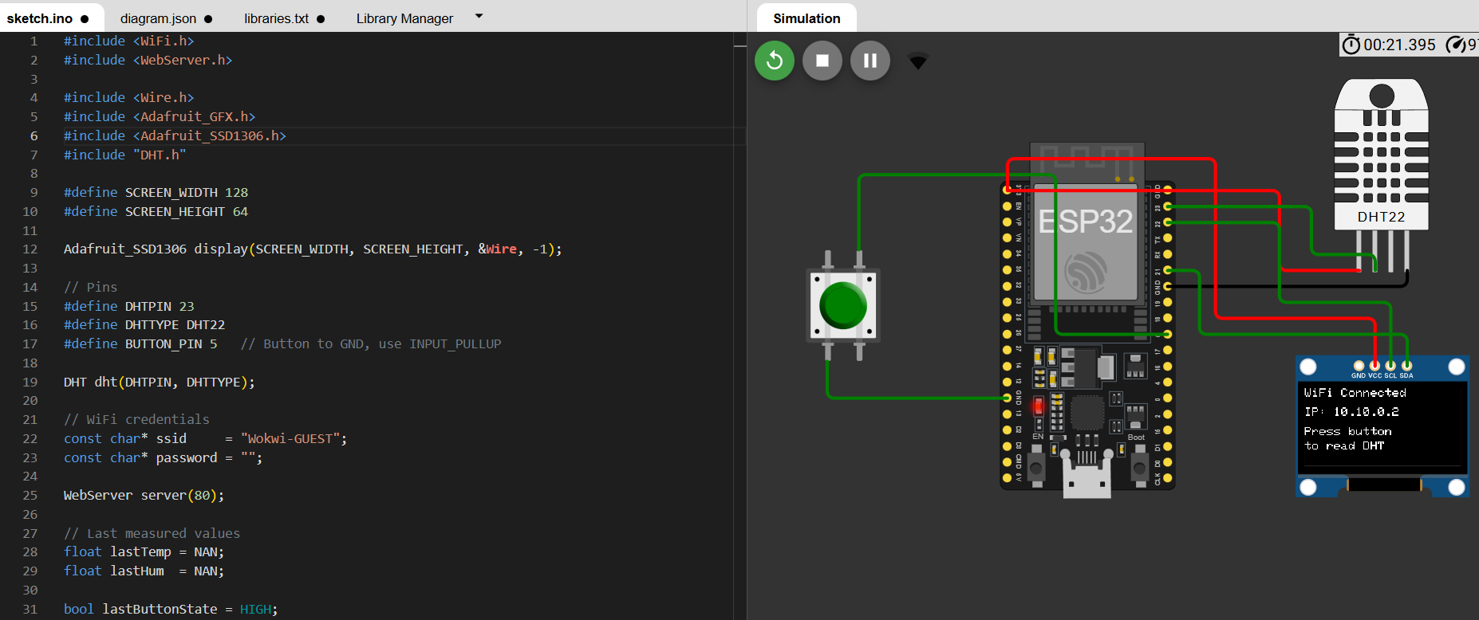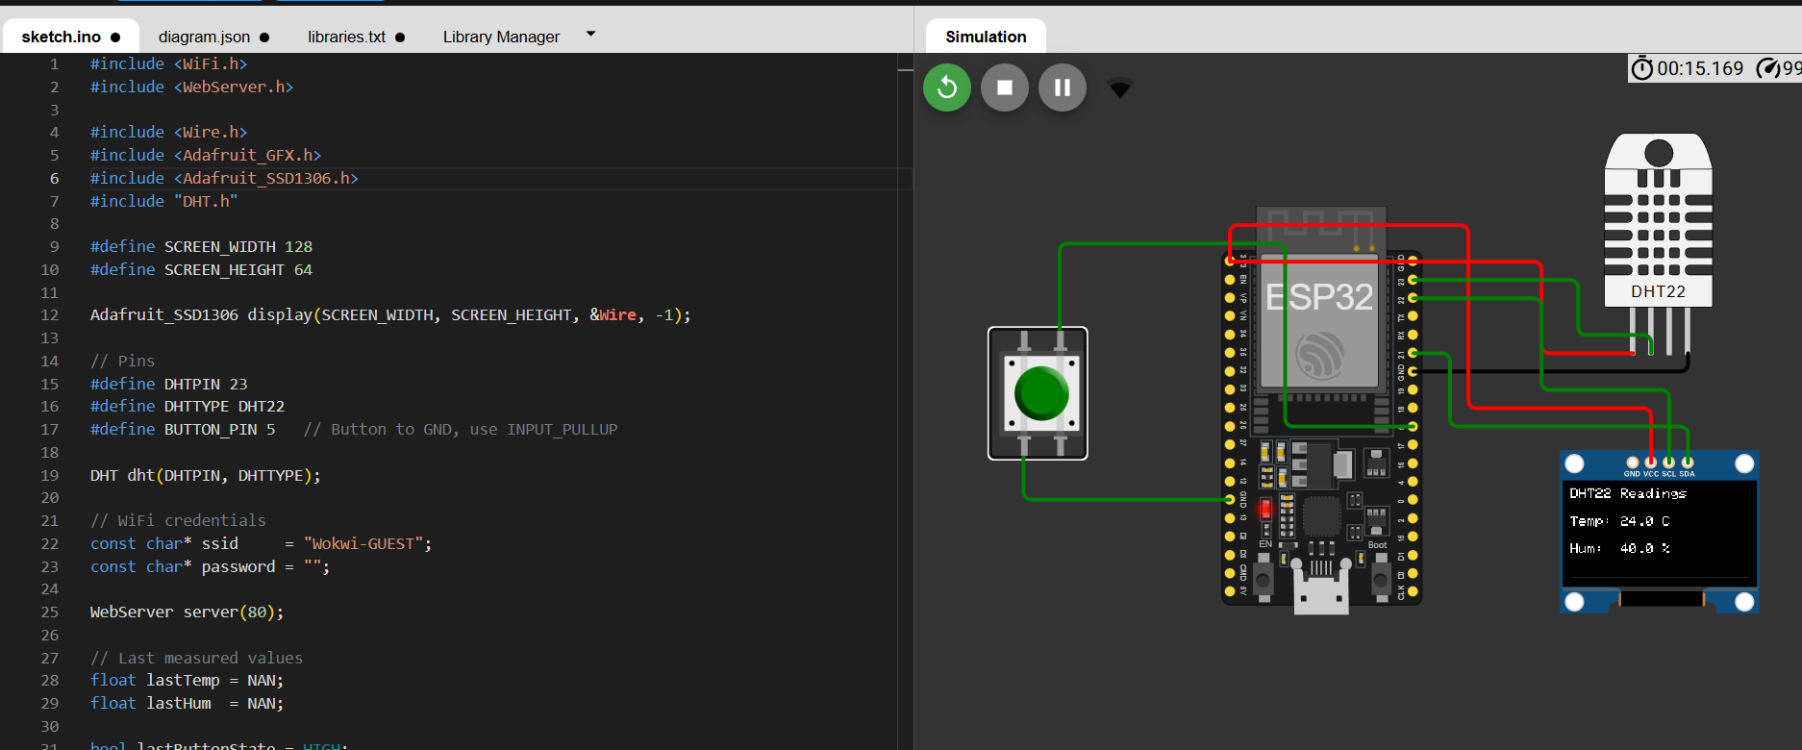

Question-2 Blynk Cloud Interfacing (blynk.cpp)
Part-A: Short Questions
1. What is the role of Blynk Template ID in an ESP32 IoT project? Why must it match the cloud template?
The Blynk Template ID uniquely links the ESP32 device to a specific project template on the Blynk Cloud.It ensures that the device communicates with the correct dashboard and datastreams.

2. Differentiate between Blynk Template ID and Blynk Auth Token.
The Template ID identifies the project structure on Blynk Cloud.
The Auth Token authenticates a specific device and allows it to send or receive data securely.

3. Why does using DHT22 code with a DHT11 sensor produce incorrect readings? Mention one key difference between the two sensors.
DHT11 and DHT22 have different data formats and accuracy levels.
DHT22 supports decimal values and wider temperature range, while DHT11 only provides integer values, leading to incorrect readings if mismatched.

4. What are Virtual Pins in Blynk? Why are they preferred over physical GPIO pins for cloud communication?
Virtual Pins are software-defined pins used for cloud communication.
They are preferred because they are independent of physical GPIO limitations and simplify data exchange between ESP32 and the Blynk app.

5. What is the purpose of using BlynkTimer instead of delay() in ESP32 IoT applications?
BlynkTimer allows non-blocking execution of tasks.
Unlike delay(), it does not freeze the ESP32, ensuring smooth Wi-Fi and Blynk communication.

Part-B: Long Question
Explain the complete workflow of interfacing ESP32 with Blynk Cloud to display temperature and humidity values.
I began the project by configuring the Blynk Cloud platform to create an online monitoring interface. I designed a project template and defined two datastreams, assigning virtual pin V0 for temperature and V1 for humidity, both with an operational range of 0 to 100. After completing the template configuration, I registered a new device, which generated the Template ID, Template Name, and Authentication Token. These parameters uniquely identify the project and provide secure authorization for communication between the ESP32 and the Blynk Cloud.
For implementation, I developed the program while carefully selecting the DHT22 sensor configuration, since using DHT11 settings would result in incorrect values due to differences in data format and resolution. I then inserted the Blynk credentials into the code to enable the ESP32 to transmit sensor data to the correct cloud template. Sensor readings were sent to the Blynk dashboard using the Blynk.virtualWrite() function, which allows cloud-based communication through virtual pins rather than direct hardware GPIOs.During development, I encountered common configuration issues, including compilation errors caused by missing Blynk and DHT libraries in the simulation environment. These issues were resolved by properly adding the required libraries. Initially, the dashboard widgets displayed incorrect values due to an improper gauge range, which I corrected by adjusting the maximum value and saving the dashboard configuration. To maintain reliable connectivity and prevent blocking behavior, I used BlynkTimer to transmit data at fixed intervals instead of using delay-based execution. Once the system initialized successfully and displayed a “Ready” status on the Serial Monitor, real-time temperature and humidity data were correctly visualized on both the Blynk web dashboard and the mobile application.
