SENIOR DESIGN PROJECT REPORT
Spring 2021
April 24, 2021
Remote-Controller Robotic Bobber
Student name | Student Major | Grade  Received
Afridi Bhuiyan | ME
Fairooz Haque | ME
Farzana Akhter | ME
Md Emtiaz | EE
Tanvir Khan | CE
Waliur Bhuiyan | ME

Advisor’s name | Advisor’s affiliation
Varad Karkhanis | SUNY New Paltz
Julio Gonzalez | SUNY New Paltz

ABSTRACT
The overall purpose of this project is to design, test and build a remote-controlled robotic bobber to streamline the fishing experience. In general, the robotic bobber will be able to move according to the user’s preferences. This essence of this control process can be simplified as such: if the bobber moves, so does the fishing hook connected to it. One important objective is to be able to make fishing more automated and dependable by employing robotic technology. Luck will play less of a role in the fishing experience. We have created three sets of prototype designs on solidWorks and have 3D printed samples of our design. The prototypes are now undergoing testing phases to make sure they are buoyant, waterproof, and are large enough to accommodate for the electronics within the bobber. These factors were taken into account in order to have a working model by the end of the semester and also to further our understanding on the steps necessary to reach our objective.
Through testing and research, we figured out how to make the bobber float and that is done through Bernoulli’s principle along with the buoyancy test. We will be applying electronic components that are not waterproof and do not have the capability to work in water hence the casing itself will be waterproof. Some parts of the Arduino, the DC motor, and servo motor radiate heat so they need to be able to transfer heat appropriately. The best way would be to use a protective 3D printed casing and silicone to cover the joints/welds of connection points. We can also use silicone and as well as gel polish to make the electronics waterproof. Regarding the power, we needed to amplify the current to power the device using a voltage source that would stay within the size constraints of the device. In this case, we used multiple lithium watch batteries in parallel to power the device. This project is important because it gives us a look into how we can insert wireless technology into an activity that doesn’t require any electrical devices. If this is possible, technology will be able to close the gap to make fishing more automated in the future. The ability to choose where you want to move your bobber would revolutionize the fishing industry.

TABLE OF CONTENTS
Topic | Page
1. About this Project……………………………………………………………………… | 1
2. Functional description of the design…………………………………………………… | 2
3. Preliminary design and results.………………………………………………………… | 7
4. Final design and results………………………………………………………………… | 19
5. Recommendations for future work…………………………………………………….  6. Conclusions…………………………………………………………………………….  7. Bibliography…………………………………………………………………………… | 23  24  25
8. Different Disciplines used in this project…………………..…………………………... | 26
9. Design constraints that drove this project………………………………………………. | 30
10. Engineering standards used in this project…………………………………………….  11. New skills acquired during the project………………………………………………... | 31  32
12. Appendix ……………………………………………………………………………… | 33

- ABOUT THIS PROJECT
1.1 Motivation
Our desired project is to make a fishing bobber that will be able to move according to the user’s desire. The bobber would indicate when a fish is caught. Previous designs use sonar technology. However this is less accurate because it picks up signals from other objects other than fishes in the water. Our project is to create a robotic bobber that will be able to move according to the user’s desire. There is a floatable piece that is connected to the fishing line called a bobber that indicates when a fish is caught. We want to control the bobber at a specific spot with a physical remote-controlled device that the user uses to control the bobber. If the bobber moves, so does the fishing hook.
1.2 Design Objective
The scope of this project is to create a remote controlled bobber. The project addresses the issue of not being able to control the bobber and make it so that it can be controlled wirelessly. The bobber is designed to make fishing easier and to help fishermen navigate the fishing lines according to their needs. This bobber will be using a variety of electronic components, motors, propellers, and mechanical components. The heat analysis needs to be performed on the bobber to determine if it can withstand different temperature variations and climates. Temperature data from different oceans are used in the simulation.

1.3 Need for Project
The remote-controlled robotic bobber will improve the fishing industry by making fishing easier and more dependable. It will show that wireless technology can be integrated into simple recreational activities like fishing. Fishing will depend less on mere luck and be more accurate as well. This project will benefit fishermen the most because they can manually choose and control where they can cast their fishing line.

1.4 Project Scope
The objective of this project is to build a robotic bobber in order to help new fishermen and to benefit the fishing/robotics industry. This robotic bobber will be remote controlled either through an app or a remote control device. In order to bring this project to fruition, a variety of criteria must be met such as the costs of the parts and the requirements necessary to get this project to work. Some of these basic necessities of getting the bobber to work is its ability to float, be waterproof and actually move. This segues into the engineering constraints and specifications of this project.

- FUNCTIONAL DESCRIPTION OF DESIGN
One of the main objectives of this project was accomplished through a variety of electrical and computer engineering concepts. This goal was to wirelessly control the robotic bobber with a remote control device. This consists of two devices: the actual robotic bobber and the remote controller. This necessitated many different parts and materials. Some of these parts are listed in the materials list below.

Electronic Materials List:

Adafruit ItsyBitsy 32u4 - 5V 16MHz
- 360 Degree Servo Motor
- L293D Motor Driver
- DC Motor
- Arduino Metro Mini
- NRF24L01 Wireless Communication Modules
- NCR18650PF Li-ion Battery
- Lithium-ion Battery
- Buttons
- Resistors
- Switches

2.1 Microcontroller Requirements
First, a microcontroller was chosen. Between a Ti-Tiva microcontroller and an Arduino microcontroller, an Arduino-compatible microcontroller was chosen because it can accomplish many simple tasks such as “read inputs - light on a sensor, a finger on a button, or a Twitter message - and turn it into an output - activating a motor, turning on an LED, publishing something online” [3]. In this case, the Arduino microcontroller is also capable of wireless communication. The Adafruit ItsyBitsy microcontroller was chosen not only because it was Arduino-compatible but also because it needed to be small enough to fit inside the remote controller. It also “runs at the same speed and voltage of an Arduino UNO or Leonardo” [4]. This also makes it compatible with the Arduino IDE. The Arduino Metro Mini was put inside the robotic bobber. This device is small and is also compatible with the Arduino IDE compiler. In addition to this, this device also runs at 16 MHz just like the Adafruit ItsyBitsy microcontroller.
2.2 Wireless Communication
However, wireless communication between the bobber and the controller is not possible without the NRF24L01 wireless communication modules. Two of these were used, with each placed in the controller and bobber. This device is what enables the bobber two move when pressing a button on the controller. In general, the communication process requires a sender and a receiver. The sender would send a message to the receiver in a specific medium and the receiver would receive this information and carry out the instructions in the message accordingly. Modulators and demodulators are also included in the sender and receiver to convert the instructions into an analogous signal and to then convert it back into its digital form once received by the receiver. The NRF24L01 module is a single chip radio transceiver and operates in the 2.4GHz range, meaning that it can act as either a sender or receiver. It can both transmit and receive information. Because of this, two were used - one acts as the sender and another acts as the receiver.
2.3 Power/Energy and Movement
Another important part of the project is the power and the movement of the bobber, For the bobber to move, both a servo motor and a DC motor were needed. The servo motor needed to rotate 360 degrees. The power/energy part of the project was tricky. At first, we thought to put two 9V DC batteries in parallel to generate enough current because enough current wasn’t being sent to the bobber. However, this shorted the circuit. Next, we used 3V lithium cell batteries which also didn’t work. Finally, we used an NCR18650PF lithium ion battery for the bobber. This battery has enough discharge to supply the device with enough current. To be specific, this battery is a 3.7V battery and can discharge up to 20A, which is more than enough for this project. A general lithium ion battery was also used for the remote controller.
2.4 Remote Controller
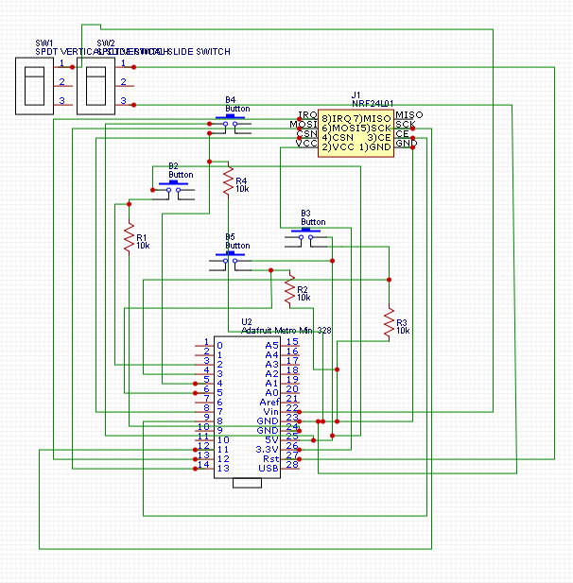
Figure 1. Block Diagram of the Remote Controller
This block diagram represents the remote controller. It consists of the Adafruit Metro Mini, the NRF24L01 wireless communication module, buttons to control the direction the bobber moves, a switch, and four 10k Ohm resistors. The NRF24L01 transceiver in the remote controller acts as the sender and sends out instructions/information to the NRF24L01 in the bobber. The figure below shows the physical interior circuit of the controller. This circuit contains buttons, switches, an Arduino module and a wireless module.
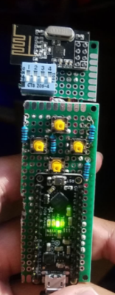
Figure 2. Interior Electronics inside the Controller.

2.5 Robotic Bobber
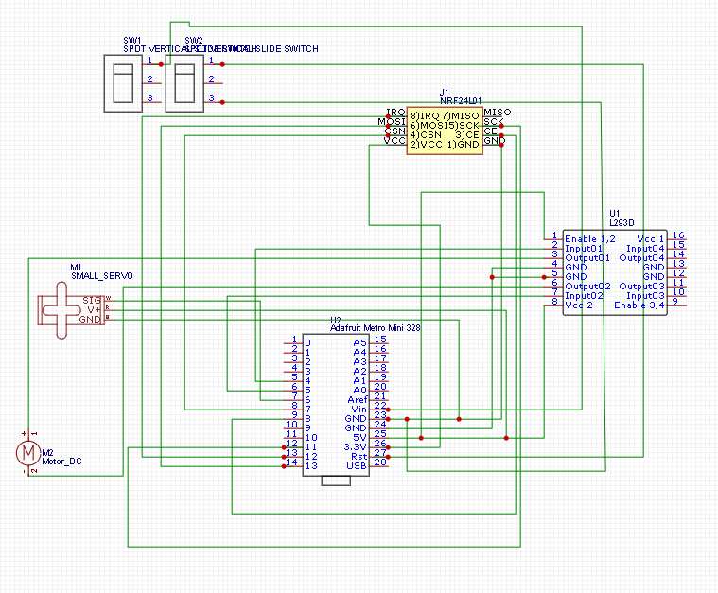
Figure 3. Block diagram of the Robotic Bobber.

This block diagram represents the robotic bobber. It consists of the Adafruit Metro Mini, the NRF24L01 wireless communication module, an L293D motor driver, a small servo motor, a DC motor, and a switch. In this case, the NRF24L01 transceiver in the robotic bobber functions as the receiver. It receives the instructions/information from the NRF24L01 in the remote controller. The figure below shows the basic circuit of the interior of the bobber with an H-bridge chip.
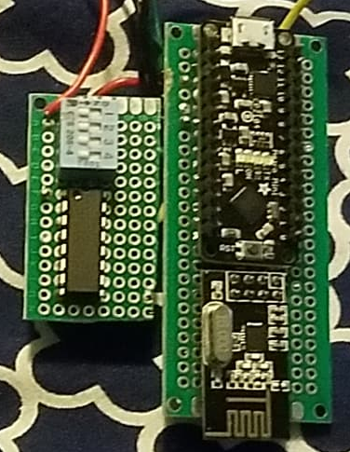
Figure 4. Basic Circuit in the Bobber.

2.6 Conclusions
Basically, the NRF24L01 transceiver in the remote controller acts as a sender and sends information to the NRF24L01 in the robotic bobber which acts as receiver and receives the information sent from the remote controller. The main parts of the electrical/computer engineering part of this project consisted of microcontrollers/coding, wireless communication and the power/energy.

- PRELIMINARY DESIGNS AND RESULTS
3.1 Design Criteria
While designing the bobber, the amount of parts and their weight needed to be considered for the bobber to float. The bobber is usually afloat(Partially submerged) for the fisherman to see and as the bobber is pulled underneath the water the fisherman knows that the fish has been caught. The remote control bobber would have electronic parts in the bobber, the parts would need to be waterproof inorder to work properly. The design would need to rotate for the bobber to turn. The wires would have to rotate and not get twisted. The propeller would also be designed to move the design forward and backward.
3.2 Design Strategies
3.2.1 Floatability
While designing we looked at multiple different components for the design. and different ideas. In order for the bobber to float, Bernoulli's principle was taken into consideration[2]. The total mass of the internal components was recorded and accounted for. The mass was determined by the parts. The internal volume was used to calculate the amount of mass the volume of the bobber could hold using Bernoulli's principle. The mass of the materials was subtracted and the remaining force was the force of the mass of the components.
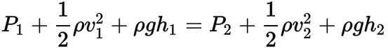 (1)
Equation 1 above is Bernoulli's principle. P1 is pressure at elevation at point 1, p is density, v represents the velocity at elevation, h1 represents elevation h2 represents elevation at point 2.
3.2.2 Waterproofing
In order for the project to work, the electrical components had to be waterproof. So we made the bobber in compartments where the electrical parts were inside the bobber and the motor in an external compartment.While waterproofing we wanted to use superglue, silicone and grease. Grease is waterproof and is immiscible with water. Silicone is waterproof as well.
Here below are some products that were tested for the project. The figure(5) is silicone and Figure (6) is marine grease.
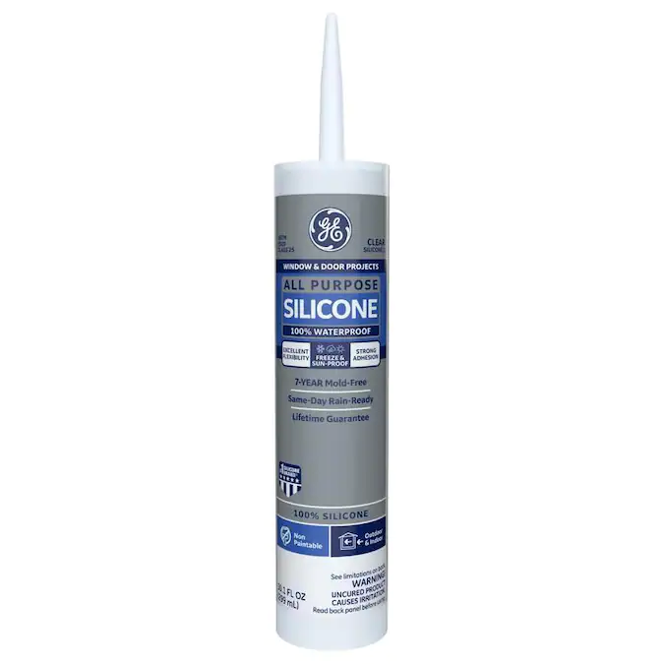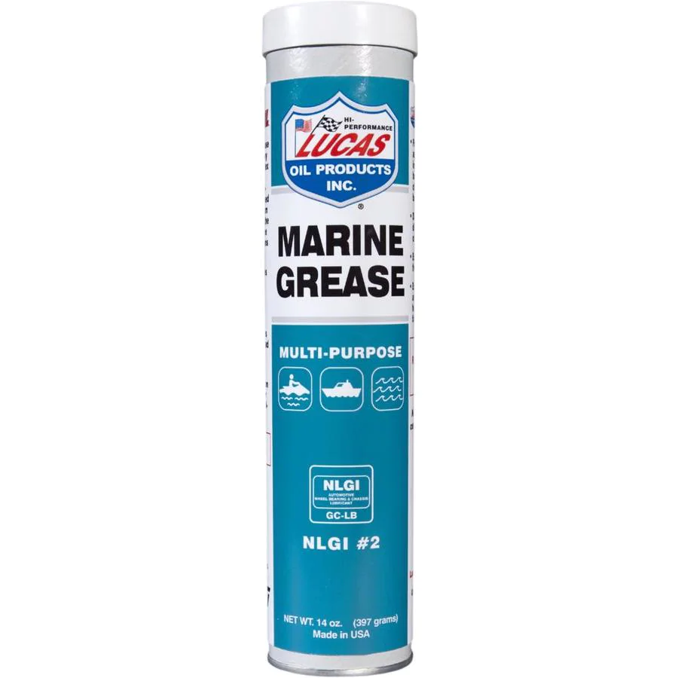
Figure 5. Silicone [1] Figure 6. Marine Grease [1]
3.2.3 Wires
The wires that connected the DC motor had to be designed in such a way that the wires did not get in the way of rotation of the servo motor. The average range of water temperature decided in this project will be between -20 degrees Celsius to 40 degrees Celsius.This will determine what type of insulation or cooling systems that are needed for the bobbre. Automatic temperature control is a microcontroller based circuit which is used to maintain a temperature specified by the user. The microcontroller based temperature control system controls the temperature of any device according to its requirement for any industrial application. At the center of the circuit is the PIC16F887A microcontroller which controls all the functions of the chip. A temperature sensor thermocouple is utilized for detecting the temperature of the surrounding environment and thus the system displays the temperature on a seven-segment display between the ranges of 0˚C to 750˚C. This temperature is then compared to the stored user value, and if the temperature exceeds the preset temperature, the heater will switch off and if it exceeds below the temperature value presented then the heater will switch on. AC bulb is interfaced with the microcontroller which is done with the help of a relay and a transistor[5]. The servo motor used in our project is a micro servo with 360 degree continuous rotation compatible with servo shields for Arduino. The torque of the motor is able to reach up to 0.7kg. It is a full rotational motor with the benefits of a servo, and capable of full 360 degree continuous rotation. This servo motor connects to an output pin of an Arduino board directly without a motor driver. There are also four different types of servo fans which assist the servo to be used in more applications. The operating temperature is between -10 degrees celsius and and 50 degrees celsius [6].
3.2.4 simulations
The images presented below represent the stress and strain simulations from the original bobber to the new bobber. The pressure on the bobber for the following simulations are at 5 meters.
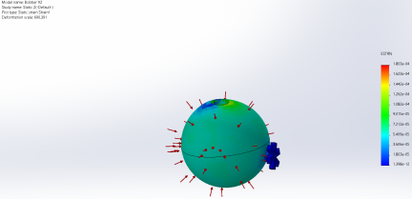
Figure 7. Strain analysis of original bobber
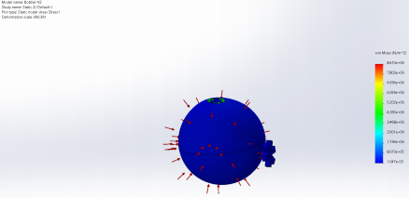
Figure 8. stress analysis of original bobber

3.3 Experiments
Experiments were conducted for every part of the bobber. For waterproofing, grease was added in the section where the motor was to be placed and placed in water for 30 minutes. It could be seen that the bobber was still floating and no water seeped through the gap. For floatability, first the total mass that the volume of the bobber can hold was calculated using equation 1. The total mass of the internal components that the bobber could support were then calculated by subtracting the weight of the bobber shell. The total mass was 230 grams. The test was conducted in a bin full of water, the bobber was placed in the water and tested for floatability. Following that, different variations of weights were added using coins as the mass until the bobber was fully submerged.
3.3.1 FEA Heat Transfer simulations
Upon running the solidworks thermal simulations on the bobber the following results below display the outcome. Using the simulation the temperatures ranges from Death valley California(hottest region) to the coast of Antarctica(coldest region) were tested. According to the results it can be assumed that the DC motor was most affected by the outside temperature. As shown in the tables below the most electronics temperature is within parameters besides the DC motor for the propeller where the temperature had reached 70 degree celsius, thus exceeding its specification limit of 60 degree. Upon further consideration a shaft was added to the simulation. According to the simulation for Death Valley the bobber seems to be able to withstand such harsh conditions. In conclusion the bobber will be able to withstand temperatures from cold waters to the Arctic to the waters of Death Valley.
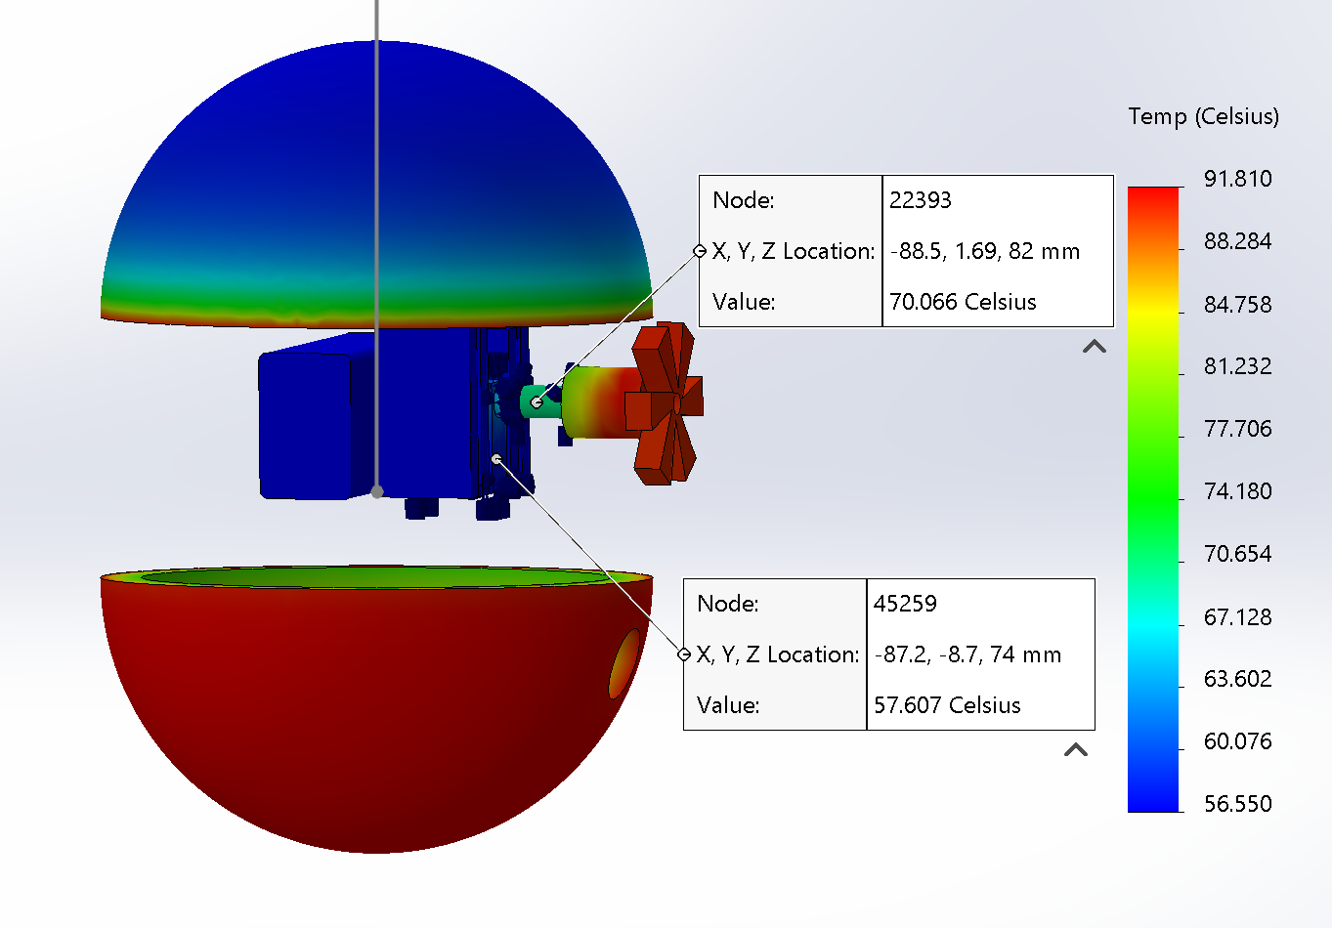
Figure 9. Heat transfer simulation on bobber in Death Valley, CA
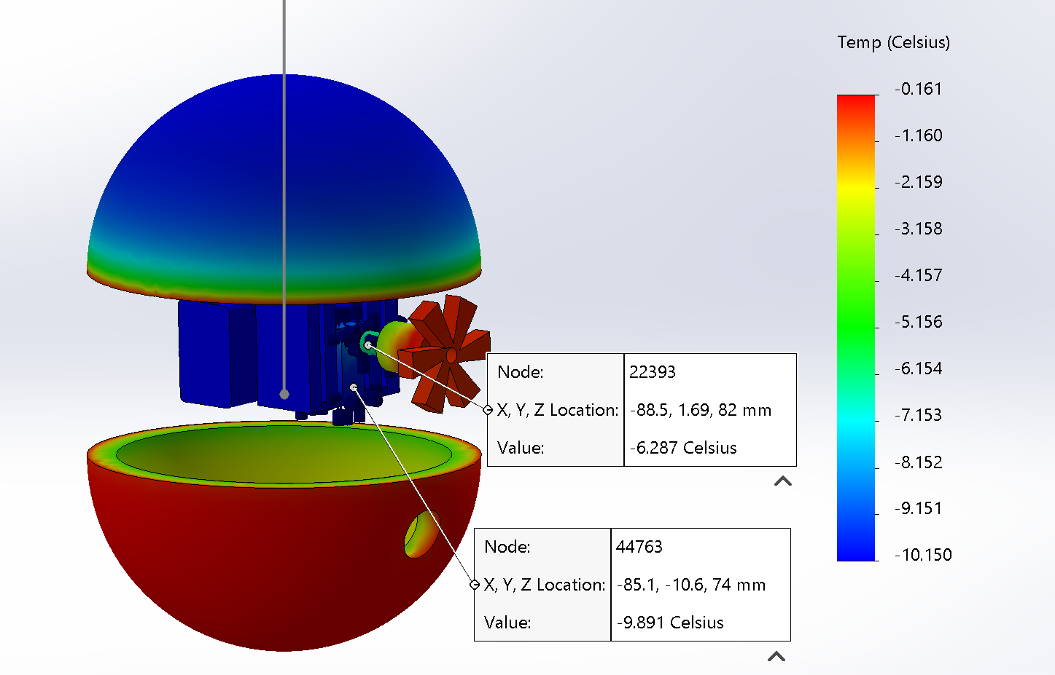
Figure 10. Heat transfer simulation on bobber Coast of Antarctica
Table 1: Wattage of motors
Motors | V(volt) | I(mA) | Watt
DC motors | 4.2 | 85 | .000085
Servo motors | 6.0 | 20 | .000020
NRF | 3.6 | 12 .3 | .0000123

Table 2: Extreme Temperature Ranges
Environment | Temperatures (K)
Air temp of Death Valley (CA) | 329.7 (K)
Water temp of Boiling lake (Dominica) | 365 (K)
Air temp of Antarctica | 263 (K)
Water temp of Antarctica | 273 (K)
Air temp ambient | 298 (K)
Water temp of average lake | 293 (K)

Table 3: Thermal Properties
Thermal Coefficient of Air | 10 W/(m^2.K)
Thermal Coefficient of water | 5,000 W/(m^2.K)
Heat output of DC motor | 0.000357 W
Heat output of servo motor | 0.00012 W

3.3.2 Drop test simulations
Dropped from 3 meters
Stress
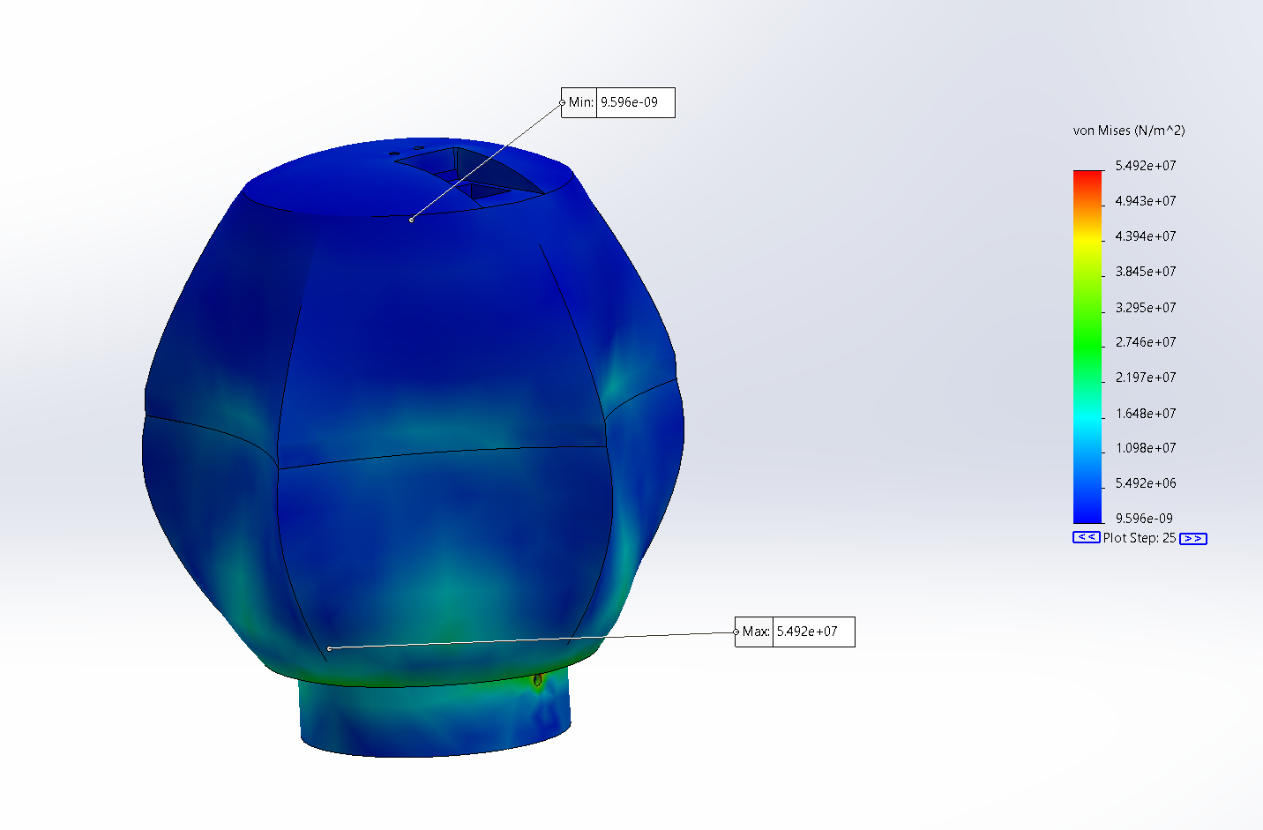

Strain
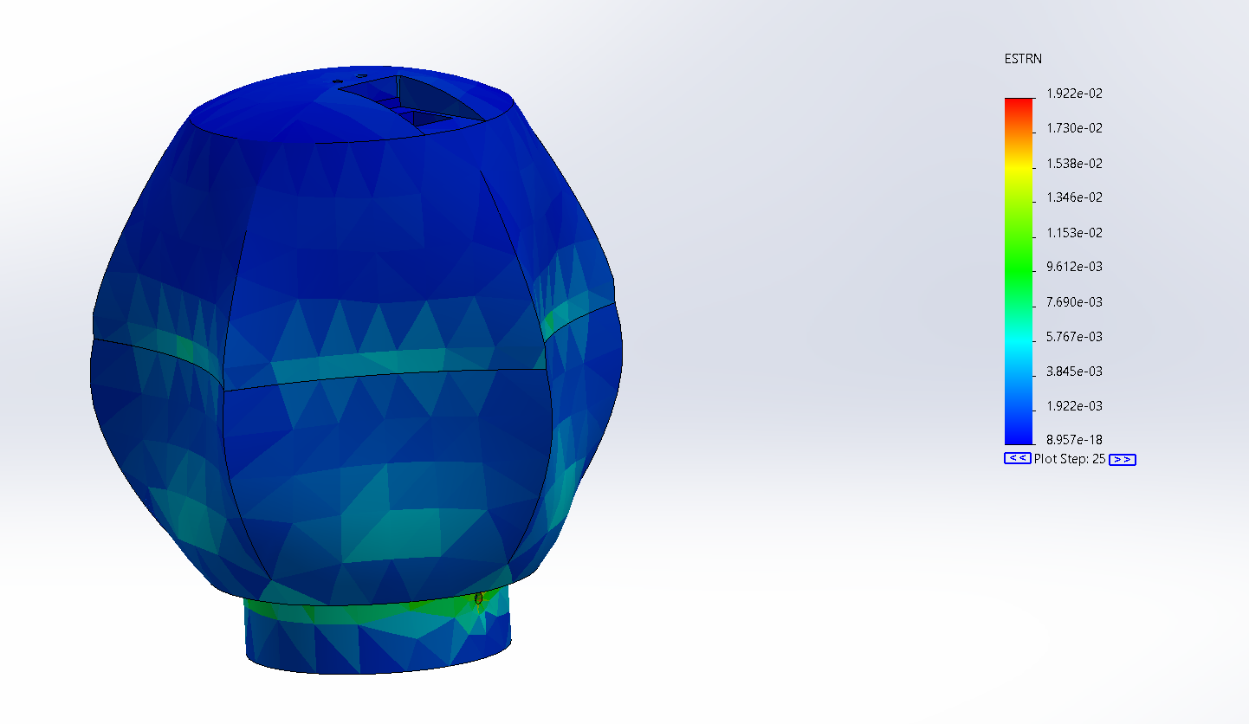
Displacement
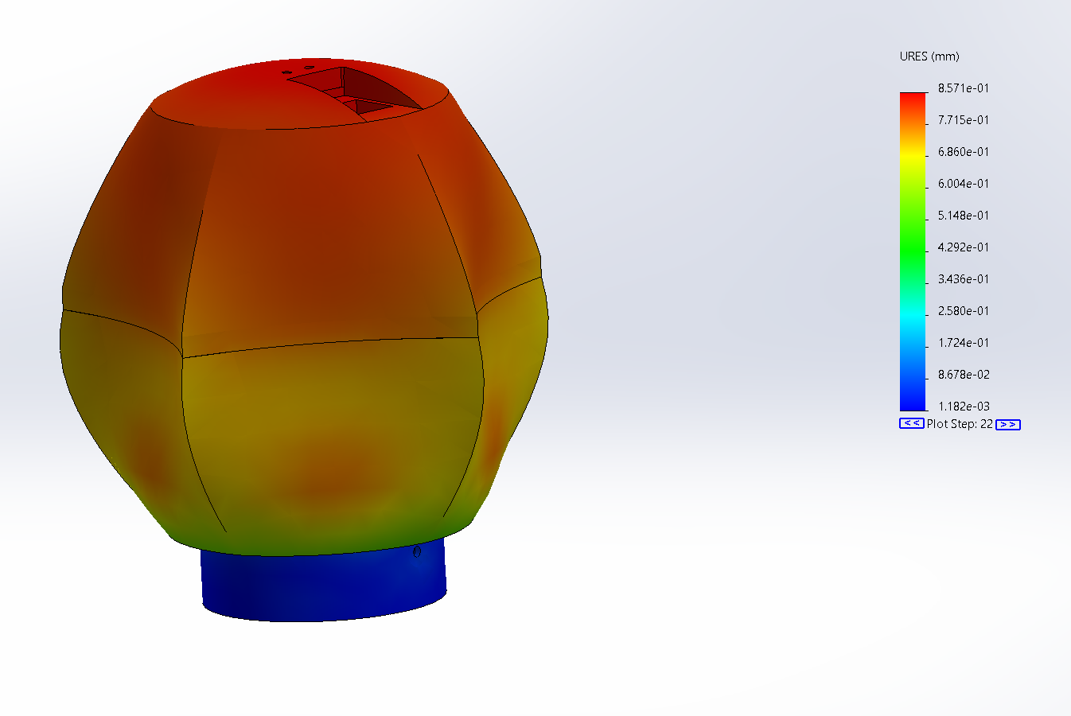
3.3.3 Static Force test simulations
Force of 100 N applied on top

Stress
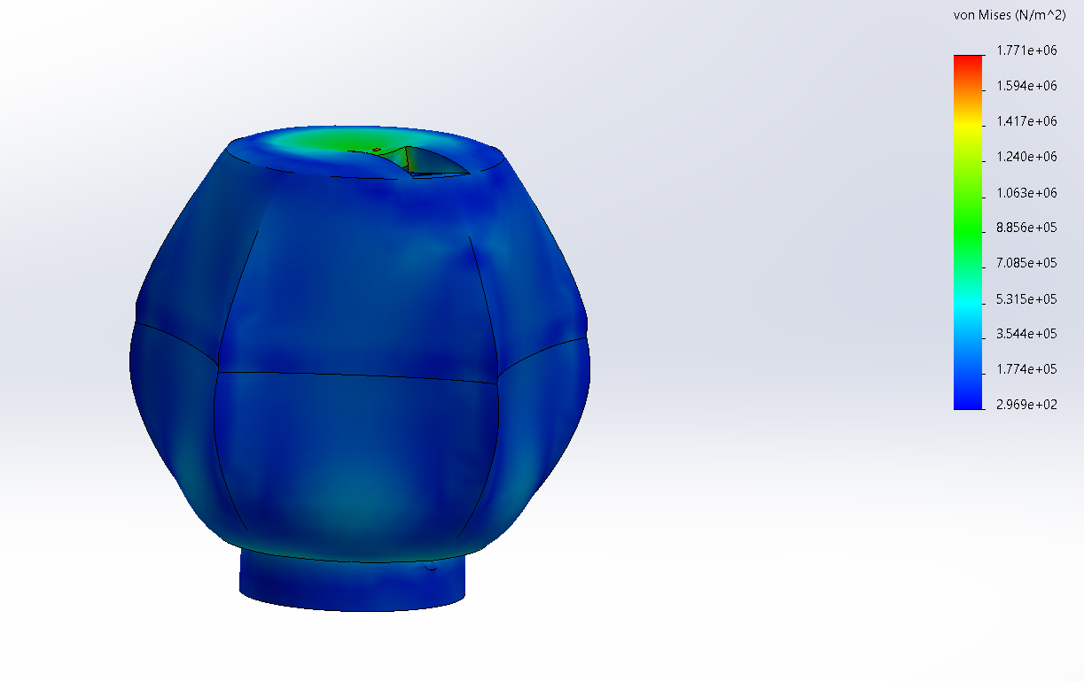
Strain
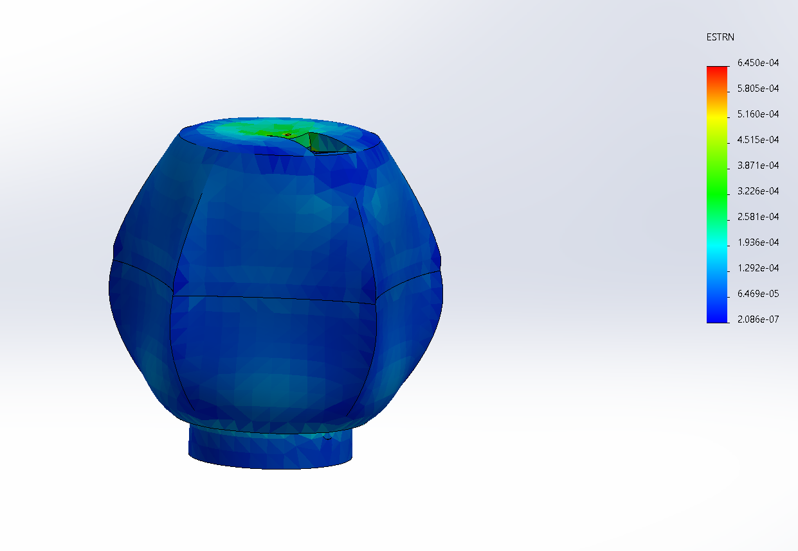

Displacement
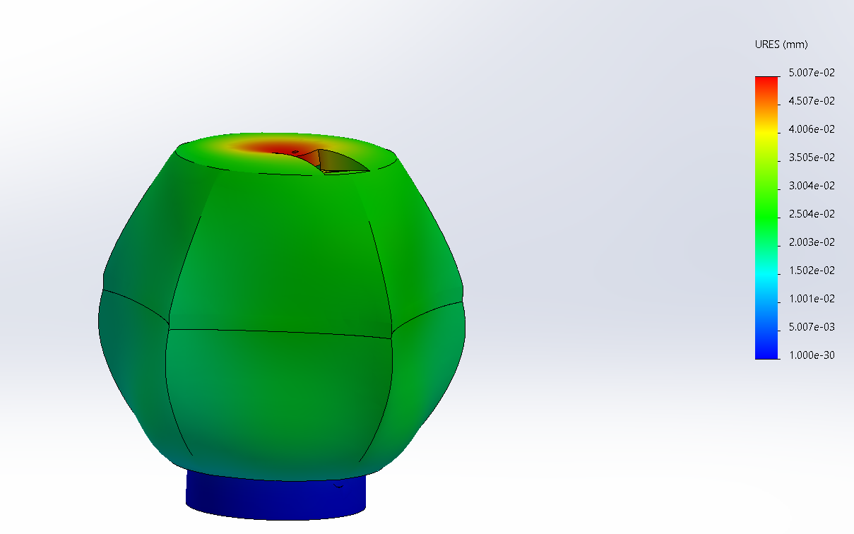

3.3.3 Hydrostatic Pressure test simulations
hydrostatic force of 49.1 kPa at 5 meter deep water
Stress
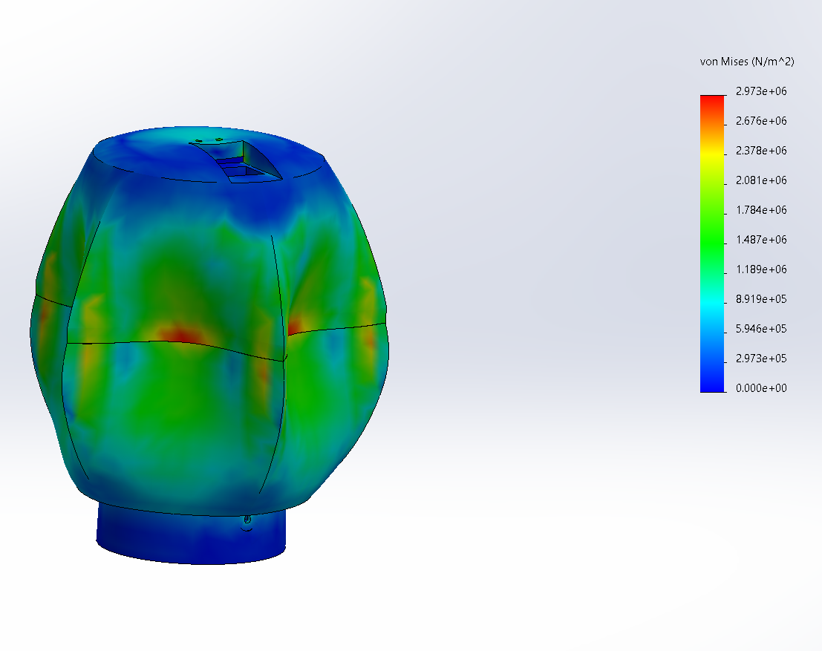

Strain
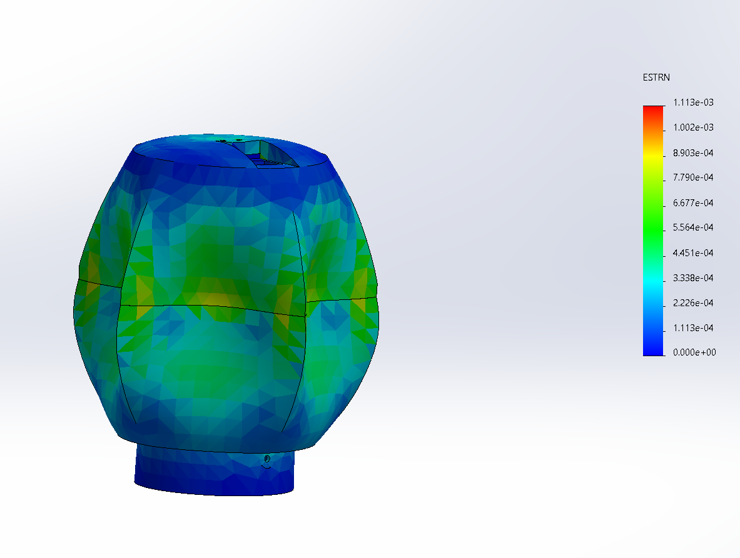

Displacement
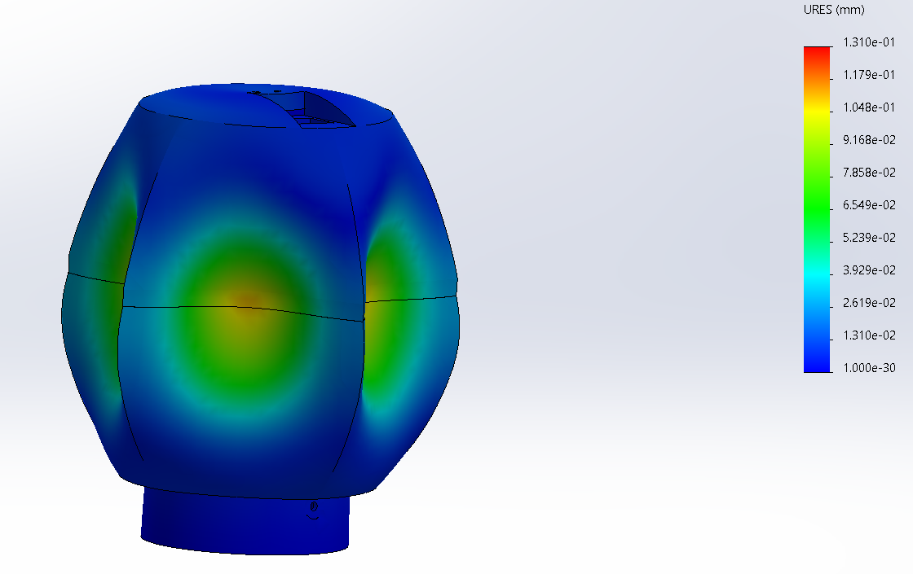

3.4 Fails
The 9V battery did not supply enough current to both the servo and DC motor. To solve this issue we put two of these batteries in parallel to increase the current. However, this didn’t work. As an alternative, a NCR18650PF lithium ion battery was used because this 3.7V battery can discharge up to 20A when we only needed 1-2A. When making it so that the bobber would be waterproof with marine grease, this marine grease hit the DC motor, causing it to not move when trying to control the bobber. However, after clearing some of the grease from the DC motor, it was shown to be moving, albeit slowly.

- FINAL DESIGN AND RESULTS
4.1 Final Design of Project Components
4.1.1 Selection of components (Bobber)
The final bobber design included multiple components. The body was 3D printed using ABS plastic. A DC motor was placed at the bottom to push the bobber. A 3D printed propeller was designed to place at the tip for efficient thrust. A wireless communication sensor was placed for it to be controlled. A servo motor was used to rotate the bottom part of the bobber to choose its direction of motion. A 3.7v battery was used to power both the motors.
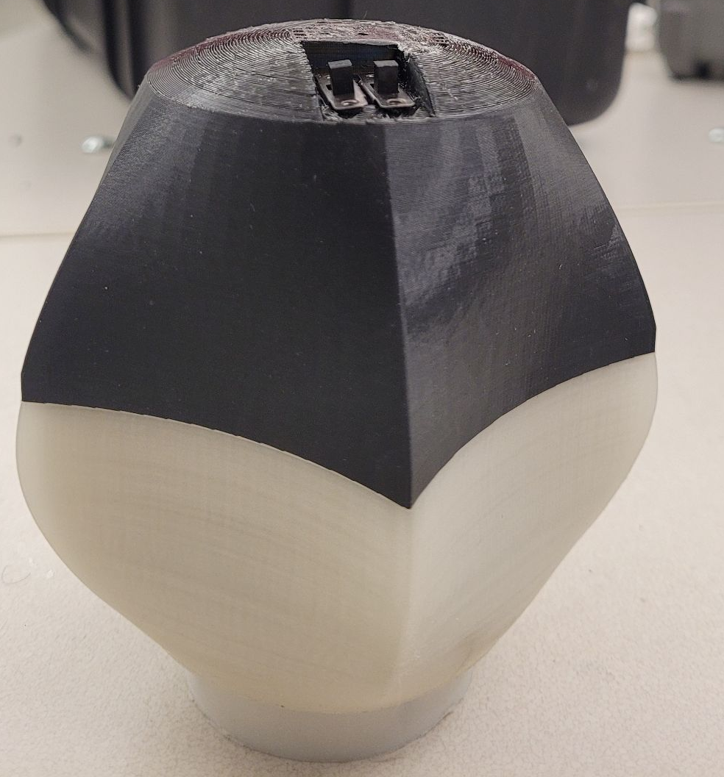
Figure 11. 3D Printed Bobber.

4.1.2 Selection of components (Remote)
The remote was also 3D printed with ABS plastic. It was designed using a wireless communication transmitter device to control the bobber. There is an on/off switch along with 4 buttons for two directions and going front and reverse. This was also powered by a 3.7v battery.
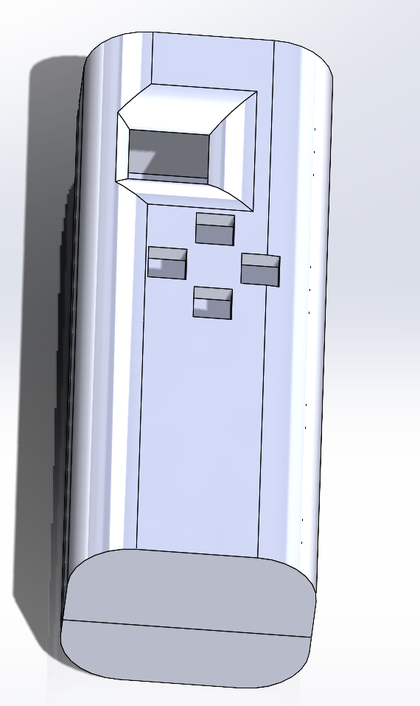
Figure 12. 3D Printed Remote Controller.
4.2 Final Design Strategy
The final design of the bobber was designed with curves on the bobber allowing it to cut through the water and have better overall control when in motion. The fan propeller is designed to move the bobber forward and reverse. The servo motor allows the bobber to move 180 degrees. The remote control features an on/off switch with 4 different directions represented by buttons for the bobber to move. The bobber can glow in the dark for visibility when dark.

4.3 Experiments
4.3.1 Design Experiments
The prototypes were tested for floatability, waterproofing, and interior fitment. All the designs went through these experiments before moving further. The floatability was performed by placing the maximum weight of 230 grams of coins inside each prototype to test the buoyancy[2]. The prototypes were also sealed and placed underwater to check if there was any water leakage for the waterproofing test.
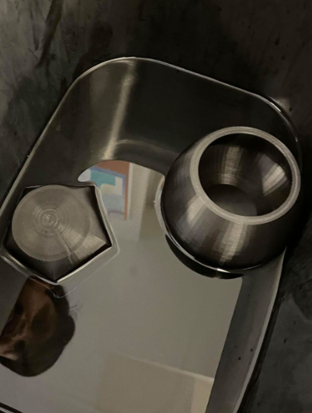
Figure 13. Floatability Test for the Bobber.
4.3.2 Final Experiments
The final assembled prototype was tested for floatability and waterproofing. Waterproofing passed since grease was used to fill in those empty spaces. The floatability had some issues at the beginning due to the weight distribution for the inner components. The battery on one side made the bobber tilt in a certain direction which made it difficult to move. This was adjusted and fixed after with more efficient weight distribution and balance for the bobber to float. This allowed the bobber to pass all the final experiments.
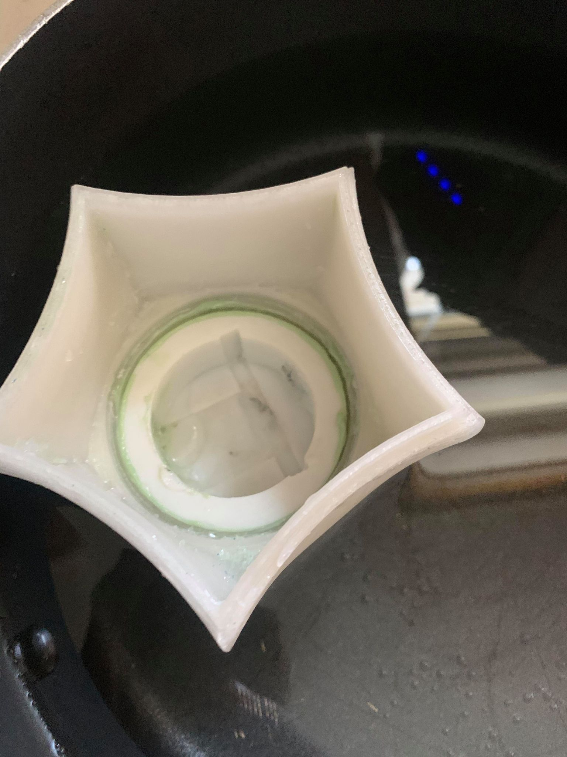
Figure 14. Internal Look into the Bobber.
4.4 Improvements and Objective
4.4.1 Design improvements
The final design is a much-refined design from the previous prototypes. It allows the bobber to move much efficiently due to the curved edges which allows it to cut through the water effectively. The new and improved bottom design also allows the bobber to move in any given direction without having any issues.
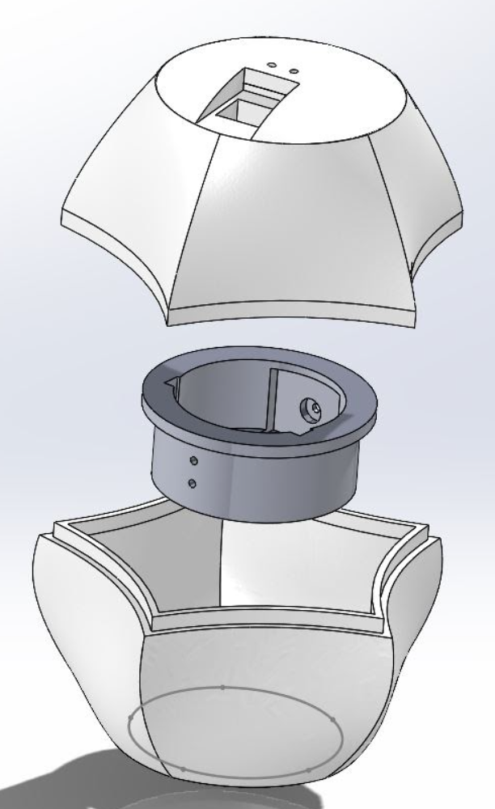
Figure 15. Final Bobber Design Components.
4.4.2 Design Objective
The objective of the design is to hold a max load of 230 grams. The bobber would need to be in 2 compartments: Top part includes servo motor, batteries, and control. The bottom part includes the dc motor. The wires when turned would need a limit of mobility as they would get tangled if the servo keeps on rotating. To make the DC motor case waterproof, marine grease is applied in the shaft. Movement requires DC and servo motors.
4.5 Conclusion
Overall, the final design has been successfully designed and assembled. It meets all the requirements and constraints set initially. The design fits all the required specifications and components and performs as expected. There is still plenty of room for improvement, like using shafts and gears for the propellers. Also by adding a camera system or motion sensor at the bottom to see what’s happening underneath it. These improvements can raise the cost but also improve the overall performance and experience for the users.

- RECOMMENDATIONS FOR FUTURE WORK
5.1 Reduce Size and Mass
Having a small and lightweight bobber is ideal for this application. This will allow the fisherman to throw the boober at a further distance more effectively. to reduce the size and mass the following design ideas should be applied
- Precision molding should be used to manufacture the shell of the bobber. this will make the body more rigid and lightweight
- All the electrical components should be consolidated into a custom microcontroller. this will allow significantly reduce the size and weight of the bobber
- DC motor and servo should be mounted with a custom gear mechanism to reduce the overall size of the propulsion mechanism. This will also allow the motor to be relocated back into the main enclosure. furthermore, this will get rid of the extra moving enclosure for the turning mechanism.

5.2 Additional Features
A bobber that can move through the water is the first step towards making an effective smart boober. The following features will make this boober more effective and increase consumer appeal.
- Multifunctional camera with infrared camera and video camera. This will provide data such as visual video feed, thermal image, the position of the hook, etc. this will allow the consumer to position the bobber at the optimal location with the most fish.
- Conductivity probe. This sensor will allow the user to sample the water and provide useful information such as salinity or other dissolved solids in the water. This will allow the bobber to be repurposed for scientific research on hazardous water bodies.
- Digital screen in the remote. This will allow the user to intuitively interact with the bobber. Furthermore, the screen will show a video feed and thermal image for the surrounding area.
- Jet propulsion. using jet propulsion instead of stern drive (propellor) will make the bobber more agile

- CONCLUSIONS
The main objective of this project is to be able to make fishing more automated and reliable by utilizing robotic technology. This way, fishing will no longer simply rely on a person’s throw and luck. A remote-controlled robotic bobber would allow the user to move the bobber according to their preferences. This control permits the user to control the RC bobber with wireless technology. The hook now has a much lower chance of becoming trapped into anything other than marine life. The components are cost-efficient and easily replaceable. They are also waterproofed with the use of resistant sealant. The bobber is floatable while considering a reasonable size and weight. The energy source is able to send enough current to the device. The RF technology allows for the signal to be transmitted within the 2.4 GHz range. The design of the bobber also follows all of the DEC fishing regulations. This design used many concepts from mechanical, computer, and electrical engineering to work. For instance, one major attribute of the robotic bobber is its ability to float. This relied on Bernoulli’s principle, which is a mechanical engineering concept. The coding relied on a solid understanding of Arduino microcontrollers and also the wireless communication, along with proficiency in Arduino/C programming. Researching the necessary electronic parts and wiring and building the circuits/block diagrams relied on knowledge in electrical engineering while the Solidworks was used to design and 3D print the mechanical components. In general, this remote-controlled robotic bobber has many important aspects that are necessary for the entire system to function. This bobber needs to be waterproof, needs to be able to float, needs to be able to be controlled wirelessly, and needs enough power to function. Basically, this project would allow fishing to be easier and more efficient and reliable.

- BIBLIOGRAPHY
[1] “Aluminum Silicone Sealant Professional Grade: Case of 12,” Sila Seal ™, 20-Oct-2020. [Online]. Available:https://sila-seal.com/caulk-shop/silicone-sealants/professional-grade/aluminum-silicone-sealant. [Accessed: 30-Apr-2021].

[2] Munson, Fundamentals of Fluid Mechanics (7th ed, Munson et al, 2012).pdf.
[3] "Arduino - Introduction", Arduino.cc, 2020. [Online]. Available: https://www.arduino.cc/en/guide/introduction. [Accessed: 06- Oct- 2020].
[4]. “Adafruit ItsyBitsy 32u4 - 5V 16MHz”, adafruit, 2021. [Online]. Available: https://www.adafruit.com/product/3677. [Accessed: 08-Feb-2021].
[5] N. mishra, Teddy, L. Kumar, M. Fatima, S. k srivastava, A. Boluwaji, M. Awais, M. nadeem, Wb, and G.murali, “Automatic Temperature controller using pic microcontroller,” Microcontrollers Lab, 05-Jan-2019. [Online]. Available: https://microcontrollerslab.com/automatic-temperature-controller-microcontroller/. [Accessed: 09-Dec-2020].
[6] “2.5g 360 degree Micro Servo (0.45kg),” DFRobot. [Online]. Available: https://www.dfrobot.com/product-1106.html. [Accessed: 09-Dec-2020].

- DIFFERENT DISCIPLINES USED IN THIS PROJECT

Table 8.1: Electrical Engineering (EE) Disciplines and Courses within discipline in the EE program
Discipline | Course in the discipline | Check if used
D1) Computers | EGC251 C/C++ Programming | X
D1) Computers | EGE331 Computer Simulation (MATLAB) | X
D1) Computers | EGC331/EGC332 Microprocessors + Lab | X
D2) Analog Electronics | EGE200/EGE201 Circuit Analysis + Lab | X
D2) Analog Electronics | EGE320/EGE322 Electronics I + Lab | X
D2) Analog Electronics | EGE321/EGE323 Electronics II + Lab
D3) Signals/ Systems | EGE311 Signals and Systems | X
D3) Signals/ Systems | EGE416 Control Systems
D3) Signals/ Systems | EGE417 Digital Control Systems
D3) Signals/ Systems | EGE412 Communication Systems Theory
D3) Signals/ Systems | EGE493 Applied Digital Signal Processing
D4) Electromagnetism | EGE340 Applied Electromagnetics | X
D4) Electromagnetism | EGE445 Antenna Systems
D4) Electromagnetism | EGE493 Intro to MEMS
D5) Energy Systems | EGE350/EGE351 Electric Energy Systems + Lab | X
D5) Energy Systems | EGE452 Electric Power Systems | X
Table 8.2: Computer Engineering (CE) Disciplines and Courses within Discipline in the CE program
Discipline  D1) Computers | Course in the discipline | Check if used
D1.a) Software | EGC251 C/C++ Programming | X
D1.a) Software | CPS210 Computer Science I | X
D1.a) Software | CPS310 Computer Science II (Data Structures) | X
D1.a) Software | CPS353 Software Engineering | X
D1.b) Computer Systems | EGC331 Microprocessors +  EGC332 Microprocessors Lab | X
D1.b) Computer Systems | EGC433 Embedded Systems | X
D1.b) Computer Systems | EGC442 Computer Architecture
D1.b) Computer Systems | EGC451 Real-Time Systems
D1.c) Digital Systems | EGC220 Digital Logic Fundamentals +  EGC221 Digital Logic Lab | X
D1.c) Digital Systems | EGC320 Digital System Design | X
D1.c) Digital Systems | EGC441 System On Chip
D1.c) Digital Systems | EGC445 VLSI Design +  EGC446 VLSI Lab
D1.c) Digital Systems | EGC447 Functional Verification

Table 8.3: Mechanical Engineering (ME) Discipline and Courses within Discipline in the ME program
Discipline | Course in the discipline | Check if used
D1) Computers | EGE331 Computer Simulations | X
D1) Computers | EGM302 Finite Element Analysis | X
D1) Computers | EGM393 Advanced Computer Aided Design | X
D6) Mechanics & Machines | EGM211 Statics | X
D6) Mechanics & Machines | EGM212 Dynamics | X
D6) Mechanics & Machines | EGM311 Kinematics of Machines | X
D6) Mechanics & Machines | EGM312 System Dynamics | X
D6) Mechanics & Machines | EGM393 Biomechanics
D7) Thermodynamics/  Fluid Dynamics | EGM331 Thermodynamics | X
D7) Thermodynamics/  Fluid Dynamics | EGM332 Fluid Mechanics +  EGM333 Fluid Mechanics Lab | X
D7) Thermodynamics/  Fluid Dynamics | EGM334 Heat Transfer | X
D7) Thermodynamics/  Fluid Dynamics | EGM335 Thermo Systems Design | X
D8) Materials | EGM221 Engineering Materials | X
D8) Materials | EGM322 Mechanics of Materials +  EGM323 Materials Lab | X
D8) Materials | EGM393 Composite Materials
D8) Materials | EGM393 Design of Machine Elements | X

We were able to utilize our knowledge of engineering principles and materials by applying them to problems to create a structure to a solution. The product was created by using the knowledge we acquired over the course of our studies here at SUNY New Paltz engineering deparpartme. This project tested our knowledge and understanding of the materials learned in each of the courses taken.

- DESIGN CONSTRAINTS THAT DROVE THIS PROJECT
Table 9.1 shows the design constraints that drove this project

Table 9.1: Design constraints that drove this project
Design Constraint | Check if applied to this project
Economic | X
Manufacturability | X
Social and Political
Environmental | X
Ethical | X
Sustainability
Health and Safety | X
Other (explain)

- Economic Constraint:
  - The total costs of the individual project should not exceed an amount that is unrealistic. It should not exceed $200 but in the case it does, it should not exceed $250.
  - Each component whether it is electronic or 3d printed should be easily replaceable in case it malfunctions or breaks.
  - The costs necessary should be easily fundable by anyone else within reason.
- Manufacturability Constraint:
  - The cost of each component should be within reason; they should not hinder or limit the progress of the project if they are not easily accessible.
  - An additional 3D printer should always be available.
- Environmental Constraint:
  - No components or fluids used in this project should be toxic or contain substances that can harm the environment in any way, shape or form.
- Ethical Constraint:
  - Team members must endeavour to always communicate their thoughts in a respectful and thoughtful manner.
  - Treat everyone with respect and fairness while being professional.
- Health and Safety Constraint:
  - Always practice proper COVID19 protocol: wear a mask, make use of online tools as possible alternatives to physical meetings.

- ENGINEERING STANDARDS USED IN THIS PROJECT
Table 10.1 shows the engineering standards used in this project:

Table 10.1: Engineering standards used in this project
Engineering Standard | Where it was used
IEEE | Source citations and to label electronic components
ASME | Measure tolerances and analyze the bobber using Mechanical Engineering software
DEP | Choosing electronic components and fluids that would not contaminate the water

- New Skills Acquired During the Project
Over the course of this project, a variety of new skills were learned and accumulated by the team. Some of these skills included PCB design using an online electrical engineering design/simulation software. Another skill learned was learning how to implement fluids like water repellent sealant such silicone and marine grease. The application of these fluids along with implementing them with electronic/3D printed components was a learning method on its own. By making mistakes and trying to understand how the different engineering disciplines would work together on one system, the team was able to understand how engineering principles could be applied practically. The greatest skill acquired was that an engineer of each discipline (mechanical, electrical, computer) learned how to absorb and analyze information from other disciplines. In other words, we didn’t limit ourselves to our major; we tried to learn skills from the other majors as well. For instance, an EE or CE would learn Solidworks while an ME would help with the wiring. In order to find the necessary information, we would do research and then meet up and go over all the information. We would then try to make use of it, even if we didn’t fully understand it.

- APPENDIX
Data Sheets
NRF24L01 Datasheet: https://www.sparkfun.com/datasheets/Components/nRF24L01_prelim_prod_spec_1_2.pdf
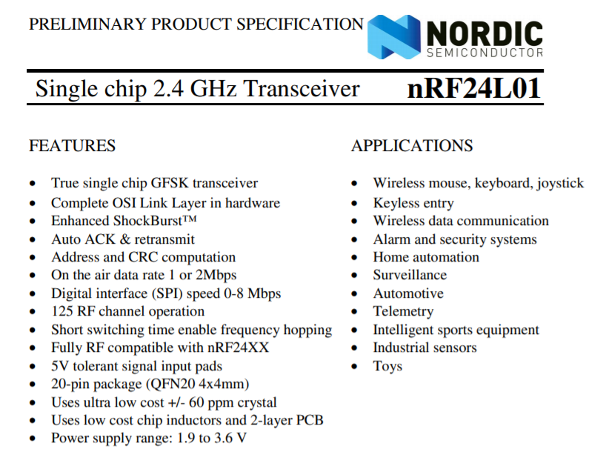

Arduino Metro Mini Datasheet:
https://www.verical.com/datasheet/adafruit-embedded-system-development-tools-2590-5038474.pdf
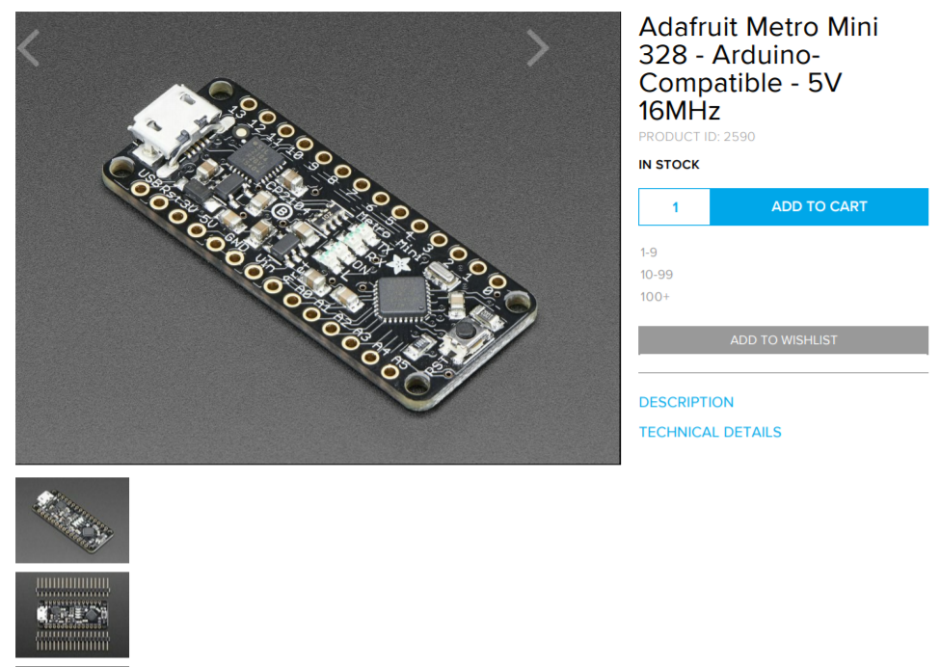
Adafruit ItsyBitsy Datasheet:
https://cdn-learn.adafruit.com/downloads/pdf/introducting-itsy-bitsy-32u4.pdf
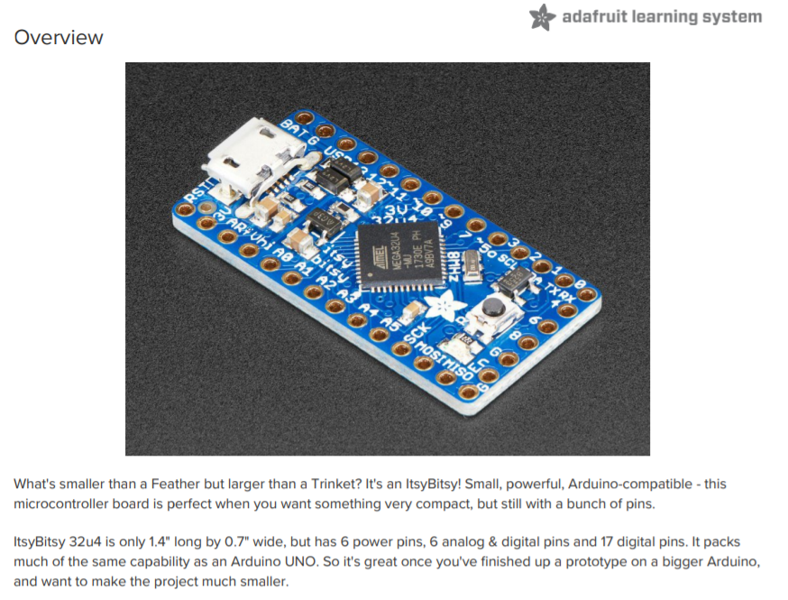

L293D Motor Driver Datasheet:
https://cdn-shop.adafruit.com/datasheets/l293d.pdf
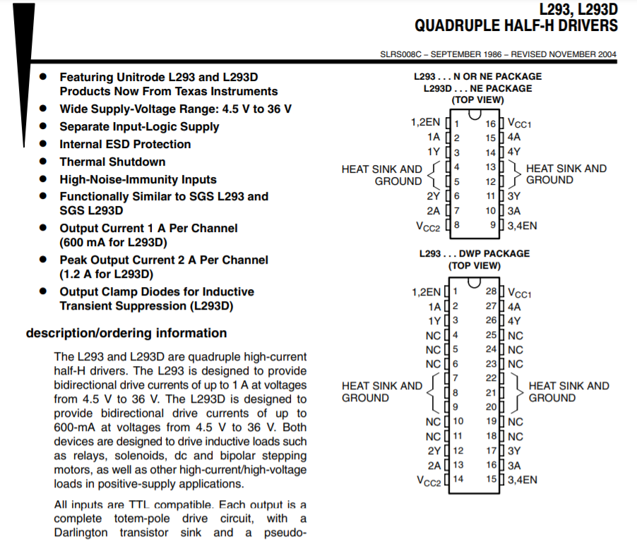

Arduino Code

Code for the Sender:
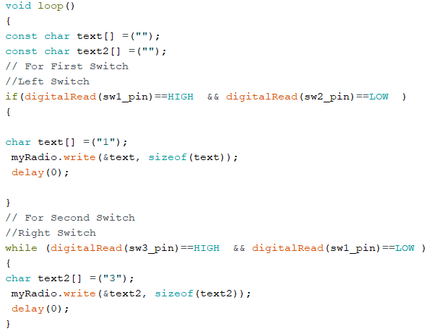

Code for the Receiver:
