COS30008 Semester March, 2026 Ms Siti Hawa

Swinburne University of Technology
School of Science, Computing and Engineering Technologies

ASSIGNMENT COVER SHEET

Subject Code: COS30008
Subject Title: Data Structures and Patterns
Assignment number and title: 2, Indexers, Method Overriding, and Lambdas
Due date: 13th May 2026, 23:59
Lecturer: Ms Siti Hawa

Your name: Khant Thu Aung Your student id: 105292912

Section | C1 | C2 | C3

Marker's comments:

Problem | Marks | Obtained
1 | 48
2 | 30+10= 40
3 | 58
Total | 146

Extension certification:

This assignment has been given an extension and is now due on

Signature of Convener:

SOLUTION:

IntVector.Cpp

Problem 1

#include "IntVector.h"
#include <stdexcept>

// Constructor: copy argument array
IntVector::IntVector(const int aArrayOfIntegers[], size_t aNumberOfElements)
{
fNumberOfElements = aNumberOfElements;

fElements = new int[fNumberOfElements];

for (size_t i = 0; i < fNumberOfElements; i++)
{
fElements[i] = aArrayOfIntegers[i];
}
}
// Destructor: release memory
IntVector::~IntVector()
{
delete[] fElements;
}

// size getter
size_t IntVector::size() const
{
return fNumberOfElements;
}

// element getter
const int IntVector::get(size_t aIndex) const
{
return (*this)[aIndex];
}

// swap two elements within the vector
void IntVector::swap(size_t aSourceIndex, size_t aTargetIndex)
{
if (aSourceIndex >= fNumberOfElements || aTargetIndex >= fNumberOfElements)
{
throw std::out_of_range("Illegal vector indices");
}

int temp = fElements[aSourceIndex];
fElements[aSourceIndex] = fElements[aTargetIndex];
fElements[aTargetIndex] = temp;
}
// indexer
const int IntVector::operator[](size_t aIndex) const
{
if (aIndex >= fNumberOfElements)
{
throw std::out_of_range("Illegal vector index");
}

return fElements[aIndex];
}

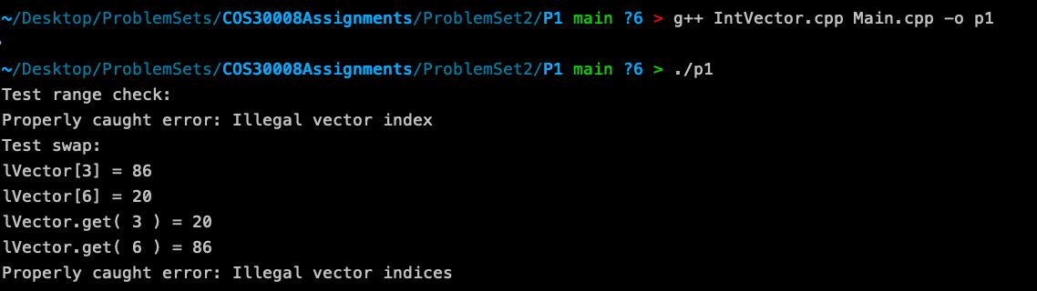

Problem 2

SortableIntVector.cpp

#include "SortableIntVector.h"

// Constructor
SortableIntVector::SortableIntVector(const int aArrayOfIntegers[], size_t aNumberOfElements): IntVector(aArrayOfIntegers, aNumberOfElements){}

// Bubble Sort
void SortableIntVector::sort(Comparable aOrderFunction)
{
for (size_t i = 0; i < size(); i++)
{
for (size_t j = 0; j < size() - i - 1; j++)
{
if (!aOrderFunction(get(j), get(j + 1)))
{
swap(j, j + 1);
}
}
}
}

Main_PS2.cpp (Cut only Problem 2 Part)
#ifdef P2

#include "SortableIntVector.h"

void runP2()
{
int lArray[] = { 34, 65, 890, 86, 16, 218, 20, 49, 2, 29 };
size_t lArrayLength = sizeof(lArray) / sizeof(int);

SortableIntVector lVector( lArray, lArrayLength );

cout << "Bubble Sort:" << endl;

cout << "Before sorting:" << endl;

for ( size_t i = 0; i < lVector.size(); i++ )
{
cout << lVector[i] << ' ';
}

cout << endl;

// Use a lambda expression here that orders integers in increasing order.
// The lambda expression does not capture any variables of throws any exceptions.
// It has to return a bool value.
lVector.sort([](int aLeft, int aRight) { return aLeft <= aRight; } );
// (10)

cout << "After sorting:" << endl;

for ( size_t i = 0; i < lVector.size(); i++ )
{
cout << lVector[i] << ' ';
}
cout << endl;
}

#endif

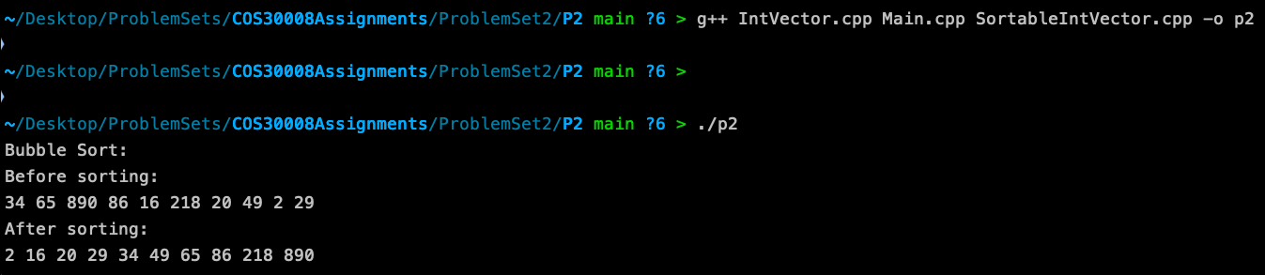

Problem 3

ShakerSortableIntVector.cpp

#include "ShakerSortableIntVector.h"

// Constructor
ShakerSortableIntVector::ShakerSortableIntVector(const int aArrayOfIntegers[],size_t aNumberOfElements): SortableIntVector(aArrayOfIntegers, aNumberOfElements){}

// Cocktail Shaker Sort
void ShakerSortableIntVector::sort(Comparable aOrderFunction)
{
if (size() <= 1)
{
return;
}

size_t left = 0;
size_t right = size() - 1;

while (left < right)
{
// Move from left to right
for (size_t i = left; i < right; i++)
{
if (aOrderFunction(get(i), get(i + 1)))
{
swap(i, i + 1);
}
}

right--;

// Move from right to left
for (size_t i = right; i > left; i--)
{
if (aOrderFunction(get(i - 1), get(i)))
{
swap(i - 1, i);
}
}

left++;
}
}
