Message.cs

namespace HelloWorld
{
internal class Message{
private string _text;

public Message(string text)
{
_text = text;
}
public void Print()
{
Console.WriteLine(_text);
}
}
}
Program.cs
using System.Security.Cryptography.X509Certificates;

namespace HelloWorld
{
internal class Program
{
static void Main(string[] args)
{
Message myMessage = new Message("Hello, World!Greetings from Message Object.");
myMessage.Print();

List<Message> messages = new List<Message>();
messages.Add(new Message("Hello, Zin!"));
messages.Add(new Message("Hello, Kaung!"));
messages.Add(new Message("Hello, Show!"));
messages.Add(new Message("Hello, Khant Thu!Welcome back!"));
messages.Add(new Message("Hello,Nice to meet you!"));

while (true)
{
Console.Write("Enter name: ");

string name = Console.ReadLine();
if (name.ToLower() == "exit")
{
break;
}
else if (name.ToLower() == "zin")
{
messages[0].Print();
}
else if (name.ToLower() == "kaung")
{
messages[1].Print();
}
else if (name.ToLower() == "show")
{
messages[2].Print();
}
else if (name.ToLower() == "khantthu")
{
messages[3].Print();
}
else
{
messages[4].Print();
}
}

}
}
}

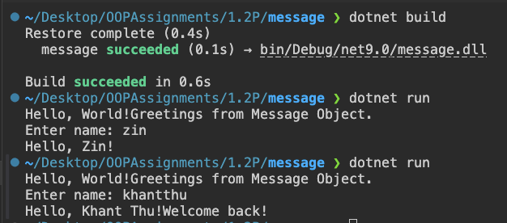
Breakpoint
