Khant Thu Aung/ 105292912
9.2C / Iteration 7
Path.cs
namespace SwinAdventure;

public class Path : GameObject
{
Location _destination;
string _name;
public Path(string[] ids, string name, string desc, Location destination) : base(ids, name, desc)
{
_name = name;
_destination = destination;
}

public void PlayerMove(Player p)
{
p.Location = _destination;
}

public string GetPathName
{
get { return _name; }
}
//property
public Location Destination
{
get { return _destination; }
}
}
MoveCommand.cs
namespace SwinAdventure;

public class MoveCommand : Command
{
public MoveCommand() :
base(new string[] { "move", "head", "leave", "go" }){}

public override string Execute(Player p, string[] text)
{
if (text.Length < 2) return "Move where?";

string direction = text[1];
Path path = p.Location.GetPath(direction);

if (path == null)
return $"There is no path to {direction}";

path.PlayerMove(p);
return $"You move {direction} to {p.Location.Name}.\n{p.Location.FullDescription}";
}
}
Location.cs
namespace SwinAdventure;

public class Location : GameObject, IHaveInventory
{
private Inventory _inventory;
private List<Path> _paths;
public Location(string name, string desc) : base(new string[] { name.ToLower() }, name, desc)
{

_paths = new List<Path>();
_inventory = new Inventory();
}
public GameObject Locate(string id)
{
if (AreYou(id)) { return this; }
return Inventory.Fetch(id);
}
public void AddPath(Path path)
{
_paths.Add(path);
}
public Path GetPath(string direction)
{
foreach (Path p in _paths)
{
if (p.AreYou(direction))
{
return p;
}
}
return null;
}
public Inventory Inventory { get { return _inventory; } }
public override string FullDescription
{
get
{
string exits = "";
foreach (Path path in _paths)
{
exits += $"- {path.FirstID} to {path.Destination.Name}\n";
}
return $"You are at {base.Name}\nThis is a {base.FullDescription}\n.In this {base.Name}, you can see \n{Inventory.ItemList}\nFrom this area, you can go \n{exits}";
}
}
}
LookCommand.cs
namespace SwinAdventure;

public class LookCommand : Command
{

public LookCommand() : base(new string[] { "look" }) { }
public override string Execute(Player p, string[] text)
{
IHaveInventory container;
if(text.Length== 1 && text[0].ToLower() == "inventory")
{
container = p;
return LookAtIn("me", container);
}
if (text[0].ToLower() != "look")
{
return "Error in look input";
}
if (text.Length == 1 && text[0].ToLower() == "look")
{
return p.Location.FullDescription;
}
if (text.Length != 3 && text.Length != 5)
{
return "I don't know how to look like that";
}
if (text[1].ToLower() != "at")
{
return "What do you want to look at?";
}
if (text.Length == 5 && text[3].ToLower() != "in")
{
return "What do you want to look in?";
}
string itemId = text[2];

if (text.Length == 3)
{
container = p;
}
else
{
string containerId = text[4];
container = FetchContainer(p, containerId);
if (container == null)
{
return $"I can't find the {containerId}";
}
}
return LookAtIn(itemId, container);
}

private IHaveInventory FetchContainer(Player p, string containerId)
{
GameObject obj = p.Locate(containerId);
return obj as IHaveInventory;
}
private string LookAtIn(string thingId, IHaveInventory container)
{
GameObject item = container.Locate(thingId);
if (item == null)
{
return $"I can't find the {thingId}";
}
return item.FullDescription;
}
}
Program.cs
namespace SwinAdventure;

public class Program
{
public static void Main()
{
string playerName;
string playerDescription;

Console.WriteLine("Enter your name, Adventurer!");
Console.Write("Name -> ");
playerName = Console.ReadLine();
Console.WriteLine("Now how do you describe yourself, Adventurer!");
Console.Write("Description -> ");
playerDescription = Console.ReadLine();

Location spawnPoint = new("Front Gate", "a Front Gate of the theme park.");
Player me = new(playerName, playerDescription, spawnPoint);
me.Location = spawnPoint;

//locations
Location ferrisWheel = new("Ferris Wheel", "a ferris wheel area that many people are lining to ride.");
Location jungleRide = new("Jungle Ride", "a water ride with the vibe full of jungle.\n You can even hear the bird noise from the front.");
Location hauntedHouse = new("Haunted House", "a really scary haunted house that many screaming voices are coming from there.");
Location iceCreamShop = new("Ice-cream Shop", "an icecream shop that many parents are lining up for their chilren.");
Location boatRace = new("Boat Race", "a boat race where you can participate.\nA race just began.");

//exits for each location
//from spawn
Path spawnEast = new(new string[] { "east" ,"e"}, "Concerete Path", "a path leadig to ferris wheel area", ferrisWheel);
spawnPoint.AddPath(spawnEast);

Path ferrisEast = new(new string[] { "east" ,"e"}, "Concerete Path", "a path leading to Jungle Ride area", jungleRide);
Path ferrisWest = new(new string[] { "west","w" }, "Concerete Path", "a path leading back to gate. ", spawnPoint);
ferrisWheel.AddPath(ferrisEast);
ferrisWheel.AddPath(ferrisWest);
Path jungleWest = new(new string[] { "west" ,"w"}, "Concerete Path", "a path leading back to Ferris Wheel area", ferrisWheel);
Path jungleNorth = new(new string[] { "north" ,"n"}, "Dirt Path", "a path leading to Haunted House area", hauntedHouse);
jungleRide.AddPath(jungleWest);
jungleRide.AddPath(jungleNorth);
Path hauntEast = new(new string[] { "east" ,"e"}, "Small Bridge", "a path leading to Ice Cream Shop", iceCreamShop);
Path hauntSouth = new(new string[] { "south" ,"s" }, "Dirt Path", "a path leading back to Jungle Ride Area", jungleRide);
Path hauntSe = new(new string[] { "southeast" ,"se" }, "Stone Path", "a path leading to Boat Racing Area", boatRace);
hauntedHouse.AddPath(hauntEast);
hauntedHouse.AddPath(hauntSouth);
hauntedHouse.AddPath(hauntSe);
Path iceSouth = new(new string[] { "south","s" }, "Concerete Path", "a path leading to Boat Racing Area", boatRace);
Path iceWest = new(new string[] { "west","w" }, "Small Bridge", "a path leading back to Haunted House Area", hauntedHouse);
iceCreamShop.AddPath(iceSouth);
iceCreamShop.AddPath(iceWest);
Path boatNw = new(new string[] { "northwest","nw" }, "Stone Path", "a path leading to Haunted House Area", hauntedHouse);
Path boatNorth = new(new string[] { "north" ,"n"}, "Concerete Path", "a path leading to Ice Cream Area", iceCreamShop);
boatRace.AddPath(boatNw);
boatRace.AddPath(boatNorth);

//items
Item phone = new(new string[] { "phone", "modern phone" }, "A modern phone", "A phone that you have been using for 2 years.");
Item wallet = new(new string[] { "wallet", "old wallet" }, "An old wallet", "A wallet that your dad gifted on your 10th birthday.");
Bag bag = new(new string[] { "bag", "school bag" }, "A school bag", "A blue school bag that you take everywhere you go.");
Item ring = new(new string[] { "ring", "gold ring" }, "A gold ring", "A high value ring that's been passed down to you");

Item ticket = new(new string[] { "ticket", "entry ticket" }, "An entry ticket", "A ticket to the theme park.");
Item miniFan = new(new string[] { "fan", "small fan" }, "A small fan", "A small fan that can make you cool");
Item coin = new(new string[] { "coin", "bronze coin" }, "A bronze coin", "A bronze coin that someone dropped");
Item flower = new(new string[] { "flower", "yellow flower" }, "A yellow flower", "A yellow flower growing near the Jungle Ride");
Item skull = new(new string[] { "skull", "plastic skull" }, "A plastic skull", "A plastic scary skull that you found in Haunted House");
Item iceCream = new(new string[] { "icecream", "vanilla icecream" }, "A vanilla icecream", "People say this vanilla icecream is the best");
Item miniBoat = new(new string[] { "miniboat", "red miniboat" }, "A red miniboat", "Staffs are giving out miniboat for the kids");

//player initial inventory
me.Inventory.Put(phone);
me.Inventory.Put(wallet);
me.Inventory.Put(bag);
bag.Inventory.Put(ring);

//locations inventories
//spawn
spawnPoint.Inventory.Put(ticket);

//ferrisWheel
ferrisWheel.Inventory.Put(miniFan);

//jungle
jungleRide.Inventory.Put(coin);
jungleRide.Inventory.Put(flower);

//haunted house
hauntedHouse.Inventory.Put(skull);

//icecream
iceCreamShop.Inventory.Put(iceCream);

//boat race
boatRace.Inventory.Put(miniBoat);

Console.WriteLine("Welcome to Swin Adventure!\nYou have arrived at the front gate of the theme park.");
while (true)
{
string command = "";
Console.Write("Command -> ");
command = Console.ReadLine();
string[] parts = command.ToLower().Split(' ');

switch (parts[0])
{
case "exit":
case "end":
{
Console.WriteLine("Bye Adventurer!");
return;
}
case "look":
case "inventory":
case "inv":
{
Console.WriteLine(new LookCommand().Execute(me,parts));
break;
}
case "move":
case "go":
case "head":
case "leave":
{
Console.WriteLine(new MoveCommand().Execute(me, parts));
break;
}
default:
{
Console.WriteLine("Sorry. I don't know how to respone that");
break;
}
}
}
}
}
TestPath.cs
using NUnit.Framework.Legacy;
using SwinAdventure;
using Path = SwinAdventure.Path;
namespace UnitTest;
[TestFixture]
public class TestPathAndMove
{
private Player player;
private Location hallway;
private Location garden;
private MoveCommand moveCommand;

[SetUp]
public void Setup()
{
hallway = new Location("Hallway", "A long well lit hallway.");
garden = new Location("Garden", "A lush garden with flowers.");

// Add two-way paths
hallway.AddPath(new Path(new string[] { "south" }, "South Path", "A path leading south.", garden));
garden.AddPath(new Path(new string[] { "north" }, "North Path", "A path leading back north.", hallway));

player = new Player("Alex", "an adventurer", hallway);
moveCommand = new MoveCommand();
}

[Test]
public void TestMoveSouth()
{
string result = moveCommand.Execute(player, new string[] { "move", "south" });

Assert.That(player.Location, Is.EqualTo(garden));
Assert.That(result, Does.Contain("You move south"));
Assert.That(result, Does.Contain("Garden"));
}

[Test]
public void TestMoveNorthBack()
{
// Move to garden first
player.Location = garden;

string result = moveCommand.Execute(player, new string[] { "move", "north" });

Assert.That(player.Location, Is.EqualTo(hallway));
Assert.That(result, Does.Contain("You move north"));
Assert.That(result, Does.Contain("Hallway"));
}

[Test]
public void TestInvalidDirection()
{
string result = moveCommand.Execute(player, new string[] { "move", "east" });

Assert.That(player.Location, Is.EqualTo(hallway)); // Still in original location
Assert.That(result, Is.EqualTo("There is no path to east"));
}

[Test]
public void TestMissingCommand()
{
string result = moveCommand.Execute(player, new string[] { "move" });

Assert.That(result, Is.EqualTo("Move where?").IgnoreCase);
}

[Test]
public void TestIdentifiablePath()
{
Path southPath = hallway.GetPath("south");

ClassicAssert.IsTrue(southPath.AreYou("south"));
ClassicAssert.IsFalse(southPath.AreYou("north"));
}
}
UML diagram
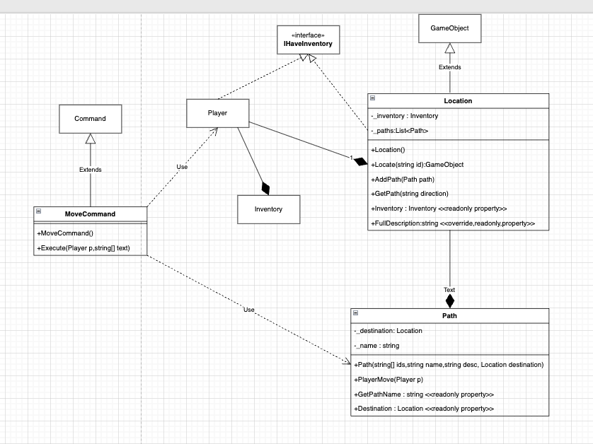
Sequence Diagram
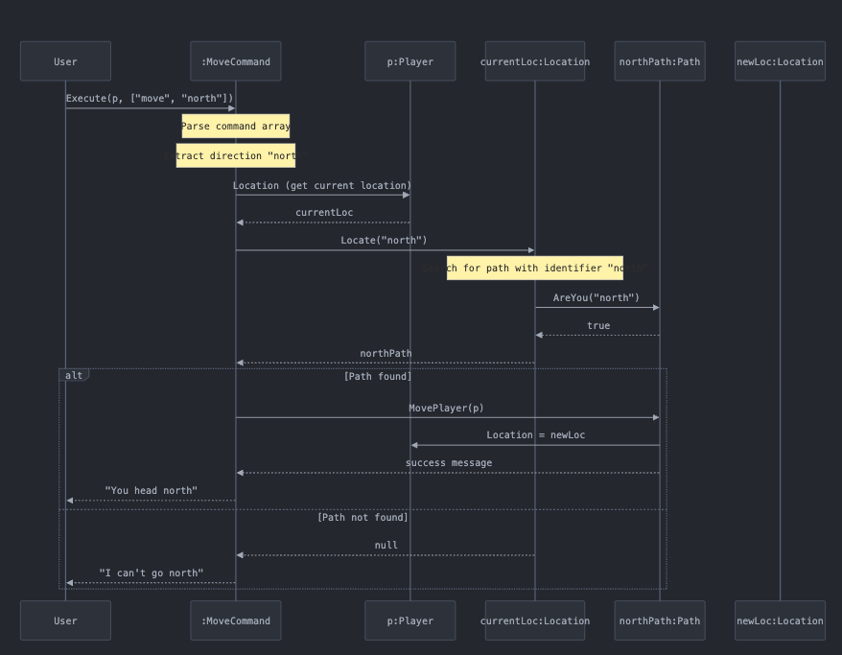
TestCase
