Khant Thu Aung / 105292912
10.1C Iteration 8
TakeCommand.cs
using System.ComponentModel;

namespace SwinAdventure;

public class TakeCommand : Command
{
public TakeCommand() : base(new string[]{"pickup","take"})
{
}

public override string Execute(Player p, string[] text)
{
if (text.Length != 2 && text.Length != 4)
return "I don't understand what you want to take.";

string itemId = text[1];

if (text.Length == 2)
{
// take from current location
GameObject item = p.Location.Inventory.Take(itemId);
if (item == null)
return $"There is no {itemId} here.";

if (item is Item takenItem)
{
p.Inventory.Put(takenItem);
return $"You took the {takenItem.Name} from {p.Location.Name}";
}
return $"{itemId} is not an item you can take.";
}
else if (text.Length == 4 && text[2].ToLower() == "from")
{
string containerId = text[3];
GameObject container = p.Locate(containerId);

if (container is IHaveInventory hasInventory)
{
GameObject item = hasInventory.Inventory.Take(itemId);
if (item == null)
return $"There is no {itemId} in the {container.Name}.";

if (item is Item takenItem)
{
p.Inventory.Put(takenItem);
return $"You took the {takenItem.Name} from the {container.Name}.";
}
return $"{itemId} is not an item you can take.";
}
return $"I can't find the {containerId}.";
}
return "I don't understand how to take like that.";
}
}
PutCommand.cs
namespace SwinAdventure;

public class PutCommand : Command
{
public PutCommand() : base(new string[] { "put", "drop" }) { }

public override string Execute(Player p, string[] text)
{
if (text.Length == 2)
{
// put item / drop item => drop to ground (location)
string itemId = text[1];
Item item = p.Inventory.Take(itemId);
if (item == null)
return $"You don't have {itemId}.";

p.Location.Inventory.Put(item);
return $"You dropped {item.Name} at {p.Location.Name}.";
}

if (text.Length == 4 && text[2].ToLower() == "in")
{
string itemId = text[1];
string containerId = text[3];

// Locate container (bag, location, etc.)
IHaveInventory container = FetchContainer(p, containerId);
if (container == null)
return $"I can't find the {containerId}.";

Item item = p.Inventory.Take(itemId);
if (item == null)
return $"You don't have {itemId}.";

container.Inventory.Put(item);
return $"You put the {item.Name} in the {containerId}.";
}

return "I don't know how to put like that.";
}
public IHaveInventory FetchContainer(Player p, string id)
{
GameObject obj = p.Locate(id);
return obj as IHaveInventory;
}
}
CommandProcessor.cs
namespace SwinAdventure;

public class CommandProcessor
{
private List<Command> _commands;

public CommandProcessor()
{
_commands = new List<Command>
{
new LookCommand(),
new MoveCommand(),
new TakeCommand(),
new PutCommand()
};
}

public string ExecuteCommand(Player player, string[] input)
{
if (input.Length == 0 || string.IsNullOrWhiteSpace(input[0]))
return "No command given.";

string commandWord = input[0].ToLower();

foreach (Command cmd in _commands)
{
if (cmd.AreYou(commandWord))
return cmd.Execute(player, input);
}
return $"I don't understand '{commandWord}'.";
}
}
Program.cs
namespace SwinAdventure;

public class Program
{
public static void Main()
{
string playerName;
string playerDescription;
CommandProcessor processor = new CommandProcessor();

Console.WriteLine("Enter your name, Adventurer!");
Console.Write("Name -> ");
playerName = Console.ReadLine();
Console.WriteLine("Now how do you describe yourself, Adventurer!");
Console.Write("Description -> ");
playerDescription = Console.ReadLine();

Location spawnPoint = new(new string[]{"gate"},"Front Gate", "a Front Gate of the theme park.");
Player me = new(playerName, playerDescription, spawnPoint);
me.Location = spawnPoint;

//locations
Location ferrisWheel = new(new string[]{"ferris"},"Ferris Wheel", "a ferris wheel area that many people are lining to ride.");
Location jungleRide = new(new string[]{"jungle"},"Jungle Ride", "a water ride with the vibe full of jungle.\n You can even hear the bird noise from the front.");
Location hauntedHouse = new(new string[]{"haunted"},"Haunted House", "a really scary haunted house that many screaming voices are coming from there.");
Location iceCreamShop = new(new string[]{"shop"},"Ice-cream Shop", "an icecream shop that many parents are lining up for their chilren.");
Location boatRace = new(new string[]{"boat"},"Boat Race", "a boat race where you can participate.\nA race just began.");

//exits for each location
//from spawn
Path spawnEast = new(new string[] { "east" ,"e"}, "Concerete Path", "a path leadig to ferris wheel area", ferrisWheel);
spawnPoint.AddPath(spawnEast);

Path ferrisEast = new(new string[] { "east" ,"e"}, "Concerete Path", "a path leading to Jungle Ride area", jungleRide);
Path ferrisWest = new(new string[] { "west","w" }, "Concerete Path", "a path leading back to gate. ", spawnPoint);
ferrisWheel.AddPath(ferrisEast);
ferrisWheel.AddPath(ferrisWest);
Path jungleWest = new(new string[] { "west" ,"w"}, "Concerete Path", "a path leading back to Ferris Wheel area", ferrisWheel);
Path jungleNorth = new(new string[] { "north" ,"n"}, "Dirt Path", "a path leading to Haunted House area", hauntedHouse);
jungleRide.AddPath(jungleWest);
jungleRide.AddPath(jungleNorth);
Path hauntEast = new(new string[] { "east" ,"e"}, "Small Bridge", "a path leading to Ice Cream Shop", iceCreamShop);
Path hauntSouth = new(new string[] { "south" ,"s" }, "Dirt Path", "a path leading back to Jungle Ride Area", jungleRide);
Path hauntSe = new(new string[] { "southeast" ,"se" }, "Stone Path", "a path leading to Boat Racing Area", boatRace);
hauntedHouse.AddPath(hauntEast);
hauntedHouse.AddPath(hauntSouth);
hauntedHouse.AddPath(hauntSe);
Path iceSouth = new(new string[] { "south","s" }, "Concerete Path", "a path leading to Boat Racing Area", boatRace);
Path iceWest = new(new string[] { "west","w" }, "Small Bridge", "a path leading back to Haunted House Area", hauntedHouse);
iceCreamShop.AddPath(iceSouth);
iceCreamShop.AddPath(iceWest);
Path boatNw = new(new string[] { "northwest","nw" }, "Stone Path", "a path leading to Haunted House Area", hauntedHouse);
Path boatNorth = new(new string[] { "north" ,"n"}, "Concerete Path", "a path leading to Ice Cream Area", iceCreamShop);
boatRace.AddPath(boatNw);
boatRace.AddPath(boatNorth);

//items
Item phone = new(new string[] { "phone", "modern phone" }, "A modern phone", "A phone that you have been using for 2 years.");
Item wallet = new(new string[] { "wallet", "old wallet" }, "An old wallet", "A wallet that your dad gifted on your 10th birthday.");
Bag bag = new(new string[] { "bag", "school bag" }, "A school bag", "A blue school bag that you take everywhere you go.");
Item ring = new(new string[] { "ring", "gold ring" }, "A gold ring", "A high value ring that's been passed down to you");

Bag oldBag = new(new string[] { "oldbag", "torn bag" }, "a torn bag", "A torn bag someone left behind");
Item ticket = new(new string[] { "ticket", "entry ticket" }, "An entry ticket", "A ticket to the theme park.");
Item miniFan = new(new string[] { "fan", "small fan" }, "A small fan", "A small fan that can make you cool");
Item coin = new(new string[] { "coin", "bronze coin" }, "A bronze coin", "A bronze coin that someone dropped");
Item flower = new(new string[] { "flower", "yellow flower" }, "A yellow flower", "A yellow flower growing near the Jungle Ride");
Item skull = new(new string[] { "skull", "plastic skull" }, "A plastic skull", "A plastic scary skull that you found in Haunted House");
Item iceCream = new(new string[] { "icecream", "vanilla icecream" }, "A vanilla icecream", "People say this vanilla icecream is the best");
Item miniBoat = new(new string[] { "miniboat", "red miniboat" }, "A red miniboat", "Staffs are giving out miniboat for the kids");
Item book = new(new string[] { "book", "small book" }, "a small book", "a book that is inside a torn bag");

//player initial inventory
me.Inventory.Put(phone);
me.Inventory.Put(wallet);
me.Inventory.Put(bag);
bag.Inventory.Put(ring);
oldBag.Inventory.Put(book);

//locations inventories
//spawn
spawnPoint.Inventory.Put(ticket);

//ferrisWheel
ferrisWheel.Inventory.Put(miniFan);
ferrisWheel.Inventory.Put(oldBag);

//jungle
jungleRide.Inventory.Put(coin);
jungleRide.Inventory.Put(flower);

//haunted house
hauntedHouse.Inventory.Put(skull);

//icecream
iceCreamShop.Inventory.Put(iceCream);

//boat race
boatRace.Inventory.Put(miniBoat);

Console.WriteLine("Welcome to Swin Adventure!\nYou have arrived at the front gate of the theme park.");
while (true)
{
string command = "";
Console.Write("Command -> ");
command = Console.ReadLine();
string[] parts = command.ToLower().Split(' ');

if (parts[0] == "exit" || parts[0] == "end")
{
Console.WriteLine("Bye Adventurer!");
return;
}
Console.WriteLine(processor.ExecuteCommand(me, parts));
}
}
}
TestCommands.cs
using NUnit.Framework.Legacy;
using SwinAdventure;
namespace UnitTest;
[TestFixture]
public class CommandTests
{
private Player player;
private Location location;
private Bag bag;
private Item phone;
private Item ring;
private CommandProcessor processor;

[SetUp]
public void Setup()
{
location = new Location(new string[]{"ground"},"ground", "The theme park entrance.");
player = new Player("Alex", "an adventurer", location);
processor = new CommandProcessor();

// Items
phone = new Item(new[] { "phone" }, "Modern Phone", "Your personal smartphone.");
ring = new Item(new[] { "ring" }, "Gold Ring", "A precious gold ring.");

// Bag setup
bag = new Bag(new[] { "bag" }, "School Bag", "A small school bag.");
player.Inventory.Put(phone);
player.Inventory.Put(bag);
}
[Test]
public void PutItemIntoBag_Success()
{
string result = processor.ExecuteCommand(player, new[] { "put", "phone", "in", "bag" });
Assert.That(result, Does.Contain("You put the Modern Phone in the bag"));

// Item should now be in the bag
ClassicAssert.IsNull(player.Inventory.Fetch("phone"));
ClassicAssert.IsNotNull(bag.Inventory.Fetch("phone"));
}

[Test]
public void DropItemToGround()
{
string result = processor.ExecuteCommand(player, new[] { "put", "phone" });
Assert.That(result, Does.Contain("You dropped Modern Phone"));

ClassicAssert.IsNull(player.Inventory.Fetch("phone"));
ClassicAssert.IsNotNull(location.Inventory.Fetch("phone"));
}

[Test]
public void PutItem_YouDontHave()
{
string result = processor.ExecuteCommand(player, new[] { "put", "wallet" });
Assert.That(result, Does.Contain("You don't have wallet"));
}

[Test]
public void TakeItemFromBag_Success()
{
bag.Inventory.Put(ring);
string expected = "You took the Gold Ring from the School Bag";
string result = processor.ExecuteCommand(player, new[] { "take", "ring", "from", "bag" });
Assert.That(result, Does.Contain(expected));

ClassicAssert.IsNotNull(player.Inventory.Fetch("ring"));
ClassicAssert.IsNull(bag.Inventory.Fetch("ring"));
}

[Test]
public void TakeItemFromGround_Success()
{
location.Inventory.Put(ring);

string result = processor.ExecuteCommand(player, new[] { "take", "ring" });
Assert.That(result, Does.Contain("You took the Gold Ring"));

ClassicAssert.IsNotNull(player.Inventory.Fetch("ring"));
}

[Test]
public void TakeItemThatDoesNotExist()
{
string result = processor.ExecuteCommand(player, new[] { "take", "key" });
Assert.That(result, Does.Contain("There is no key here"));
}

[Test]
public void ExecuteUnknownCommand_ReturnsError()
{
string result = processor.ExecuteCommand(player, new[] { "fly", "north" });
ClassicAssert.AreEqual("I don't understand 'fly'.", result);
}

[Test]
public void ExecutePutCommand_Works()
{
string result = processor.ExecuteCommand(player, new[] { "put", "phone" });
Assert.That(result, Does.Contain("You dropped"));
}

[Test]
public void ExecuteTakeCommand_Works()
{
location.Inventory.Put(phone);
string result = processor.ExecuteCommand(player, new[] { "take", "phone" });

Assert.That(result, Does.Contain("You took the Modern Phone"));
ClassicAssert.IsNotNull(player.Inventory.Fetch("phone"));
}
}
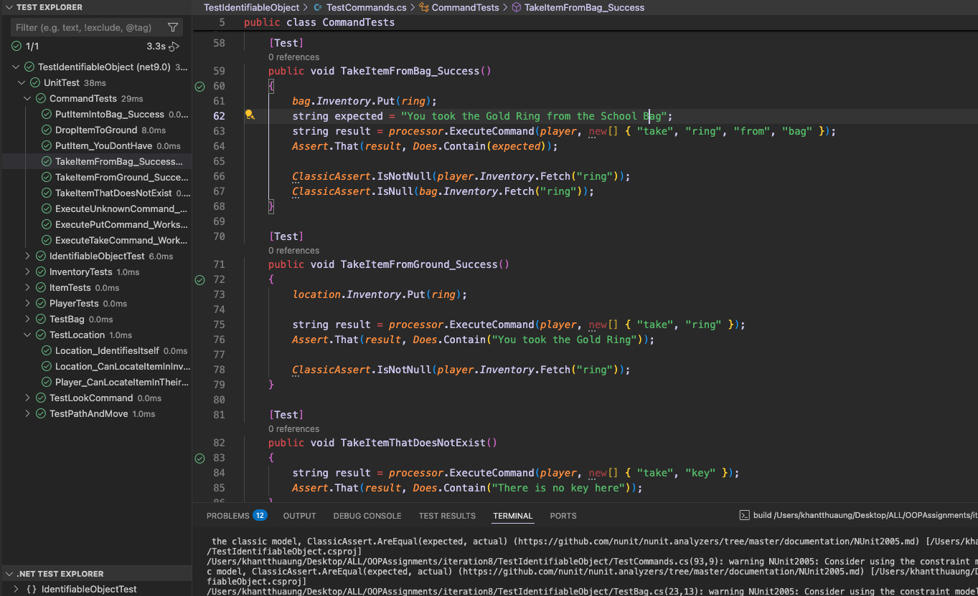
UML Diagram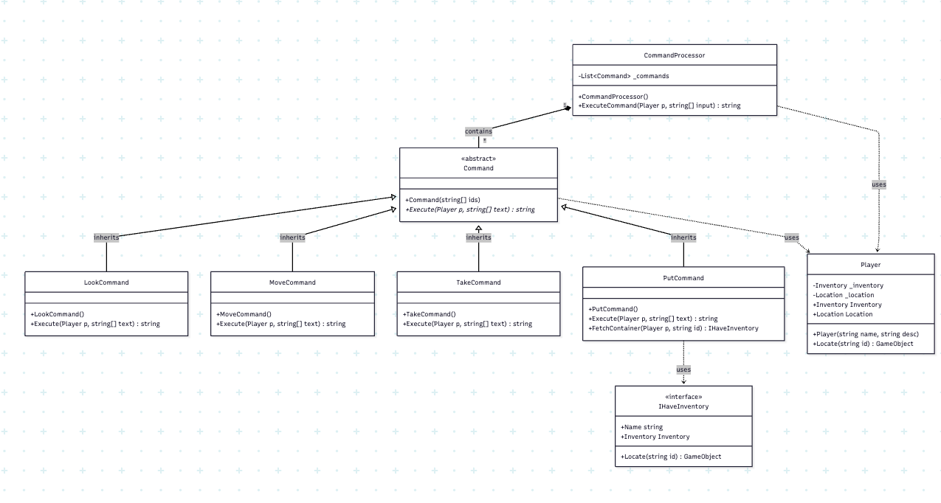
Sequence Diagram