Khant Thu Aung / 105292912
7.3C – Iteration 6
Location.cs
namespace SwinAdventure;

public class Location : GameObject, IHaveInventory
{
private Inventory _inventory;
public Location(string name, string desc) : base(new string[] { name.ToLower() }, name, desc)
{
_inventory = new Inventory();
}
public GameObject Locate(string id)
{
if (AreYou(id)) { return this; }
return Inventory.Fetch(id);
}
public Inventory Inventory { get { return _inventory; } }
public override string FullDescription
{
get
{
return $"You are at {base.Name}\nThis is a {base.FullDescription}\nIn this {base.Name}, you can see {Inventory.ItemList}";
}
}
}
GameObject.cs
namespace SwinAdventure
{
public abstract class GameObject : IdentifiableObject
{
private string _description;
private string _name;
public GameObject(string[] ids, string name, string desc) : base(ids)
{
_name = name;
_description = desc;
}
public string Name
{
get { return _name; }
}
public string ShortDescription
{
get { return _name + " (" + FirstID + ")"; }
}
public virtual string FullDescription
{
get { return _description; }
}
}
}
Player.cs
using System.Reflection.Metadata.Ecma335;

namespace SwinAdventure
{
public class Player : GameObject, IHaveInventory
{
private Inventory _inventory;
private Location _location;
public Player(string name, string desc) : base(new string[] { "me", "inventory" }, name, desc)
{
_inventory = new Inventory();
_location = null;
}
public GameObject Locate(string id)
{
if (AreYou(id)) return this;
GameObject item = Inventory.Fetch(id);
if (item != null) return item;
if (Location != null) return Location.Locate(id);
return null;
}
public override string FullDescription
{
get
{
return $"You are {Name}, {base.FullDescription}.\nYou are carrying:\n{Inventory.ItemList}";
}
}
public Inventory Inventory
{
get { return _inventory; }
}
public Location Location
{
get { return _location; }
set { _location = value; }
}
}
}
LookCommand.cs
namespace SwinAdventure;

public class LookCommand : Command
{

public LookCommand() : base(new string[] { "look" }) { }
public override string Execute(Player p, string[] text)
{

if (text[0].ToLower() != "look")
{
return "Error in look input";
}
if(text.Length== 1 && text[0].ToLower() == "look")
{
return p.Location.FullDescription;
}
if (text.Length != 3 && text.Length != 5)
{
return "I don't know how to look like that";
}
if (text[1].ToLower() != "at")
{
return "What do you want to look at?";
}
if (text.Length == 5 && text[3].ToLower() != "in")
{
return "What do you want to look in?";
}
string itemId = text[2];
IHaveInventory container;

if (text.Length == 3)
{
container = p;
}
else
{
string containerId = text[4];
container = FetchContainer(p, containerId);
if (container == null)
{
return $"I can't find the {containerId}";
}
}
return LookAtIn(itemId, container);
}

private IHaveInventory FetchContainer(Player p, string containerId)
{
GameObject obj = p.Locate(containerId);
return obj as IHaveInventory;
}
private string LookAtIn(string thingId, IHaveInventory container)
{
GameObject item = container.Locate(thingId);
if (item == null)
{
return $"I can't find the {thingId}";
}
return item.FullDescription;
}
}
TestLocation.cs
using SwinAdventure;
using NUnit.Framework.Legacy;
namespace UnitTest;

[TestFixture]
public class TestLocation
{
private Location room;
private Item gem;
private Player player;

[SetUp]
public void SetUp()
{
room = new Location("hall", "a large empty hall");
gem = new Item(new string[] { "Gem", "a gem" }, "A beautiful gem", "A beautiful gem that you found in the chest");
player = new("Fred", "a mighty adventurer");
player.Location = room;
room.Inventory.Put(gem);
}
[Test]
public void Location_IdentifiesItself()
{
ClassicAssert.IsTrue(room.AreYou("hall"));
ClassicAssert.AreEqual(room, room.Locate("hall"));
}
[Test]
public void Location_CanLocateItemInInventory()
{
GameObject found = room.Locate("gem");
ClassicAssert.IsNotNull(found);
ClassicAssert.AreEqual(gem, found);
}
[Test]
public void Player_CanLocateItemInTheirLocation()
{
GameObject found = player.Locate("gem");
ClassicAssert.IsNotNull(found);
ClassicAssert.AreEqual(gem, found);
}

}

TestCases
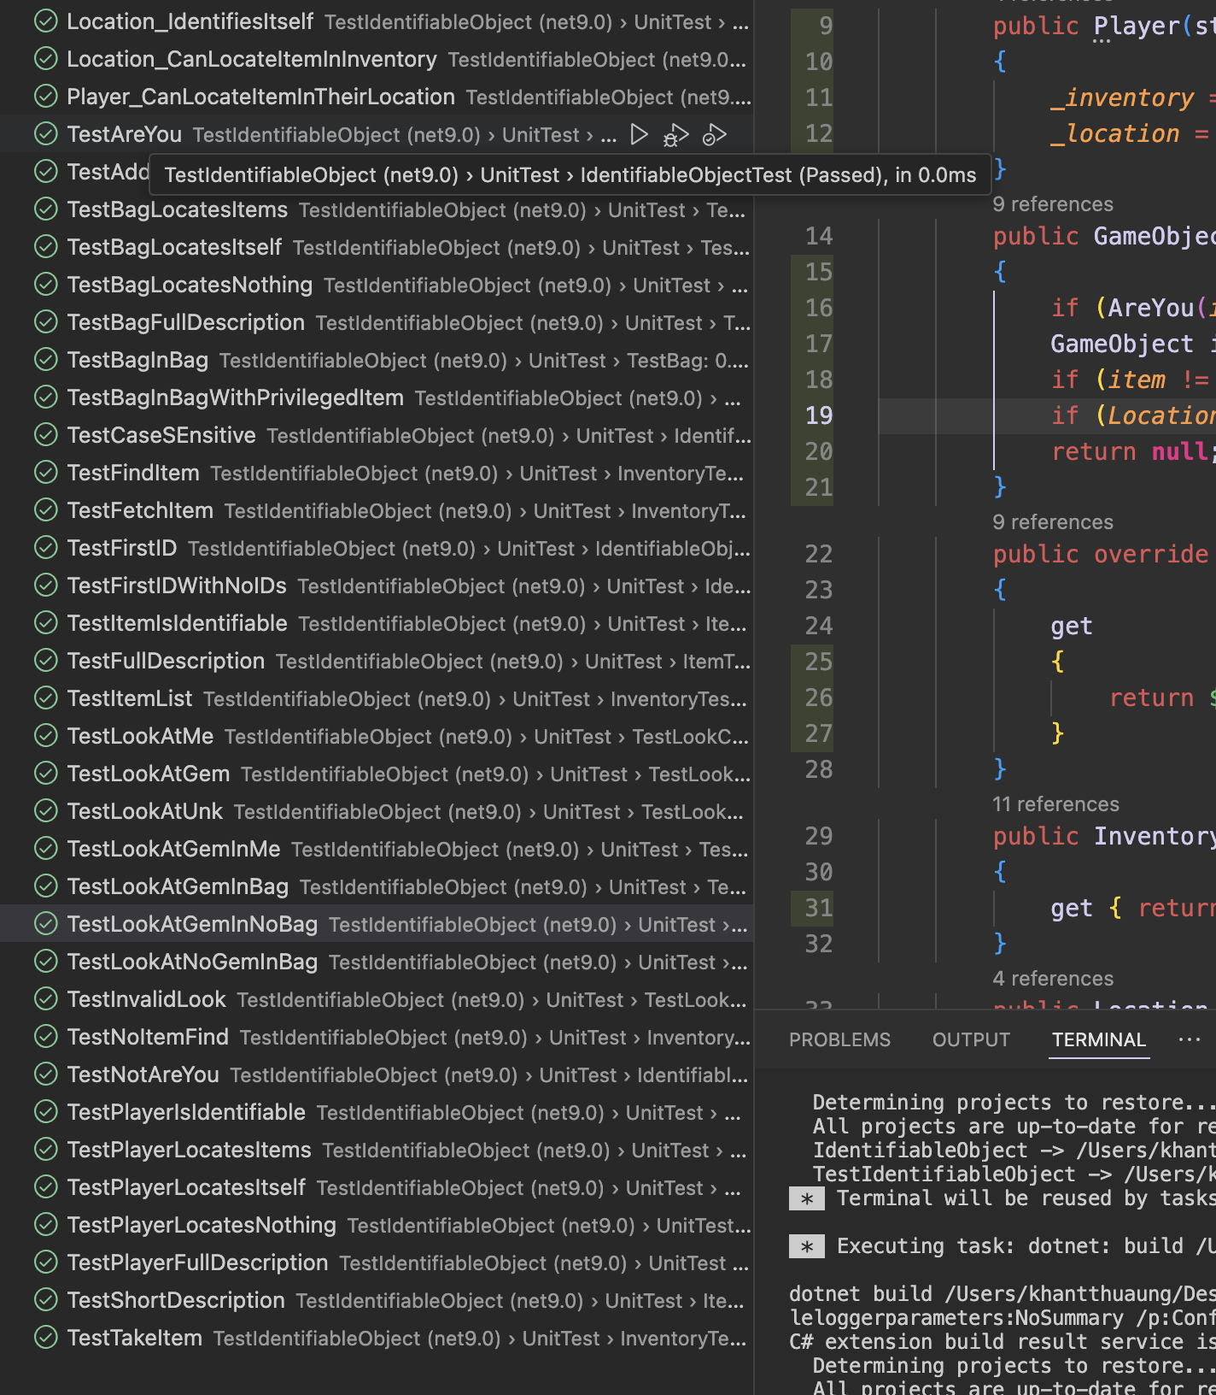
UML Diagram
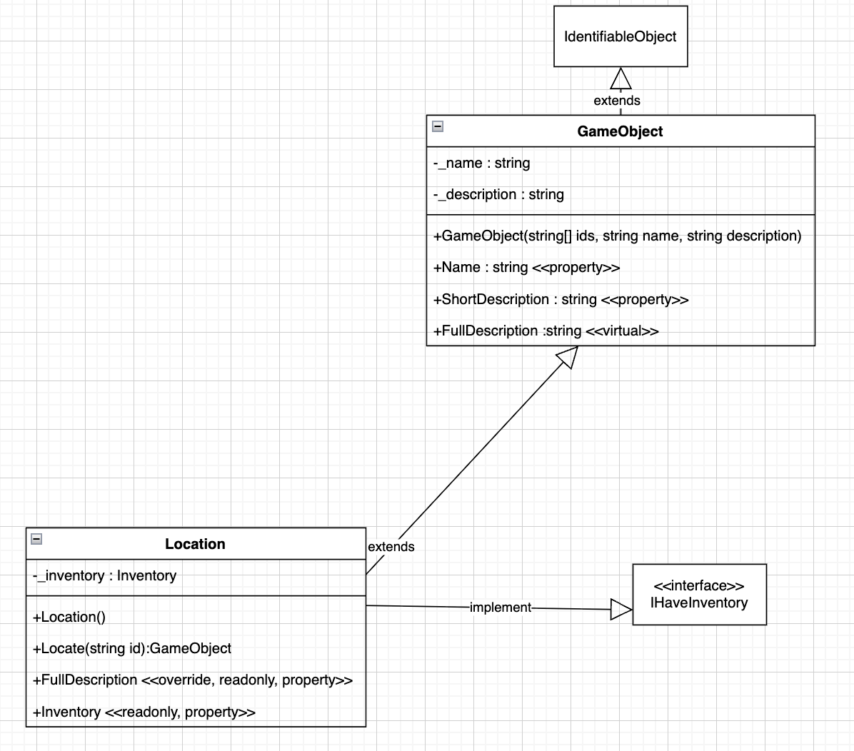
Sequence Diagram
