How Project is created:

* Prerequisite:
  + Install MongoDB Compass
    - <https://www.mongodb.com/try/download/compass>
  + Install MongoDB Server for Windows(Locally, community edition)
    - https://www.mongodb.com/try/download/community
  + Reference
    - https://docs.mongodb.com/manual/tutorial/install-mongodb-on-windows/
* Run npm init
  + Package name: ems-bits-assignment
  + entry point: server.js
* Install dependencies:
  + npm i --save express mongoose express-handlebars body-parser
* Install global dependencies:
  + Npm I nodemon(we can use node directl, but nodemon will auto refresh & restart server and compile when we change any file)
* Start MongoDB server:
  + startMongoDB.bat file from project, Check/change MongoDB installation directory & database path
  + Currently Server path is set to C:\Program Files\MongoDB\Server\5.0\data\ & database path is set to C:\DATA\workspace\EMS-EmployeeManagementSystem\mongo-data
* Open MongoDb Compass, connect to server with default config & create DB and collection as shown below:
  + 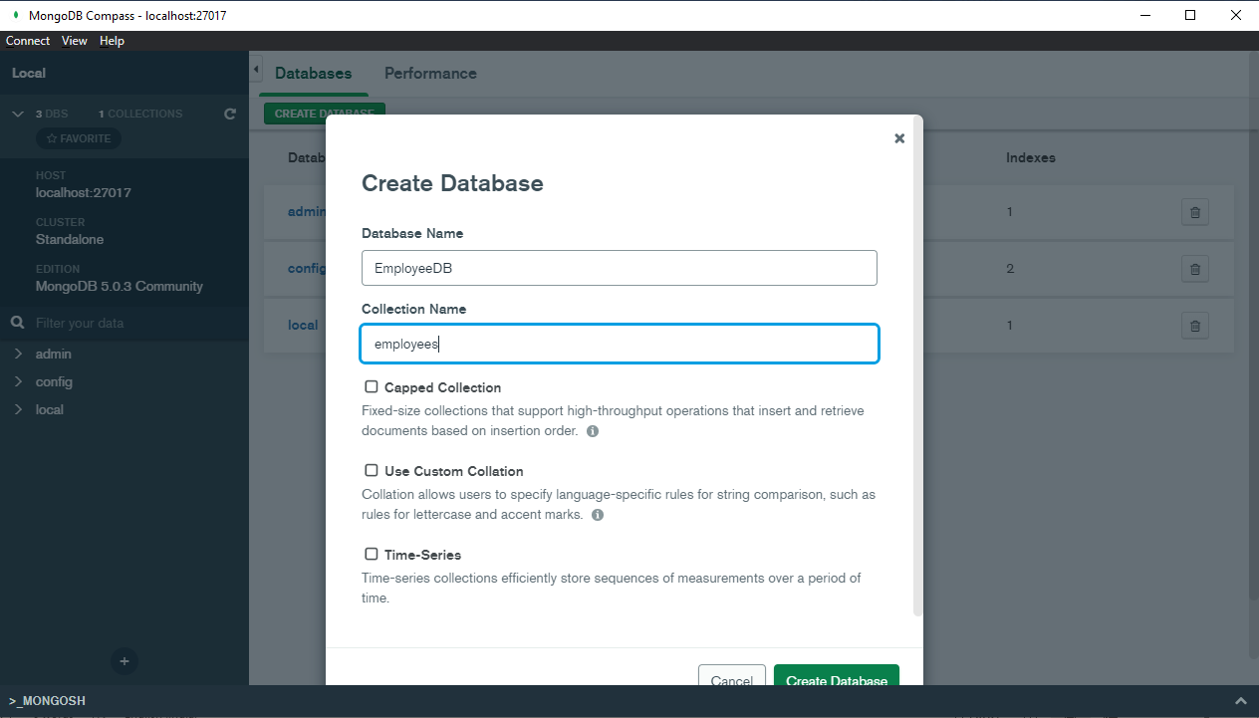
* Start the server with nodemon server.js
  + 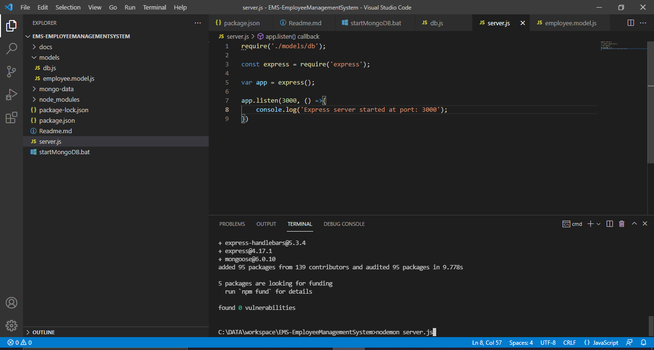
* Navigate to <http://localhost:3000/> & you should see server running with no router added ( Cannot get /)

Adding Empoyee Router & controller

* Add employee Controller:
  + 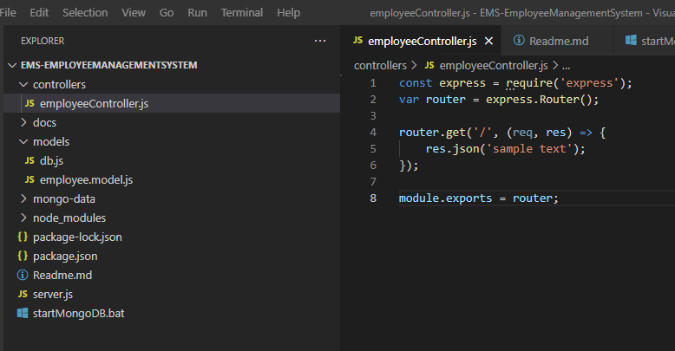
* Update server.js
  + 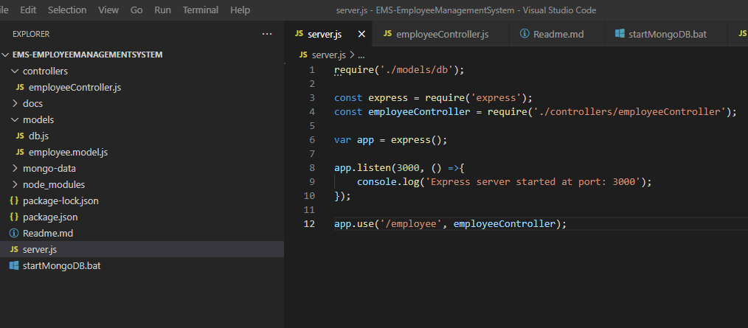
* Now navigate to browser and navigate to employee route to see the changes:
  + 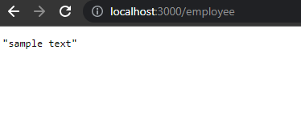

Using handlebar